Excluded samples that had missing exposure or outcome data
(n = 3)
Excluded non-mature oocytes
(n = 6)
Supplemental Figure S1: Flow-chart of exclusion criteria and analyses

Supplemental Figure S2: Correlation plot of Pearson’s correlation coefficient among all the metabolites examined. Asterisk denotes a significant correlation (p < 0.05)

KEGG analysis of top Hit EV-miRNAs:
hsa-miR-125b
hsa-miR-15b
hsa-miR-106b
hsa-miR-374a
hsa-miR-24
hsa-let-7c
hsa-miR-19a
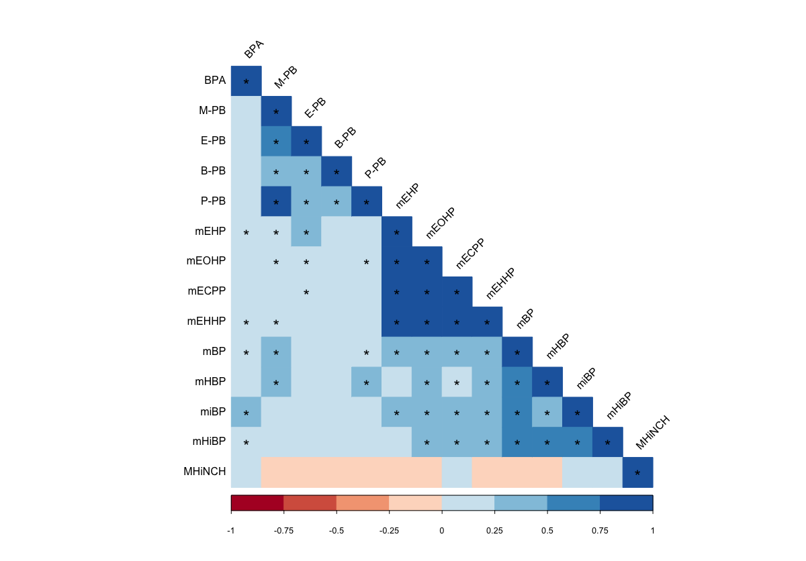
Supplemental Figure S2: Correlation plot of Pearson’s correlation coefficient among all the metabolites examined. Asterisk denotes a significant correlation (p < 0.05)

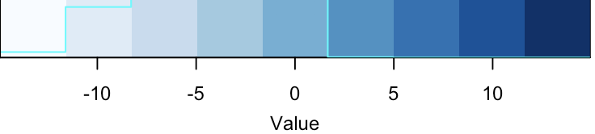
Batch 1
Batch 2
Supplementary Figure S3: Heatmap of normalized EV-miRNA expression data. Each row is an individual and each column is an EV-miRNA. Data is sorted by batch as shown on the left-hand side, green is batch 1 and yellow is batch 2. The lighter the blue, the more negative the normalized the expression and the darker the blue, the more positive the normalized expression
-10
-5
0
5
10
Value

