**Supplemental Figure A.1** Probabilities of assigned rate orders by age group, aggregated across all years.

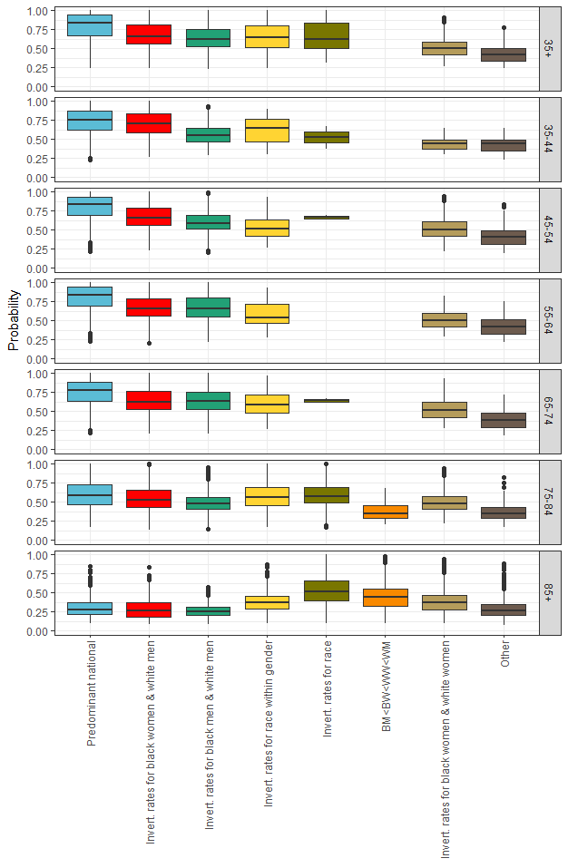

**Supplemental Figure A.2** Rate orders of county-level race-gender heart disease death rates, 2015, by age group

**Ages 35 and older**

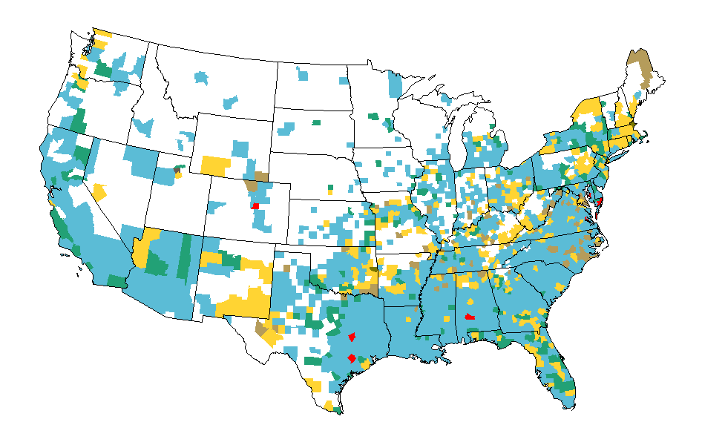

**Ages 35-44**

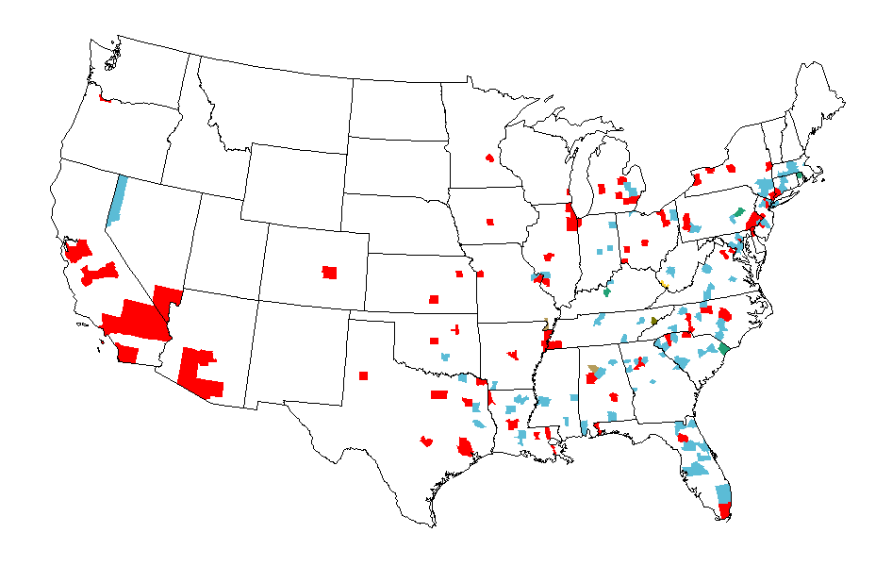

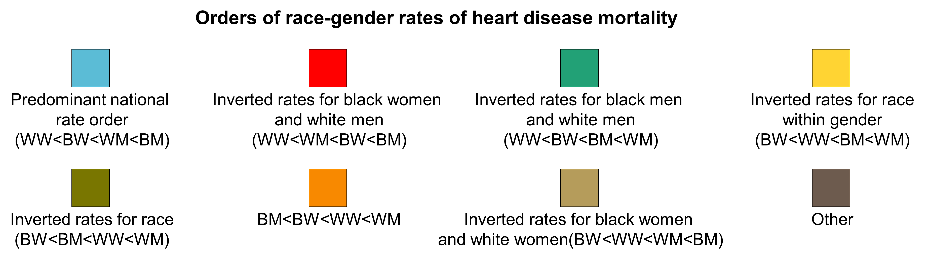

**Ages 45-54**

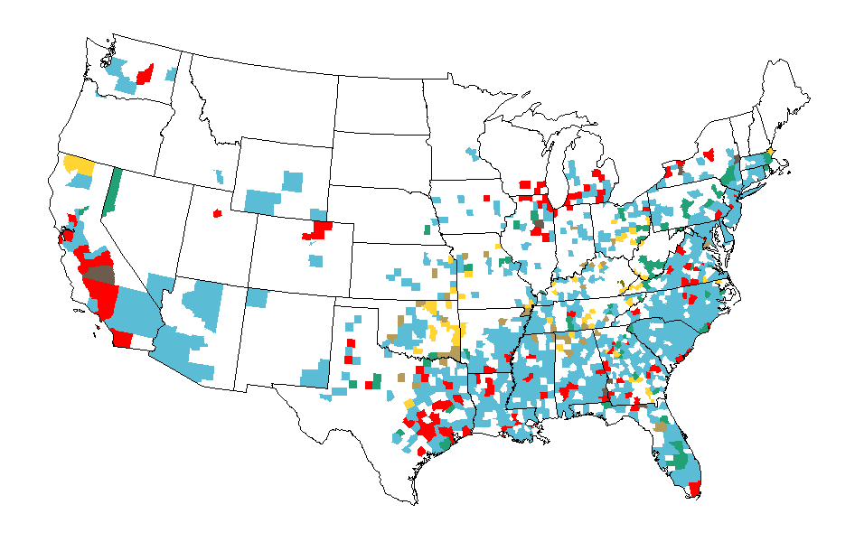

**Ages 55-64**

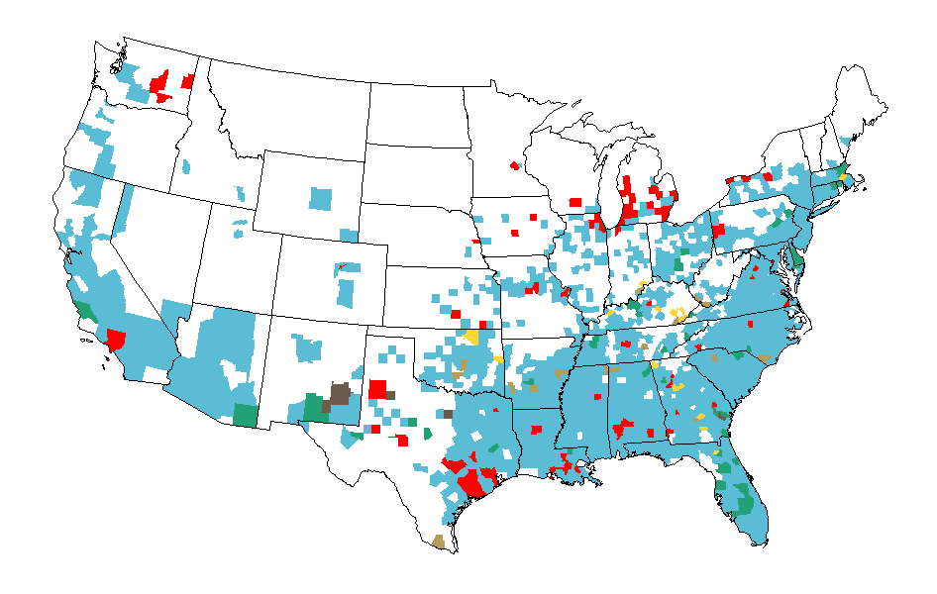****

**Ages 65-74**

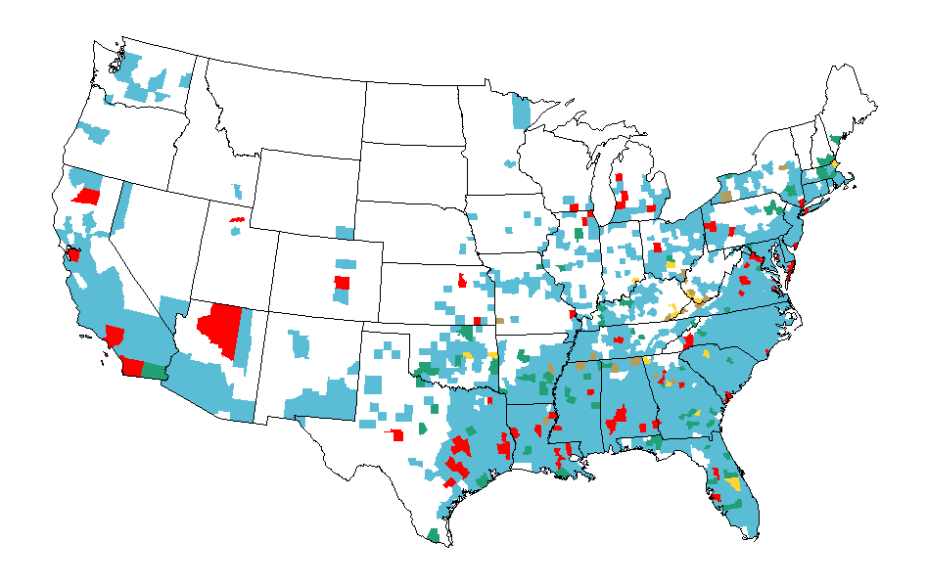

**Ages 75-84**

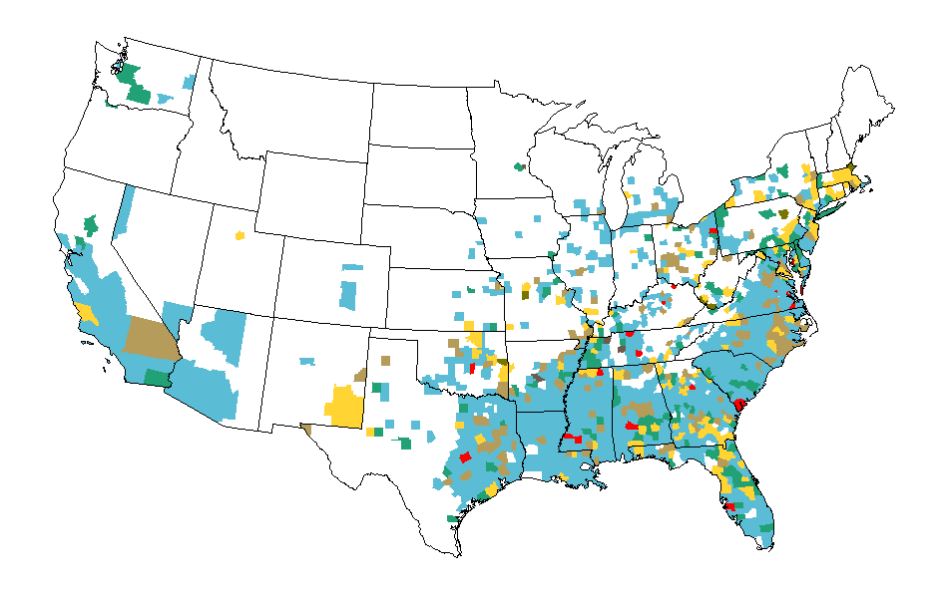



**Ages 85 and older**



