Online Supplemental Tables
Online Table 1. Median and Interquartile range of poverty by race/ethnicity
Race/Ethnicity | Median (%) | Interquartile Range (%)
White | 8.5 | 4.9, 14.0
Black | 21.2 | 10.4, 32.3
Mexican American | 17.8 | 11, 27.5

Online Table 2. Distribution of racial/ethnic groups by overall poverty quartiles
 | Area-level Poverty
 | Quartile 1  N (% in quartile) | % Race/ethnic Population | Quartile 2  N (% in quartile) | % Race/ethnic Population | Quartile 3  N (% in quartile) | % Race/ethnic Population | Quartile 4  N (% in quartile) | % Race/ethnic Population
Total population (n= 10415) | 2599 (100) | - | 2615  (100) | - | 2584  (100) | - | 2595  (100) | -
White (n= 2756) | 1257 (48.37) | 45.61 | 880 (33.65) | 31.93 | 418 (16.18) | 15.17 | 194  (7.48) | 7.04
Black (n= 3052) | 525 (20.20) | 17.02 | 573 (21.91) | 18.77 | 794 (30.73) | 26.01 | 1152  (44.39) | 37.74
Mex.Am. (n= 3342) | 484 (18.62) | 14.48 | 819 (31.32) | 24.50 | 1079 (41.76) | 32.28 | 954  (36.76) | 28.54
Other (n= 1265) | 333 (12.81) | 26.32 | 343 (13.12) | 27.11 | 293 (11.33) | 23.16 | 295  (11.37) | 23.32
Distribution for missing area-level poverty (tract n = 22) not reported. As a result, reported race/ethnicity specific n and percent will not add to total population n and percent.

Online Table 3. Fully adjusted regression results using overall poverty distribution
 | Overall poverty distribution | Overall Poverty Distribution
Variable | Cardiometabolic Dysfunction  (n= 10415)  OR (95% CI) | NH White  (n= 2756)  OR (95% CI) | NH Black  (n= 3052)  OR (95% CI) | Mexican American  (n = 3342)  OR (95% CI)
Area-level poverty
Quartile 1 | Ref. | Ref. | Ref. | Ref.
Quartile 2 | 1.05 (.92, 1.20) | 1.06 (0.86, 1.33) | 1.06 (0.77, 1.45) | 1.22 (0.86, 1.73)
Quartile 3 | 1.27 (1.11, 1.45) | 1.54 (1.15, 2.05) | 1.07 (0.79, 1.44) | 1.63 (1.17, 2.28)
Quartile 4 | 1.25 (1.10, 1.43) | 1.60 (1.09, 2.34) | 1.18 (0.87, 1.59) | 1.52 (1.08, 2.13)

Online Supplemental Figures
Online Figure 1. Data linkage: NHANES, U.S. Census, American Community Survey
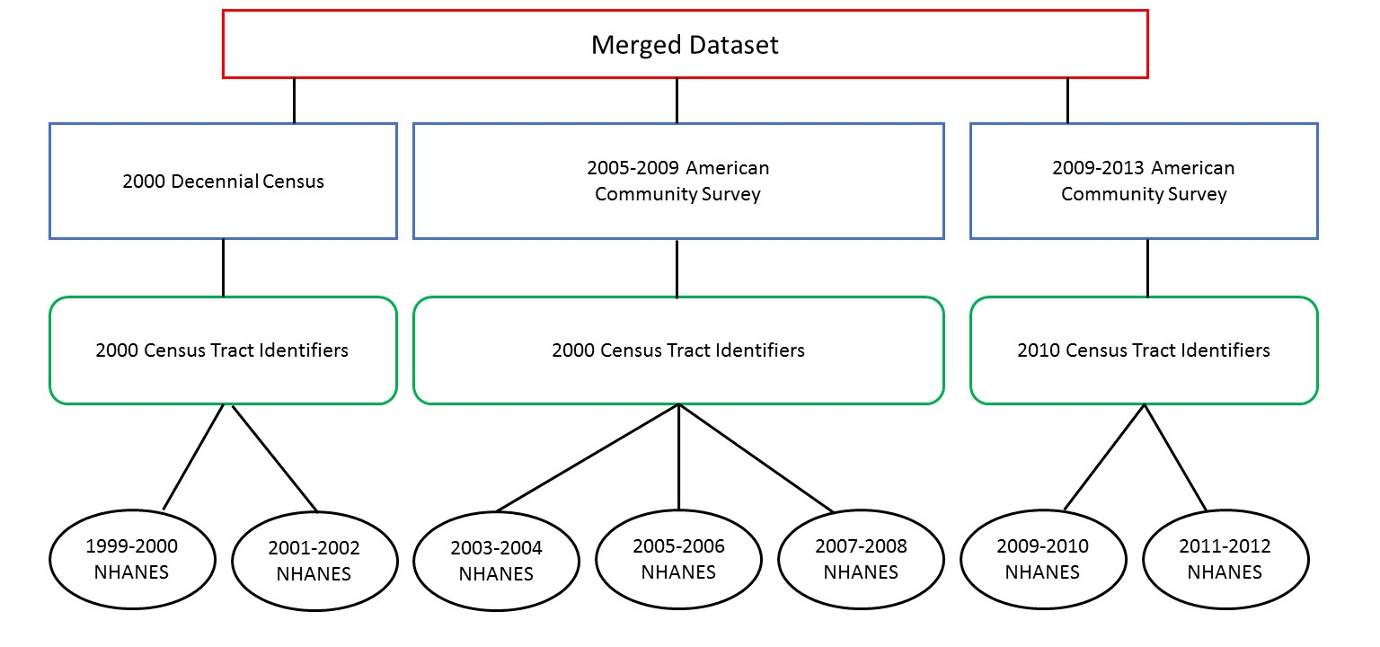

Online Figure 2. Area-level Poverty and Cardiometabolic dysfunction: race-specific odds ratios and 95% confidence intervals
