Appendix 1: Comparison of methods for estimating prescriber registration percentage.

California requires all prescribers with a DEA number for prescribing controlled substances to register for the PDMP. As not all prescribers obtain a DEA number, precisely tracking the rates of registration among prescribers mandated to register for the PDMP requires first identifying the subset of prescribers who have DEA numbers to prescribe controlled substances. Identifying this subset in California is challenging because there is no single database that links DEA numbers to professional license numbers, which serves as the primary prescriber identifier in the PDMD. Identifying prescribers by DEA numbers is further complicated by both a “many-to-one” problem, where many prescribers prescribe controlled substances using a single institutional DEA number, and a “one-to-many” problem where one prescriber may use multiple DEA numbers.
The Controlled Substances Act requires a separate DEA number at each place of business of professional practice where the prescriber or dispenser distributes or dispenses controlled substances (21 U.S.C. 822(e)). This regulation creates a possibility for prescribers to have multiple DEA numbers. California’s PDMP requires users to specify one DEA number and does allow users the option to specify multiple DEA numbers, but specifying multiple DEA numbers is not common. Thus a prescriber with two DEA numbers who has specified only one DEA number in his or her CURES registration will not be readily identified as the prescriber of prescriptions written using the DEA number not specified in the CURES registration file.
Additionally, provisions exist in the Controlled Substances Act that allow for a prescriber to be exempt from registering for a DEA number. Specifically, a hospital or other institution may register to dispense controlled substances, and an employee may dispense under the DEA number of the hospital or institution without registering with the DEA given certain conditions have been met. One of these conditions is that the hospital or institution assigns a unique suffix for each prescriber that is dispensing under the DEA number of that hospital or institution (21 U.S.C. 1301.22(c)). California’s PDMP does not collect these suffixes.
To determine the extent that these challenges might influence the results, we first computed the proportion DEA numbers registered to an institution as well as the proportion of controlled substances in California prescribed using institutional DEA numbers. California’s PDMP references a table provided by the DEA of all DEA numbers licensed in California. This table indicates which DEA numbers are assigned to institutions, so it can be used to identify which prescriptions originated from an institution.

To identify the subset of prescribers who have DEA numbers and so are required to register for California’s PDMP, we compared three different methods for tracking monthly prescriber PDMP registration using three separate data sources. We assessed the validity of our estimate by examining agreement among the 3 different estimators of registration rates. The three methods are described in detail below.

Method 1: Percentage of prescriptions written by registered users

The first estimator, used to compute the results in the main text, is a modification of the estimator recommended by Brandeis¹. This method relies solely on PDMP records of controlled substances prescribed by those with a DEA number associated with a California address. We estimate monthly registration rates by dividing number of unique registered prescribers that appear in the PDMP for prescribing controlled substances in the past 12 months by the number of all unique prescribers who appeared in the PDMP for prescribing controlled substances in the past 12 months.
$$\% Registered= \frac{\# unique users registered in the PDMP that prescribed (past 12 months) }{\# unique users that prescribed (past 12 months)}$$
The numerator in the Brandeis method is the number of patients registered for the PDMP in a given month, in contrast, the method recommend here uses the number of users registered in the PDMP that have also prescribed a controlled substance in the past 12 months. Looking back a year in both the numerator and the denominator smooths out the overall trend and protects against overestimating the true percentage of prescribers registered. This estimate is likely to be valid because the percentage of prescription records for controlled substances in the PDMP that are linked to registered users is closely tied to the percentage of prescribers of controlled substances that are registered in the PDMP.

Method 2: In-state prescriber DEA count

The second estimator attempts to compute the proportion of DEA numbers registered in California that are also registered for the PDMP using data published by the DEA. We divide the number of prescribers registered in the PDMP by the count of prescriber DEA numbers registered in California. Monthly numbers of active prescriber DEA numbers for each state are published on the DEA’s website (https://apps.deadiversion.usdoj.gov/webforms/jsp/odrReports/odrStateReport.jsp), and a state’s PDMP should have the number of prescribers registered for the PDMP readily available. Therefore, this number is straightforward to compute even though it requires getting data from outside the PDMP.
$$\% Registered= \frac{\# prescribers registered in the PDMP}{\# prescriber DEA numbers in state}$$
This estimator remains inexact due to the many-to-one and one-to-many matching problems with DEA numbers. However, only 0.1% of DEA numbers are registered to an institution on the PDMP’s table of DEA numbers and only 0.3% of all controlled substances in California are prescribed using a DEA number identified as being registered by an institution, so this number is likely not too far from the true percentage of registered prescribers.

Method 3: Medical license counts

The third estimator attempts to directly compute the rate of PDMP registration by estimating the number of physicians licensed to practice in California that have a DEA number. In a statewide survey of California physicians, 91.3% of physicians reporting having a DEA license to prescribe controlled substances in California. Assuming that the proportion of physicians with a DEA license remains constant over time, adjusting the number of allopathic and osteopathic physicians licensed in California by the estimated percentage who have DEA licenses gives an estimate of the number of California physicians required to register for the PDMP. The percentage of physicians registered is then estimated by dividing the number of physicians registered for the PDMP by the estimated number of physicians required to register for the PDMP.
$$\% Registered= \frac{\# physicians registered in the PDMP}{\left(\#physician licenses\right)∙(proportion physician licenses with DEA)}$$
Of the three methods, this estimate is most like the exact registration rate estimated for pharmacists. The accuracy of this method is limited by the amount and quality of the additional information on the percentage of prescribers with DEA numbers and the representativeness of the physician sample who responded to the statewide survey. In this case, the survey results have a non-negligible margin of error and we are using physicians as a proxy for all prescribers.
  - Results
Figure A1 shows the estimated prescriber registration computed using each of the three methods. All three methods closely follow the same trend with no major deviances. On average, over all months, the greatest pairwise difference between estimates was only 1.3%, and the largest difference between two methods observed was 8.3% and we observed only two months with a difference greater than 5%. Overall, the three methods suggested the same general trend as well as the same specific rate of registration. These results provide evidence that the estimate of prescriber registration presented in the main results is close to the true percentage of registration.
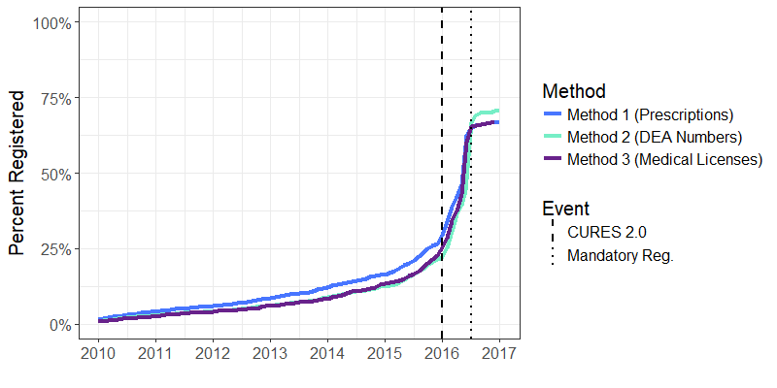
Figure A1. Registration percentage estimated by three methods each using a different data source. The black dashed line denotes the launch of CURES 2.0 in January 2016, and the dotted line denotes the deadline for mandatory registration on July 1, 2016.
Recommendations
We presented three methods for estimating the percentage of prescriber registration. The resources available to a PDMP might facilitate choosing one method over others and the results above provide evidence that any of the methods would be suitable. As a general recommendation we suggest
using Method 1, based on prescription data, to estimate the percentage of prescriber registration. This method uses only prescription data that should be readily available to any PDMP, whereas Method 2 and Method 3 require additional information. Method 2 is hindered by the many-to-one and one-to-many issues of DEA numbers unless the mapping of DEA numbers to unique prescribers is known, and Method 3 requires additional knowledge of the percentage of prescribers with DEA numbers. If a PDMP had a mapping of DEA numbers to unique prescribers, Method 2 would be our recommendation as it is computationally much simpler. A PDMP could do this be requiring suffixes tied to individual prescribers on institutional DEA numbers to be reported when prescribing and by maintaining a linkage between state license numbers and DEA numbers by requiring reporting of DEA numbers during the state licensing process.

References
- Calculating the Level of Prescriber Enrollment in a Prescription Monitoring Program. http://www.pdmpassist.org/pdf/COE_documents/Add_to_TTAC/PMP_management_tool_2_1_FINAL_2011_01_24.pdf

Appendix 2: CURES User Registration Information

Required Data Field | Description
User role | Prescriber or Dispenser
Name | First, middle, and last names
License state | State you are licensed in to prescriber
License type | Physician (MD and DO), pharmacist, nurse practitioner or midwife, physician’s assistant, dentist, podiatrist, veterinarian, naturopathic doctor, and optometrist.
Board certified
Specialty | Users specialty within role/license type.
DEA number | Number of DEA license to prescribe controlled substances.
Phone number
Primary address
Email address
Table A1: Information required from users when registering for California’s PDMP.

Appendix 3: Patient Report Counts

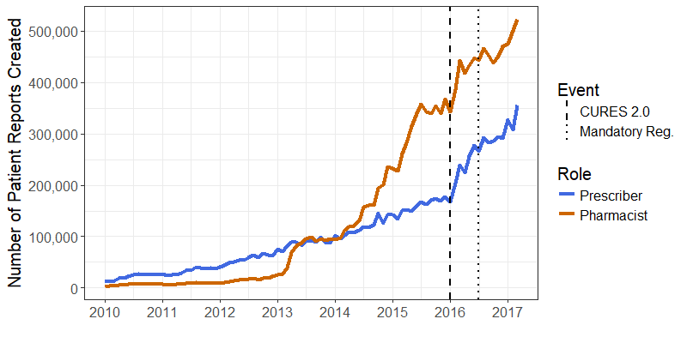
Figure A2: Counts of prescriber and pharmacist created patient reports from January 2010 through March 2017. The black dashed line denotes the launch of CURES 2.0 in January 2016, and the dotted line denotes the deadline for mandatory registration on July 1, 2016.

