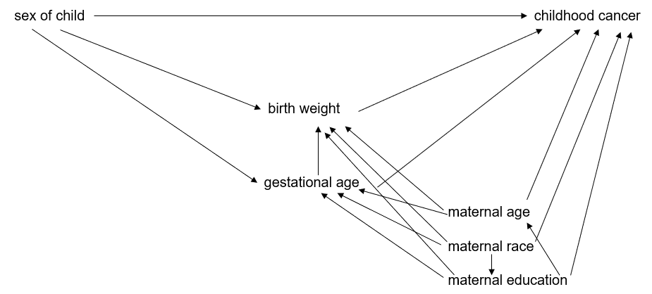

**Supplemental Figure 1**. Directed Acyclic Graph (DAG) of the relationship between child sex, birthweight and childhood cancer

**Supplemental Table 1. Counts of cases and controls by sex included in the crude logistic regression model, multivariable-adjusted logistic regression model, and mediation analysis, 3-state pooled analysis (1970-2014)**

|  |  |  |  |  |  |
| --- | --- | --- | --- | --- | --- |
|  | Crude Modela | |  | Adjusted model and Mediation analysisb | |
|  | Cases | |  | Cases | |
|  | Females [n (%)] | Males [n (%)] |  | Females [n (%)] | Males [n (%)] |
| All cancers combined | 5708 (45.1) | 6924 (54.8) |  | 4358 (45.0) | 5326 (55.0) |
| Lymphoid leukemia | 1349 (43.9) | 1722 (56.0) |  | 1030 (43.1) | 1362 (56.9) |
| Acute myeloid leukemia | 254 (46.0) | 298 (54.0) |  | 194 (46.6) | 222 ( 53.4) |
| Chronic myelodysplastic diseases | 31 (43.1) | 41 (56.9) |  | 28 ( 50.9) | 27 (49.1) |
| Hodgkin lymphoma | 171 (38.1) | 278 (61.9) |  | 120 ( 37.7) | 198 ( 62.3) |
| Burkitt lymphoma | 33 (15.7) | 177 (84.3) |  | 24 (14.6) | 141 ( 85.5) |
| Other non-Hodgkin lymphoma | 202 (39.6) | 308 (60.4) |  | 157 (40.3) | 233 (59.7) |
| Ependymoma | 122 (42.7) | 164 (57.3) |  | 101 (44.5) | 126 (55.5) |
| Astrocytoma | 642 (46.5) | 738 (53.5) |  | 481 (46.3) | 559 ( 53.8) |
| Intracranial embryonal | 239 (38.6) | 380 (61.4) |  | 181 (38.8) | 286 (61.2) |
| Neuroblastoma | 458 (46.0) | 538 (54.0) |  | 358 (44.8) | 442 (55.3) |
| Retinoblastoma | 186 (53.3) | 163 (46.7) |  | 151 (54.3) | 127 (45.7) |
| Wilms tumor | 389 (49.2) | 401 (50.8) |  | 314 (49.6) | 319 (50.4) |
| Hepatoblastoma | 64 (34.8) | 120 (65.2) |  | 52 (34.7) | 98 (65.3) |
| Osteosarcoma | 117 (48.0) | 127 (52.1) |  | 77 (46.4) | 89 (53.6) |
| Ewing sarcoma | 94 (47.7) | 103 (52.3) |  | 75 (49.3) | 77 (50.6) |
| Rhabdomyosarcoma | 156 (38.4) | 250 (61.6) |  | 120 (38.7) | 190 (61.3) |
| Intracranial GCT | 41 (40.2) | 61 (59.8) |  | 28 (40.6) | 41 (59.4) |
| Extracranial GCT | 67 (68.4) | 31 (31.6) |  | 54 (66.7) | 27 (33.3) |
| Gonadal GCT | 101 (57.7) | 74 (42.3) |  | 71 (53.8) | 61 (46.2) |
| Thyroid carcinoma | 124 (72.9) | 46 (27.1) |  | 90 (70.9) | 37 (29.1) |
| Melanoma | 53 (45.7) | 63 (54.3) |  | 29 (40.3) | 43 (59.7) |

aControls included in the crude model: females n=31,144 (48.3%); males n=33,295 (51.7%)

bControls included in the adjusted model and mediation analysis: females n=21,688 (48.3%); males n=23,173 (51.7%)

**Supplemental Table 2. Inverse odds weighting first leg results of sex regressed onto birthweighta, 3-state pooled study analysis (1970-2014)**

|  |  |  |  |  |  |  |  |  |  |  |  |  |
| --- | --- | --- | --- | --- | --- | --- | --- | --- | --- | --- | --- | --- |
|  | Normal birthweight (referent) (2,500-<4,000g) | | Low birthweight  (350-<2,500g) | | | | | High birthweight  (≥4,000g) | | | | |
|  | Males  n (%) | Females  n (%) | Males  n (%) | Females  n (%) | 2  p-value | OR (95% CI) | Males  n (%) | | Females  n (%) | 2  p-value | OR (95% CI) |
| All cancers combined | 4,153 (53.4) | 3,618 (46.6) | 264 (50.1) | 263 (49.9) | 0.14 | 0.7 (0.6-0.9) | 909 (65.6) | | 477 (34.4) | <0.01 | 1.7(1.5-2.0) |
| Lymphoid leukemia | 1,054 (55.5) | 846 (44.5) | 63 (52.1) | 58 (47.9) | 0.46 | 0.8 (0.5-1.3) | 245 (66.0) | | 126 (34.0) | <0.01 | 1.6 (1.3-2.0) |
| Hodgkin lymphoma | 145 (56.9) | 110 (43.1) | 9 (75.0) | 3 (25.0) | 0.25 | 1.2 (0.2-6.2) | 44 (86.3) | | 7 (13.7) | <0.01 | 6.9 (2.8-17.3) |
| Burkitt lymphoma | 113 (84.3) | 21 (15.7) | 2 (66.7) | 1 (33.3) | 0.41 | * | 26 (92.9) | | 2 (7.1) | 0.37 | 7.4 (1.2-45.2) |
| Other non-Hodgkin lymphoma | 185 (58.0) | 134 (42.0) | 14 (58.3) | 10 (41.7) | 1 | 1.4 (0.5-4.2) | 34 (72.3) | | 13 (27.7) | 0.08 | 2.0 (0.9-4.4) |
| Intracranial embryonal | 237 (61.1) | 151 (38.9) | 11 (52.4) | 10 (47.6) | 0.49 | 0.5 (0.1-1.4) | 38 (65.5) | | 20 (34.5) | 0.56 | 1.2 (0.6-2.12) |
| Hepatoblastoma | 67 (63.2) | 39 (36.8) | 20 (60.6) | 13 (39.4) | 0.84 | 0.4 (0.03-4.7) | 11 (100.0) | | 0 (0.0) | 0.01 | * |
| Rhabdomyosarcoma | 152 (60.1) | 101 (39.9) | 6 (66.7) | 3 (33.3) | 1 | 7.4 (0.6-94.9) | 32 (66.7) | | 16 (33.3) | 0.42 | 1.3 (0.7-2.7) |
| Extracranial GCT | 19 (28.8) | 47 (71.2) | 2 (66.7) | 1 (33.3) | 0.22 | * | 6 (50.0) | | 6 (50.0) | 0.18 | 1.3 (0.2-9.2) |
| Thyroid carcinoma | 30 (27.8) | 78 (72.2) | 5 (55.6) | 4 (44.4) | 0.12 | 9.5 (0.6-141.2) | 2 (20.0) | | 8 (80.0) | 0.73 | 0.3 (0.03-2.7) |

**\***Odds ratios non-estimable due to low sample size

aModel adjusted for gestational age, maternal race/ethnicity, maternal age, maternal education, state of birth, and birth year.

**Supplemental Table 3. Odds ratios (OR) and 95% confidence intervals (95% CI) from the mediation analysis for the association between sex and childhood cancer risk mediated by birthweighta, 3-state pooled analysis (1970-2014)**

|  |  |  |  |  |  |  |  |  |  |
| --- | --- | --- | --- | --- | --- | --- | --- | --- | --- |
|  | Indirect | | Direct | | Total | | | % Change from total to direct effectb | |
|  | OR (95% CI) | p-value | OR (95% CI) | p-value | | OR (95% CI) | p-value | |  | |
| All cancers combined | 1.02 (1.01-1.03) | <0.001 | 1.12 (1.07-1.17) | <0.001 | | 1.14 (1.09-1.19) | <0.001 | | 14 | |
| Lymphoid leukemia | 1.03 (1.02-1.05) | <0.001 | 1.20 (1.10-1.31) | <0.001 | | 1.24 (1.14-1.35) | <0.001 | | 15 | |
| Hodgkin lymphoma | 1.04 (0.99-1.09) | 0.1 | 1.47 (1.17-1.85) | 0.001 | | 1.52 (1.22-1.91) | <0.001 | | 9 | |
| Burkitt lymphoma | 1.01 (0.96-1.07) | 0.6 | 5.45 (3.49-8.52) | <0.001 (3.49-8.52) | | 5.53 (3.55-8.6) | <0.001 | | 1 | |
| Other non-Hodgkin lymphoma | 0.97 (0.93-1.02) | 0.2 | 1.43 (1.16-1.77) | 0.001 | | 1.39 (1.13-1.71) | <0.001 | | -9 | |
| Intracranial embryonal | 0.97 (0.94-1.00) | 0.07 | 1.53 (1.27-1.84) | <0.001 | | 1.48 (1.23-1.77) | <0.001 | | -8 | |
| Hepatoblastoma | 0.98 (0.93-1.04) | 0.5 | 1.66 (1.18-2.34) | 0.004 | | 1.63 (1.16-2.29) | 0.01 | | -4 | |
| Rhabdomyosarcoma | 1.03 (0.98-1.07) | 0.3 | 1.45 (1.15-1.82) | 0.002 | | 1.48 (1.19-1.86) | <0.001 | | 7 | |
| Extracranial GCT | 1.12 (0.99-1.26) | 0.07 | 0.43 (0.26-0.69) | <0.001 | | 0.47 (0.30-0.76) | <0.001 | | -15 | |
| Thyroid carcinoma | 0.96 (0.89-1.04) | 0.3 | 0.40 (0.27-0.57) | <0.001 | | 0.38 (0.26-0.55) | <0.001 | | 4 | |

aModel adjusted for gestational age, maternal race/ethnicity, maternal age, maternal education, state of birth, and birth year.

bPercent change from total to direct effect ((total-direct)/total)*100