Figure S1. ROC curve for fully adjusted model predicting influenza vaccination from continuous MWI.
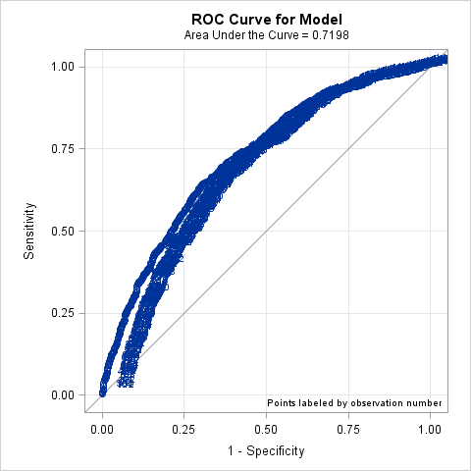

Figure S2. ROC curve for fully adjusted model predicting influenza vaccination from MWI category.
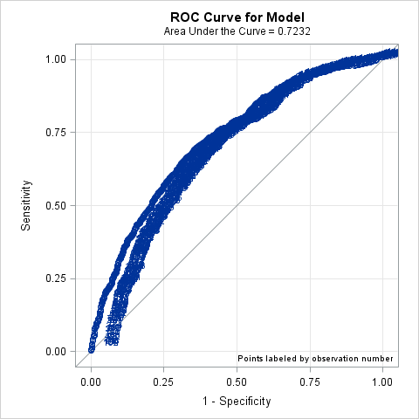

Figure S3. ROC curve for fully adjusted model predicting influenza vaccination from ACIP high risk status.
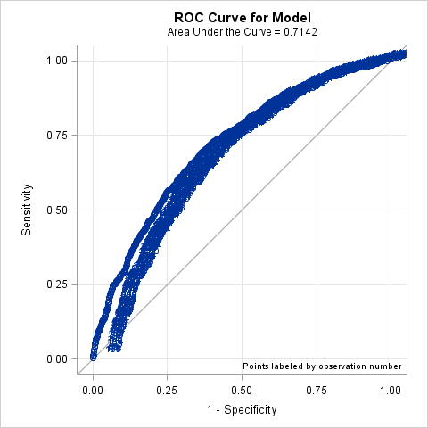

Table S1. Adjusted Model Estimates, All Estimates
 | Odds Ratio (95% Confidence Interval)
 | MWI, continuous | MWI, category | ACIP high-risk
MWI, continuous | 1.08 (1.06, 1.10)
MWI, category
0.00-0.00 |  | Ref
0.01-1.50 |  | 1.17 (0.92, 1.50)
1.51-3.00 |  | 1.58 (1.26, 1.99)
3.01-6.00 |  | 2.30 (1.78, 2.98)
6.01-45.00 |  | 3.14 (2.41, 4.10)
ACIP high risk |  |  | 1.86 (1.56, 2.21)
Age (years) | 1.03 (1.02, 1.03) | 1.02 (1.02, 1.03) | 1.03 (1.02, 1.03)
Sex
Female | Ref | Ref | Ref
Male | 0.85 (0.73, 1.01) | 0.84 (0.71, 0.98) | 0.84 (0.72, 0.99)
Hispanic
No | Ref | Ref | Ref
Yes | 1.03 (0.70, 1.51) | 1.07 (0.73, 1.57) | 1.08 (0.74, 1.58)
Race
White | Ref | Ref | Ref
Black | 0.81 (0.65, 1.01) | 0.78 (0.62, 0.97) | 0.82 (0.66, 1.02)
Asian | 0.91 (0.62, 1.33) | 0.92 (0.63, 1.34) | 0.90 (0.61, 1.31)
Other race | 0.93 (0.67, 1.28) | 0.92 (0.67, 1.28) | 0.92 (0.67, 1.28)
Socioeconomic status
Low | Ref | Ref | Ref
High | 1.08 (0.91, 1.28) | 1.09 (0.93, 1.30) | 1.05 (0.89, 1.24)
Smoking status
Nonsmoker | Ref | Ref | Ref
Smoker | 0.83 (0.64, 1.06) | 0.83 (0.64, 1.07) | 0.85 (0.66, 1.09)
Health system
Henry Ford | Ref | Ref | Ref
Univ. of Michigan | 2.55 (2.13, 3.06) | 2.60 (2.17, 3.11) | 2.51 (2.10, 3.01)
Influenza Season
2011-2012 | Ref | Ref | Ref
2012-2013 | 1.15 (0.89, 1.49) | 1.15 (0.88, 1.49) | 1.18 (0.91, 1.52)
2013-2014 | 1.35 (1.02, 1.78) | 1.33 (1.01, 1.76) | 1.33 (1.01, 1.75)
2014-2015 | 1.38 (1.07, 1.77) | 1.34 (1.04, 1.73) | 1.37 (1.06, 1.76)
2015-2016 | 1.48 (1.12, 1.95) | 1.48 (1.12, 1.95) | 1.50 (1.14, 1.97)

