Supplemental Table S1: Predictive equations (Model L¹) was used to generate estimated body fat percentage (eBFP). Models were sex-specific and incorporated race/ethnicity (White, Black, Mexican-American, and “Other”), age, height, weight, BMI and waist circumference (abbreviated here as waist).

Table S1A: Female Model Terms and Coefficients

Term | Coefficient | Exponent
(bmi) | 3.38455 | -1
Intercept | -3.005071 | 0
I(adult=Y)*(age^2)*(height^3) | -5.08143 | -12
I(adult=Y)*(age^(-1))*(bmi^(-3)) | 5.18882986247 | 5
I(adult=Y)*(age^1)*(height^3) | 3.93451 | -8
I(adult=Y)*(age^1)*(weight^1) | -1.15001 | -3
I(adult=Y)*(bmi^(-3)) | -3.7256226636 | 4
(age^(-3))*(bmi^(-3)) | 8.831271951197 | 6
(age^(-3))*(waist^3) | 2.83504 | -3
I(Ethinicity=Black)*(bmi^(-1)) | -3.1503633 | 1
(bmi^(-1)) | -3.00973059 | 2
(height^(-2)) | -5.2805552597 | 5
(height^(-1)) | 9.922209816 | 3
I(Ethinicity=Other)*(bmi^(-3)) | 8.317251369 | 3
I(Ethinicity=Other)*(waist^(-3)) | -1.485154603 | 5
I(Ethinicity=Mexican)*(bmi^(-2)) | 5.8336699 | 1
I(Ethinicity=Mexican)*(bmi^(-3)) | 5.46756358 | 3
(waist^(-2)) | -7.3648351165 | 4
(waist^(-1)) | 9.78852706 | 2

Table S1B: Male Model Terms and Coefficients

Term | Coefficient | Exponent
Intercept | 5.3674287 | 1
I(adult=Y)*(age^(-3))*(bmi^3) | -9.23282 | -1
I(adult=Y)*(age^3)*(bmi^2) | 5.15457 | -9
I(adult=Y)*(age^3)*(height^(-3)) | -5.967012 | 0
I(adult=Y)*(age^(-1))*(waist^(-3)) | -4.9048437981651 | 7
I(adult=Y)*(age^1)*(height^3) | 1.73244 | -8
I(adult=Y)*(bmi^(-3)) | 1.0540743455 | 4
I(adult=Y)*(height^3) | 7.90368 | -7
(age^(-3))*(height^(-3)) | -6.4791877292024 | 9
(age^(-3))*(waist^3) | -8.0465 | -3
(age^(-3))*(weight^(-2)) | -8.44240917075 | 5
(age^(-1))*(waist^1) | 2.95427 | 0
(age^(-1))*(waist^2) | 6.28643 | -3
(age^(-1))*(weight^3) | -1.62781 | -5
(age^1)*(waist^(-3)) | -7.609617679 | 3
(age^1)*(weight^(-3)) | 4.337292241 | 3
I(Ethinicity=Black)*I(adult=Y)*(weight^3) | -2.98474 | -7
I(Ethinicity=Black)*(waist^(-3)) | 6.070860817 | 4
I(Ethinicity=Black)*(weight^2) | -4.0563 | -6
I(Ethinicity=Black)*(weight^3) | -1.95374 | -7
I(Ethinicity=Black)*(weight^(-3)) | -2.6748715222 | 4
(bmi^3) | -3.93451 | -5
(height^1) | -2.79536 | -1
I(Ethinicity=Other)*I(adult=Y)*(bmi^(-3)) | 1.1239620079 | 4
I(Ethinicity=Mexican)*I(adult=Y)*(weight^3) | 3.9821 | -7
I(Ethinicity=Mexican)*I(adult=Y)*(weight^(-3)) | -8.6570724653 | 4
I(Ethinicity=Mexican)*(weight^(-3)) | 8.089864033 | 3
(waist^1) | 2.03813 | -1
(waist^(-1)) | -1.130985791 | 3

¹Stevens J, Ou FS, Cai J, Heymsfield SB, Truesdale KP. Prediction of percent body fat measurements in Americans 8 years and older. Int J Obes (Lond). 2016;40(4):587-594.

Supplemental Figure S1: Trajectories of Body Mass Index (BMI) in Youth Ages 10+ with Type1 Diabetes in the SEARCH for Diabetes in Youth Study (n=363 females, n=376 males) over a mean follow-up of 107 months (with 95% confidence intervals). Group-based trajectory modeling identified three distinct BMI trajectories over a mean type 1 diabetes duration of 108 months in females (2A) and males (2B). In females, 3 distinct BMI trajectories included Group F-A: lowest BMI (54.3%; mean baseline BMI: 18.6±2.2%); Group F-B: moderate BMI (35.8%; mean baseline BMI: 23.6±2.6%), and Group F-C: highest BMI (9.9%; mean baseline BMI: 32.3±5.6%). In males, three distinct trajectories included Group M-A: Lowest BMI (44.7%; mean baseline BMI: 18.5±1.8%), Group M-B: Moderate BMI (42.6%; mean baseline BMI: 22.5±2.5), and Group M-C: highest BMI (128%; mean baseline BMI: 27.7±3.2%).
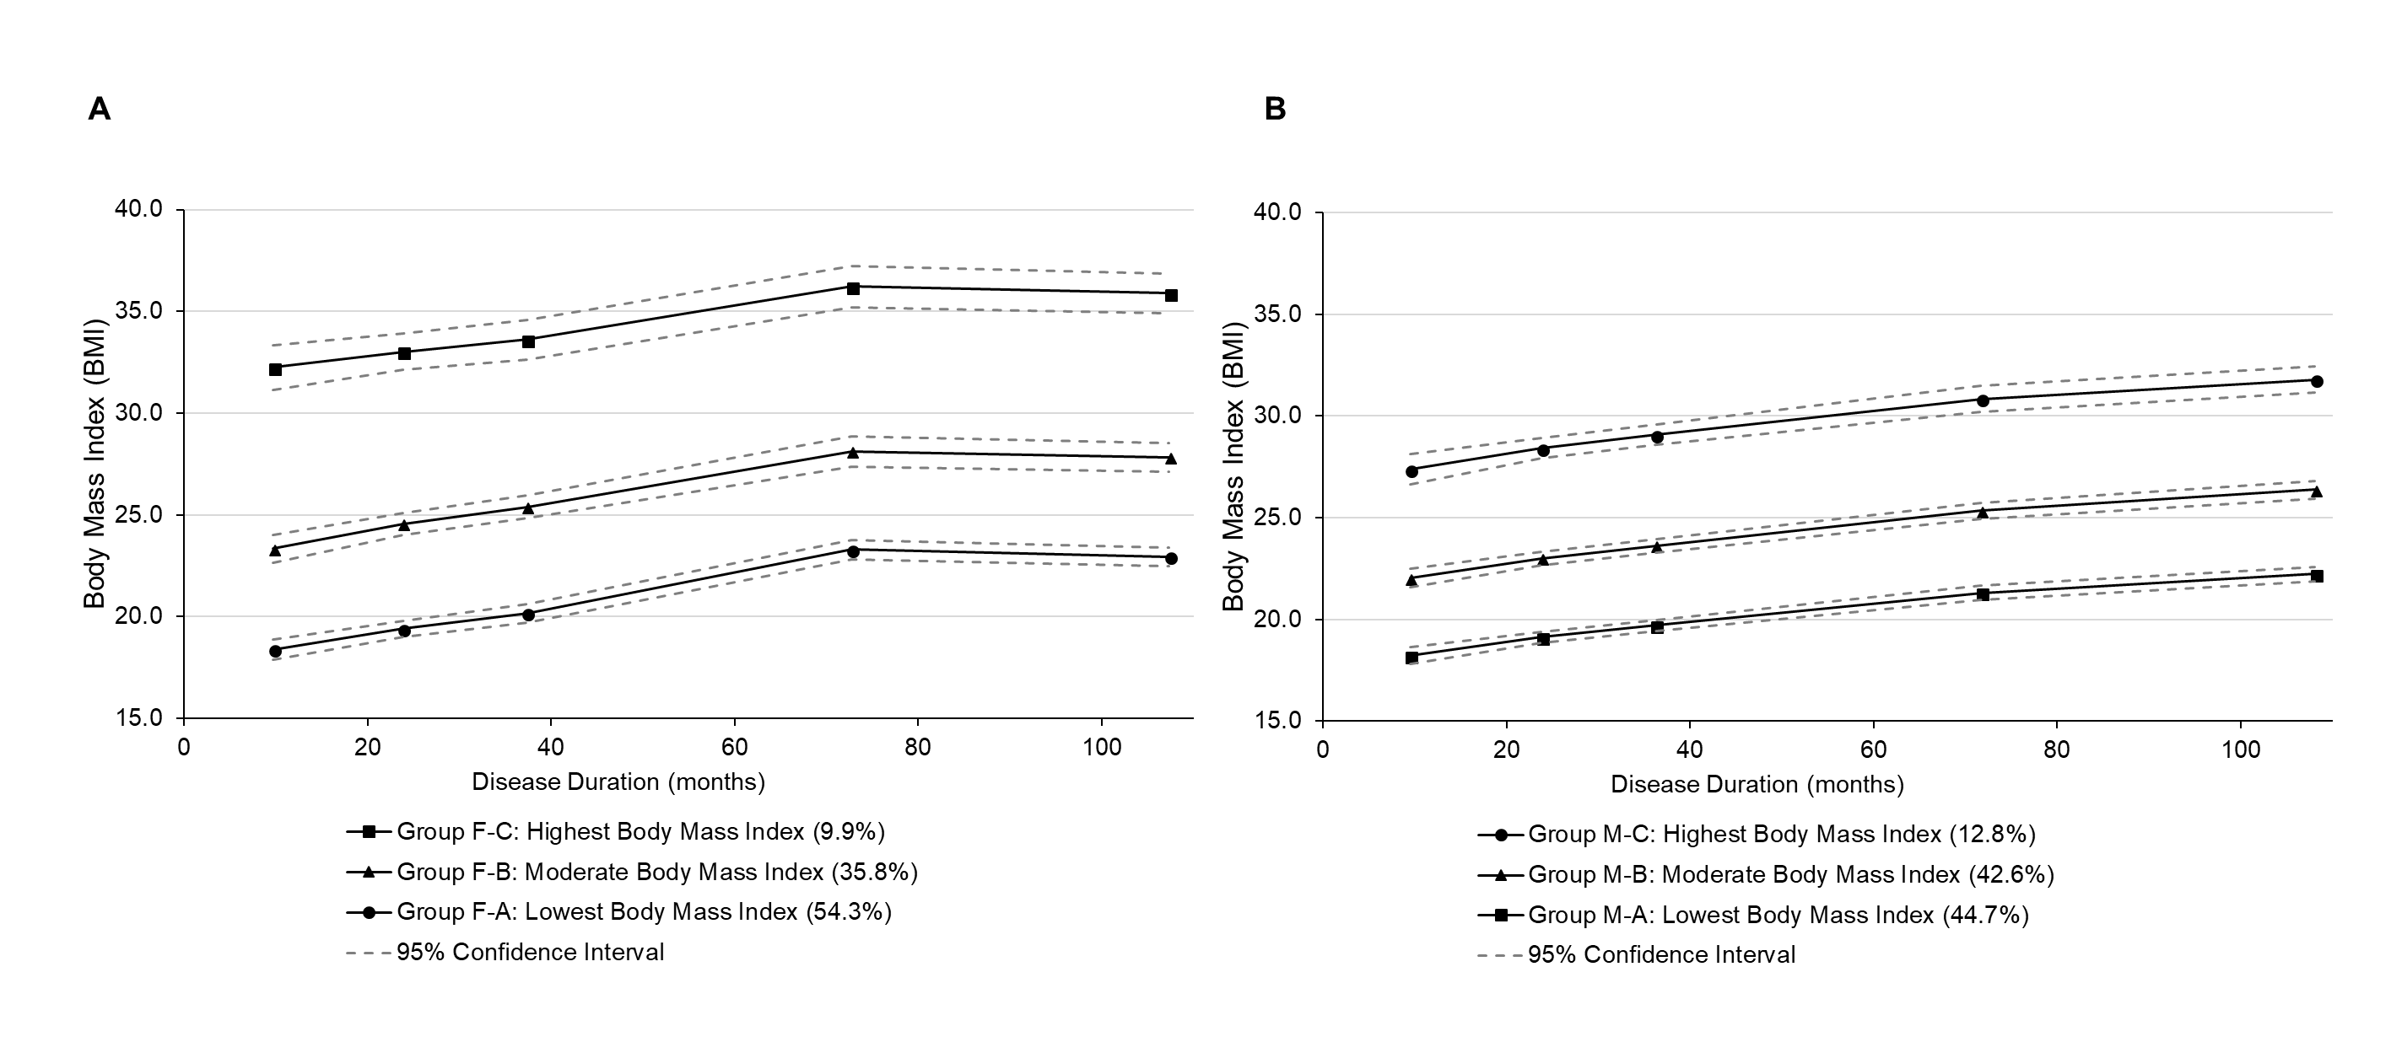

Supplemental Table S2: Comparison of Estimated body fat percentage trajectory groups and body mass index trajectory groups. stratified by sex. S1.A: Female groups F1, F2, and F3 represent subgroups defined by estimated body fat trajectory. Females group F-A, F-B, and F-C represent subgroups defined by body mass index trajectory. S1.B: Male groups M1, M2, and M3 represent subgroups defined by estimated body fat trajectory. Male groups M-A, M-B, and M-C represent subgroups defined by body mass index trajectory. Abbreviations: BMI = body mass index. eBFP = estimated body fat percentage.
S1.A Females | BMI trajectory subgroup
eBFP trajectory subgroup |  | F-A | F-B | F-C | Total , (n, %)
 | F1, (n, %) | 138 (70.5) | 0 (0.0) | 0 (0.0) | 138 (38.0)
 | F2, (n, %) | 59 (30.9) | 115 (66.1) | 0 (0.0) | 174 (47.9)
 | F3, (n, %) | 0 (0.0) | 15 (29.4) | 36 (70.6) | 51 (14.1)
 | Total (n, %) | 197 (54.3) | 130 (35.8) | 36 (9.9) | 363 (100.0)

S1.B Males | BMI trajectory subgroup
eBFP trajectory subgroup |  | M-A | M-B | M-C | Total
 | M1, (n, %) | 139 (64.7) | 75 (34.9) | 1 (0.5) | 215 (57.2)
 | M2, (n, %) | 28 (24.1) | 67 (57.8) | 21 (43.8) | 116 (30.9)
 | M3, (n, %) | 1 (2.2) | 18 (40.0) | 26 (57.8) | 45 (12.0)
 | Total, (n, %) | 168 (44.7) | 160 (42.6) | 48 (12.3) | 376 (100)

