Online Supplemental Figure – Alternative structural equation model of agreement demographics, health conditions and services

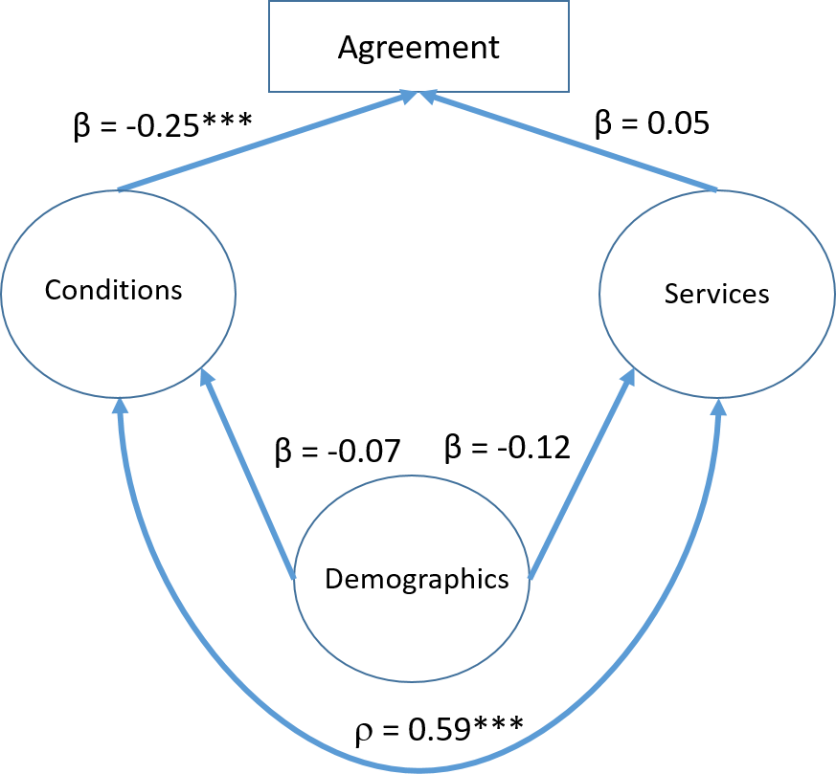

Notes: The following variables were used in creating the latent variables; Demographics: child’s sex, age, race/ethnicity, family income recorded as a percentage of the federal poverty level, educational attainment of the highest educated household member, geographic region of residence, metropolitan statistical area (MSA) status of residence, family structure, respondent’s relationship to sample child. Conditions: hay fever, any kind of respiratory allergy, any kind of food or digestive allergy, eczema or any kind of skin allergy, frequent or repeated diarrhea or colitis, anemia, frequent or severe headaches, including migraines, three or more ear infections, seizures. Services: In the past 12 months, saw generalist, specialist, mental health professional, therapist, had an office visit, emergency department visit, home visit.

Source: 2000-2005 CMS Medicaid Analytic eXtract (MAX) data, linked to 2001-2005 National Health Interview Survey data

