Supplemental Figure 1. Clusters inferred at 0.5% genetic distance threshold with 3 years of diagnoses and at least 5 diagnoses in the past 12 months.

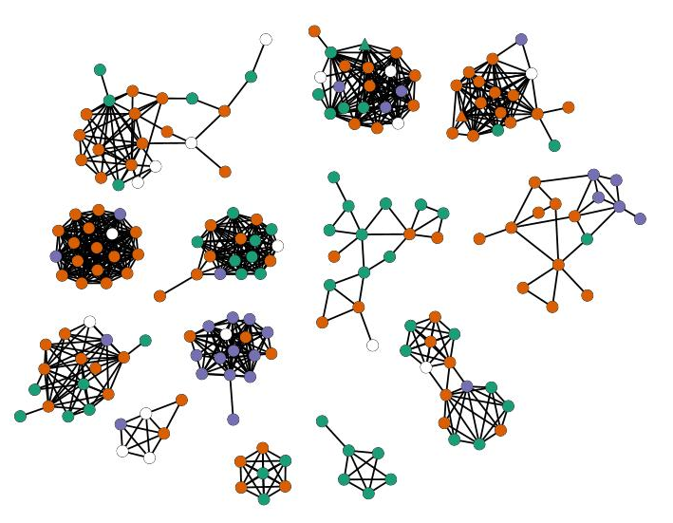
Supplemental Table 1. Estimates of time to most recent common ancestor (tMRCA) for 13 clusters identified at 0.5% genetic distance threshold with 3 years of diagnoses and at least 5 diagnoses in the past 12 months, including median tMRCA and 95% highest posterior density (HPD).

Cluster | Cluster Size | tMRCA median | tMRCA 95% HPD
1 | 17 | 4.1 | 3.1–5.5
2 | 6 | 2.4 | 1.4–3.7
3 | 18 | 2.0 | 1.4–2.9
4 | 18 | 4.7 | 3.6–6.3
5 | 21 | 4.4 | 3.2–5.8
6 | 22 | 7.4 | 4.8–10.4
7 | 15 | 6.5 | 4.3–8.9
8 | 17 | 6.1 | 4.7–8.0
9 | 16 | 7.4 | 5.2–10.1
10 | 16 | 7.3 | 5.1–9.8
11 | 16 | 7.7 | 6.0–9.7
12 | 6 | 3.9 | 2.6–5.6
13 | 7 | 1.8 | 1.5–2.5

