SUPPLEMENTARY TABLES

Supplementary Table 1. Population characteristics by study
Characteristic | GWAS Datasets |  | The Cancer Genome Atlas
 | Cases | Controls | Cases
Total | 4,512 | 10,582 | 356
GICCª | 2,456 | 3,264 | --
SFAGS-GWAS^{b} | 511 | 2,367 | --
MDA-GWAS^{c} | 643 | 2,228 | --
Gliomascan^{d} | 902 | 2,723 | --
Male (%) | 2,832 (62.8%) | 5,167 (48.8%) | 221 (62.1%)
GICCª | 1,573 (64.0%) | 1,868 (57.2%) | --
SFAGS-GWAS^{b} | 333 (65.2%) | 749 (31.6%) | --
MDA-GWAS^{c} | 397 (61.7%) | 1,086 (48.7%) | --
Gliomascan^{d} | 529 (58.6%) | 1,464 (53.8%) | --
Mean Age (SD) | 57.5 (12.0) | 56.4 (15.4) | 59.8 (12.9)
GICCª | 57.8 (11.4) | 54.9 (13.8) | --
SFAGS-GWAS^{b} | 56.3 (11.8) | 49.7 (13.8) | --
MDA-GWAS^{c} | 52.7 (11.6) | Modal age group:60-69e (males); and 65-69^{f} (females) | --
Gliomascan^{d} | 60.8 (12.8) | 64.0 (15.4) | --
a. Data from Glioma International Case-Control Study (GICC; Melin, et al.¹)
b. Data from San Francisco Adult Glioma Study GWAS (SFAGS-GWAS; Wrensch, et al.²)
c. data from MD Anderson Cancer Center GWAS (MDA-GWAS; Shete, et al. ³)
d. Data from the National Cancer Institute’s Gliomascan (Gliomascan; Rajaraman, et al.⁴)
e. Data from CGEMS prostate study (Yeager et al.⁵). Continuous age is not available, age distribution is as follows 50-59: 12.3%, 60-69: 56.7%, 70-79: 30.7%, 80-89: 0.3%
f. Data from CGEMS breast study (Hunter et al.⁶). Continuous age is not available, age distribution is as follows: 0-54: 4.3%, 55-59: 15.0%, 60-64: 23.6%, 65-69: 27.5%, 70-74: 19.0%, 75-99: 10.7%

Supplementary Table 2. Age-specific odds ratios (OR), 95% confidence intervals (95% CI), and p values from meta-analysis and individual studies.
RSID (Loci) | Risk Allele | Associated Gene | Study | Minor allele frequencies |  |  |  | Age-stratified results
 |  |  |  | Controls (all ages) | Cases |  |  |  | Diagnosis Ages 18-53  (Below Median Age-at-diagnosis) |  |  |  |  |  | Diagnosis Ages 54-63  (Median Age-at-diagnosis) |  |  |  |  | Diagnosis Ages 64+  (Above Median Age-at-diagnosis)
 |  |  |  |  | 18-53 | 54-63 | 64+ |  | P | OR (95% CI) | P_{het} | Q | I² | P |  | OR (95% CI) | P_{het} | Q | I² | P | OR (95% CI) | P_{het} | Q | I²
rs723527 (7p11.2) | A/G | EGFR | Meta-analysis | 0.410 | 0.366 | 0.351 | 0.347 |  | 1.37x10⁻⁵ | 1.19 (1.10-1.29) | 0.2992 | 3.67 | 18.29 | 1.50x10⁻⁹ |  | 1.28 (1.18-1.39) | 0.6193 | 1.78 | 0.00 | 2.14x10⁻¹¹ | 1.32 (1.21-1.43) | 0.2263 | 4.35 | 30.99
 |  |  | GICC | 0.427 | 0.355 | 0.348 | 0.351 |  | 2.66x10⁻⁵ | 1.28 (1.14-1.43) | -- | -- | -- | 3.72x10⁻⁷ |  | 1.33 (1.19-1.49) | -- | -- | -- | 2.12x10⁻⁷ | 1.34 (1.20-1.49) | -- | -- | --
 |  |  | SFAGS-GWAS | 0.398 | 0.345 | 0.334 | 0.358 |  | 0.0601 | 1.23 (0.99-1.53) | -- | -- | -- | 0.0360 |  | 1.29 (1.02-1.64) | -- | -- | -- | 0.3053 | 1.14 (0.89-1.46) | -- | -- | --
 |  |  | Gliomascan | 0.405 | 0.389 | 0.376 | 0.325 |  | 0.3372 | 1.10 (0.90-1.35) | -- | -- | -- | 0.1460 |  | 1.15 (0.95-1.39) | -- | -- | -- | 4.84x10⁻⁶ | 1.43 (1.23-1.67) | -- | -- | --
 |  |  | MDA-GWAS | 0.403 | 0.390 | 0.346 | 0.382 |  | 0.4872 | 1.06 (0.89-1.27) | -- | -- | -- | 0.0146 |  | 1.28 (1.05-1.57) | -- | -- | -- | 0.5770 | 1.08 (0.82-1.44) | -- | -- | --
rs11979158 (7p11.2) | A/G | EGFR | Meta-analysis | 0.166 | 0.141 | 0.131 | 0.124 |  | 2.47x10⁻⁴ | 1.22 (1.10-1.36) | 0.8084 | 0.97 | 0.00 | 6.13x10⁻⁸ |  | 1.35 (1.21-1.50) | 0.8007 | 1.00 | 0.00 | 2.18x10⁻¹⁰ | 1.42 (1.27-1.58) | 0.8696 | 0.72 | 0.00
 |  |  | GICC | 0.176 | 0.140 | 0.127 | 0.126 |  | 0.0038 | 1.25 (1.08-1.46) | -- | -- | -- | 5.56x10⁻⁶ |  | 1.42 (1.22-1.64) | -- | -- | -- | 7.99x10⁻⁷ | 1.45 (1.25-1.68) | -- | -- | --
 |  |  | SFAGS-GWAS | 0.152 | 0.120 | 0.126 | 0.125 |  | 0.0573 | 1.33 (0.99-1.77) | -- | -- | -- | 0.0944 |  | 1.31 (0.95-1.80) | -- | -- | -- | 0.2050 | 1.24 (0.89-1.74) | -- | -- | --
 |  |  | Gliomascan | 0.166 | 0.155 | 0.149 | 0.120 |  | 0.3124 | 1.14 (0.88-1.48) | -- | -- | -- | 0.0972 |  | 1.23 (0.96-1.58) | -- | -- | -- | 5.17x10⁻⁴ | 1.43 (1.17-1.76) | -- | -- | --
 |  |  | MDA-GWAS | 0.168 | 0.147 | 0.129 | 0.118 |  | 0.2420 | 1.15 (0.91-1.44) | -- | -- | -- | 0.0419 |  | 1.31 (1.01-1.70) | -- | -- | -- | 0.0837 | 1.39 (0.96-2.01) | -- | -- | --
rs55705857 (8q24.21) | A/G | CCDC26 | Meta-analysis | 0.060 | 0.088 | 0.063 | 0.069 |  | 9.30x10⁻¹¹ | 1.76 (1.49-2.10) | 0.3040 | 3.63 | 17.41 | 0.4225 |  | 1.08 (0.90-1.28) | 0.5380 | 2.17 | 0.00 | 0.0280 | 1.21 (1.02-1.44) | 0.0811 | 6.73 | 55.41
 |  |  | GICC | 0.056 | 0.085 | 0.056 | 0.058 |  | 6.93x10⁻⁷ | 1.82 (1.44-2.31) | -- | -- | -- | 0.6121 |  | 1.06 (0.84-1.36) | -- | -- | -- | 0.4955 | 1.09 (0.86-1.38) | -- | -- | --
 |  |  | SFAGS-GWAS | 0.054 | 0.099 | 0.067 | 0.049 |  | 2.88x10⁻⁴ | 2.50 (1.52-4.09) | -- | -- | -- | 0.5241 |  | 1.19 (0.69-2.05) | -- | -- | -- | 0.4330 | 0.79 (0.45-1.41) | -- | -- | --
 |  |  | Gliomascan | 0.065 | 0.087 | 0.084 | 0.090 |  | 0.1666 | 1.35 (0.88-2.07) | -- | -- | -- | 0.2083 |  | 1.31 (0.86-1.98) | -- | -- | -- | 0.0138 | 1.48 (1.08-2.02) | -- | -- | --
 |  |  | MDA-GWAS | 0.067 | 0.090 | 0.060 | 0.097 |  | 0.0151 | 1.63 (1.10-2.41) | -- | -- | -- | 0.4518 |  | 0.85 (0.56-1.30) | -- | -- | -- | 0.0356 | 1.99 (1.05-3.80) | -- | -- | --
Abbreviations: GICC: Glioma International Case-Control Study; SFAGS-GWAS: San Francisco Adult Glioma Study GWAS; MAF: Minor allele frequency; MDA-GWAS: MD Anderson GWAS

Supplementary Table 3 Age-specific odds ratios (OR), 95% confidence intervals (95% CI), and p values from meta-analysis and individual studies for rs723527, rs11979158, and rs55705857 for cases diagnosed in 2000 and later
RSID (Loci) | Risk Allele | Associated Gene | Study | Minor allele frequencies |  |  |  | Sample size |  |  |  | Age-stratified results
 |  |  |  | Controls (all ages) | Cases |  |  | Controls (all ages) | Cases |  |  | Diagnosis Ages 18-53  (Below Median Age-at-diagnosis) |  |  |  |  |  | Diagnosis Ages 54-63  (Median Age-at-diagnosis) |  |  |  |  | Diagnosis Ages 64+  (Above Median Age-at-diagnosis)
 |  |  |  |  | 18-53 | 54-63 | 64+ |  | 18-53 | 54-63 | 64+ | P | OR (95% CI) | P_{het} | Q | I² | P |  | OR (95% CI) | P_{het} | Q | I² | P | OR (95% CI) | P_{het} | Q | I²
rs723527 (7p11.2) | A/G | EGFR | Meta-analysis | 0.410 | 0.364 | 0.351 | 0.349 | 10,582 | 1,258 | 1,272 | 1,292 | 3.54x10⁻⁵ | 1.21 (1.11-1.33) | 0.1637 | 5.11 | 41.33 | 6.96x10⁻⁸ |  | 1.28 (1.17-1.40) | 0.2731 | 3.89 | 22.96 | 3.68x10⁻⁹ | 1.31 (1.20-1.43) | 0.0221 | 9.62 | 68.80
 |  |  | GICC | 0.427 | 0.355 | 0.348 | 0.351 | 3,264 | 795 | 823 | 838 | 2.66x10⁻⁵ | 1.28 (1.14-1.43) | -- | -- | -- | 3.72x10⁻⁷ |  | 1.33 (1.19-1.49) | -- | -- | -- | 2.12x10⁻⁷ | 1.34 (1.20-1.49) | -- | -- | --
 |  |  | SFAGS-GWAS | 0.398 | 0.338 | 0.339 | 0.355 | 2,367 | 167 | 143 | 114 | 0.0406 | 1.28 (1.01-1.61) | -- | -- | -- | 0.0718 |  | 1.26 (0.98-1.62) | -- | -- | -- | 0.3152 | 1.15 (0.87-1.53) | -- | -- | --
 |  |  | Gliomascan | 0.405 | 0.406 | 0.380 | 0.318 | 2,228 | 117 | 175 | 267 | 0.5962 | 0.90 (0.61-1.33) | -- | -- | -- | 0.7554 |  | 0.95 (0.69-1.31) | -- | -- | -- | 7.36x10⁻⁵ | 1.59 (1.26-1.99) | -- | -- | --
 |  |  | MDA-GWAS | 0.403 | 0.397 | 0.344 | 0.438 | 2,723 | 179 | 131 | 73 | 0.7588 | 1.04 (0.83-1.29) | -- | -- | -- | 0.0514 |  | 1.29 (1.00-1.67) | -- | -- | -- | 0.3839 | 0.86 (0.62-1.21) | -- | -- | --
rs11979158 (7p11.2) | A/G | EGFR | Meta-analysis | 0.166 | 0.138 | 0.129 | 0.126 | 10,582 | 1,258 | 1,272 | 1,292 | 3.24x10⁻⁴ | 1.25 (1.11-1.41) | 0.778 | 1.10 | 0.00 | 1.08x10⁻⁷ |  | 1.39 (1.23-1.57) | 0.7724 | 1.12 | 0.00 | 8.09x10⁻⁹ | 1.43 (1.26-1.61) | 0.5305 | 2.21 | 0.00
 |  |  | GICC | 0.176 | 0.140 | 0.127 | 0.126 | 3,264 | 795 | 823 | 838 | 0.0038 | 1.25 (1.08-1.46) | -- | -- | -- | 5.56x10⁻⁶ |  | 1.42 (1.22-1.64) | -- | -- | -- | 7.99x10⁻⁷ | 1.45 (1.25-1.68) | -- | -- | --
 |  |  | SFAGS-GWAS | 0.152 | 0.117 | 0.115 | 0.132 | 2,367 | 167 | 143 | 114 | 0.0466 | 1.37 (1.00-1.88) | -- | -- | -- | 0.0384 |  | 1.42 (1.02-1.99) | -- | -- | -- | 0.3867 | 1.18 (0.81-1.72) | -- | -- | --
 |  |  | Gliomascan | 0.166 | 0.154 | 0.154 | 0.118 | 2,228 | 117 | 175 | 267 | 0.9552 | 1.01 (0.62-1.66) | -- | -- | -- | 0.5762 |  | 1.12 (0.75-1.69) | -- | -- | -- | 0.0019 | 1.62 (1.19-2.19) | -- | -- | --
 |  |  | MDA-GWAS | 0.168 | 0.140 | 0.118 | 0.137 | 2,723 | 179 | 131 | 73 | 0.1977 | 1.21 (0.91-1.61) | -- | -- | -- | 0.0426 |  | 1.41 (1.01-1.97) | -- | -- | -- | 0.3922 | 1.21 (0.78-1.88) | -- | -- | --
rs55705857 (8q24.21) | A/G | CCDC26 | Meta-analysis | 0.060 | 0.088 | 0.061 | 0.067 | 10,582 | 1,258 | 1,272 | 1,292 | 5.47x10⁻¹⁰ | 1.84 (1.52-2.23) | 0.2703 | 3.92 | 23.45 | 0.7143 |  | 1.04 (0.85-1.27) | 0.7178 | 1.35 | 0.00 | 0.1916 | 1.14 (0.94-1.39) | 0.2472 | 4.14 | 27.45
 |  |  | GICC | 0.056 | 0.085 | 0.056 | 0.058 | 3,264 | 795 | 823 | 838 | 6.93x10⁻⁷ | 1.82 (1.44-2.31) | -- | -- | -- | 0.6121 |  | 1.06 (0.84-1.36) | -- | -- | -- | 0.4955 | 1.09 (0.86-1.38) | -- | -- | --
 |  |  | SFAGS-GWAS | 0.054 | 0.100 | 0.069 | 0.055 | 2,367 | 167 | 143 | 114 | 4.84x10⁻⁴ | 2.61 (1.52-4.47) | -- | -- | -- | 0.4708 |  | 1.24 (0.69-2.21) | -- | -- | -- | 0.8318 | 0.93 (0.48-1.82) | -- | -- | --
 |  |  | Gliomascan | 0.065 | 0.079 | 0.081 | 0.088 | 2,228 | 117 | 175 | 267 | 0.9631 | 1.02 (0.47-2.19) | -- | -- | -- | 0.9968 |  | 1.00 (0.50-2.00) | -- | -- | -- | 0.5867 | 1.14 (0.71-1.81) | -- | -- | --
 |  |  | MDA-GWAS | 0.067 | 0.097 | 0.056 | 0.107 | 2,723 | 179 | 131 | 73 | 0.0179 | 1.83 (1.11-3.01) | -- | -- | -- | 0.4011 |  | 0.79 (0.45-1.38) | -- | -- | -- | 0.0248 | 2.37 (1.12-5.06) | -- | -- | --

Abbreviations: GICC: Glioma International Case-Control Study; SFAGS-GWAS: San Francisco Adult Glioma Study GWAS; MAF: Minor allele frequency; MDA-GWAS: MD Anderson GWAS

Supplementary Table 4 .Case-only betas, 95% confidence intervals (95% CI), and p values from meta-analysis and individual studies for selected previous GWAS hits
SNP (Locus) | Risk Allele | Associated Gene | Study | All Ages |  |  |  |  |  |  | Ages 54+ only
 |  |  |  | Beta (95% CI) | P | Meta-analysis |  |  |  |  | Beta (95% CI) | p | Meta-analysis
 |  |  |  |  |  | p_{Fixed} | p_{Random} | P_{het} | Q | I² |  |  | p_{Fixed} | p_{Random} | P_{het} | Q | I²
rs10069690 (5p15.33) | C/T | TERT | Meta-analysis | 0.76 (0.24,1.29) | -- | 0.0043 | 0.0053 | 0.3754 | 3.11 | 3.45 | 0.13 (-0.23,0.50) |  | 0.4818 | 0.4814 | 0.0328 | 8.75 | 65.71
 |  |  | GICC | 0.60 (-0.07,1.27) | 0.0812 | -- | -- | -- | -- | -- | 0.06 (-0.40,0.51) | 0.8102 | -- | -- | --
 |  |  | SFAGS-GWAS | 1.92 (0.24,3.61) | 0.0255 | -- | -- | -- | -- | -- | 1.32 (0.08,2.57) | 0.0375 | -- | -- | --
 |  |  | Gliomascan | 1.33 (-0.17,2.84) | 0.0828 | -- | -- | -- | -- | -- | -0.75 (-1.69,0.18) | 0.1144 | -- | -- | --
 |  |  | MDA-GWAS | 0.31 (-0.93,1.55) | 0.6263 | -- | -- | -- | -- | -- | 0.85 (-0.23,1.94) | 0.1240 | -- | -- | --
rs723527 (7p11.2) | A/G | EGFR | Meta-analysis | -0.48 (-0.98,0.01) | -- | 0.0564 | 0.0848 | 0.2490 | 4.12 | 27.14 | -0.02 (-0.37,0.33) |  | 0.9158 | 0.8817 | 0.3719 | 1.00 | 0.00
 |  |  | GICC | -0.14 (-0.81,0.52) | 0.6704 | -- | -- | -- | -- | -- | 0.14 (-0.31,0.59) | 0.5434 | -- | -- | --
 |  |  | SFAGS-GWAS | -0.17 (-1.67,1.34) | 0.8276 | -- | -- | -- | -- | -- | -0.32 (-1.51,0.86) | 0.5916 | -- | -- | --
 |  |  | Gliomascan | -0.70 (-2.02,0.62) | 0.2977 | -- | -- | -- | -- | -- | -0.63 (-1.46,0.21) | 0.1409 | -- | -- | --
 |  |  | MDA-GWAS | -1.44 (-2.55,-0.33) | 0.0111 | -- | -- | -- | -- | -- | 0.29 (-0.71,1.29) | 0.5736 | -- | -- | --
rs11979158 (7p11.2) | A/G | EGFR | Meta-analysis | -1.08 (-1.76,-0.39) | -- | 0.0021 | 0.0021 | 0.6140 | 1.80 | 0.00 | -0.05 (-0.55,0.45) |  | 0.8507 | 0.8507 | 0.7327 | 3.13 | 4.17
 |  |  | GICC | -0.83 (-1.76,0.10) | 0.0809 | -- | -- | -- | -- | -- | 0.10 (-0.55,0.74) | 0.7628 | -- | -- | --
 |  |  | SFAGS-GWAS | -0.84 (-3.03,1.35) | 0.4519 | -- | -- | -- | -- | -- | -0.84 (-2.52,0.85) | 0.3305 | -- | -- | --
 |  |  | Gliomascan | -0.80 (-2.65,1.04) | 0.3936 | -- | -- | -- | -- | -- | -0.30 (-1.48,0.89) | 0.6252 | -- | -- | --
 |  |  | MDA-GWAS | -1.97 (-3.44,-0.50) | 0.0087 | -- | -- | -- | -- | -- | 0.15 (-1.27,1.58) | 0.8344 | -- | -- | --
rs55705857 (8q24.21) | A/G | CCDC26 | Meta-analysis | -3.21 (-4.14,-2.28) | -- | 1.51x10⁻¹¹ | 3.70x10⁻⁶ | 0.1267 | 5.71 | 47.44 | 0.21 (-0.50,0.92) |  | 0.5659 | 0.6331 | 0.0469 | 1.28 | 0.00
 |  |  | GICC | -2.66 (-3.92,-1.40) | 3.41x10⁻⁵ | -- | -- | -- | -- | -- | -0.09 (-1.00,0.82) | 0.8419 | -- | -- | --
 |  |  | SFAGS-GWAS | -5.54 (-8.51,-2.56) | 2.64x10⁻⁴ | -- | -- | -- | -- | -- | -1.96 (-4.67,0.76) | 0.1572 | -- | -- | --
 |  |  | Gliomascan | -1.57 (-4.31,1.18) | 0.2640 | -- | -- | -- | -- | -- | 0.45 (-1.09,2.00) | 0.5672 | -- | -- | --
 |  |  | MDA-GWAS | -4.30 (-6.21,-2.39) | 1.01x10⁻⁵ | -- | -- | -- | -- | -- | 2.56 (0.50,4.62) | 0.0150 | -- | -- | --
rs634537 (9p21.3) | T/G | CDKN2B | Meta-analysis | 0.17 (-0.30,0.64) | -- | 0.4835 | 0.8009 | 0.0602 | 7.40 | 59.45 | -0.23 (-0.56,0.11) |  | 0.1826 | 0.3170 | 0.1067 | 7.96 | 62.30
 |  |  | GICC | 0.25 (-0.38,0.88) | 0.4309 | -- | -- | -- | -- | -- | -0.16 (-0.58,0.27) | 0.4736 | -- | -- | --
 |  |  | SFAGS-GWAS | 0.72 (-0.75,2.19) | 0.3365 | -- | -- | -- | -- | -- | -0.03 (-1.17,1.12) | 0.9644 | -- | -- | --
 |  |  | Gliomascan | -1.37 (-2.64,-0.11) | 0.0329 | -- | -- | -- | -- | -- | 0.19 (-0.61,0.98) | 0.6463 | -- | -- | --
 |  |  | MDA-GWAS | 0.72 (-0.33,1.77) | 0.1804 | -- | -- | -- | -- | -- | -1.28 (-2.21,-0.34) | 0.0075 | -- | -- | --
rs498872 (11q23.3) | A/G | PHLDB1 | Meta-analysis | 1.44 (0.93,1.95) | -- | 2.91x10⁻⁸ | 0.0034 | 0.0138 | 10.65 | 71.83 | 0.52 (0.15,0.88) |  | 0.0056 | 0.0225 | 0.1739 | 6.10 | 50.85
 |  |  | GICC | 0.97 (0.29,1.66) | 0.0055 | -- | -- | -- | -- | -- | 0.30 (-0.17,0.77) | 0.2043 |  |  | --
 |  |  | SFAGS-GWAS | 1.45 (-0.06,2.96) | 0.0595 | -- | -- | -- | -- | -- | 1.51 (0.35,2.68) | 0.0110 |  |  | --
 |  |  | Gliomascan | 0.87 (-0.51,2.25) | 0.2147 | -- | -- | -- | -- | -- | 0.98 (0.07,1.89) | 0.0350 |  |  | --
 |  |  | MDA-GWAS | 3.11 (1.97,4.25) | 8.89x10⁻⁸ | -- | -- | -- | -- | -- | 0.19 (-0.83,1.21) | 0.7106 |  |  | --
rs12803321 (11q23.3) | G/C | PHLDB1 | Meta-analysis | 1.49 (0.99,1.99) | -- | 6.00x10⁻⁹ | 0.0148 | 5.15x10⁻⁵ | 22.49 | 86.66 | 0.35 (-0.01,0.70) |  | 0.0554 | 0.0554 | 0.4408 | 4.97 | 39.66
 |  |  | GICC | 0.61 (-0.06,1.29) | 0.0754 | -- | -- | -- | -- | -- | 0.15 (-0.30,0.61) | 0.5089 | -- | -- | --
 |  |  | SFAGS-GWAS | 1.37 (-0.12,2.87) | 0.0716 | -- | -- | -- | -- | -- | 1.15 (-0.02,2.32) | 0.0548 | -- | -- | --
 |  |  | Gliomascan | 1.85 (0.53,3.17) | 0.0061 | -- | -- | -- | -- | -- | 0.55 (-0.30,1.39) | 0.2025 | -- | -- | --
 |  |  | MDA-GWAS | 3.80 (2.66,4.94) | 7.42x10⁻¹¹ | -- | -- | -- | -- | -- | 0.39 (-0.59,1.38) | 0.4320 | -- | -- | --
rs78378222 (17p13.1) | T/G | TP53 | Meta-analysis | -0.61 (-2.04,0.81) | -- | 0.3987 | 0.4353 | 0.0977 | 6.30 | 52.42 | 0.35 (-0.67,1.36) |  | 0.5020 | 0.5233 | 0.3621 | 2.70 | 0.00
 |  |  | GICC | -0.11 (-1.99,1.77) | 0.9084 | -- | -- | -- | -- | -- | 0.18 (-1.11,1.47) | 0.7844 | -- | -- | --
 |  |  | SFAGS-GWAS | -5.63 (-10.37,-0.90) | 0.0197 | -- | -- | -- | -- | -- | -1.73 (-6.16,2.69) | 0.4420 | -- | -- | --
 |  |  | Gliomascan | 1.88 (-2.10,5.85) | 0.3556 | -- | -- | -- | -- | -- | 2.04 (-0.31,4.39) | 0.0883 | -- | -- | --
 |  |  | MDA-GWAS | -1.34 (-4.45,1.77) | 0.3987 | -- | -- | -- | -- | -- | -0.38 (-3.08,2.31) | 0.7814 | -- | -- | --
rs2297440 (20q13.33) | T/C | RTEL1 | Meta-analysis | 0.79 (0.16,1.43) | -- | 0.0144 | 0.0512 | 0.0607 | 7.38 | 59.35 | -0.19 (-0.65,0.26) |  | 0.4031 | 0.4031 | 0.6680 | 3.20 | 6.19
 |  |  | GICC | 0.05 (-0.80,0.90) | 0.9105 | -- | -- | -- | -- | -- | -0.11 (-0.68,0.47) | 0.7200 | -- | -- | --
 |  |  | SFAGS-GWAS | 1.11 (-0.97,3.19) | 0.2958 | -- | -- | -- | -- | -- | -1.01 (-2.71,0.69) | 0.2442 | -- | -- | --
 |  |  | Gliomascan | 1.58 (-0.06,3.21) | 0.0583 | -- | -- | -- | -- | -- | 0.10 (-1.00,1.20) | 0.8534 | -- | -- | --
 |  |  | MDA-GWAS | 2.15 (0.72,3.58) | 0.0032 | -- | -- | -- | -- | -- | -0.54 (-1.77,0.69) | 0.3888 | -- | -- | --
Abbreviations: GICC: Glioma International Case-Control Study; SFAGS-GWAS: San Francisco Adult Glioma Study GWAS; MAF: Minor allele frequency; MDA-GWAS: MD Anderson GWAS

SUPPLEMENTARY Figures
Supplementary Figure 1 Manhattan plot of -log(p) values for glioblastoma in A) ages 18-53, B) ages 54-63, and C) ages 64+
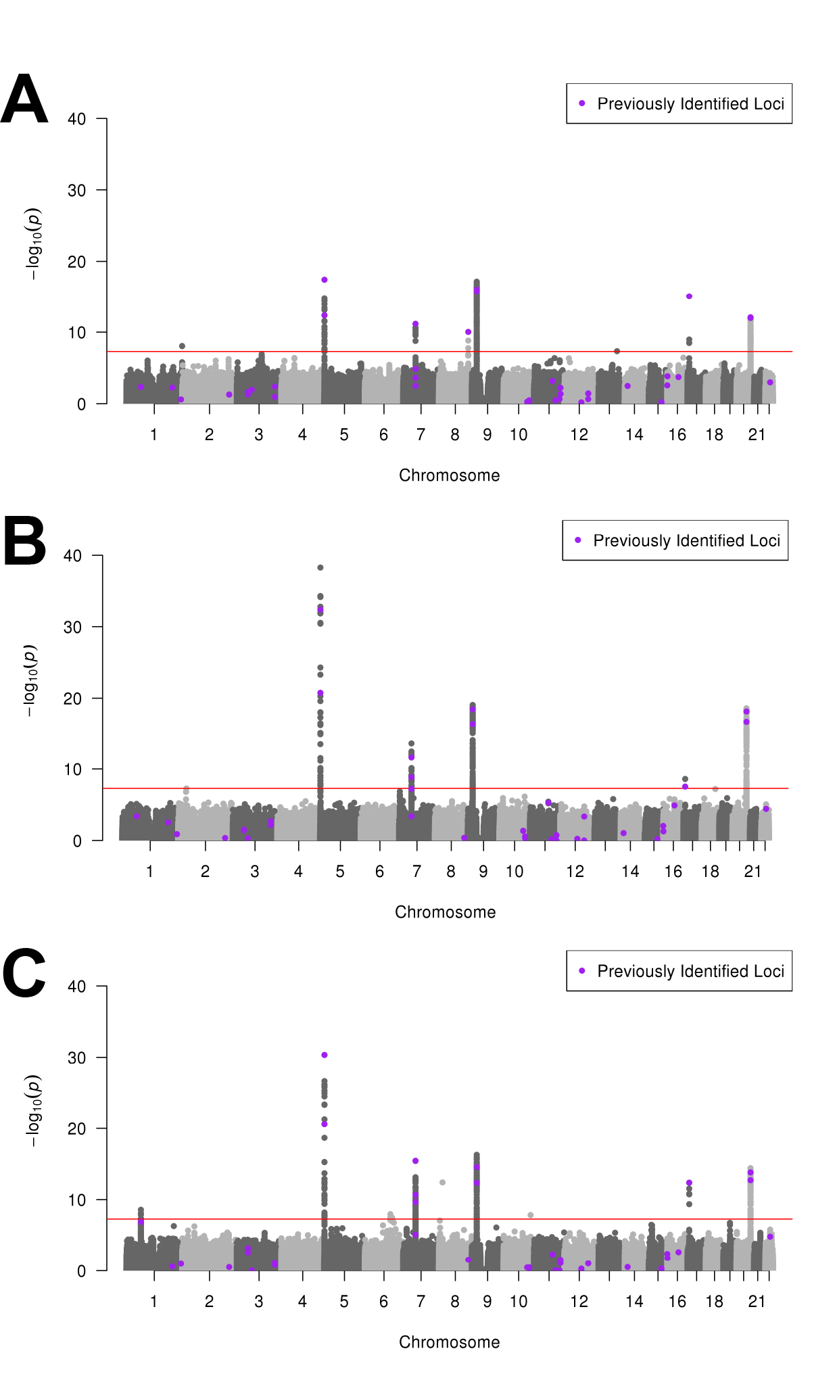

Supplementary Figure 2. Age-specific odds ratios, 95% CI and p values for selected previous GWAS hits
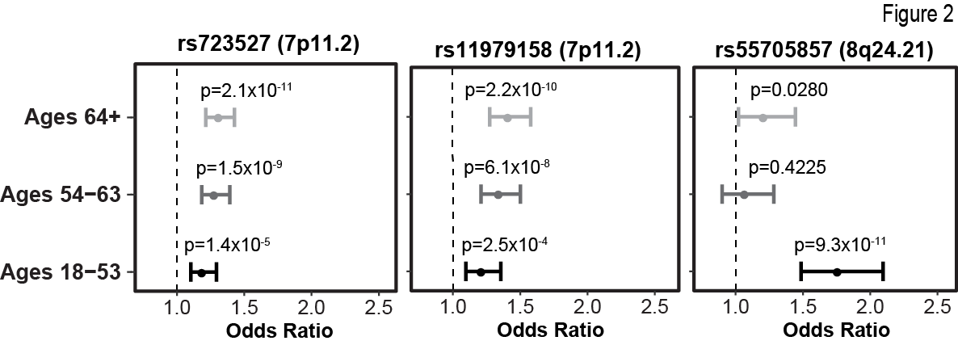

Supplementary Figure 3 Age-specific odds ratios and 95% CI from meta-analysis and by study for rs55705857 (8q24.21, CCDC26)
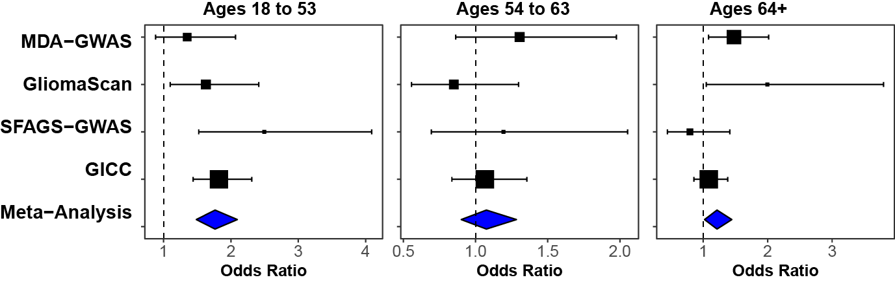

Supplementary Figure 4 Manhattan plot of -log(p) values for case-only analysis of age of diagnosis glioblastoma by meta-analysis using A) fixed effects and B) random effects
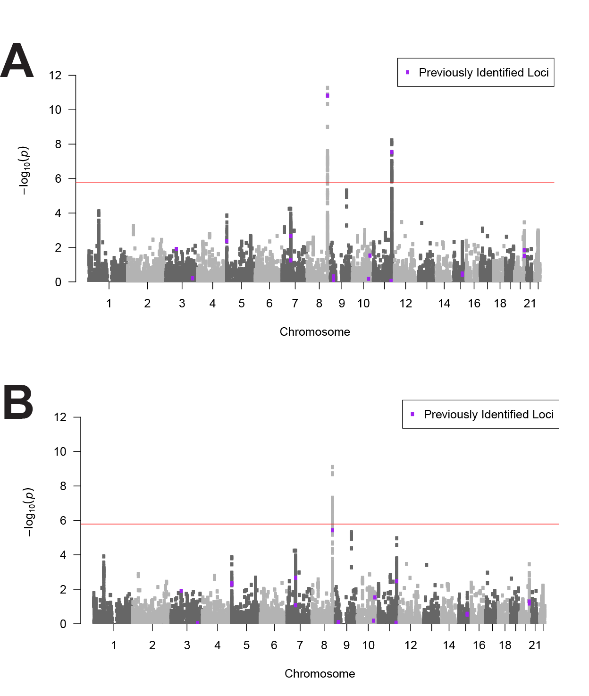

Supplementary Figure 5 Age-specific odds ratios and 95% CI from meta-analysis and by study for rs723527 (7p11.2, EGFR)
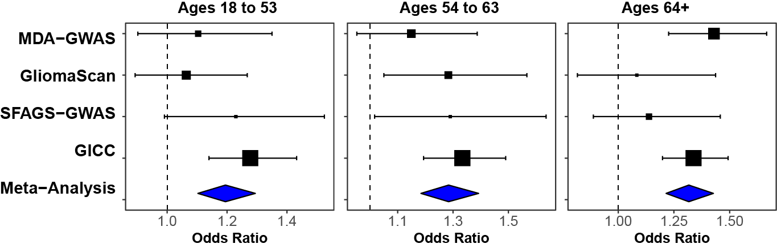

Supplementary Figure 6 Age-specific odds ratios and 95% CI from meta-analysis and by study for rs11979158 (7p11.2, EGFR)
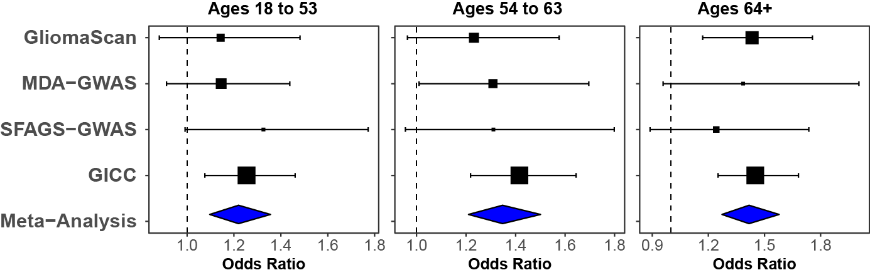

References
1. Melin BS, Barnholtz-Sloan JS, Wrensch MR, Johansen C, Il'yasova D, Kinnersley B, Ostrom QT, Labreche K, Chen Y, Armstrong G, Liu Y, Eckel-Passow JE, et al. Genome-wide association study of glioma subtypes identifies specific differences in genetic susceptibility to glioblastoma and non-glioblastoma tumors. Nature genetics 2017;49: 789-94.
2. Wrensch M, Jenkins RB, Chang JS, Yeh RF, Xiao Y, Decker PA, Ballman KV, Berger M, Buckner JC, Chang S, Giannini C, Halder C, et al. Variants in the CDKN2B and RTEL1 regions are associated with high-grade glioma susceptibility. Nature genetics 2009;41: 905-8.
3. Shete S, Hosking FJ, Robertson LB, Dobbins SE, Sanson M, Malmer B, Simon M, Marie Y, Boisselier B, Delattre JY, Hoang-Xuan K, El Hallani S, et al. Genome-wide association study identifies five susceptibility loci for glioma. Nature genetics 2009;41: 899-904.
4. Rajaraman P, Melin BS, Wang Z, McKean-Cowdin R, Michaud DS, Wang SS, Bondy M, Houlston R, Jenkins RB, Wrensch M, Yeager M, Ahlbom A, et al. Genome-wide association study of glioma and meta-analysis. Human Genetics 2012;131: 1877-88.
5. Yeager M, Chatterjee N, Ciampa J, Jacobs KB, Gonzalez-Bosquet J, Hayes RB, Kraft P, Wacholder S, Orr N, Berndt S, Yu K, Hutchinson A, et al. Identification of a new prostate cancer susceptibility locus on chromosome 8q24. Nature genetics 2009;41: 1055-7.
6. Hunter DJ, Kraft P, Jacobs KB, Cox DG, Yeager M, Hankinson SE, Wacholder S, Wang Z, Welch R, Hutchinson A, Wang J, Yu K, et al. A genome-wide association study identifies alleles in FGFR2 associated with risk of sporadic postmenopausal breast cancer. Nature genetics 2007;39: 870-4.

