**Supplemental Material**

Table S1: CMIP5 modeling centers or groups and model names

|  |  |  |
| --- | --- | --- |
| **Modeling Center (or Group)** | **Institute ID** | **Model Name** |
| Commonwealth Scientific and Industrial Research Organization (CSIRO) and Bureau of Meteorology (BOM), Australia | CSIRO-BOM | ACCESS1.0 |
| Beijing Climate Center, China Meteorological Administration | BCC | BCC-CSM1.1 |
| Canadian Centre for Climate Modelling and Analysis | CCCMA | CanESM2.1  CanESM2.2  CanESM2.3  CanESM2.4  CanESM2.5 |
| National Center for Atmospheric Research | NCAR | CCSM4.1  CCSM4.2 |
| Community Earth System Model Contributors | NSF-DOE-NCAR | CESM1(BGC) |
| Centre National de Recherches Météorologiques / Centre Européen de Recherche et Formation Avancée en Calcul Scientifique | CNRM-CERFACS | CNRM-CM5 |
| Commonwealth Scientific and Industrial Research Organization in collaboration with Queensland Climate Change Centre of Excellence | CSIRO-QCCCE | CSIRO-Mk3.6.0.1  CSIRO-Mk3.6.0.2  CSIRO-Mk3.6.0.3  CSIRO-Mk3.6.0.4  CSIRO-Mk3.6.0.5  CSIRO-Mk3.6.0.6  CSIRO-Mk3.6.0.7  CSIRO-Mk3.6.0.8  CSIRO-Mk3.6.0.9  CSIRO-Mk3.6.0.10 |
| NOAA Geophysical Fluid Dynamics Laboratory | NOAA GFDL | GFDL-ESM2G  GFDL-ESM2M  GFDL-HIRAM-C360a |
| Institute for Numerical Mathematics | INM | INM-CM4 |
| Institut Pierre-Simon Laplace | IPSL | IPSL-CM5A-LR1  IPSL-CM5A-MR1  IPSL-CM5A-LR2  IPSL-CM5A-LR3  IPSL-CM5A-LR4 |
| Japan Agency for Marine-Earth Science and Technology, Atmosphere and Ocean Research Institute (The University of Tokyo), and National Institute for Environmental Studies | MIROC | MIROC-ESM  MIROC-ESM-CHEM1 |
| Atmosphere and Ocean Research Institute (The University of Tokyo), National Institute for Environmental Studies, and Japan Agency for Marine-Earth Science and Technology | MIROC | MIROC5.1  MIROC5.2  MIROC5.3 |
| Max-Planck-Institut für Meteorologie (Max Planck Institute for Meteorology) | MPI-M | MPI-ESM-LR.1  MPI-ESM-LR.2  MPI-ESM-LR.3  MPI-ESM-MR-1  MPI-ESM-MR-2b  MPI-ESM-MR-3b |
| Meteorological Research Institute | MRI | MRI-CGCM3 |
| Norwegian Climate Centre | NCC | NorESM1-M |

a RCP 8.5 only

b RCP 4.5 only

Table S2: Percent change in rate for (1) 21-day cumulative all-cause, all-ages emergency department (ED) visits compared to the location-specific minimum morbidity temperature (MMBT) and (2) 21-day cumulative all-cause, all-ages mortality compared to the location-specific minimum mortality temperature (MMT) in Rhode Island and Boston.

|  |  |  |  |  |
| --- | --- | --- | --- | --- |
|  | **% increase in rate (95% CI)** | | | |
| Mean temperature (°C) | ED visits  (Rhode Island) | ED visits  (Boston) | Deaths  (Rhode Island) | Deaths  (Boston) |
| -10.0 | 4.3 (-0.7, 9.5) | 0.0 (-7.7, 8.2) | 34.8 (12.1, 62.1) | 37.8 (14.3, 66.0) |
| -5.0 | 4.1 (1.2, 7.1) | 3.0 (-2.7, 8.9) | 29.6 (10.5, 52.1) | 31.6 (11.2, 55.9) |
| 0.0 | 3.1 (0.6, 5.6) | 3.1 (-1.0, 7.3) | 26.8 (8.7, 47.8) | 30.9 (11.5, 53.6) |
| 5.0 | 1.1 (-0.5, 2.7) | 0.7 (-1.0, 2.5) | 25.7 (8.4, 45.7) | 33.3 (14.4, 55.3) |
| 9.2 a |  | 0 (ref) |  |  |
| 10.0 | 0.0 (-0.3, 0.4) | 0.0 (-0.4, 0.5) | 18.2 (3.8, 34.5) | 23.6 (8.0, 41.5) |
| 10.9 b | 0 (ref) |  |  |  |
| 15.0 | 0.4 (-1.3, 2.0) | 1.2 (-2.6, 5.1) | 6.4 (-4.5, 18.4) | 8.3 (-3.4, 21.6) |
| 20.0 | 1.6 (-1.3, 4.6( | 2.2 (-2.6, 7.3) | 0.7 (-2.9, 4.4) | 1.5 (-3.7, 7.0) |
| 22.5 c |  |  | 0 (ref) |  |
| 24.0 d |  |  |  | 0 (ref) |
| 25.0 | 5.9 (1.7, 10.2) | 5.5 (-0.5, 11.8) | 0.6 (-3.6, 5.1) | 0.1 (-1.6, 1.7) |
| 30.0 | 15.2 (9.0, 21.7) | 12.7 (3.7, 22.6) | 6.1 (-15.5, 33.2) | 3.0 (-15.8, 25.8) |

a MMBT, Boston

b MMBT, Rhode Island

c MMT, Rhode Island

d MMT, Boston

Figure S1: Association between daily mean temperature and (A) cumulative 21-day all-cause emergency department (ED) visits relative to the location-specific minimum morbidity temperature, and (B) cumulative 21-day all-cause deaths relative to the location-specific minimum mortality temperature in Boston.

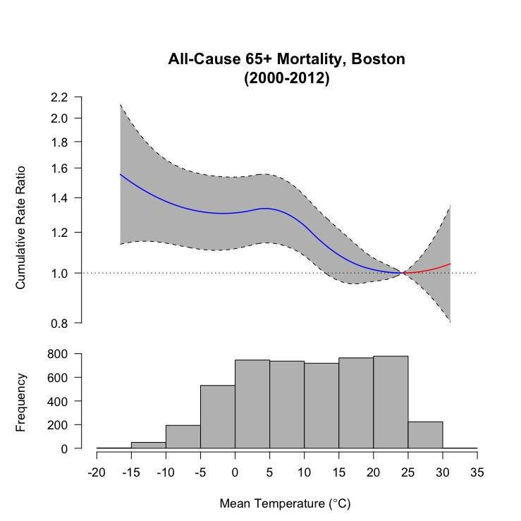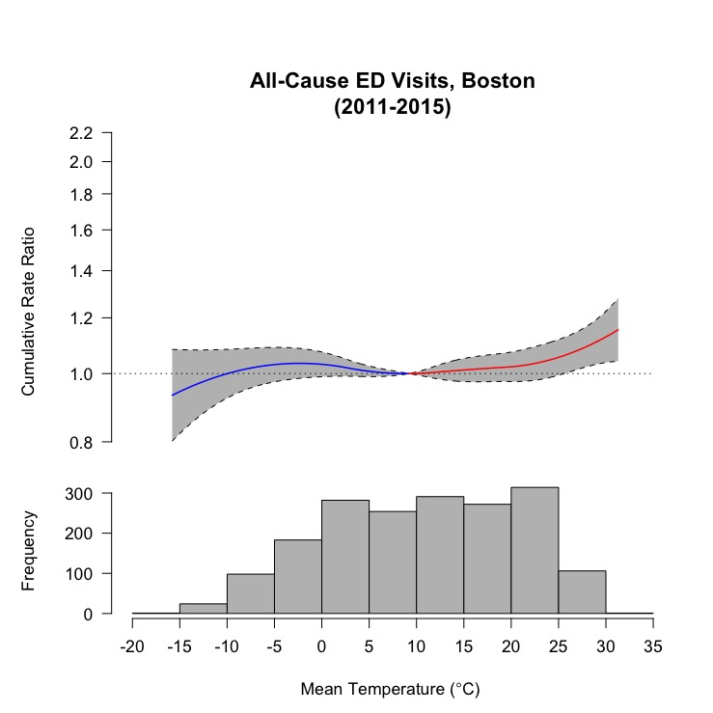

**(A)**

**(B)**

Figure S2: Boxplot of the increase in mean temperature projected by the CMIP5 model ensemble in Rhode Island and Boston in two future decades and under two emissions scenarios, compared to 2001-2010.

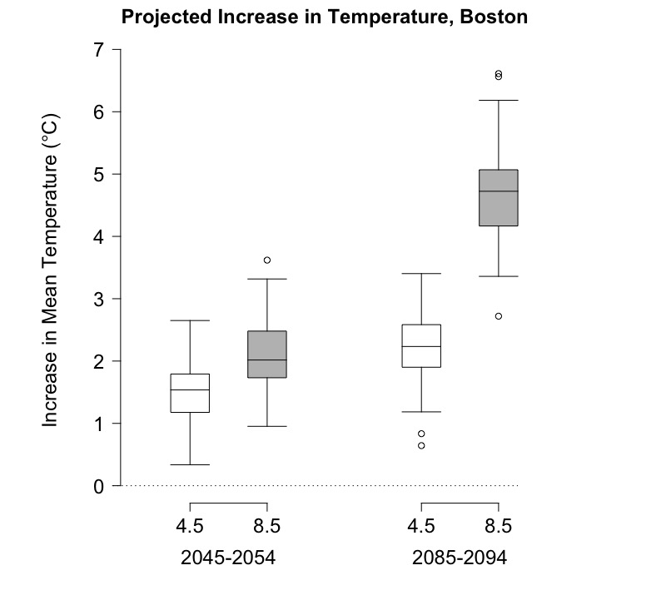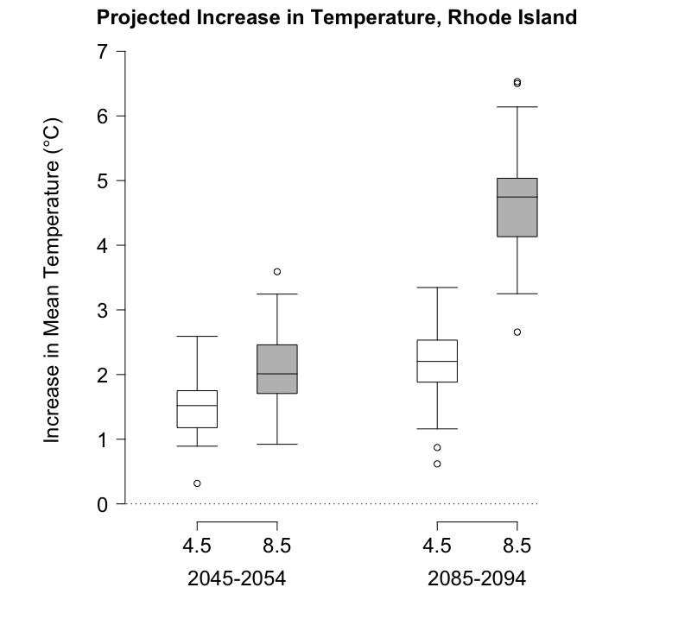

Table S3: Change in annual all-cause emergency department (ED) visits attributable to temperature (i.e., deviations from the minimum morbidity temperature), heat only (temperatures greater than the minimum morbidity temperature), and cold only (temperatures less than the minimum morbidity temperature) in 2045-2054 and 2085-2094 versus 2001-2010 under two emissions scenarios.

|  |  |  |  |  |  |
| --- | --- | --- | --- | --- | --- |
|  |  |  | Change in annual all-cause ED visits (95% CI) | | |
| Site | Decade | RCP | Attributable to heat | Attributable to cold | Attributable to all temperatures |
| Rhode Island | 2045-2054 | 4.5 | 1989 (612, 3556) | -671 (-1868, -53) | 1255 (-99, 2822) |
|  | 2045-2054 | 8.5 | 2814 (1102, 5320) | -918 (-2219, -158) | 1875 (291, 4270) |
|  | 2085-2094 | 4.5 | 3085 (927, 5117) | -1015 (-2372, -119) | 1980 (72, 4093) |
|  | 2085-2094 | 8.5 | 8099 (3332, 13648) | -2032 (-3852, -575) | 5976 (1630, 11379) |
|  |  |  |  |  |  |
| Boston | 2045-2054 | 4.5 | 2411 (1022, 4311) | 235 (-552, 1037) | 2671 (1121, 4538) |
|  | 2045-2054 | 8.5 | 3528 (1242, 7029) | 321 (-964, 1088) | 3845 (1774, 7009) |
|  | 2085-2094 | 4.5 | 3802 (1012, 7114) | 324 (-959, 1140) | 4086 (1337, 7296) |
|  | 2085-2094 | 8.5 | 10186 (4278, 19162) | -401 (-2291, 1065) | 9828 (4299, 18165) |

Table S4: Change in annual all-cause deaths attributable to temperature (i.e., deviations from the minimum mortality temperature), heat only (temperatures greater than the minimum mortality temperature), and cold only (temperatures less than the minimum mortality temperature) in 2045-2054 and 2085-2094 versus 2001-2010 under two emissions scenarios.

|  |  |  |  |  |  |
| --- | --- | --- | --- | --- | --- |
|  |  |  | Change in annual all-cause deaths (95% CI) | | |
| Site | Decade | RCP | Attributable to heat | Attributable to cold | Attributable to all temperatures |
| Rhode Island | 2045-2054 | 4.5 | 8 (-39, 59) | -89 (-186, -23) | -80 (-196, -4) |
|  | 2045-2054 | 8.5 | 14 (-58, 93) | -122 (-247, -41) | -105 (-254, -3) |
|  | 2085-2094 | 4.5 | 13 (-70, 95) | -133 (-253, -38) | -115 (-260, -7) |
|  | 2085-2094 | 8.5 | 51 (-215, 316) | -271 (-480, -101) | -218 (-551, 43) |
|  |  |  |  |  |  |
| Boston | 2045-2054 | 4.5 | 6 (-62, 73) | -111 (-252, -27) | -105 (-260, -5) |
|  | 2045-2054 | 8.5 | 9 (-90, 110) | -155 (-324, -51) | -144 (-342, -9) |
|  | 2085-2094 | 4.5 | 8 (-105, 118) | -166 (-322, -45) | -152 (-352, -7) |
|  | 2085-2094 | 8.5 | 33 (-287, 332) | -339 (-616, -131) | -301 (-743, 54) |