doi: 10.1111/ina.12502

“Online supporting information for the following article published in Indoor Air, DOI: TO BE ADDED BY THE PRODUCTION EDITOR”
Title: Effectiveness of a Portable Air Cleaner in Removing Aerosol Particles in Homes Close to Highways

SUPPLEMENTAL INFORMATION
August 15, 2018
Indoor Air

Effectiveness of a portable air cleaner in removing aerosol particles in homes close to highways

Jennie Cox¹, Kelechi Isiugo¹, Patrick Ryan^{1,2}, Sergey A. Grinshpun¹, Michael Yermakov¹, Colleen Desmond¹, Roman Jandarov¹, Stephen Vesper³, James Ross⁴, Steven Chillrud⁴, Karen Dannemiller^{5,6}, Tiina Reponen¹
¹Department of Environmental Health, University of Cincinnati, P.O. Box 670056, Cincinnati, Ohio
²Cincinnati Children's Hospital Medical Center, Cincinnati, Ohio
³United States Environmental Protection Agency, 26 W. M. L. King Drive, Mail Stop 314, Cincinnati, Ohio
⁴ Lamont-Doherty Earth Observatory of Columbia University, Palisades, New York
⁵ Civil, Environmental & Geodetic Engineering, College of Engineering, The Ohio State University, 470 Hitchcock Hall, 2070 Neil Ave, Columbus, Ohio
⁶ Environmental Health Sciences, College of Public Health, The Ohio State University, 410 Cunz Hall, 1841 Neil Ave, Columbus, Ohio
Corresponding author:
T. Reponen
University of Cincinnati, Department of Environmental Health, P.O. Box 670056. Cincinnati, OH, 45267-0056 USA; Telephone: 513-558-0571. E-mail: Tiina.Reponen@uc.edu

1.0 Methods: Fungal DNA
The term “ERMI-like” is used instead of ERMI when describing the results of the analyses of air samples, because air sample results are in different units, i.e., SE/m³ air, rather than SE/mg dust which is used to determine the ERMI value.¹
In 21 homes, samples collected using co-located Button™ samplers were also analyzed for total DNA utilizing Qubit® 3.0 Fluorometer (Invitrogen, Thermo Fisher Scientific, Carlsbad, CA) and for total fungal DNA utilizing universal fungal primers in quantitative PCR (qPCR).^{2, 3} Qubit results were reported in ng/µl, multiplied by the amount of the elution extraction and divided by the volume of air per sample yielding results of total DNA (ng/m³).⁴ Total fungal concentration was measured using universal fungal primers 5.8F1/5.8R1 targeting the internal transcribed spacer (ITS) regions of nuclear ribosomal DNA (rDNA) (Step One Plus, Applied Biosystems, Life Technologies, Carlsbad CA). The results were divided by the volume of air to yield results of total fungal DNA in spore equivalents per cubic meter (SE/m³).
Total fungal concentration was measured using universal fungal primers 5.8F1/5.8R1 targeting the internal transcribed spacer (ITS) regions of nuclear ribosomal DNA (rDNA)(Step One Plus, Applied Biosystems, Life Technologies, Carlsbad ,CA)³. The assay contained 12.5 µl of “Universal Master Mix” (Applied Biosystems Inc., Foster City, CA), 0.04 µl of forward and reverse primers at 0.2 µM each, 2.5 µl of a 400 nM TaqMan probe (Applied Biosystems Inc., Foster City, CA), and 2.5 µl of 2 mg/ml fraction V bovine serum albumin (Sigma Chemical, St. Louis, MO). This mix and 1 µl of the DNA extract from the sample were combined for a total volume of 25 µl. Reactions were performed with thermal cycling conditions consisting of 2 min at 50 ᵒC, 10 minutes at 95ᵒC, followed by 40 cycles of 15 seconds at 95ᵒC for template denaturation and 1 minute at 60ᵒC for probe and primer annealing and primer extension. The cycle threshold determinations were automatically performed by the instrument using default parameters. Samples were tested in triplicate with R² > 0.9 and efficiency >90%. Inhibition testing was conducted on all samples using qPCR by spiking the samples. A known quantity of extracted Aspergillus fumigatus DNA was compared to samples spiked with the same quantity of extracted Aspergillus fumigatus DNA. Standard curves of serial dilutions were produced with Aspergillus fumigatus (ATCC 34506) for spore equivalents.^{3, 5}
1.2 Results: Fungal
In a subset of 21 homes, samples taken with co-located Button samplers were collected and analyzed for total fungal DNA with qPCR and total DNA with Qubit. The levels of total DNA were below the detection limit of the Qubit instrument in 20 of the 42 samples. When both pre- and post-HEPA values were too low, these 12 data points were removed. For 8 samples, the estimate of half the method detection limit was assumed. Seven homes had valid pre- and post-HEPA values, and an additional 8 homes were added when utilizing ½ the method detection limit (n=15). The median qubit value pre-HEPA was 147 pg/m³ (with the range of 43 – 870 pg/m³), and the median post-HEPA value was 106 pg/m³ (42 – 1261 pg/m³) (Supplemental Figure 9A). Total fungal DNA measured with qPCR universal primers for all 21 homes had a pre-HEPA median of 1432 SE/m³ and a post-HEPA median of 575 SE/m³ (Figure S9B). When only evaluating this subset of 21 homes for the summed MSQPCR-fungi, the median pre-HEPA value was 196 SE/m³ and the co-located post-HEPA value was 128 SE/m³ (Figure S9C).
Wilcoxon signed rank test showed that the median values for pre- and post-HEPA treatment were reduced in all three of these measurements, however, the only borderline significant change was with summed MSQPCR-fungi pre- and post-HEPA treatment (p=0.019). The Spearman correlation analysis showed that the total fungal DNA and summed MSQPCR-fungi pre-HEPA concentrations correlated significantly (r=0.57, p<0.01), as well as their post-HEPA concentrations (r=0.85, p<0.001). Total fungal DNA and total DNA pre-HEPA values (r=0.85, p<0.001) and post-HEPA values (r=0.68, p<0.001) also correlated significantly.

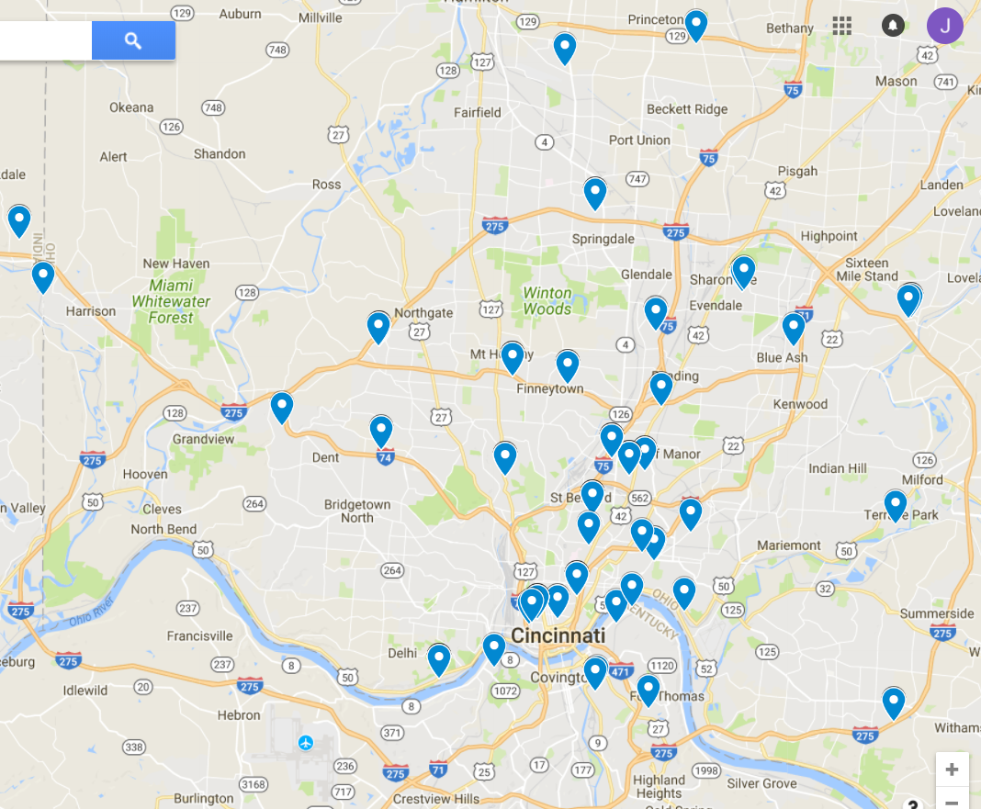

Figure S1. Map showing the location of the study in relation to major roadways
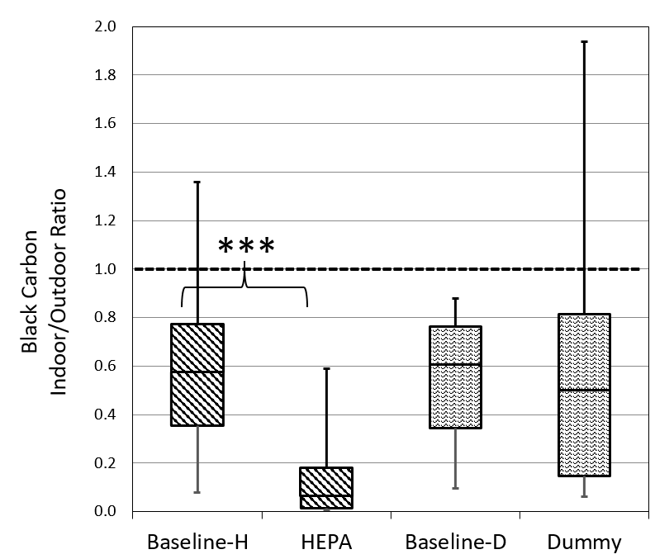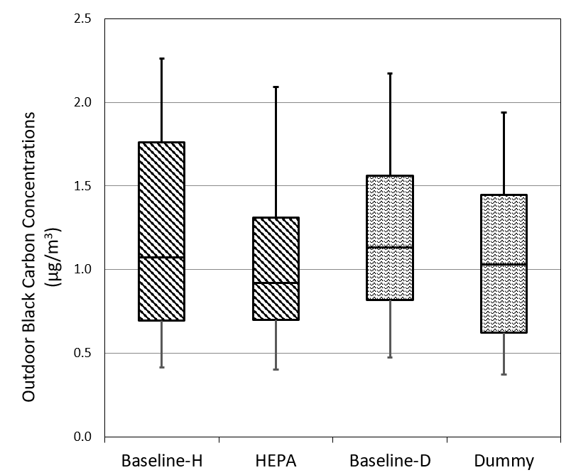
B.
A.
Figure S2. A. Indoor/Outdoor ratios of black carbon (BC) (HEPA n=40, Dummy n=36). Dashed line is threshold where indoor exceeds outdoor. B. Outdoor concentrations of BC (µg/m³) (HEPA n=41 homes, Dummy n=36 homes). Baseline-H or Baseline-D indicates 48 hours prior to HEPA or Dummy installation and HEPA or Dummy indicates the last 48 hours during the treatment. Horizontal lines in the box plots represent the 10%, 25%, 50%, 75% and 90% percentiles. Due to Bonferroni correction, p-value <0.0125 was considered significant. ***p<0.001

B.
A.
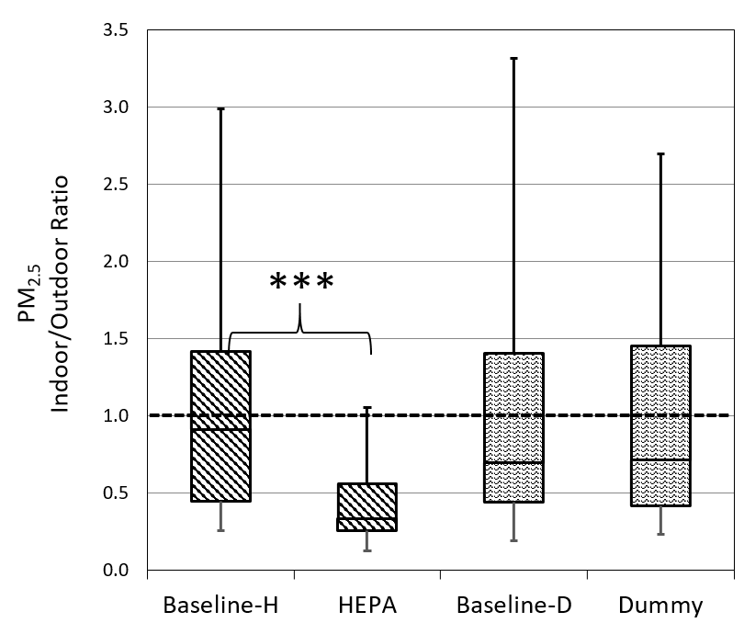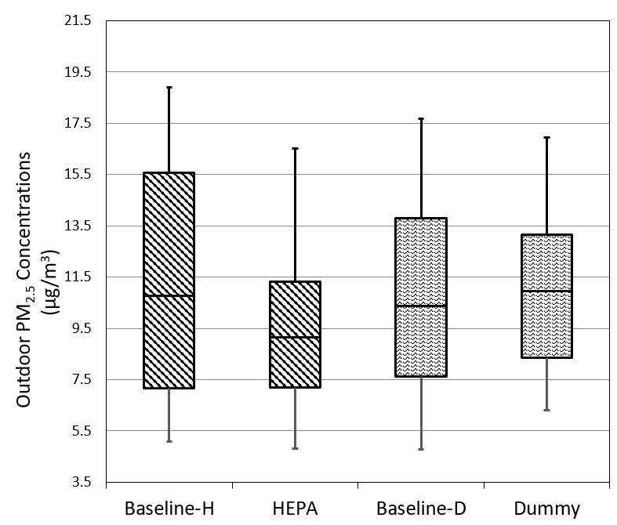

Figure S3. A. Indoor/Outdoor ratios of PM_{2.5} (HEPA n=40 homes, Dummy n=35 homes). Dashed line is threshold where indoor exceeds outdoor. B. Outdoor concentrations of PM_{2.5} (µg/m³) (HEPA n=41 homes, Dummy n=35 homes). Baseline-H or Baseline-D indicates 48 hours prior to HEPA or Dummy installation and HEPA or Dummy indicates the last 48 hours during the treatment. Horizontal lines in the box plots represent the 10%, 25%, 50%, 75% and 90% percentiles. Due to Bonferroni correction, p-value <0.0125 was considered significant. ***p<0.001
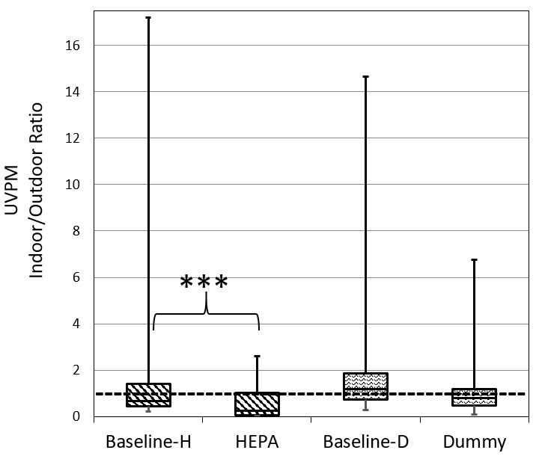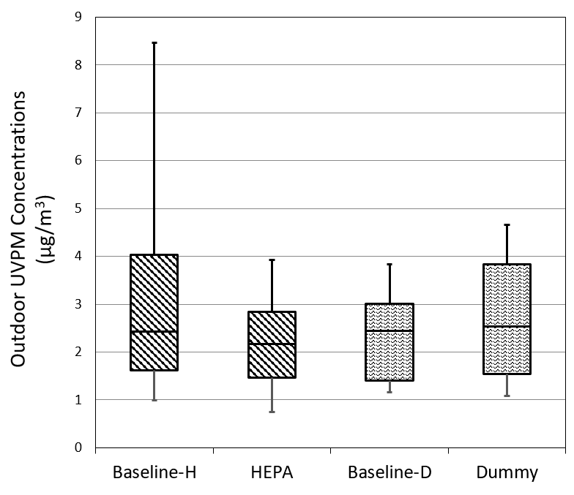
A.
B.
Figure S4. A. Indoor/Outdoor ratios of ultraviolet light absorbing particulate matter (UVPM) (HEPA n=40, Dummy n=35). Dashed line is threshold where indoor exceeds outdoor. B. Outdoor concentrations of UVPM (µg/m³) (HEPA n=41 homes, Dummy n=36 homes). Baseline-H or Baseline-D indicates 48 hours prior to HEPA or Dummy installation and HEPA or Dummy indicates the last 48 hours during the treatment. Horizontal lines in the box plots represent the 10%, 25%, 50%, 75% and 90% percentiles. Due to Bonferroni correction, p-value <0.0125 was considered significant. ***p<0.001

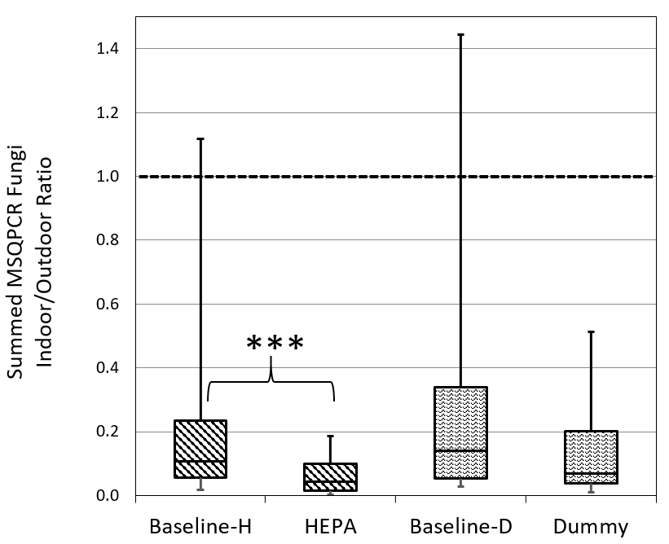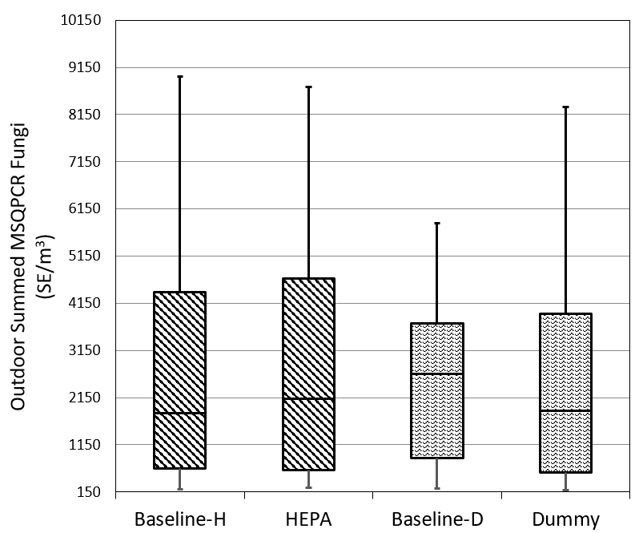
B.
A.
Figure S5. A. Indoor/Outdoor ratios of summed Mold Specific Quantitative PCR (MSQPCR) fungi (HEPA n=38, Dummy n=40). Dashed line is threshold where indoor exceeds outdoor. B. Outdoor concentrations of summed MSQPCR-fungi (SE/m³)(HEPA n=39 homes, Dummy n=40 homes Baseline-H or Baseline-D indicates 48 hours prior to HEPA or Dummy installation and HEPA or Dummy indicates the last 48 hours during the treatment. Horizontal lines in the box plots represent the 10%, 25%, 50%, 75% and 90% percentiles. Due to Bonferroni correction, p-value <0.0125 was considered significant. ***p<0.001, SE = Spore Equivalents
B.
A.
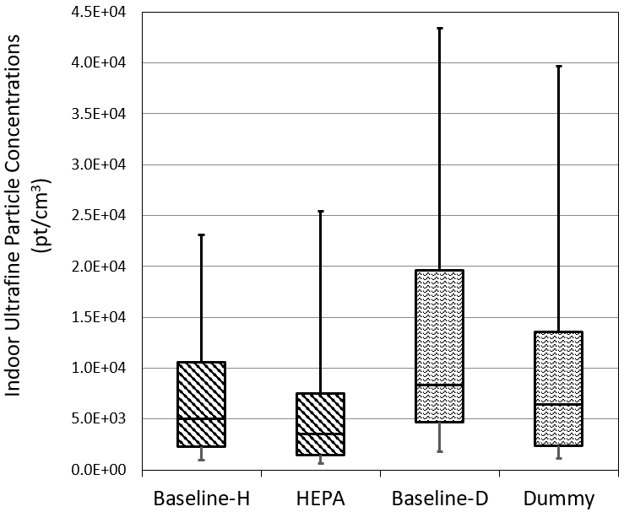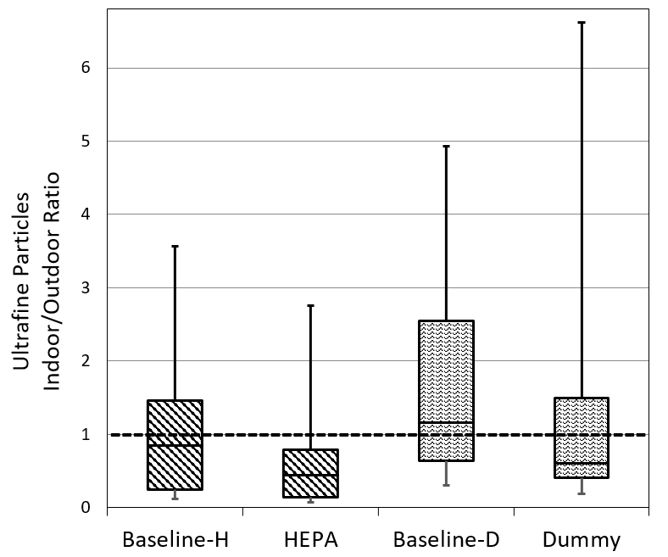
C.
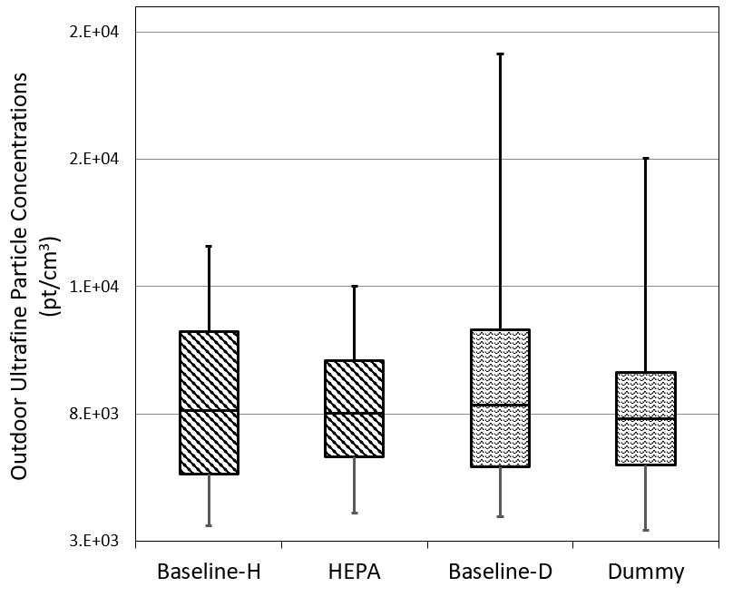
Figure S6. A. Indoor concentrations of ultrafine particles (pt/cm³) (HEPA n=40, Dummy n=39). B. Indoor/Outdoor ratios of ultrafine particles (UFP) (HEPA n=34, Dummy n=30). Dashed line is threshold where indoor exceeds outdoor. C. Outdoor concentrations of UFP (pt/cm³) (HEPA n=36 homes, Dummy n=31 homes). Baseline-H or Baseline-D indicates 48 hours prior to HEPA or Dummy installation and HEPA or Dummy indicates the last 48 hours during the treatment. Horizontal lines in the box plot represent the 10%, 25%, 50%, 75% and 90% percentiles. Due to Bonferroni correction, p-value <0.0125 was considered significant.

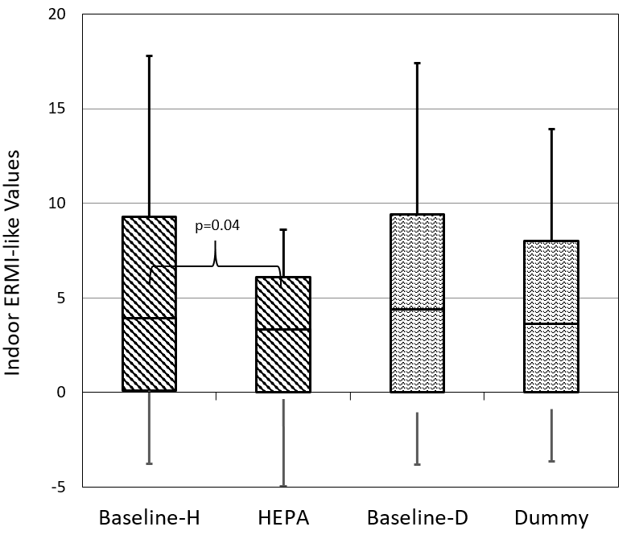
Figure S7. Indoor ERMI-like values (HEPA n=41 homes, Dummy n=40 homes). Baseline-H or Baseline-D indicates 48 hours prior to HEPA or Dummy installation and HEPA or Dummy indicates the last 48 hours during the treatment. Horizontal lines in the box plots represent the 10%, 25%, 50%, 75% and 90% percentiles. Due to Bonferroni correction, p-value <0.0125 was considered significant.

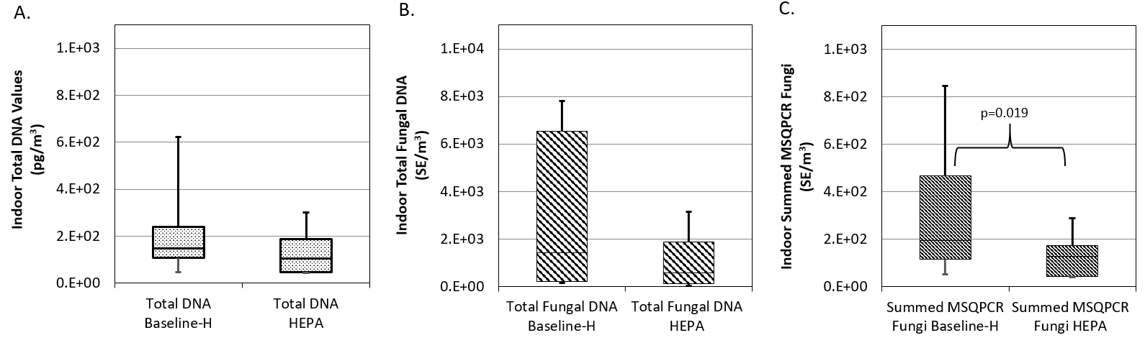
Figure S8. A. Indoor concentration of total DNA (n=15 homes), B. Indoor concentration of total fungal DNA (n=21 homes) and C. Indoor concentration of summed MSQPCR-fungi (n=21 homes, co-located). Baseline-H or Baseline-D indicates 48 hours prior to HEPA or Dummy installation and HEPA or Dummy indicates the last 48 hours during the treatment. Horizontal lines in the box plot represent the 15%, 25%, 50%, 75% and 85% percentiles. Due to Bonferroni correction, p-value <0.0125 was considered significant. SE = Spore Equivalents

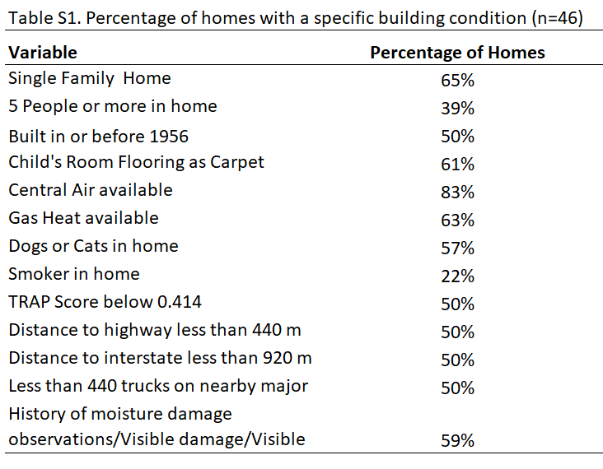

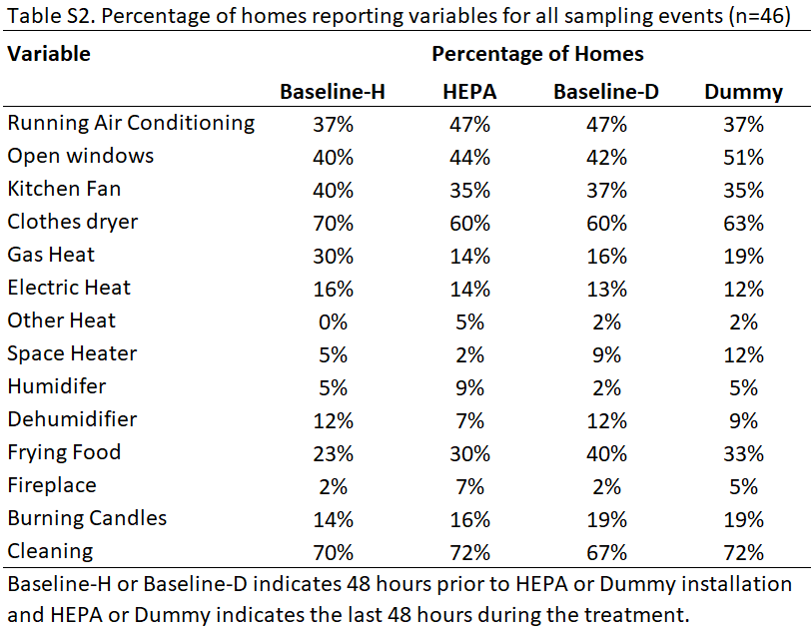

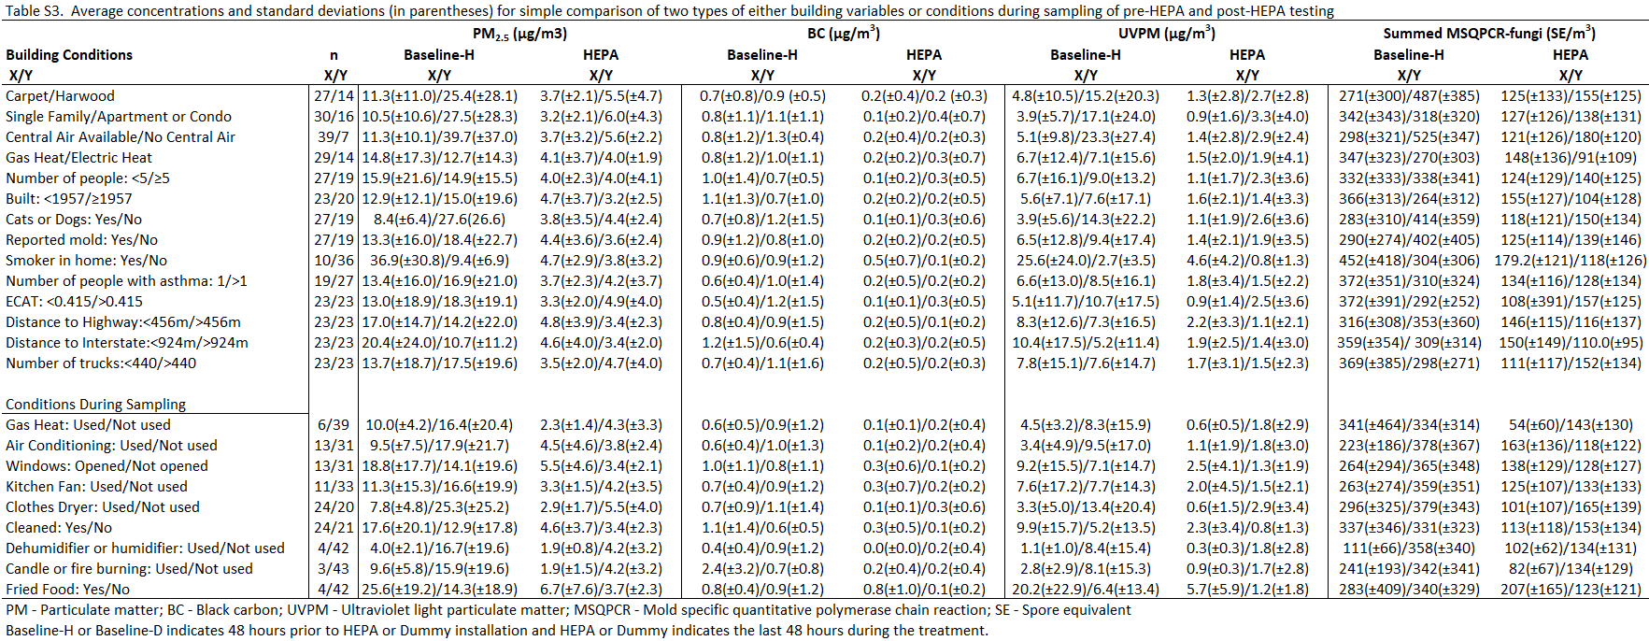

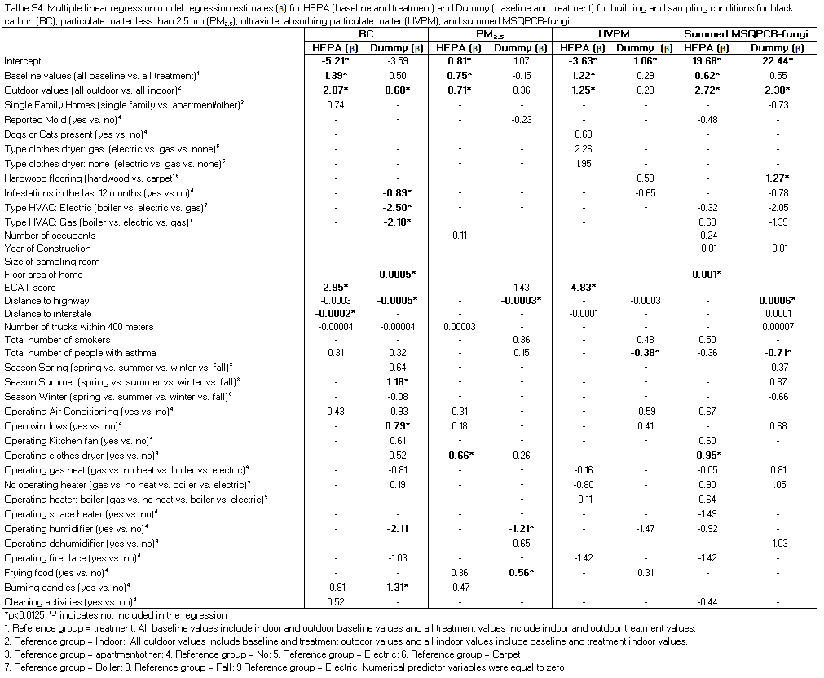

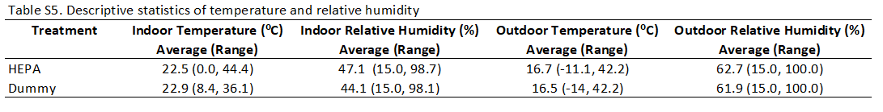

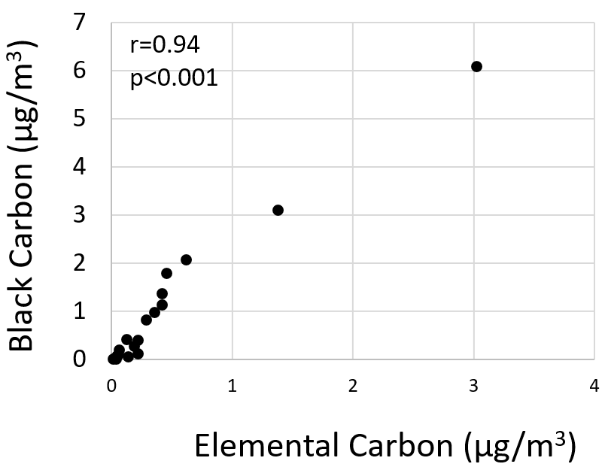
Figure S9. Indoor concentrations of elemental carbon and black carbon (µg/m³)(n=18).

References
1. Méheust D, Gangneux J-P, Reponen T, et al. Correlation between Environmental Relative Moldiness Index (ERMI) values in French dwellings and other measures of fungal contamination. Sci Total Environ. 2012; 438: 319-324.
2. Dannemiller KC, Lang-Yona N, Yamamoto N, et al. Combining real-time PCR and next-generation DNA sequencing to provide quantitative comparisons of fungal aerosol populations. Atmos Environ. 2014; 84: 113-121.
3. Haugland R, Vesper S. Method of identifying and quantifying specific fungi and bacteria. US. Environmental Protection Agency, Washington, DC (US). US Patent 6,387,652 B1. 2002.
4. Luhung I, Wu Y, Ng CK, et al. Protocol improvements for low concentration DNA-based bioaerosol sampling and analysis. PLOS ONE. 2015; 10: e0141158.
5. Dannemiller KC, Gent JF, Leaderer BP, et al. Influence of housing characteristics on bacterial and fungal communities in homes of asthmatic children. Indoor Air. 2016; 26: 179-192.

