Online Appendix

Appendix 1 economic search terms in search strategy

economic, cost, benefit, cost-benefit, benefit-cost, utility, cost-utility, expenditure, cost effectiveness, cost of illness, cost saving, cost averted, $, dollar, WTP, willingness to pay, net cost, increment, opportunity cost, travel cost, treatment cost, lost productivity, fixed cost, operating cost, variable cost, sensitivity analysis, breakeven, discount rate, value, QALY, DALY, capital cost, life time cost, medical cost, time cost, treatment saving, dental fee, money

Appendix Figure 1

Per Capita Annual Cost by Community Population Size (3% to 4% discount rate)*

* Tchouaket et al. was not included in the graph since no community size information was reported in the paper. The community size in Cobiac and Vos was reported as <= 1000 and was in the category of 1000-4999 in the graph.

Appendix Figure 2

Per Capita Annual Cost by Community Population Size (5% discount rate)

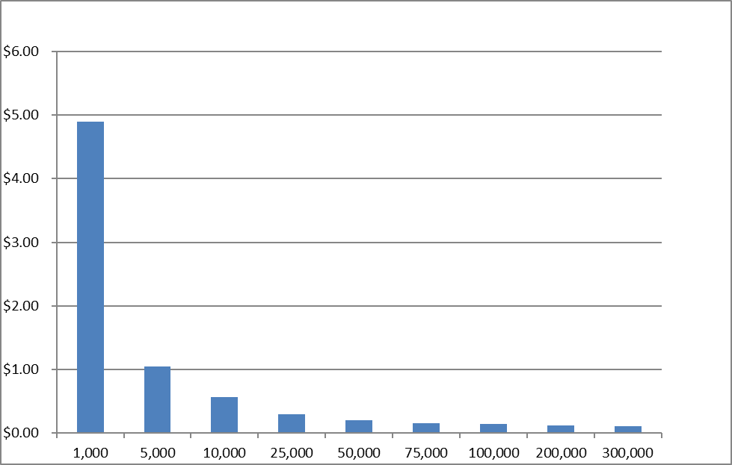

Wright

Appendix Figure 3

Benefit-Cost Ratio by Community Population Size*

(3% to 4% Discount Rate, 15% to 20% caries reduction rate)

* Tchouaket et al. was not included in the graph since no community size information was reported in the paper. The community size in Cobiac and Vos was reported as <= 1000 and was in the category of 1000-4999 in the graph.

Appendix Figure 4

Benefit-Cost Ratio by Community Population Size*

(5% Discount Rate, 33% caries reduction rate)

Appendix Table 1. Highlighted Results from Benefit-Only Studies

|  |  |  |
| --- | --- | --- |
| **Study** | **Sample** | **Main result** |
| Kumar 2010 | Children under 21 | For every 10% increase in the population in fluoridated area, the number of claims per child for caries-related services declined by 0.06. |
| Maupome 2007 | HMO members | CWF was associated with reduced total and restorative cost among members with dental visits. |
| Dept of Health, TX 2000 | 253 counties with Medicaid dental costs | For a unit rise of 1 ppm fluoride, the average Texas Medicaid dental treatment cost per child across the entire state fell by $33.56. |
| CDC, MMWR 1999 | Medicaid-eligible children | On average, fluoridated parishes have $55.46 less treatment cost than non-fluoridated parishes. |

CWF, community water fluoridation; ppm, parts per million.

Appendix Table 2. CWF Benefit Components

|  |  |  |  |  |  |  |
| --- | --- | --- | --- | --- | --- | --- |
| **Study** | **Healthcare cost averted** | | | | **Productivity losses averted** | |
| Examination | Restorationa | Extraction | Lifetime  Treatmenta | Productivity | Transportation |
| Tchouaket 2013 | **🗸** | **🗸** |  | **🗸** | **🗸** | **🗸** |
| Cobiac 2012b | **🗸** | **🗸** |  |  |  |  |
| Ciketic 2010b |  | **🗸** |  |  |  |  |
| O’Connell 2005 |  | **🗸** | **🗸** | **🗸** | **🗸** |  |
| Wright 2001 |  | **🗸** | **🗸** |  |  |  |
| Griffin 2001 |  | **🗸** |  | **🗸** | **🗸** |  |

a Major benefit drivers

b Also cost-effectiveness studies but used DALY, disability-adjusted life year

|  |  |  |  |  |  |  |
| --- | --- | --- | --- | --- | --- | --- |
| **Study** | **Examination** | **Restoration** | **Extract-ion** | **Producti-vity** | **Travel** | **Time per visit (hrs)** |
| Tchouaket 2013 | [36.12, 78.81]a | [61.52, 116.03]a | **—** | 8.45/hour | [2.7, 5.38]a | [1.43, 2.84]a |
| Cobiac 2012 | 42.2 (12.2) | 102.2 (19.69) | — | **—** | **—** | **—** |
| Ciketic 2010 | **—** | 143.99 | **—** | **—** | **—** | **—** |
| O’Connell 2005 | **—** | [178.5, 384.86]b | 121.54 | 25.46/hour | **—** | 1.6 |
| Wright 2001 | **—** | [23.47, 64.54]c | 39.11 | **—** | **—** | **—** |
| Griffin 2001 | **—** | 82.54 | **—** | 27.7/hour | **—** | 1 |

Appendix Table 3. Per Unit Cost for Treatment and Productivity (2013$)

Note: Brackets indicate ranges of values. Parentheses indicate SD.

a Range is due to different age groups.

b Value depends on whether it is initial, second, third, or fourth restoration.

c Lower bound is the restoration cost for an adolescent and upper bound is that for an adult.

**—** Not reported

Appendix Table 4. Cost Per DALY Averted

|  |  |  |  |  |
| --- | --- | --- | --- | --- |
| **Study** | **Cost** | **DALY Averted** | **Cost/DALY AAAverted** | **Population** |
| Cobiac 2012 | $18.7 million | 26,000 | $719.23 | **—** |
| Ciketic 2010 | $34.76 million | 10,437 | $3330.46 | 2.86 million |

**—** Not reported

DALY, disability-adjusted life year