Appendix.

TSEIR model structure
The epidemic model was based on several published models for measles ³⁶⁻³⁸. Our model is characterized by the following difference equations:
[1] $\frac{∆S}{∆t}=-β{\left({I_{t}}/{N_{all}}\right)}^{λ}S_{t}-θ_{t}\left({N_{child}}/{N_{all}}\right)1_{\left[θ_{t}≤S_{t}\right]}-S_{t}\left({N_{child}}/{N_{all}}\right)1_{\left[θ_{t}>S_{t}\right]}$
[2] $\frac{∆E}{∆t}=β{\left({I_{t}}/{N_{all}}\right)}^{λ}S_{t}-αE_{t}$
[3] $\frac{∆I}{∆t}=αE_{t}-γI_{t}$
[4] $\frac{∆R}{∆t}=γI_{t}$
[5] $\frac{∆V}{∆t}=θ_{t}\left({N_{child}}/{N_{all}}\right)1_{\left[θ_{t}≤S_{t}\right]}+S_{t}\left({N_{child}}/{N_{all}}\right)1_{\left[θ_{t}>S_{t}\right]}$
Population compartments are represented by $S$,$E$,$I$,$R$, and $V$. These refer to, respectively, individuals who are susceptible, exposed, infectious, removed, and vaccinated. The total population of the system is represented by $N_{all}$, the population of “children” is represented by $N_{child}$. The proportion of children in the population is captured by the ratio ${N_{child}}/{N_{all}}$. In addition to population levels in the susceptible and infectous compartments, the parameters that dictate transmission of the pathogen are the contact rate $β$ and a mixing coefficient $λ$. A mixing coefficient less than one can reduce bias from non-uniform mixing in the population. The vaccination parameter $θ_{t}$ is the daily change in vaccine coverage for the target age. Transition out of the exposed and infectious compartments occur at, respectively, rates $α$ and $γ$.
Two terms govern the movement of susceptibles from the susceptible compartment to the vaccinated compartment. These terms are found in both the susceptible difference equation (Equation 1, second and third term), as well as the vaccinated difference equation (Equation 5). Depending on the extent of an outbreak, the number of susceptibles in the population may be insufficient to meet the vaccine coverage levels observed in data (rising infected populations remove susceptibles before they can be vaccinated). This potential event is captured in the model as the conditional: $θ_{t}>S_{t}$. If there are sufficient numbers of susceptibles, then the remaining susceptibles of the target age group are vaccinated, even if that implies a vaccination coverage level that is lower than the level observed in the data.
In addition to the difference equations, each simulation began with a set of initial conditions, which will be discussed in the next section, on model parameterization.

Model parameterization

Initial conditions
At the beginning of the simulation, the infected population was set equal to one. The vaccinated population was set equal to the total population multiplied by the proportion of adults with a history of vaccination, 89.5%. The best available, published data on this value comes from a report in 2014, when the proportion of susceptible individuals under the age of 15 was approximately 11.5% ³². The vaccinated population also included the proportion of two to three year olds targeted by the vaccine recommendations who had already received a vaccine, per the data collected.

Population size
The total population sizes for Chuuk, Kosrae, Pohnpei, and Yap simulations were assumed to be 48,651, 6,616, 36,196, and 11,376 ³⁹. The population size for the children in our target age group were computed during the survey used in this study. Those values are 1,226, 172, 847, and 238, for Chuuk, Kosrae, Pohnpei, and Yap, respectively.

Vaccine coverage
In the on time simulations, the vaccine coverage rate was assumed to start high, at the “final” coverage percentage identified by the survey data. In the status quo simulation, the vaccine coverage rate equaled the coverage level observed when the median-aged individual in the cohort of toddlers was recommended to receive the vaccine on day one of the simulation. In the following days and months, the vaccine coverage rate increased until it reached the “final” vaccine coverage rate used in the on time simulation. The rate of increase for vaccine coverage in the status quo simulation reflected the monthly coverage data identified in the survey data, with linear interpolation of coverage levels on the days between the first day of each month. Infected individuals were not vaccinated. So in the case where infections spread through the susceptible population before vaccine coverage could reach targeted levels, any available susceptibles were vaccinated or no one was vaccinated.

Contact rate and mixing coefficient
Local conditions can drive disease dynamics. In particular, regions with high seasonal rainfall and high birth rates have more erratic outbreaks ⁴⁰. Past studies have found that contact rates scale with population size ³⁸, suggesting measles transmission is consistent with frequency dependent transmission. Finding no estimation of contact rate specifically estimated for the islands of FSM, we set the contact rate equal to 500 in the base case, based on a general value found in the literature ⁴¹. To accommodate uncertainty about the contact rate, we conducted sensitivity analyses on this parameter.
Similar to the contact rate, no study has been conducted that estimated a mixing coefficients for the FSM or surrounding region. Evidence suggests that values slightly less than 1 may be appropriate ³⁷, especially for smaller communities ³⁸ so we assume a value of 0.97 ³⁸. Functionally, a mixing coefficient less than one reduces the number of new infections in the model. Conceptually, this term is used to approximate more heterogeneous mixing among susceptible and infected individuals. By assuming$λ<1$, less mixing occurs than would occur under a “mass-action” assumption where$λ=1$.

Model scenarios and island states
The model was parameterized to represent scenarios with varying levels of vaccination timeliness, on time vaccination and a delayed vaccination scenario. Each pair of scenarios is simulated for four states in the FSM: Chuuk, Kosrae, Pohnpei, and Yap. The island states differ in their total population size, the population size of the target age group, and the observed levels of vaccine coverage for the target age group. We assume all the other epidemiologic parameters are constant across the different states’ simulations.

Sensitivity analyses
We conducted sensitivity analyses on two parameters, the contact rate and the starting vaccine coverage level. During sensitivity analyses, we ran 1,000 simulations with contact rates and starting vaccine coverage levels randomly selected. Based on extreme values found in literature sources, the contact rate was distributed uniformly between 364 ³⁸ and 1016.6 ⁴². In the base case, the starting vaccine coverage level assumed was the coverage level observed when the median age person targeted for vaccination should have been vaccinated. For sensitivity analyses, the starting vaccine coverage level was uniformly drawn from between the coverage level at the earliest observation and the final coverage level observed for targeted population. These minimum and maximum of this distribution is specific to each of the four states, since vaccine coverage data was available for each of the four states.

Figure A-1. Differences in total numbers of cases comparing two scenarios for vaccine timeliness while varying contact coefficients and starting vaccine coverage levels in 1,000 simulations, sensitivity analyses from an outbreak model for measles in Chuuk, Kosrae, Pohnpei, and Yap of the Federated States of Micronesia
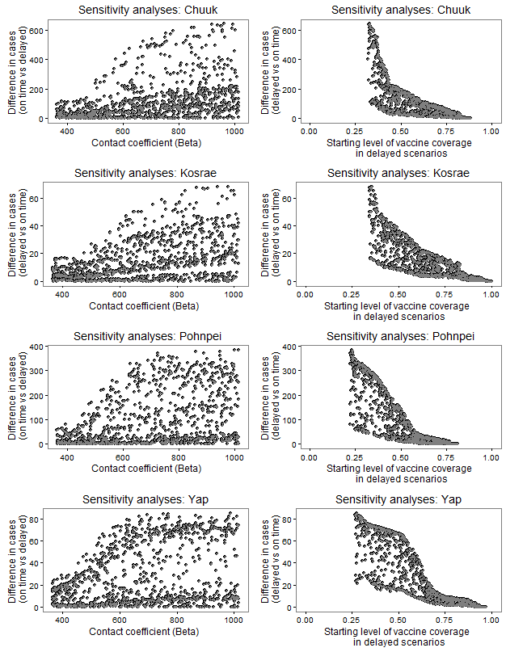

TABLE A-1. Estimated on time coverage, median age at vaccination, and maximum delay of fourth dose of diphtheria and tetanus toxoids and acellular pertussis (DTaP4) vaccine, and first dose of measles, mumps and rubella vaccine (MMR1), among children 24-35 months, stratified by place of residence for two states of the Federated States of Micronesia.
State | Place of residence | Population estimate | DTAP4 |  |  |  | MMR1
 |  |  | Total coverage* | On time coverage† | Median age at vaccination (months) | Maximum delay§ (months) | Total coverage* | On time coverage† | Median age at vaccination (months) | Maximum  delay§ (months)
Chuuk | Outer islands¶ | 996 | 29.6% | 1.5% | 21 | 21 | 88.6% | 18.7% | 14 | 20
 | Main island** | 230 | 61.7% | 10.4% | 16 | 20 | 87.4% | 31.7% | 13 | 18
Yap | Outer islands†† | 122 | 82.8% | 10.7% | 24 | 21 | 96.7% | 28.7% | 14 | 11
 | Main island§§ | 112 | 93.8% | 37.5% | 14 | 23 | 97.3% | 60.7% | 12 | 14
*Total coverage is a measure of doses received by end of follow-up.
†On time coverage is a measure of doses administered from 4 days before the age of 12 months through the end of the 12th month of age.
§Maximum delay is a measure of the difference in months from the recommended age to the age at which total coverage is reached, according to the Kaplan-Meier curves.
¶Includes all islands in Chuuk state, except Weno Island.
**Weno Island
††Includes all islands in Yap state, except Yap Island.
§§Yap Island

