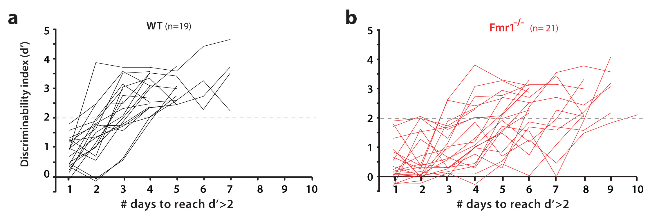
Supplementary Figure 1

Behavioral performance on visual discrimination task according to genotype (corresponds to data in Fig. 1d, e).
a, b. Discriminability index (d’) for WT (a, black) and Fmr1^{-/-} mice (b, red). Each line represents a different mouse. The horizontal dashed line indicates a d’ = 2, which corresponds to 90% correct rejections.
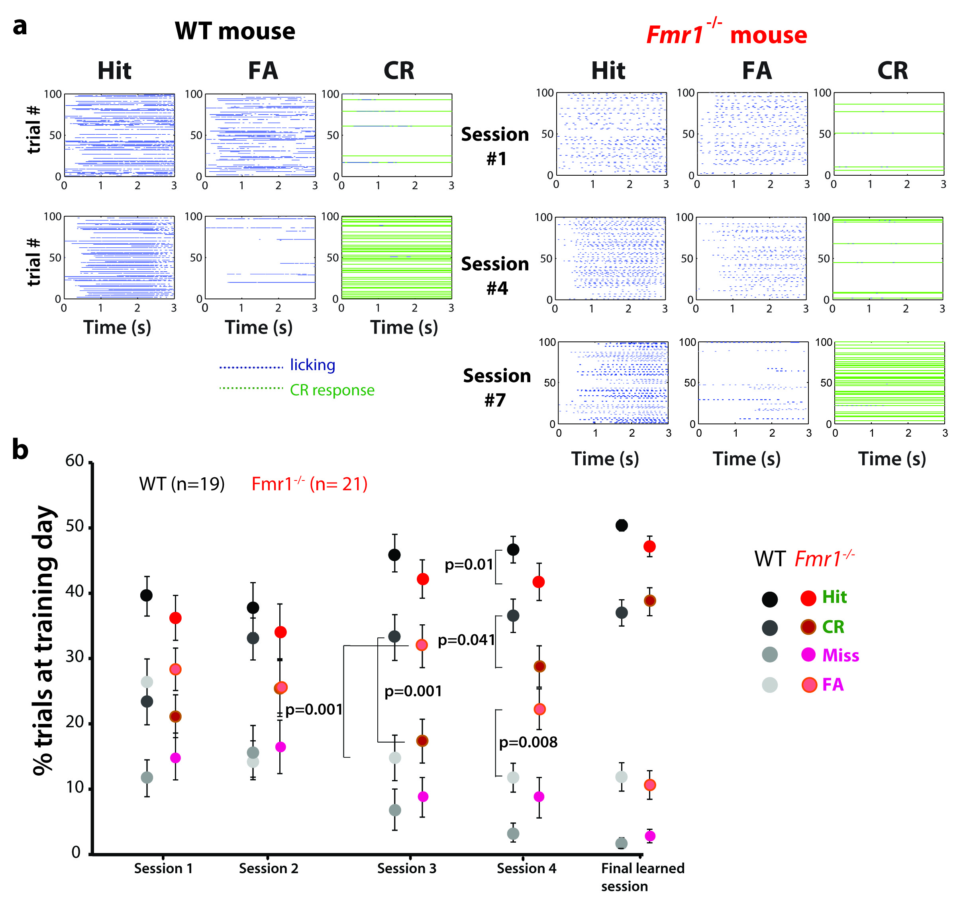
Supplementary Figure 2

Fmr1^{-/-} mice are delayed in suppressing the ‘No-Go’ response (corresponds to data in Fig. 1e).
a. Sample behavioral data for a representative WT mouse (top) and Fmr1^{-/-} mouse (bottom) over 100 trials in session #1 vs. Session #4. Only ‘Hit’, ‘false alarm’ (FA) and ‘correct rejection (CR) responses are shown. Note how the WT animal is able to suppress the FA responses and increase the proportion of CR responses by session #4, whereas there is virtually no change in response characteristics for the Fmr1^{-/-} animal between session #1 and session #4. However, by the learned session (session #7), the Fmr1^{-/-} mouse has suppressed its FA responses.
b. Profile of proportion of Hit, CR, FA and Miss responses over the course of training. Hit: F_{4,156}= 1.05, p= 0.03, CR: F_{4,156}= 2.29, p= 0.1 x 10⁻³; Miss: F_{4,156}= 2.99, p= 0.5 x 10⁻⁵; FA: F_{4,156}= 2.53, p= 0.4 x 10⁻⁵; Friedman test with repeated measures on training. Two-sided Mann-Whitney tests (genotypes), p-values shown on the Figure.
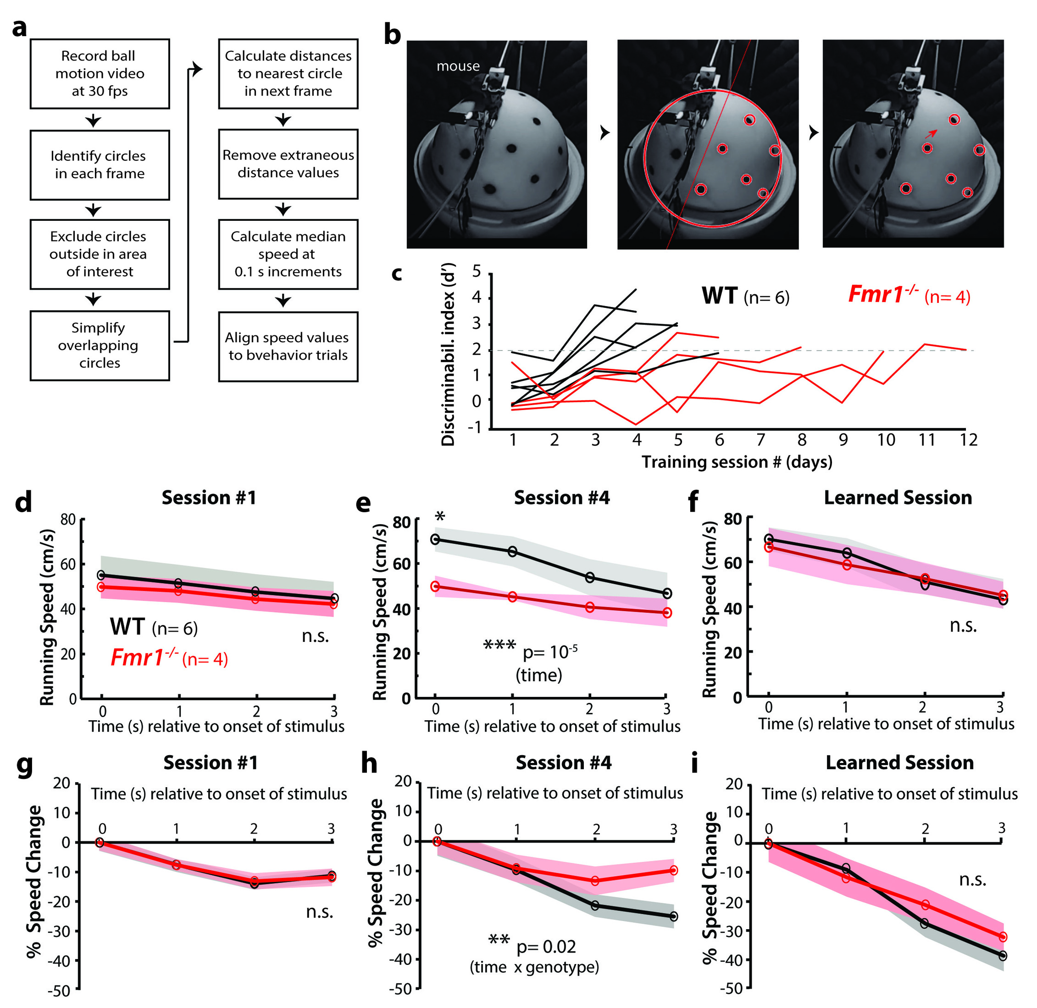
Supplementary Figure 3
Fmr1^{-/-} mice do not slow down as much as WT mice during preferred stimuli (Hit responses) (corresponds to data Fig. 1e, f).
a. Workflow for ball motion analysis
b. Analysis of ball motion was done with semi-automated, custom MATLAB scripts to detect black dots painted evenly onto the polystyrene ball.
c. Discriminability index for a subset of the mice shown in Fig. 1d in which we recorded running speed.
d-f. Overall running speed (as determined by ball motion analysis) in WT and Fmr1^{-/-} mice at session #1 (d), session #4 (e) and final learned session (f) for Hit + Miss trials only (corresponding to preferred stimuli). We observed a significant difference in the degree to which WT and Fmr1^{-/-} mice slow down at session #4, but not in the final learned session. Repeated measures ANOVA F_{2,16}=5.49, p=2 X 10⁻⁵. Note there is no significant genotype differences in running speed in session 1 or in the final learned session.
g-i. Change in running speed (as above). F_{2,16}=2.13, p=0.02
Shaded area in panels d-i indicate s.e.m.
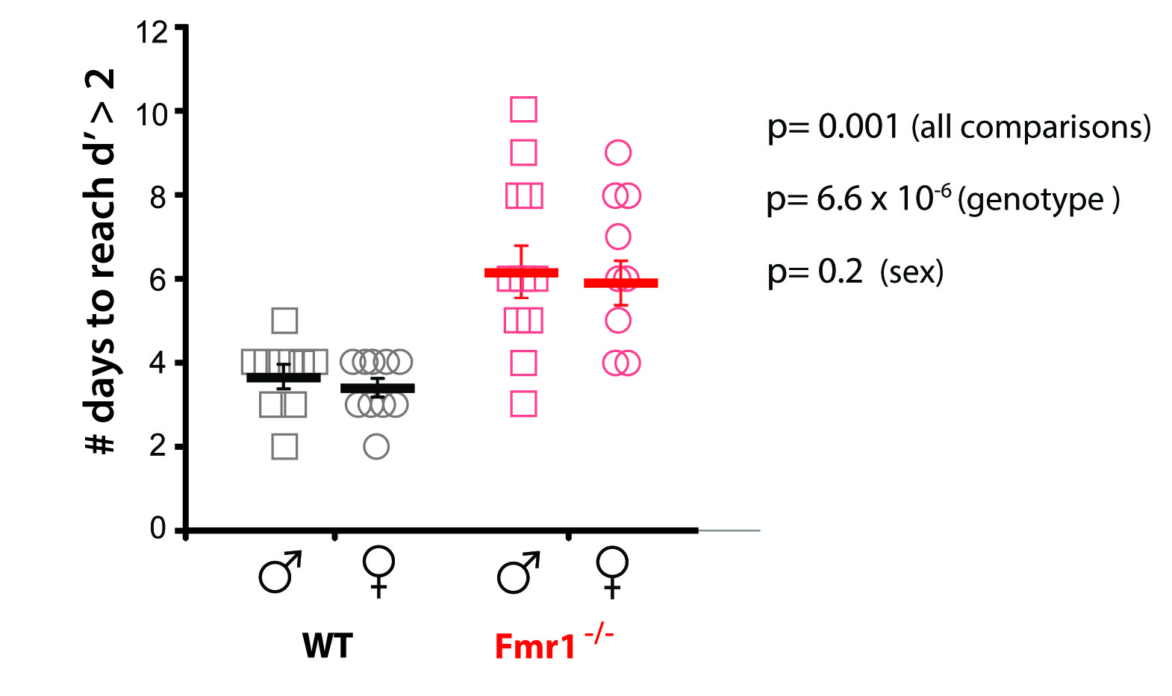
Supplementary Figure 4
No sex differences in task performance (corresponds to data in Fig. 1d)
There were no significant differences in task performance between n=mice, male (n= 22) and female mice (n= 18) of either genotype. χ²_{3,37}=11.7, p= 0.001, Kruskal-Wallis test (all comparisons); effect of sex: p= 0.20, two-sided Mann-Whitney; effect of genotype: p= 6.6 x 10⁻⁶, two-sided Mann-Whitney. Horizontal bars indicate mean and error bars indicate s.e.m.
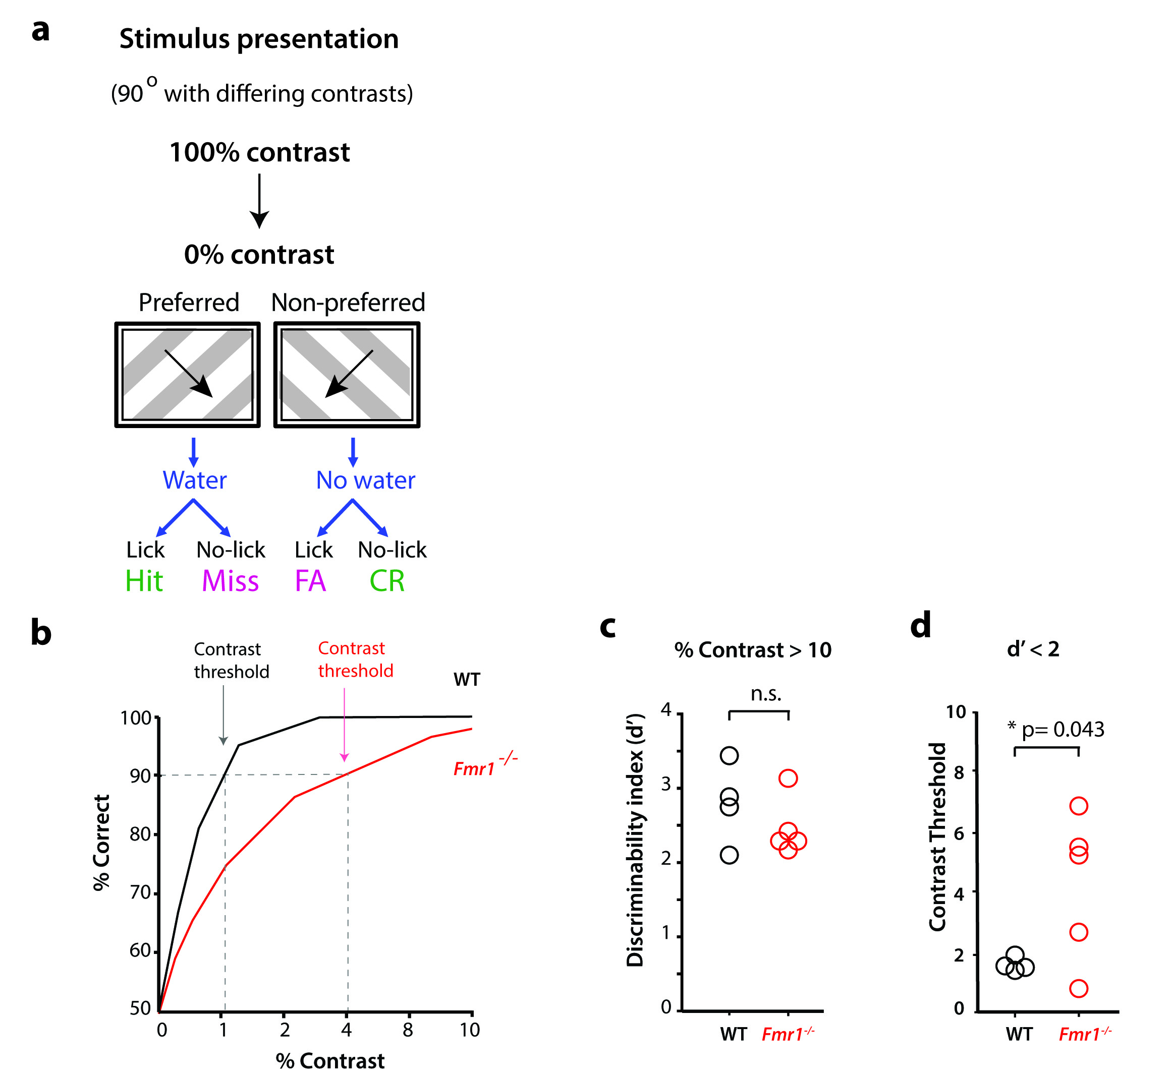
Supplementary Figure 5
No deficits in task performance above >10% contrast (corresponds to data in Fig. 1)
a. To investigate whether Fmr1^{-/-} mice have impairments in basic visual discrimination, we randomly presented drifting gratings of varying contrast, from 0% to 100%, and tested mice of both genotypes that had already reached a d’ > 2 at 100% contrast on the visual discrimination task with 90º as the angle difference between preferred and non-preferred directions.
b. Representative cumulative histograms of % correct responses from a WT and a Fmr1^{-/-} mouse at different contrasts (data in panels b-d is for mice after they learned the basic 90º task).
c. There were no significant differences in task performance between WT and Fmr1^{-/-} mice when the contrast for gratings was >10%. p=0.6, Two-sided Mann-Whitney test .n=mice, Fmr1^{-/-}(5), WT (4).
d. Mice that had learned the task at 100% contrast then performed poorly (d’ < 2) below a certain contrast threshold and Fmr1^{-/-} mice had a higher contrast threshold than WT mice.
n=mice, Fmr1^{-/-}(5), WT (4). p=0.043, Two-sided Mann-Whitney test
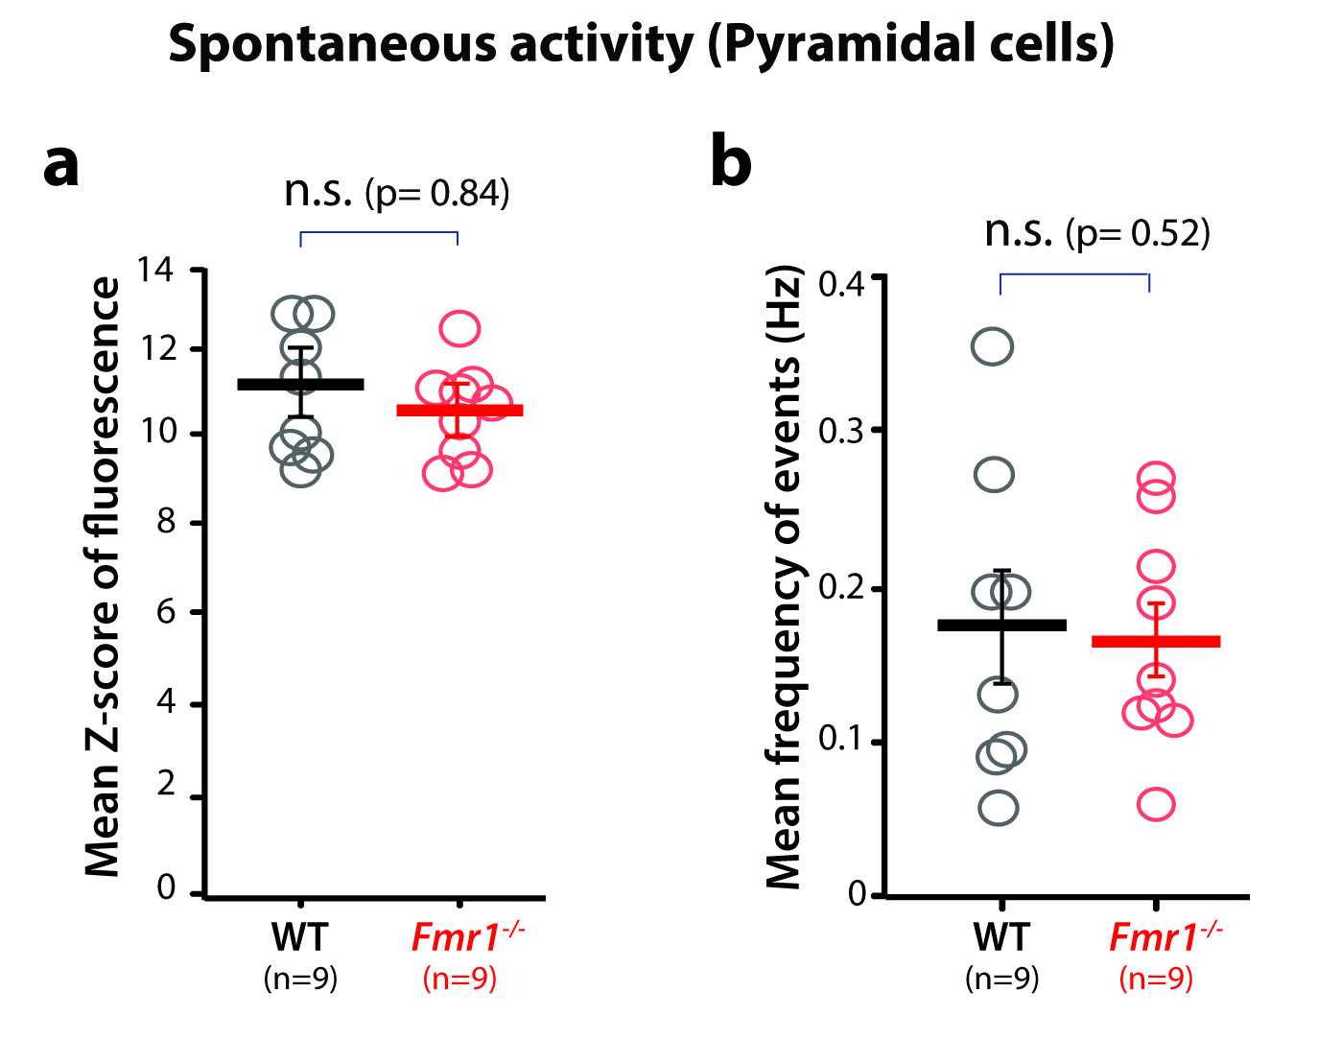
Supplementary Figure 6
Calcium imaging of spontaneous activity in pyramidal neurons† in V1 (corresponds to data in Fig. 3)
a. There was no significant difference in the amplitude of the calcium signals (as assessed with the mean Z-score of fluorescence) of pyramidal neurons in L2/3 of V1 cortex between WT and Fmr1^{-/-} mice during recordings of spontaneous activity. Unpaired two-tailed Student’s t-test for panels a-b. In both panels horizontal bars indicate the mean and error bars indicate s.e.m.
b. There was no significant difference in the frequency of peaks of calcium fluorescence of pyramidal neurons in L2/3 of V1 cortex between WT and Fmr1^{-/-} mice during recordings of spontaneous activity.

† In this legend, the term “pyramidal” refers to all cells recorded using GCaMP6s, the vast majority of which are pyramidal neurons.
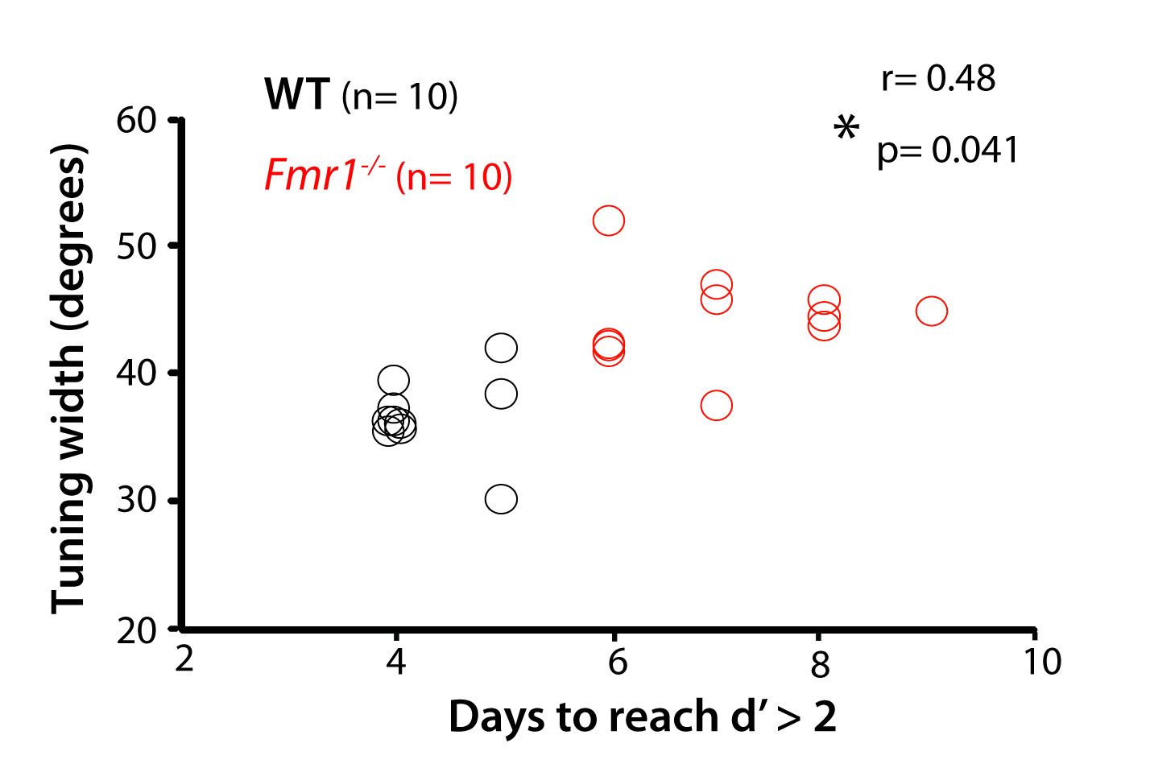
Supplementary Figure 7
The tuning width of pyramidal neurons correlates with task performance (corresponds to data in Fig. 3h)
The performance of mice on the visual discrimination task correlates with the tuning width of pyramidal neurons, r= 0.48, p= 0.041. Pearson’s correlation
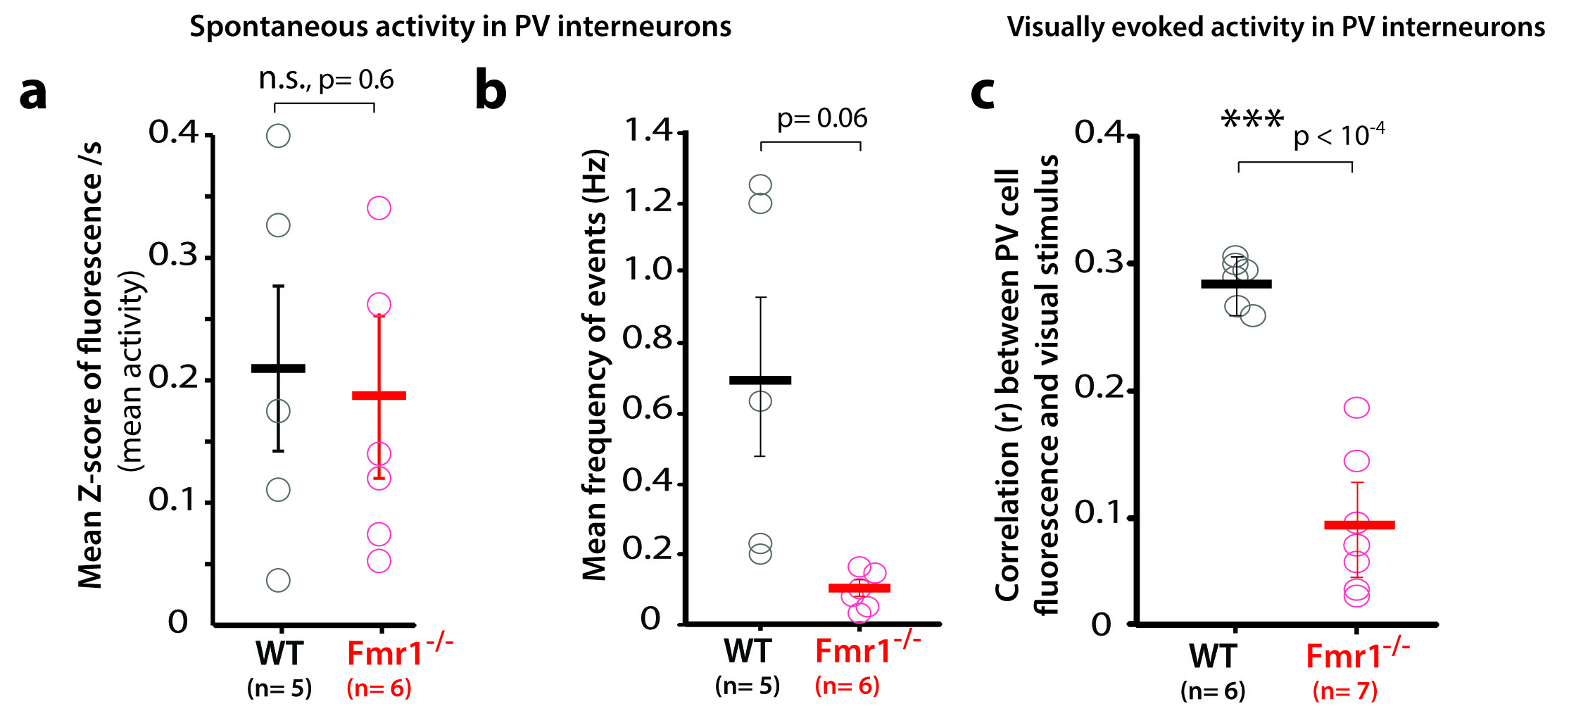
Supplementary Figure 8
Calcium imaging of spontaneous activity in PV neurons in V1 (corresponds to data in Fig. 4)
a. There was no significant difference in the overall frequency of calcium transients (as measured by the mean fluorescence Z-scores per s) of PV neurons in L2/3 between WT and Fmr1-/- mice during recordings of spontaneous activity in V1 (unpaired two-tailed Student’s t-test). n=mice. Fmr1^{-/-}(5), WT (6).
b. There was a non-significant trend for lower frequency of peaks of calcium fluorescence of PV neurons in L2/3 of Fmr1^{-/-} mice compared to WT mice, during recordings of spontaneous activity in V1 (two-sided Mann-Whitney test). n=mice. Fmr1^{-/-}(5), WT (6).
c. Fmr1^{-/-} mice showed a significantly lower correlation between the activity of PV cells (as assessed by their fluorescence calcium signals) and the epochs of visual stimulation, compared to WT mice, p=0.0005 (two-sided Mann-Whitney test). n=mice. Fmr1^{-/-}(6), WT (7).
In all 3 panels horizontal bars indicate the mean and error bars indicate s.e.m.
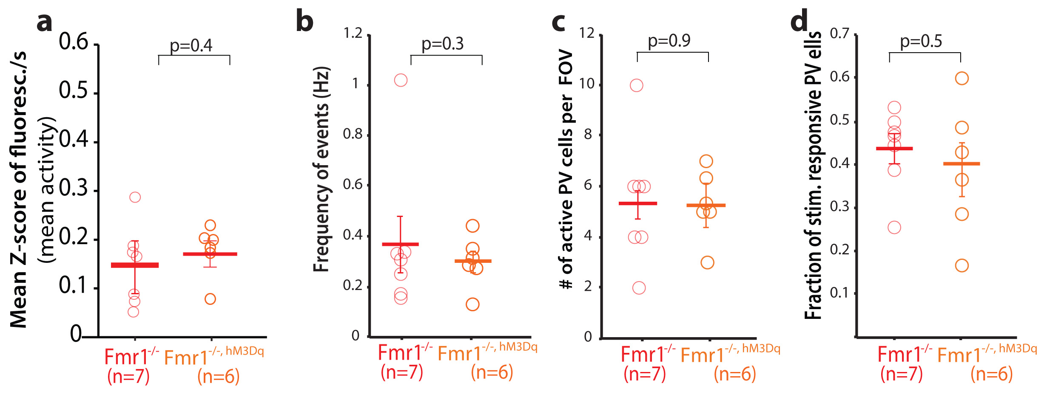
Supplementary Figure 9
Controls for DREADD experiments (corresponds to data in Fig. 5)
a-d. DREADD expression does not alter activity of PV cells, as we observed no differences in visual evoked calcium transients (as measured by the mean fluorescence Z-scores per s) (a)
or frequency of visually evoked peaks of activity (b) or in the number of active PV cells (c), or the fraction of PV cells that responded to visual stimuli (d) between Fmr1-/- mice and Fmr1-/-, hM3Dq mice (before CNO administration).
Two-sided Mann-Whitney test for panels a-b and unpaired two-tailed student’s t-test for panels c-d.
In all the panels horizontal bars indicate the mean and error bars indicate s.e.m.
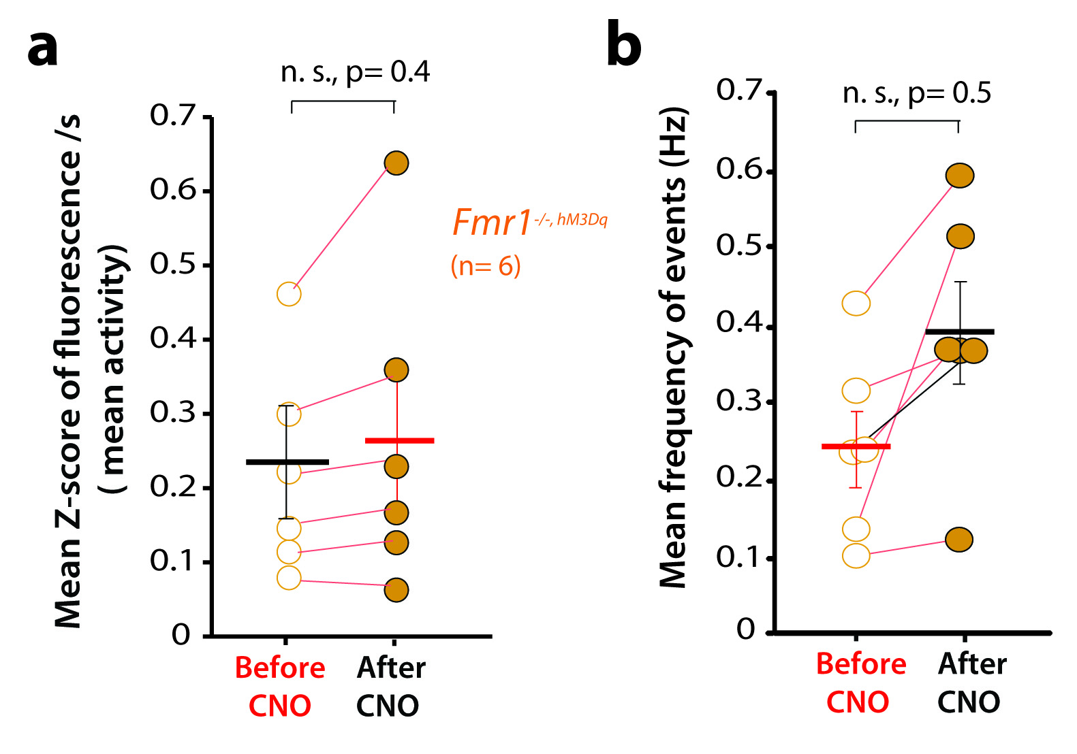
Supplementary Figure 10
No significant effect of hM3Dq and CNO on spontaneous PV cell activity (corresponds to data in Fig. 5 a-e)
a,b. In PV-Cre x Fmr1-/- mice injected with the hM3Dq DREADD virus in V1, CNO injection led to no significant changes in either the overall frequency of calcium transients (as measured by the mean fluorescence Z-scores per s) or the frequency of calcium peaks for PV cells. n=mice, Fmr1^{-/-, HM3Dq} (before and after CNO) (6). Unpaired two-tailed student’s t-test.
In both panels horizontal bars indicate the mean and error bars indicate s.e.m.
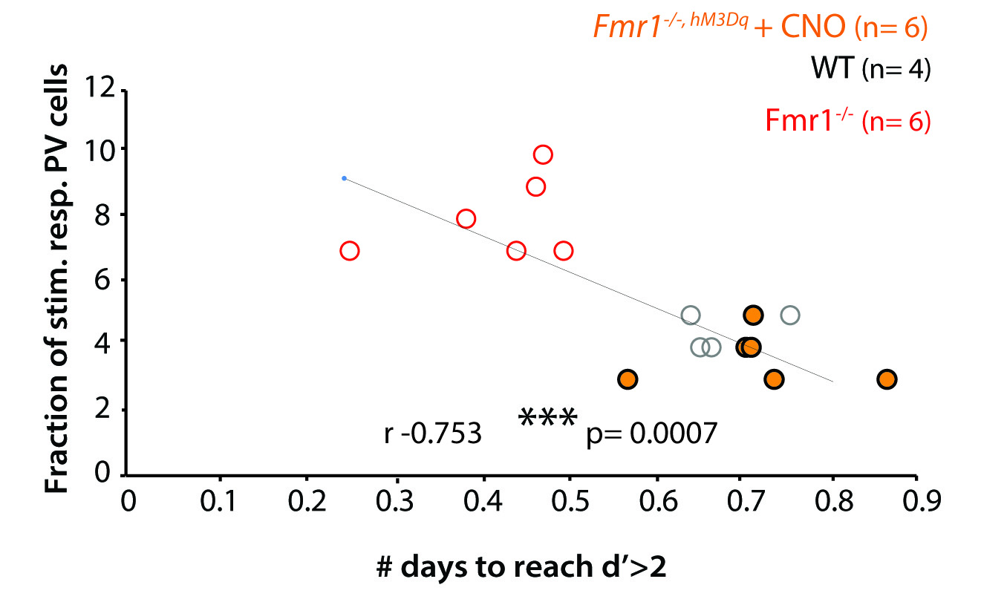
Supplementary Figure 11
Correlation between task performance and PV cells (corresponds to data in Fig. 5)
There is a strong inverse correlation between task performance (days to reach d’>2) and the fraction of stimulus-responsive PV cells in V1, r -0.753, p= 0.0007. Pearson’s correlation.

