Additional file 1
Use of menstrual cups among school girls: longitudinal observations nested in a randomised controlled feasibility study in rural western Kenya

Figure S1. Image of mooncup
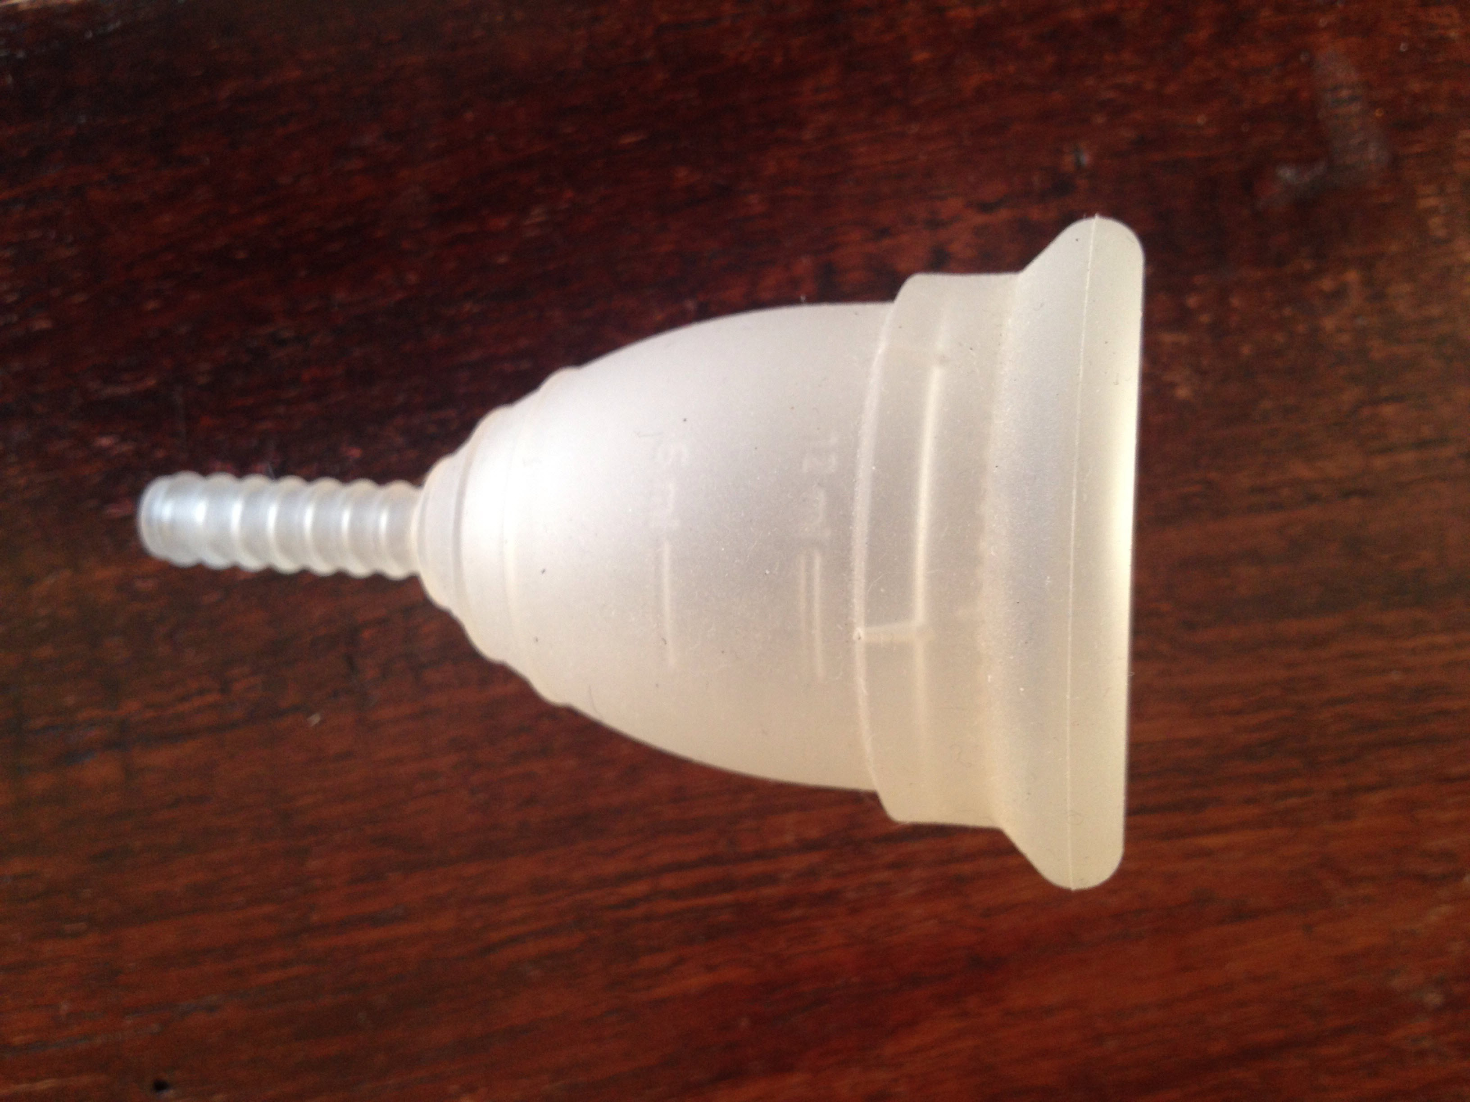

Figure S2. Use of menstrual cup by self-report, colour change, or presence of clipped tail per study year quarter, Western Kenya, 2012-2013

Note: If more than one nurse visit was made in the 3-month period, only information from the last visit was included

Figure S3. Observed and reported menstrual cup hygiene among school girls, western Kenya

*Observed by nurses during menstrual cup screening visits
†Before and after emptying of the menstrual cup

Figure S4. Menstrual cup use by verbal report at first report of cup colour change or at last nurse visit if no colour change, and as assessed by cup colour change by school, Western Kenya, 2012-2013

* Verbal response at the time of first report of cup colour change or at the last nurse assessment visit if the cup colour change did not occur; chi-square test comparing cup colour change among schools: p<0.001, chi-square test comparing verbal response among schools: p=0.184.

Table S1. Monitoring of menstrual cup use
During the monitoring visits to the nurse, girls in the menstrual cup arm were asked specific questions on their cup use, if they dropped it, shared use with another person, and how they cleaned it. Girls were required to bring in their cup (barring current use) for physical examination at each visit, summarised below.
Look | Describe | Ask
What colour is the menstrual cup? | Clear/white, pink, yellow, green | Anything else
General wear and tear | None, small from use, damaged | Why damaged
Is the rim structure damaged? | Complete, small split, large split | Why split
Is the cup structure damaged? | Complete, cracked, hole/s | Why damaged
Is the tail length corrected? | Long (untrimmed), medium, short, none | Trimming issues
Is the tail structure damaged? | End smooth, end ragged/split | Why damaged
Is there detritus (faeces, paper)? | No deposits, grainy deposits, thick deposits | Describe
Smell | None, blood, other | Describe other

Table S2. Examples of complaints and issues reported to the nurses on menstrual cup use by school girls, Western Kenya
Complaint or issue
It is challenging inserting and removing the cup during the initial states
Painful during insertion
Some girls found it disgusting especially when removing and emptying the cup when the water is not available or limited.
Some parents/guardian did not allow their girls to use mooncup (e.g. some had the misconception that use of the menstrual cup will make girls urge for sex
Some girls felt embarrassed to boil the cup and it was challenging to find an item (e.g. tin) for boiling the cup.
Some girls felt uncomfortable when using mooncup
Some girls complained of unhygienic latrines and lack of proper structures in school latrines; (unlockable latrine doors hence girls forced to hold onto doors while in the latrines.)
Where do we empty the menstrual cup for homes without latrines
Spillage of blood during removal (Spillage of blood during removal was asked by our participants and the experienced peer-group girls demonstrated the angle at which it should be removed to avoid spillage).
What do I use in case it falls on the latrine floor as am changing?
Mine is leaking even when it is not full
What if there is no water in the school how do I clean my hands after changing

Table S3. Factors associated with a verbal report of cup use during the study period among school girls in Western Kenya
Characteristic | No of visits (N=849) | verbal report of cupuse (% of category) | p-value (χ²-test) | Risk ratio, 95% CI*  Univariate analysis | p-value
Class at time of enrolment
5 or 6 | 282 | 255 (90.4) | 0.276 | 1.00, 0.97-1.04 | 0.846
7 or 8 | 567 | 525 (92.6) |  | Reference
Age at enrolment (years)
14 | 438 | 407 (92.9) | 0.168 | Reference
15 | 328 | 301 (91.8) |  | 0.69, 0.39-1.24 | 0.216
16 | 83 | 72 (86.8) |  | 0.54, 0.21-1.37 | 0.192
Socioeconomic status household of girls
Poorest 2 quintiles | 79 | 74 (93.7) | 0.640 | Reference
Higher 3 quintiles | 627 | 577 (92.0) |  | 1.17, 0.45-3.08 | 0.744
No information | 143 | 129 (90.2) |  | 1.34, 0.44-4.08 | 0.610
Material used for menstruation before enrolment
Used some pads | 96 | 85 (88.5) | 0.205 | 0.80, 0.44-1.44 | 0.449
Cloth/other | 753 | 695 (92.3) |  | Reference
Time since menarche (enrolment)
< 1 year | 232 | 224 (96.6) | 0.002 | 2.03, 1.04-3.94 | 0.037
≥ 1 year | 617 | 556 (90.1) |  | Reference
Enrolment year
2012 | 611 | 570 (93.3) | 0.015 | Reference | 0.060
2013 | 238 | 210 (88.2) |  | 0.96, 0.92-1.00
Enrolled before/after peer education
Before | 494 | 456 (92.3) | 0.584 | Reference | 0.263
After | 355 | 324 (91.3) |  | 0.70, 0.38-1.30
Follow up time at time of visit
<3 months | 208 | 174 (83.7) | <0.001 | 0.38, 0.19-0.79 | 0.010
3-<6 months | 229 | 217 (94.8) |  | 1.44, 0.59-3.49 | 0.421
6-<9 months | 176 | 171 (97.2) |  | 1.80, 0.65-4.98 | 0.255
9+ months | 236 | 218 (92.4) |  | Reference
School number
1 | 43 | 30 (69.8) | <0.001 | 0.25, 0.09-0.74 | 0.012
2 | 69 | 68 (98.6) |  | 7.30, 0.79-67.46 | 0.080
3 | 51 | 46 (90.2) |  | Reference
4 | 133 | 122 (91.7) |  | 1.21, 0.40-3.64 | 0.737
5 | 93 | 90 (96.8) |  | 3.24, 0.75-13.93 | 0.114
6 | 208 | 203 (97.6) |  | 4.44, 1.15-17.10 | 0.030
7 | 79 | 79 (100.0)
8 | 63 | 43 (68.3) |  | 0.23, 0.08-0.69 | 0.008
9 | 79 | 72 (91.1) |  | 1.12, 0.37-3.34 | 0.841
10 | 31 | 27 (87.1) |  | 0.74, 0.25-2.15 | 0.576
* Generalized estimating equations with a logit link and exchangeable correlation. All models were adjusted for school. Factors examined but not significant: Socioeconomic status of the school catchment area, age at menarche, days of bleeding, amount of bleeding and cramps when menstruating. Multivariate models could not be conducted because models would not converge.

Table S4. Factors associated with the presence of cup colour change during the study period among school girls in Western Kenya
Characteristic | Prevalence  N=192  (% of sample size) | Uptake of cup (% of category) | p-value (χ²-test) | Risk ratio, 95% CI*  Univariate analysis | p-value | Adjusted Risk ratio, 95% CI*  Multivariate analysis | p-value
Class at time of enrolment
5 or 6 | 61 (31.8) | 42 (68.9) | 0.680 | 0.96, 0.78-1.18 | 0.698
7 or 8 | 131 (68.2) | 91 (71.8) |  | Reference
Age at enrolment (years)
14 | 93 (48.4) | 68 (73.1) | 0.437 | Reference
15 | 80 (41.7) | 53 (66.3) |  | 0.91, 0.76-1.07 | 0.255
16 | 19 (9.9) | 15 (79.0) |  | 1.08, 0.70-1.65 | 0.725
Socioeconomic status household of girls
Poorest 2 quintiles | 22 (11.5) | 14 (63.6) | 0.672 | 0.93, 0.58-1.48 | 0.745
Higher 3 quintiles | 138 (71.9) | 100 (72.5) |  | 1.05, 0.83-1.34 | 0.669
No information | 32 (16.7) | 22 (68.8) |  | Reference
Material used for menstruation before enrolment
Used some pads | 169 (88.0) | 120 (71.0) | 0.887 | Reference
Cloth/other | 23 (12.0) | 16 (69.6) |  | 0.98, 0.77-1.24 | 0.866
Time since menarche (enrolment)
< 1 year | 51 (26.6) | 43 (84.3) | 0.013 | 1.28, 1.05-1.56 | 0.016 | 1.29, 1.04-1.60 | 0.023
≥ 1 year | 141 (73.4) | 93 (66.0) |  | Reference
Enrolment year
2012 | 126 (65.6) | 89 (70.6) | 0.933 | Reference
2013 | 66 (34.4) | 47 (71.2) |  | 1.01, 0.82-1.24 | 0.938
Enrolled before/after peer education
Before | 102 (53.1) | 70 (68.6) | 0.474 | Reference | 0.596
After | 90 (46.9) | 73 (73.3) |  | 1.07, 0.84-1.37
Total duration of participation in study
<3 months | 23 (12.0) | 8 (34.8) | <0.001 | 0.43, 0.27-0.68 | <0.001 | 0.63, 0.43-0.93 | 0.019
3-<6 months | 53 (27.6) | 34 (64.2) |  | 0.80, 0.68-0.94 | 0.007 | 1.10, 0.91-1.33 | 0.348
6-<9 months | 35 (18.2) | 29 (82.9) |  | 1.03, 0.89-1.20 | 0.674 | 1.20, 1.01-1.42 | 0.041
9+ months | 81 (42.2) | 65 (80.3) |  | Reference
Number of visits made in study
1-3 visits | 74 (38.5) | 37 (50.0) | <0.001 | 0.60, 0.44-0.81 | 0.001 | 0.63, 0.45-0.88 | 0.007
4+ visits | 118 (61.5) | 99 (83.9) |  | Reference |  | Reference
*Generalized linear regression with a log link and binomial distribution. All models were adjusted for school as a cluster. Factors examined but not significant: Socioeconomic status of the school catchment area, age at menarche, days of bleeding, amount of bleeding and cramps when menstruating.

Table S5. Factors associated with self-report of menstrual cup use among school girls with no cup colour change compared to self-report of cup use among school girls with cup-colour change, Western Kenya
Characteristic | Prevalence  N=181  (% of sample size) | Self report of cup use  and no cup colour change at last visit  N=50 (% in category) | Self report of cup use at time of colour change  N=131 (% in category) | p-value (χ²-test)
Class at time of enrolment
5 or 6 | 57 (6.6) | 18 (31.6) | 39 (68.4) | 0.420
7 or 8 | 124 (24.9) | 32 (25.8) | 92 (74.2)
Age at enrolment (years)
14 | 91 (50.3) | 24 (26.4) | 67 (73.6) | 0.564
15 | 74 (40.9) | 23 (31.1) | 51 (68.9)
16 | 16 (8.8) | 3 (18.8) | 13 (81.3)
Socioeconomic status household of girls
Poorest 2 quintiles | 20 (11.1) | 6 (30.0) | 14 (70.0) | 0.907
Higher 3 quintiles | 131 (72.4) | 35 (26.7) | 96 (73.3)
No information | 30 (16.6) | 9 (30.0) | 21 (70.0)
Time since menarche (enrolment)
< 1 year | 51 (28.2) | 8 (15.7) | 43 (84.3) | 0.024*
≥ 1 year | 130 (71.8) | 42 (32.3) | 88 (67.7)
* Generalized linear regression with a log link and binomial distribution with school as cluster: risk ratio 0.49, 0.29-0.82, p=0.007; girls within their first year of the start of menstruation were less likely to report cup use without colour change compared to girls who started menstruation more than a year ago.

