**Air pollutant strategies to reduce adverse health impacts and health inequalities: a quantitative assessment for Detroit, Michigan.**

Sheena E. Martenies1, Chad W. Milando1, Stuart A. Batterman1,2

1 Department of Environmental Health Sciences

University of Michigan School of Public Health

1415 Washington Heights, Ann Arbor, Michigan, USA

2 Corresponding author

Email: [stuartb@umich.edu](mailto:stuartb@umich.edu)

Phone: +1-734-763-2417

**SUPPLEMENTAL MATERIALS**

**1. FRESH-EST Health Impact Assessment Databases**

The health impact assessment (HIA) methods used in FRESH-EST follow those used by the US EPA when conducting regulatory impact analyses (RIAs, US EPA, 2015) and those used by other health impact assessment studies.

**1.1 Health Impact Functions**

The following describes the health impact functions used in FRESH-EST to estimate attributable health impacts.

The health impact functions (HIF) used in the FRESH-EST HIAs are based on the expression for attributable risk. Health impact functions require four inputs in order to predict the number of attributable cases (Y): the baseline health outcome incidence rate for the exposed population (y0); the concentration-response (CR) coefficient (β) taken from an epidemiological study of the relationship between the pollutant and outcome; the exposure concentration (C); and the “at risk” (exposed) population (P). Multiple forms of the HIF are used depending on the statistical model from which the CR coefficient is drawn. In this analysis, the HIF can take a log-linear form:

*Y*u = y0,u (1 – e – β Cu ) Pu (S1)

or a logistic form:

Yu = y0,u (1 – 1 / { [1 – y0,u] e β Cu + y0,u}) Pu (S2)

where the subscript *u* denotes the spatial unit. The total number of attributable cases is the sum of attributable cases in each spatial unit across the entire study area.

The following section describes the health and population data needed for the health impact calculations.

**1.2 Baseline health outcome rates**

For this analysis, outcomes were included when there was sufficient evidence of a causal relationship, based on the determination by the US EPA in the most recent Integrated Science Assessment (ISA) for sulfur dioxide (US EPA, 2008). US EPA is currently updating the SO2 ISA, and the draft ISA was reviewed for additional relevant health outcomes.

SO2-related health outcomes include hospitalizations for respiratory diseases (asthma and chronic obstructive pulmonary disease, COPD) and asthma-related emergency department visits and symptom days (i.e., exacerbations). Baseline health outcome incidence rates used in this analysis are available at various scales, with ZIP codes being the smallest spatial unit. Asthma and COPD hospitalization rates are available at the ZIP code level and are estimated using incidence data from the Michigan Inpatient Database and population data from the American Community Survey (US Census Bureau, 2014). Rates for ED visits for asthma are available at the ZIP code level for Detroit and the county level outside of Detroit (DeGuire et al., 2016; MDHHS, 2016). Asthma related respiratory symptom day rates (0.421 cases per child with asthma per day) are taken from a cohort study of children with asthma in Detroit (Batterman et al., manuscript in preparation).

**1.3 Concentration-response coefficients**

The CRs used in this study have been taken from studies identified in the ISA for SO2 (US EPA, 2008). The BenMAP User’s Manual (US EPA, 2015) and the epidemiological literature were also reviewed to identify other potential studies for inclusion. (BenMAP is an HIA tool used by the US EPA to conduct HIAs for Regulatory Impact Analyses and other assessments). In addition to the studies summarized by the ISAs, effect estimates from studies conducted in Detroit were also considered, as local studies may better reflect the underlying population risk than studies conducted elsewhere, but can be subject to limitations based on statistical power or study design (Hubbell et al., 2009). This analysis uses a single CR coefficient for each pollutant-outcome pair, although estimates could be pooled across multiple studies (Hubbell et al., 2009). The health outcomes, at-risk populations, and CR coefficients are listed in Supplemental Table 1.

**1.4 Health impact metric inputs**

FRESH-EST uses three health impact metrics: the number of incident cases of mortality or morbidity attributable to pollutant exposure (attributable cases), disability-adjusted life years (DALYs), and monetized impacts. DALYs and monetized impacts are derived from the number of attributable cases. A DALY is the sum of years of life lost (due to premature mortality) and years lived with disability (due to morbidity), and calculations require a disability-weight (DW) and duration (D) for each outcome (Murray, 1994). The morbidity outcomes associated with SO2 use DWs less than one and durations that correspond to the amount of time spent in poor health due to the specific outcome assessed, e.g., the number of days hospitalized for COPD rather than the number of years living with COPD. Monetized values are typically assigned to mortalities based on the value of a statistical life (VSL) and to morbidities based on the cost of illness (COI) or willingness to pay (WTP) estimates of cost (US EPA, 2010). In order to monetize the health impacts, monetary values from the RIA for the most recent particulate matter standard in the US are used (US EPA, 2012). Monetized values are reported in 2010 dollars projected to a 2020 income level. The values used to calculate the DALY and monetized impact metrics are provided in Supplemental Table 2.

**1.5 At-risk populations**

FRESH-EST uses age-stratified estimates of at-risk populations at the block level. Population data at the block level are based on the 2010 Census estimates of total block population (not age stratified) (US Census Bureau, 2015b). In order to stratify the population of each block by age, age distributions at the block group level are determined from population estimates from the 2013 5-Year American Community Survey (US Census Bureau, 2015b) and applied to the block-level populations. The prevalence of asthma among children in Detroit (11.3%) is used to estimate the population with asthma in each census block (DeGuire et al., 2016).

# 2. Sensitivity Analysis

We conduct two sensitivity analyses to examine the influence of spatial scale and resolution on the health impact and inequality metrics. First, to examine spatial resolution, we estimate the health and inequality metrics for the SO2 base case at the ZIP code level, which matches the baseline health incidence rates used in the health impact functions. Second, to examine spatial scale, we again estimate health and inequality metrics for the SO2 base case only for those census blocks that fall within the non-attainment area. In this analysis, most of Detroit’s non-Hispanic black population is excluded.

# 2. Supplemental Figures and Tables

Supplemental Figure 1. Crude baseline health rates for asthma (A) and COPD (B) hospitalizations and asthma emergency department visits (C) used in the health impact assessments. Baseline health rates for asthma exacerbations are not spatially resolved.

A

B

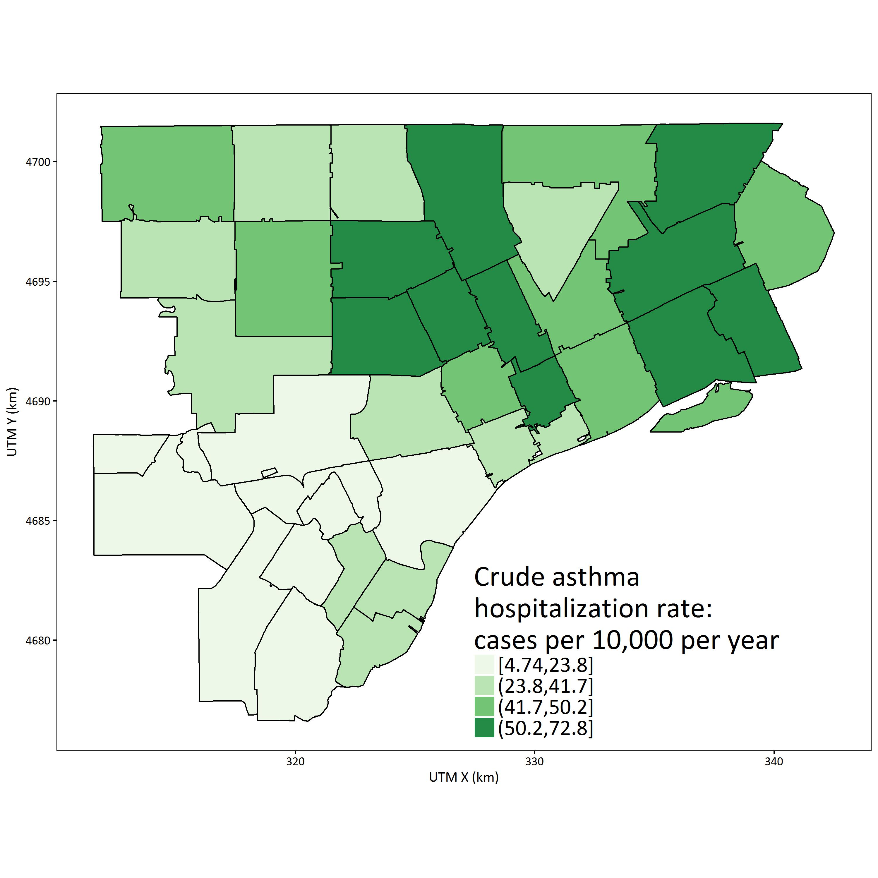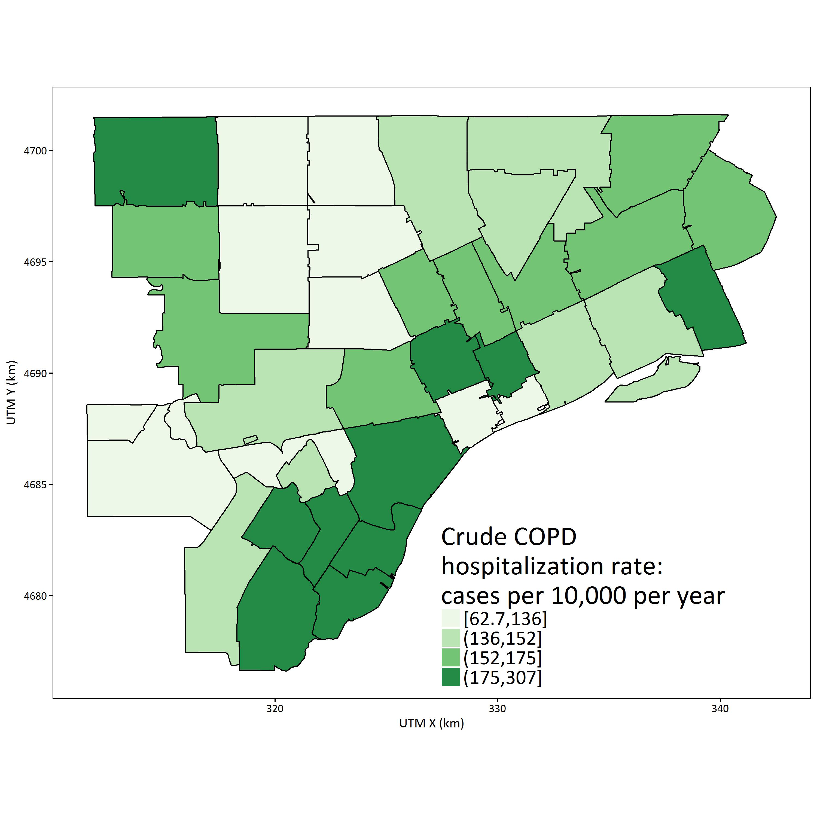

C

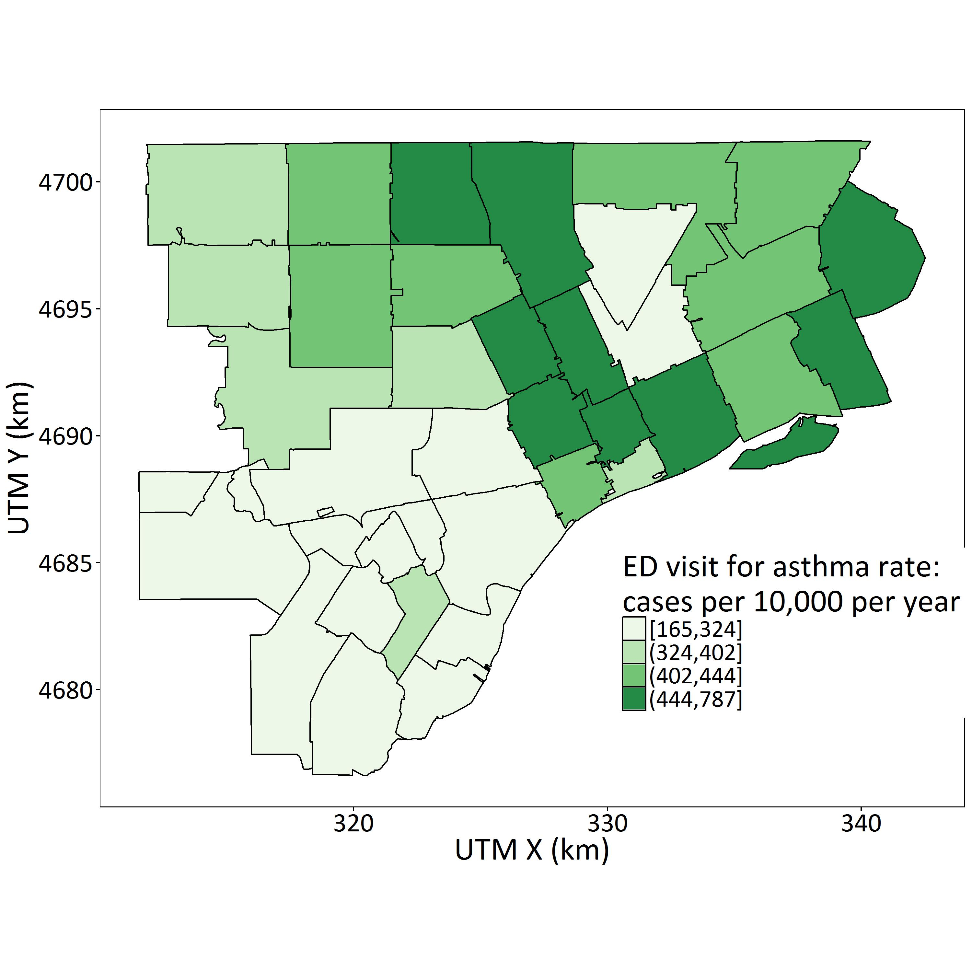

Supplemental Figure 2. Maps showing the spatial distribution of the demographic characteristics used in the concentration index calculations.

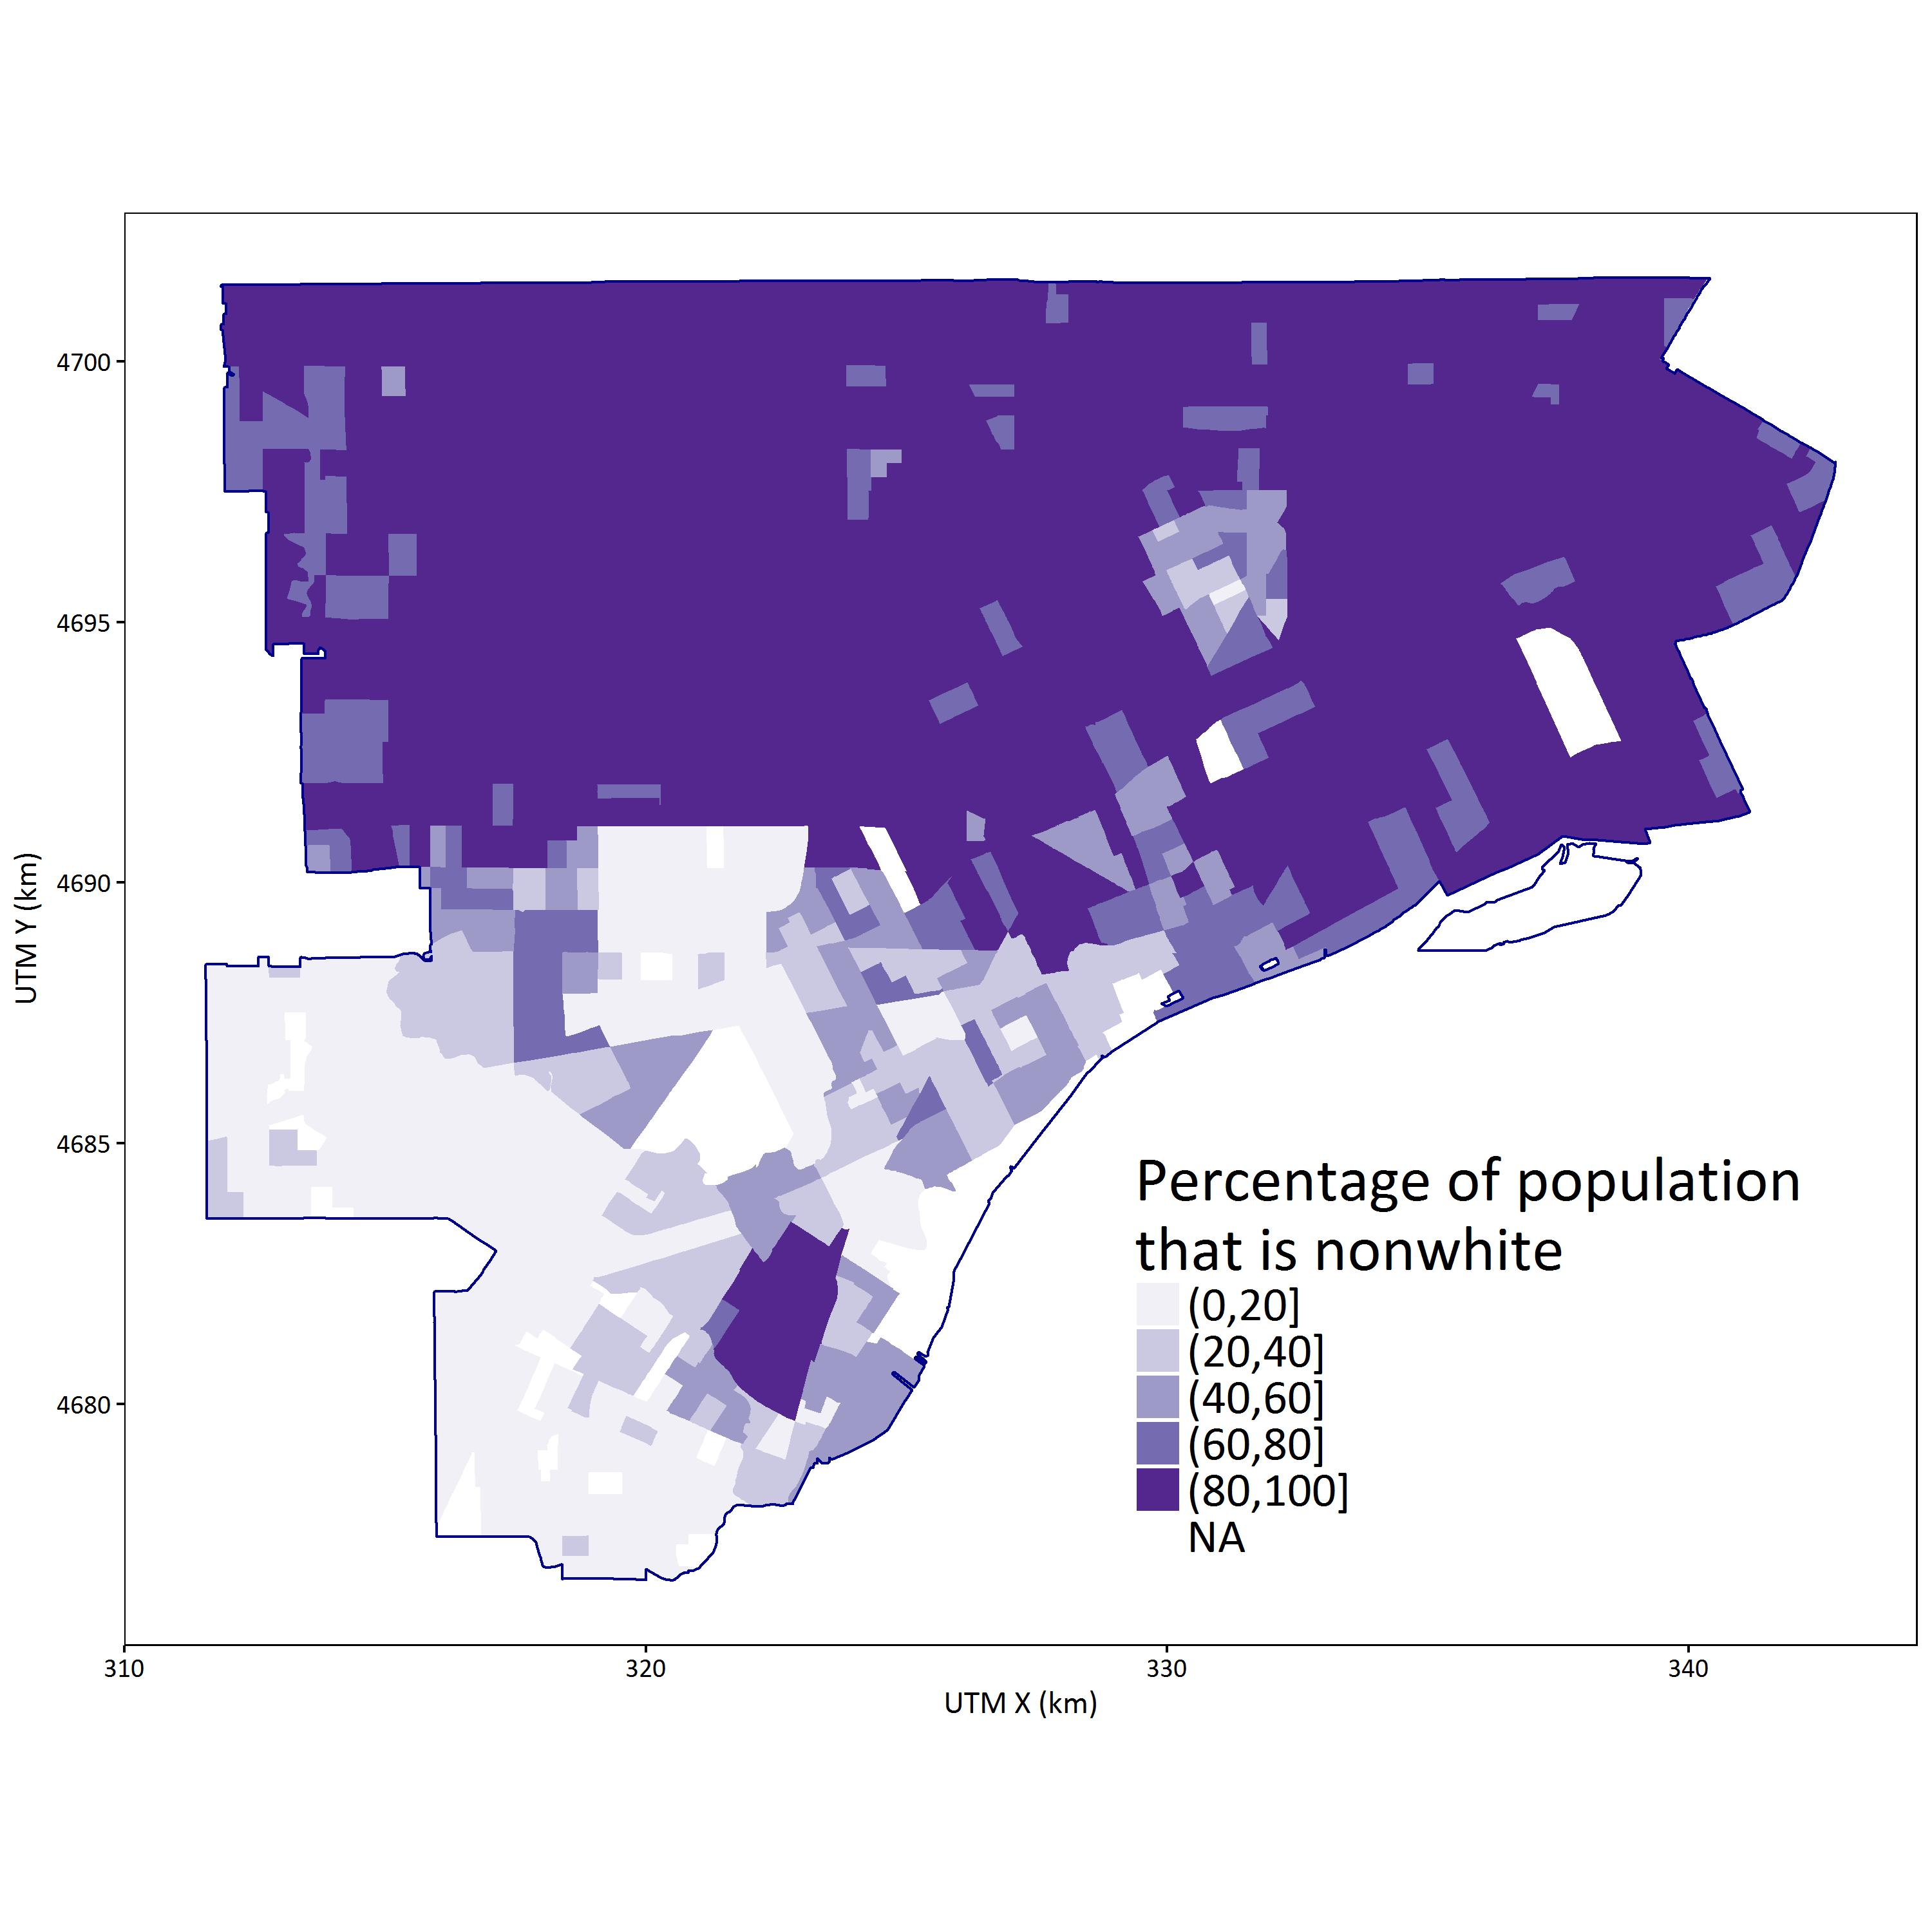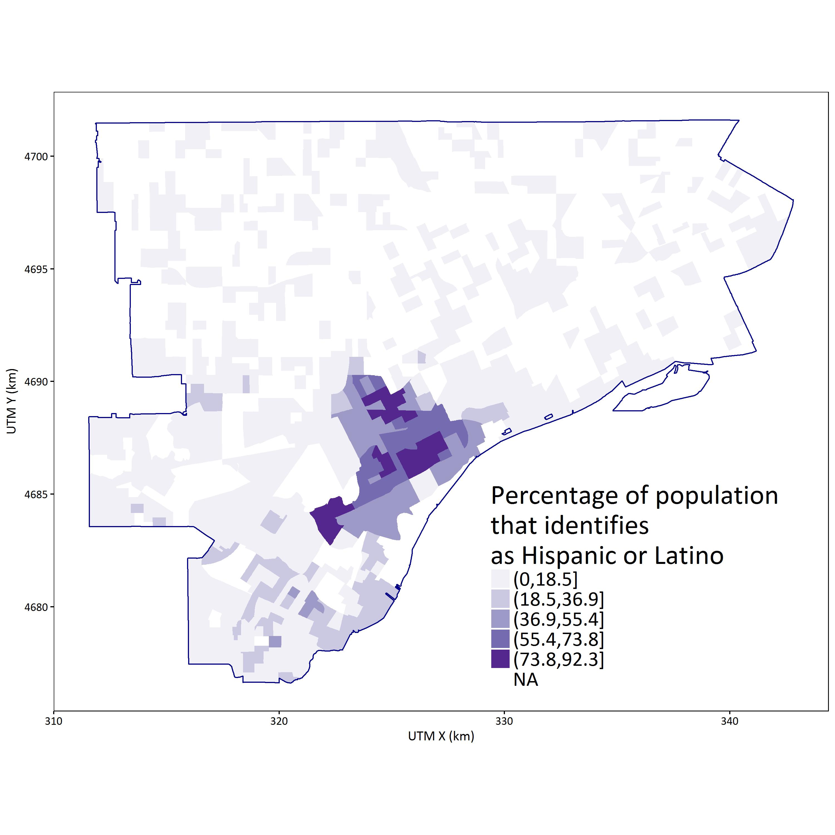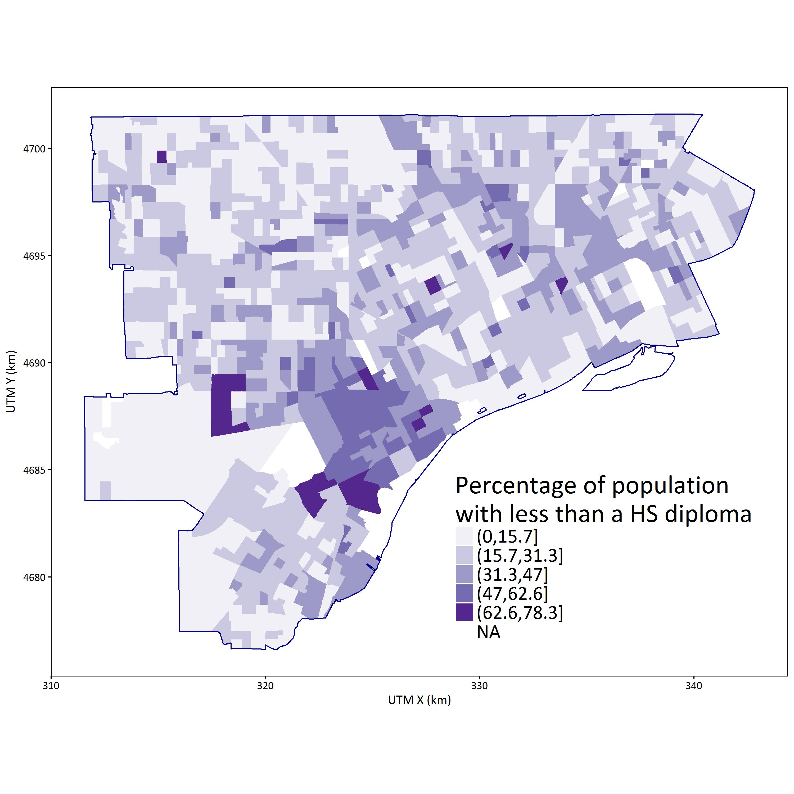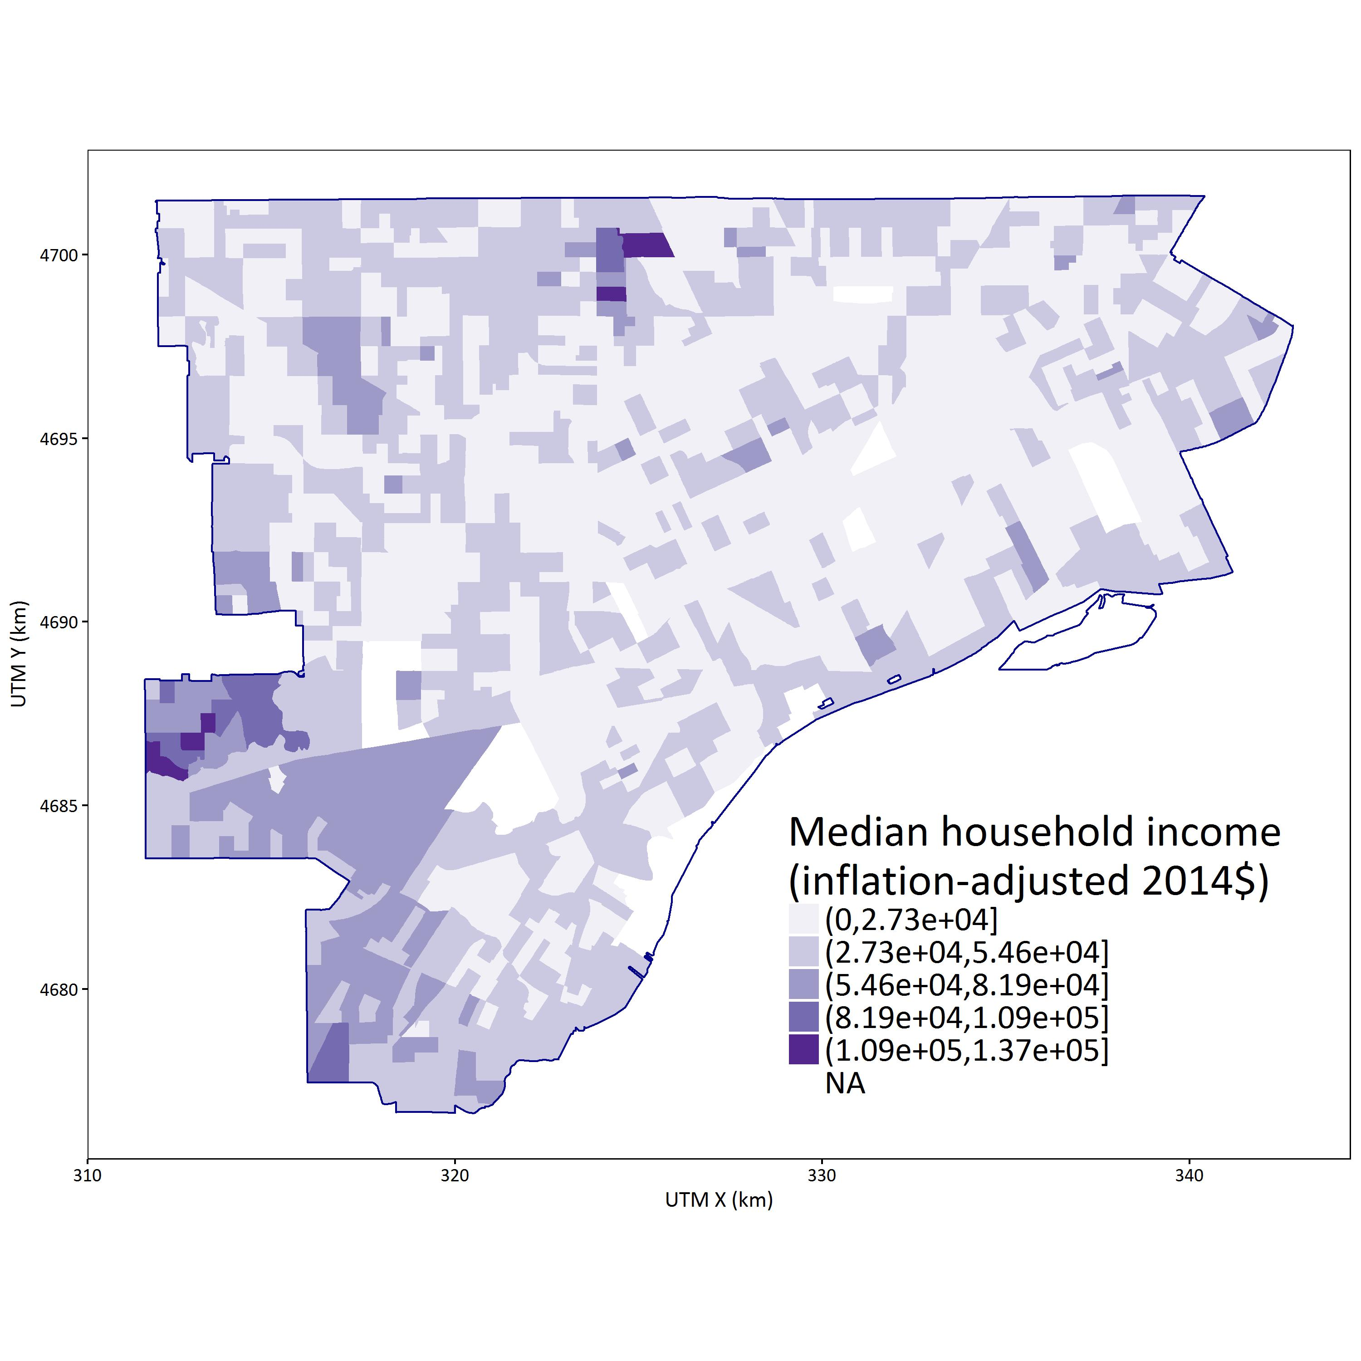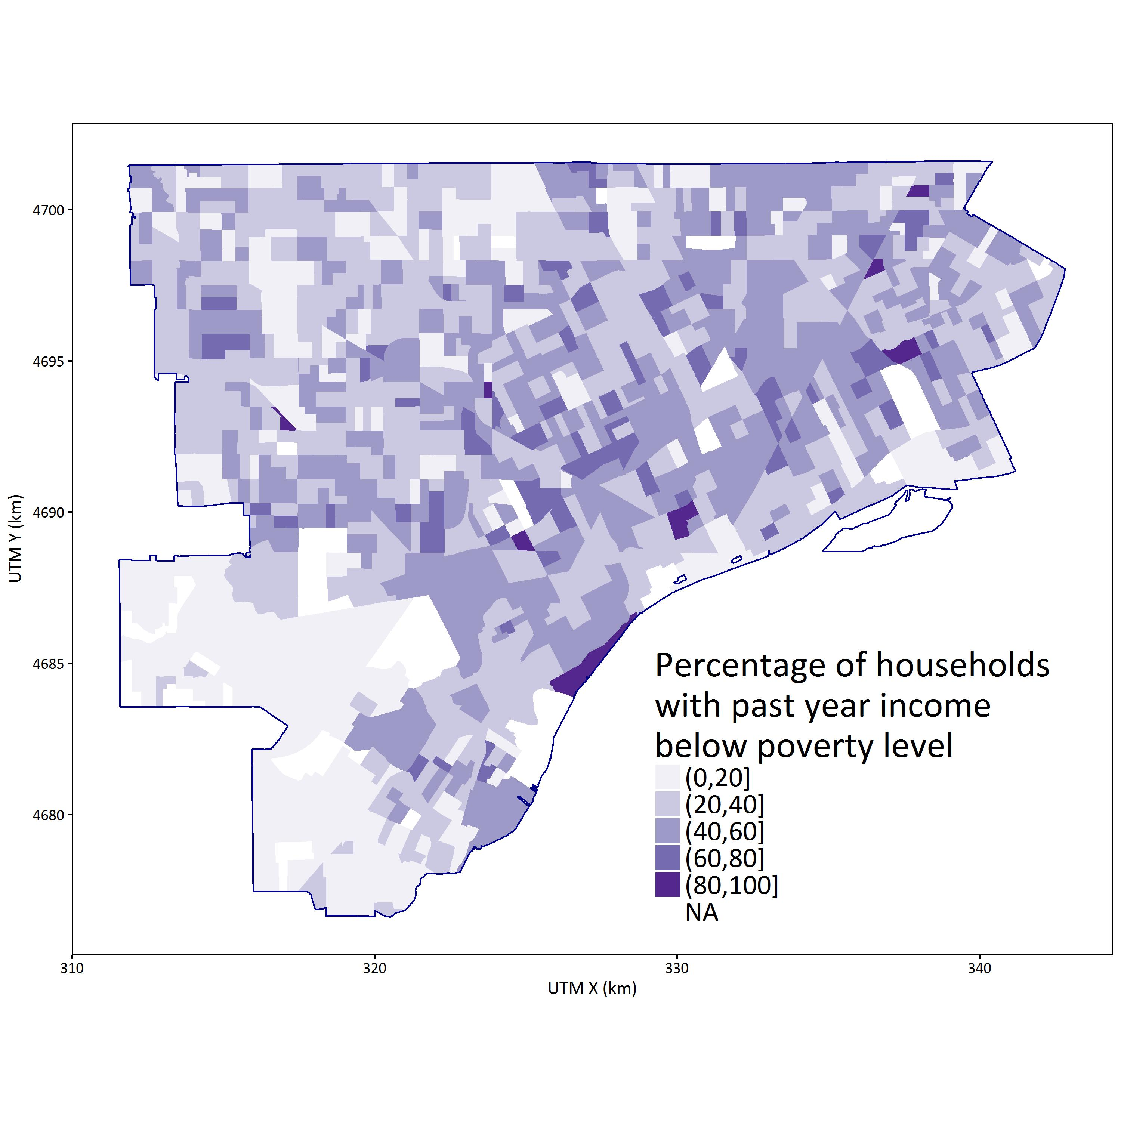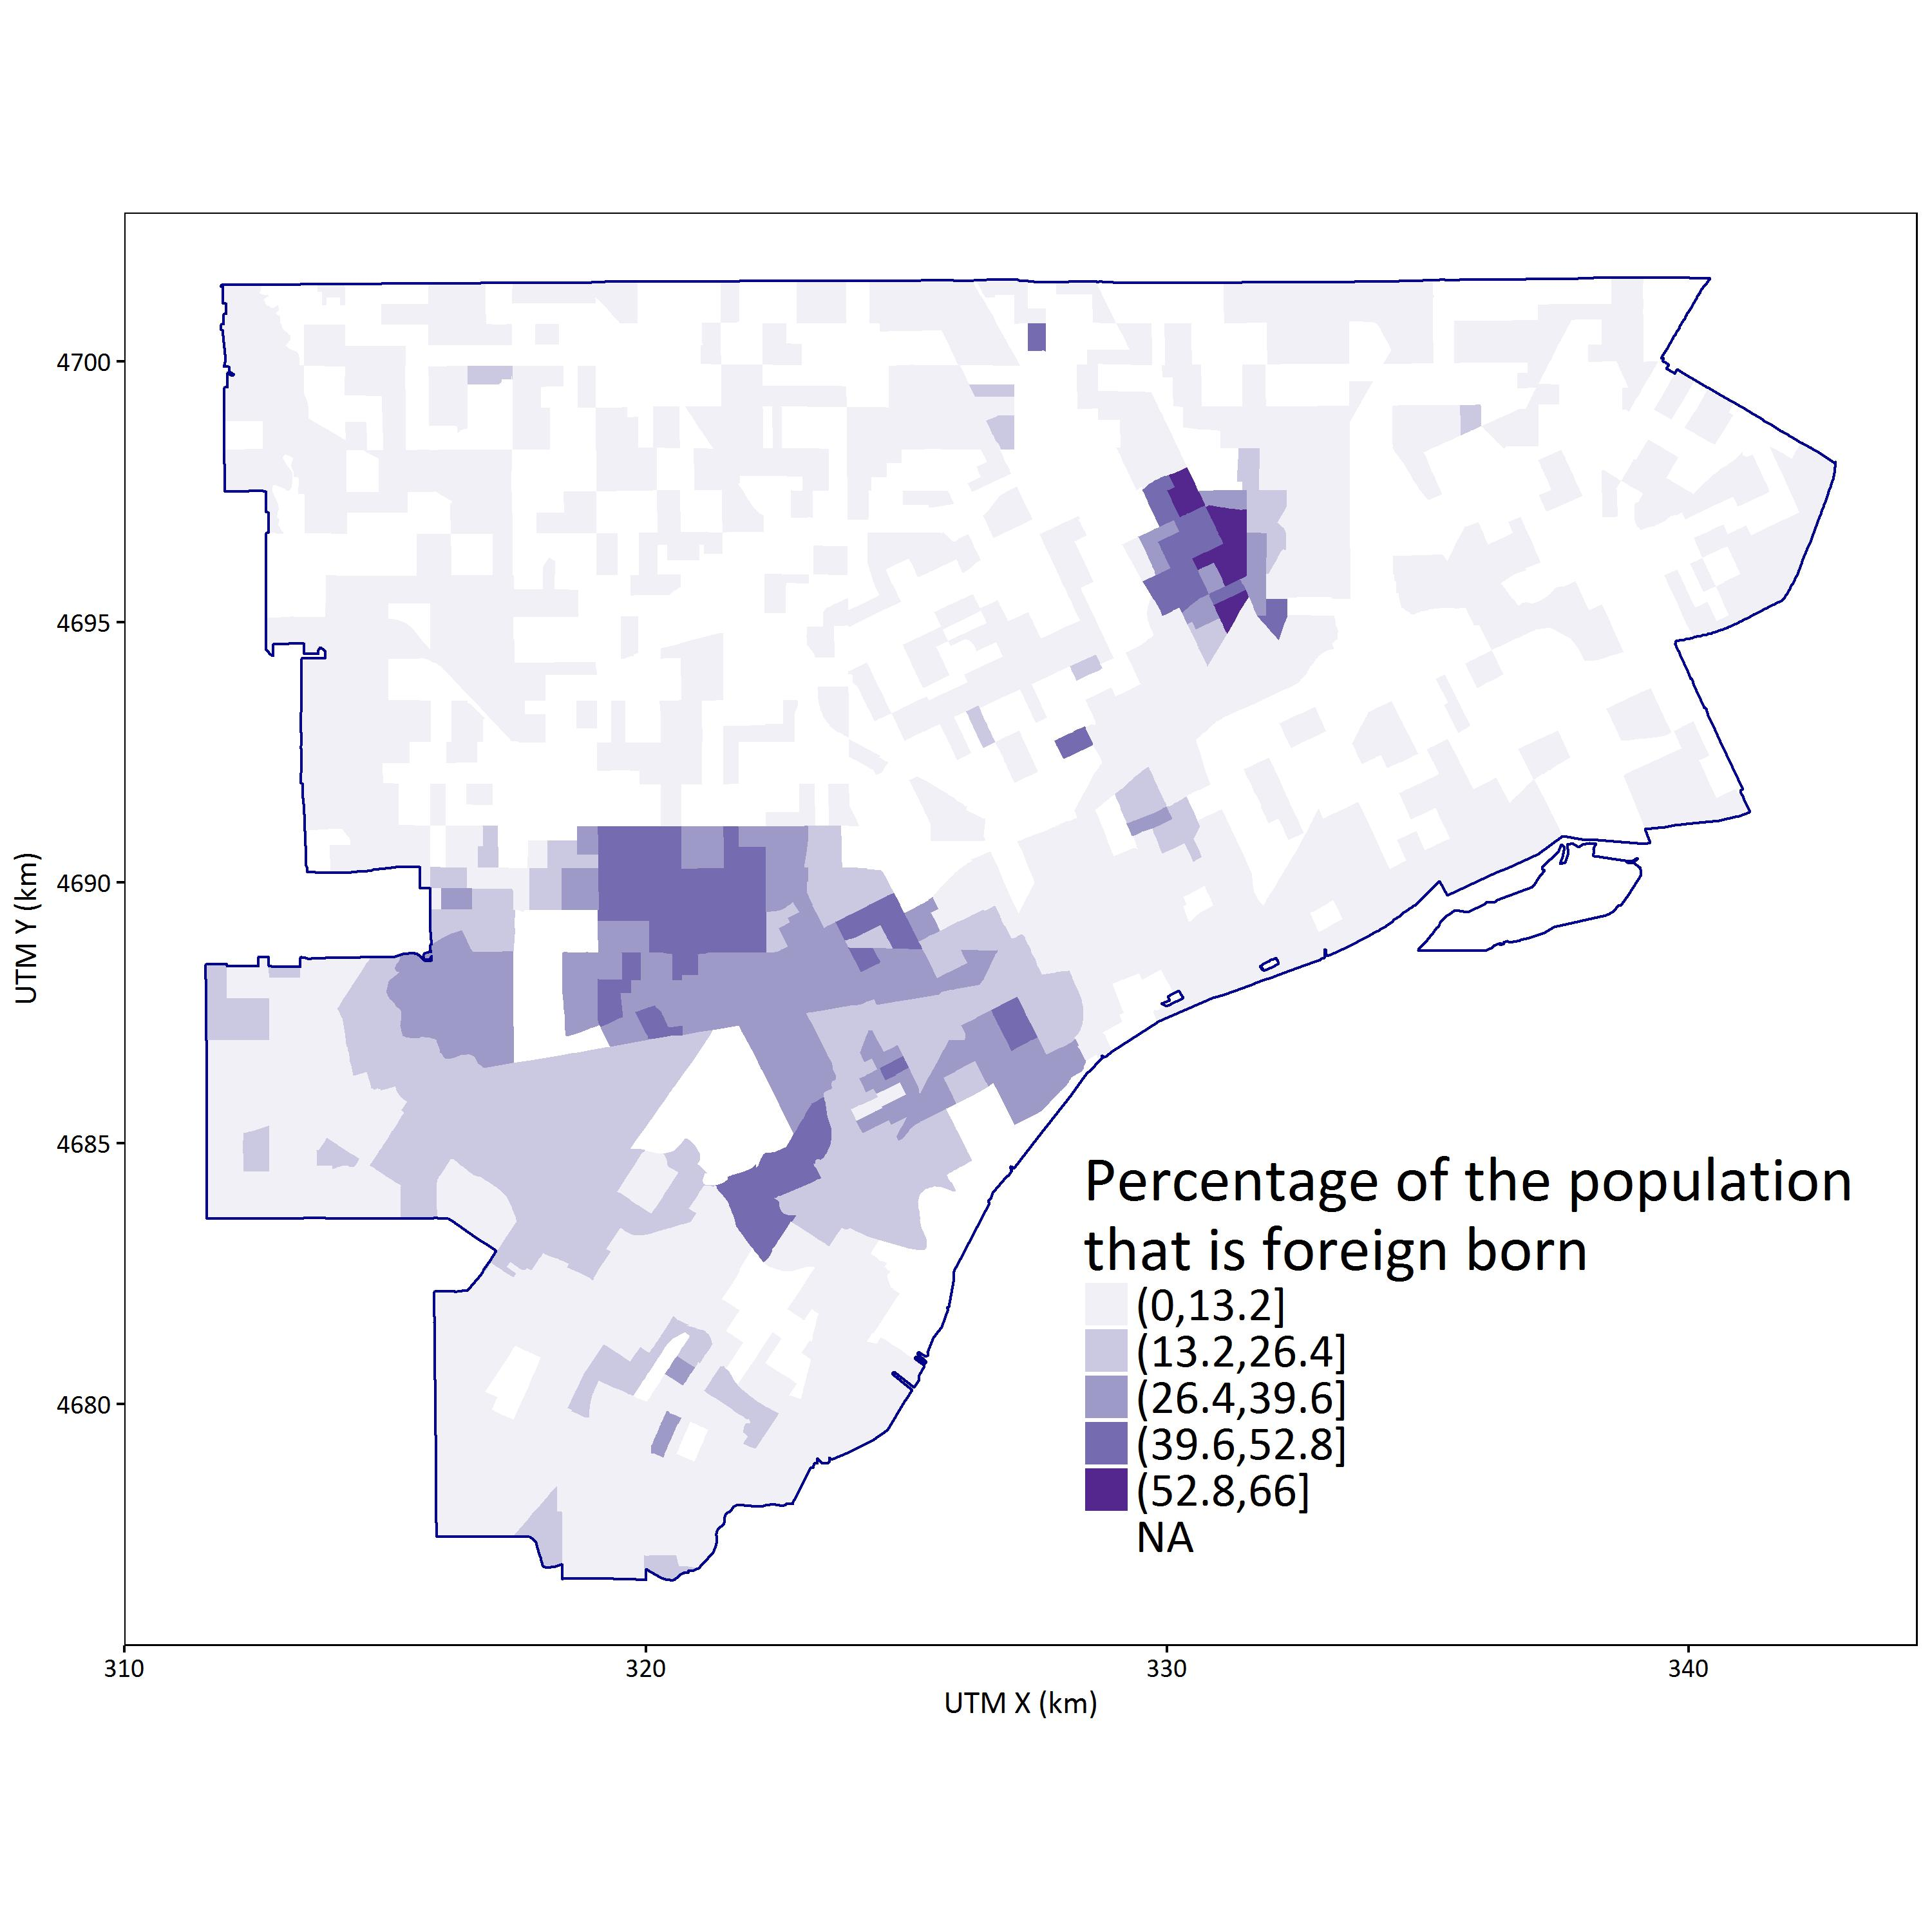

Supplemental Figure 3. Empirical cumulative distributions of the measured daily mean SO2 concentrations at the Southwest High School monitor and predicted daily mean SO2 at the four FRESH-EST receptors (R1, R2, R3, and R4) closest to the monitor (distance < 160 m.) K-S tests showed no statistically significant difference between the distributions of measured and predicted daily means (p > 0.05).

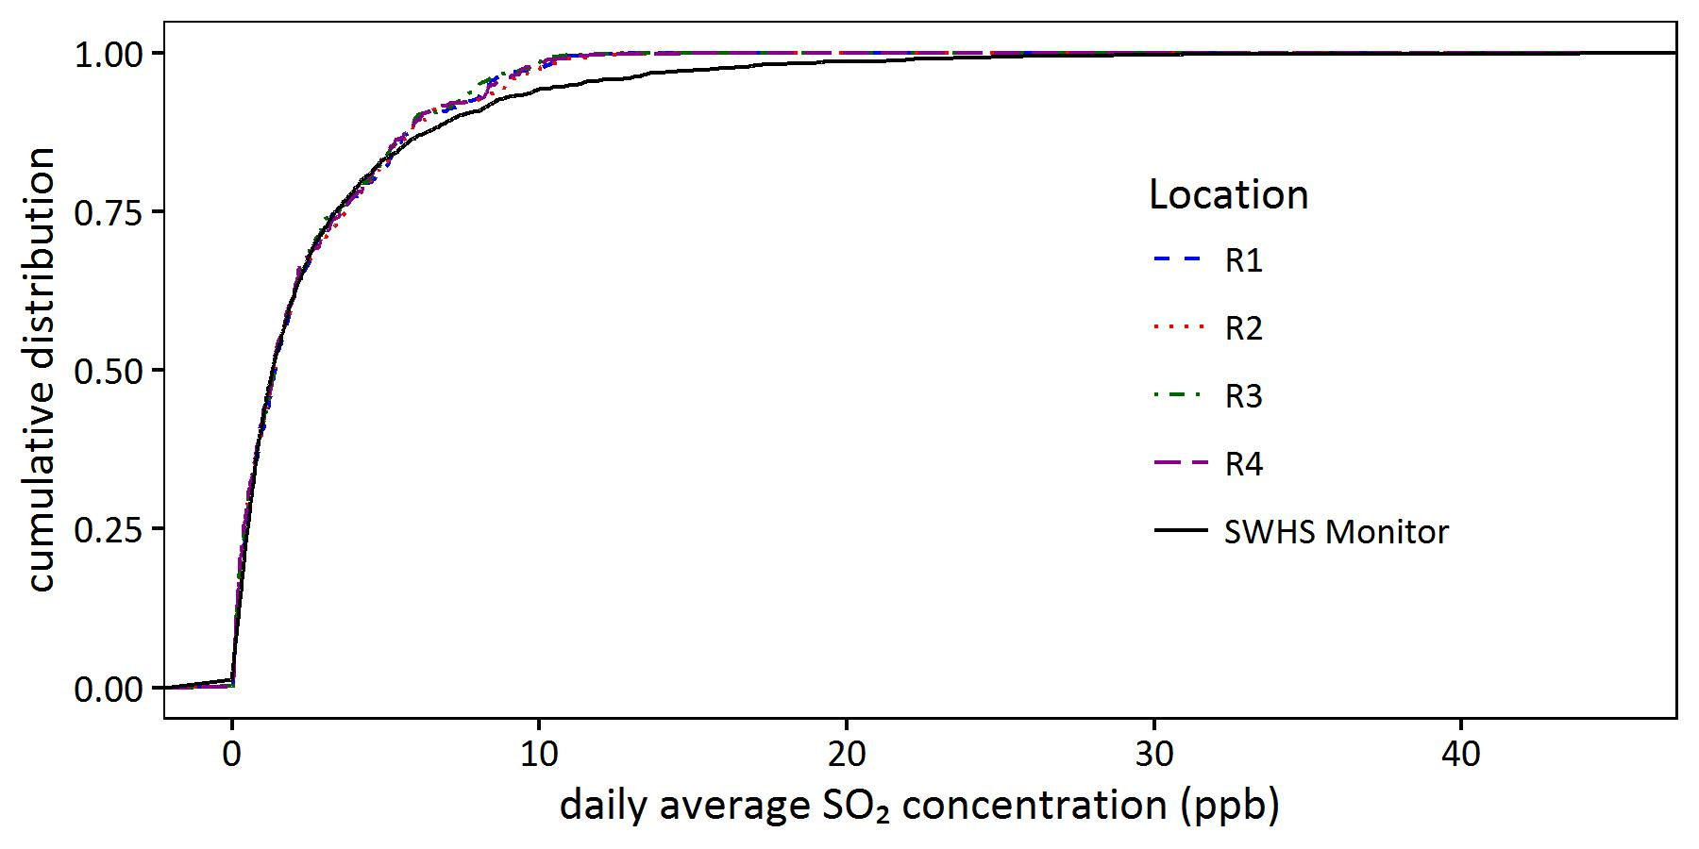

Supplemental Figure 4. Attributable health burden (DALYs/year) versus concentration index (CI) for each emission control alternative based on actual emissions and population subgroup. Lines connect alternatives with the same SO2 emissions reduction target (15 to 90%). A CI equal to zero indicates perfect equality across census blocks. Negative CI values indicates the lower-ranked census block carries a disproportionate impact. Thus, alternatives that result in CI values closer to 0 are preferred.

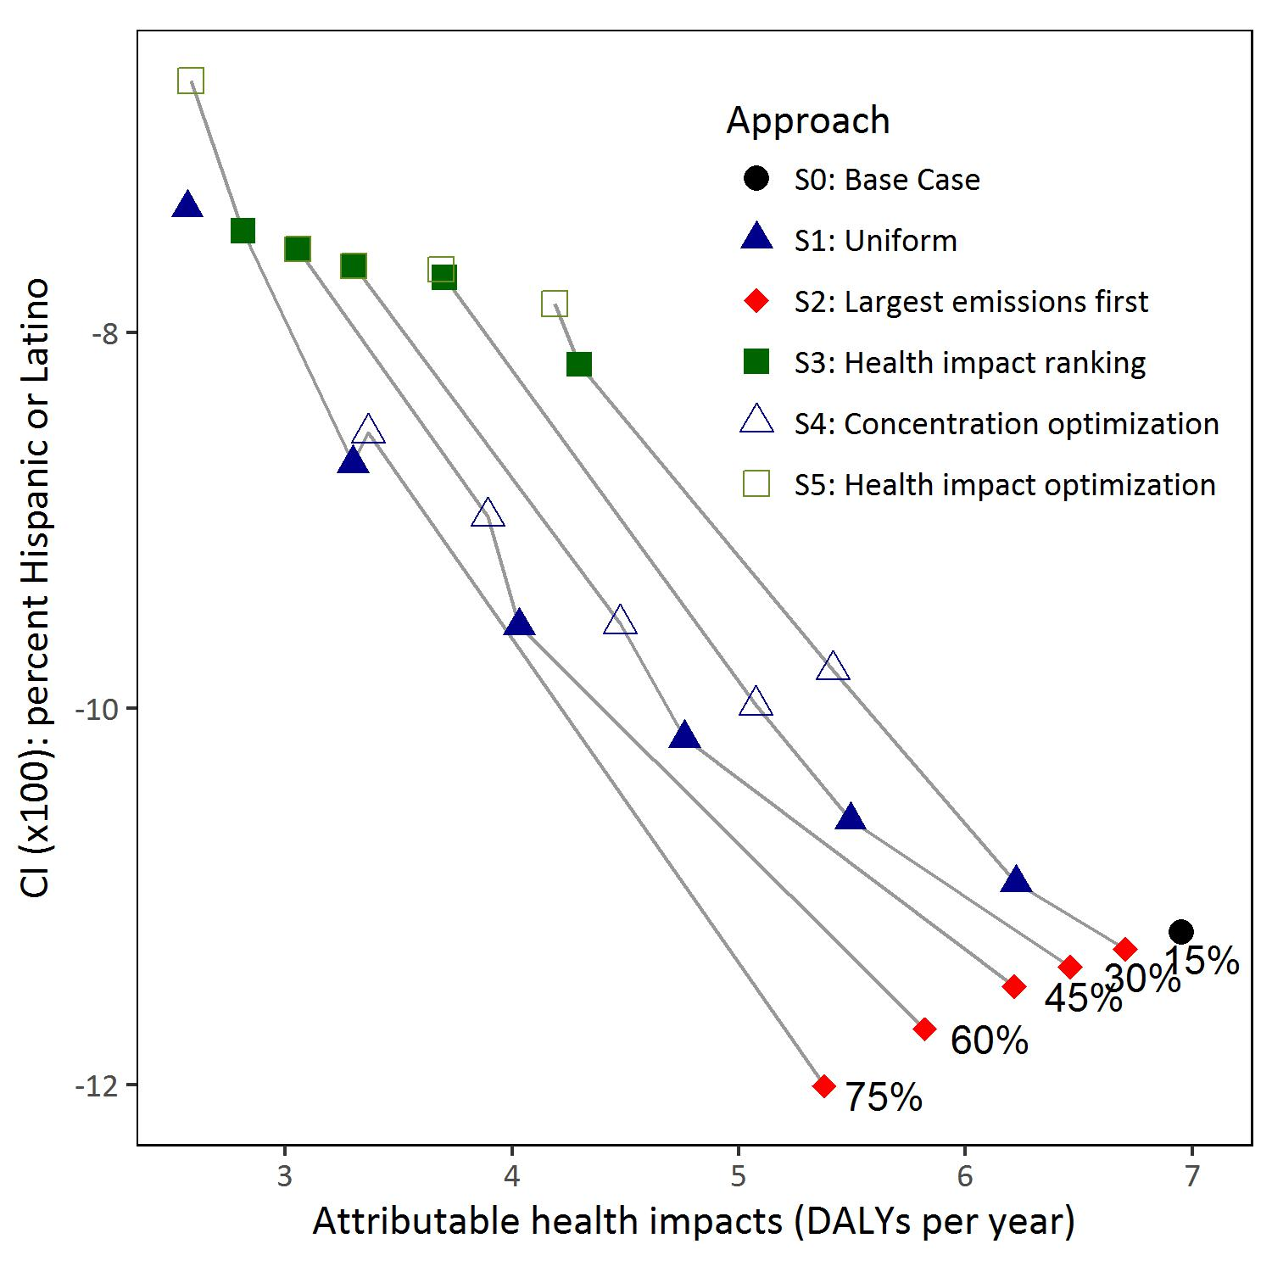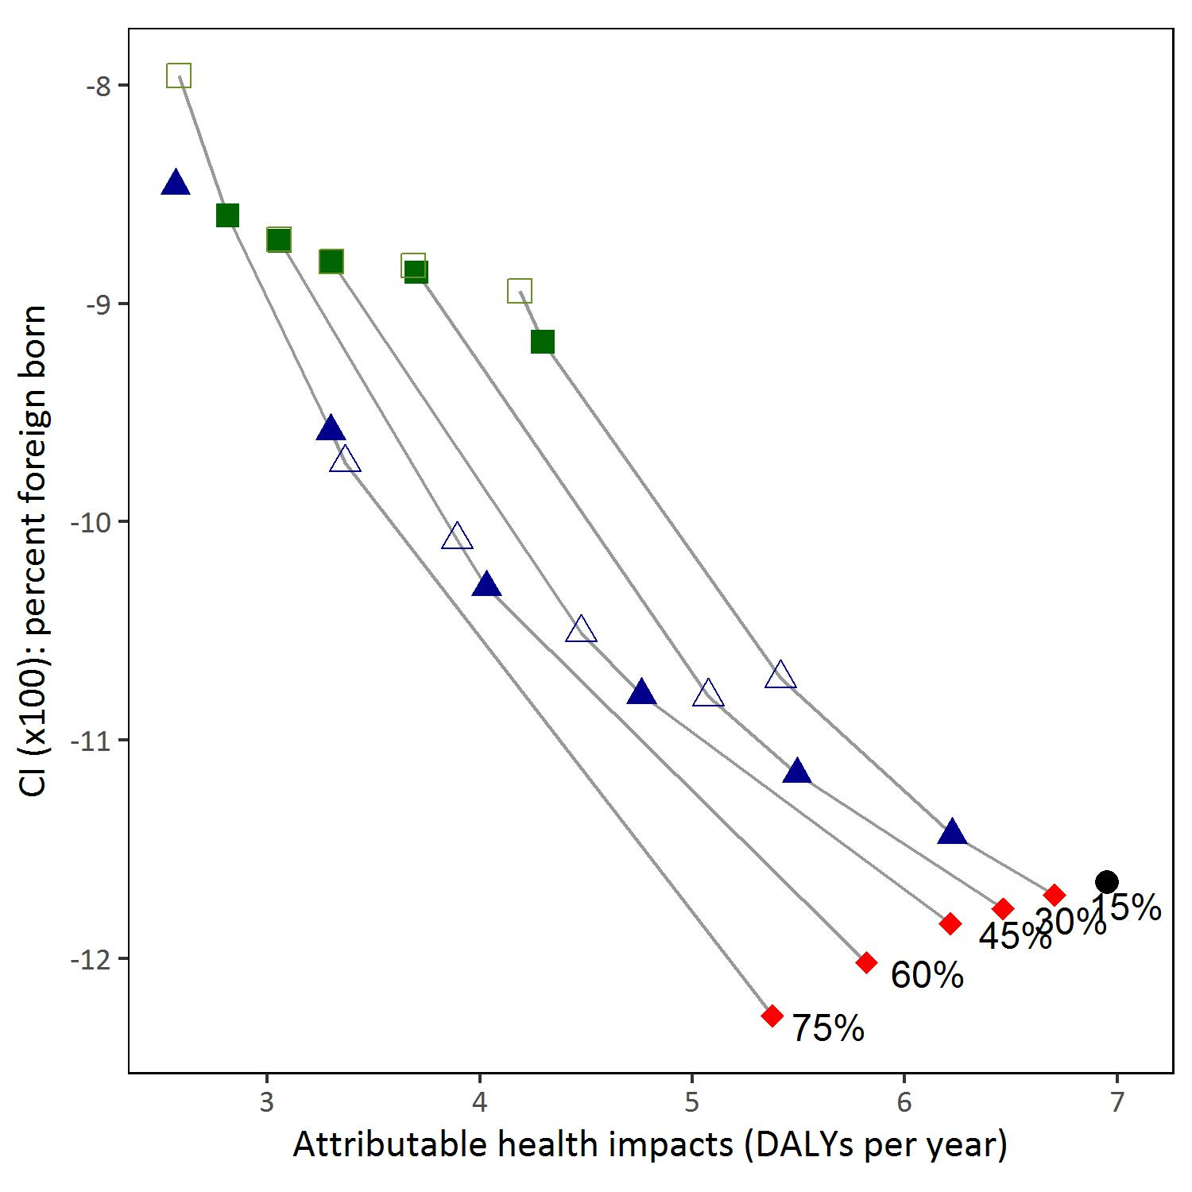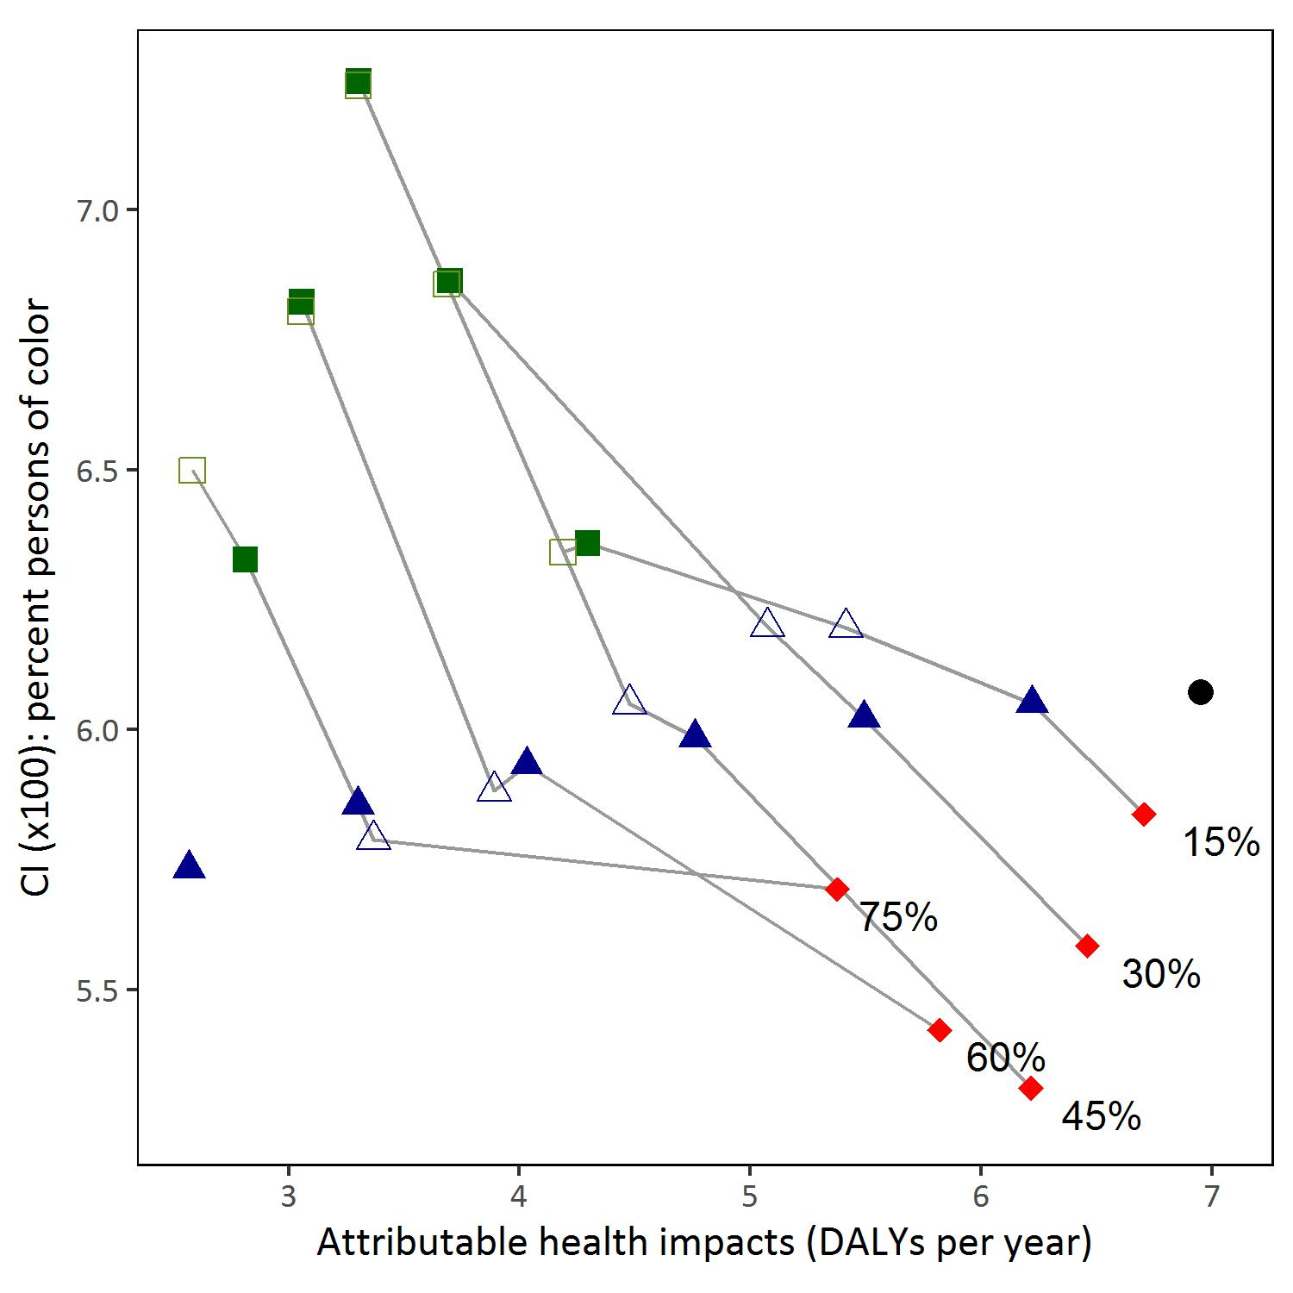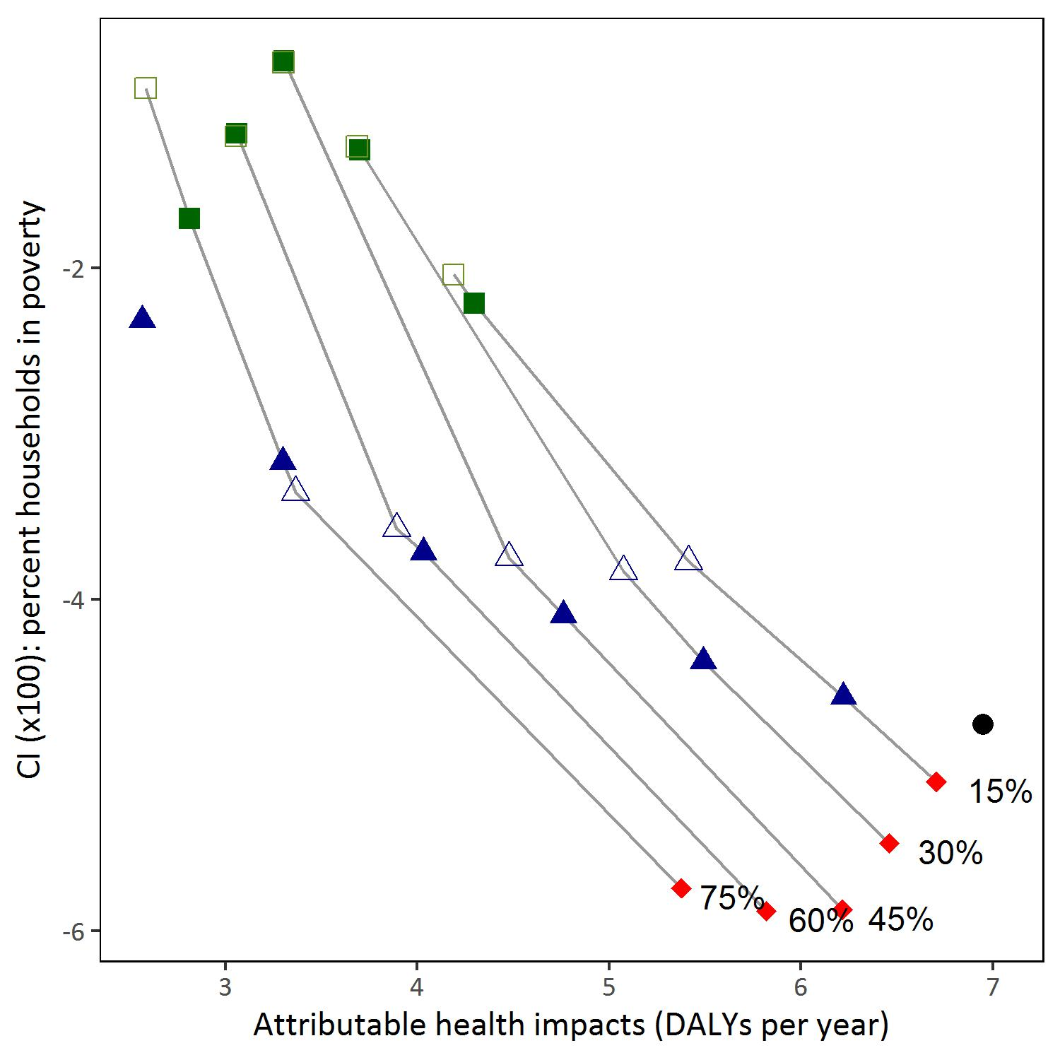

Supplemental Figure 4 (continued). Attributable health burden (DALYs/year) versus concentration index (CI) for each emission control alternative based on actual emissions and population subgroup. Lines connect alternatives with the same SO2 emissions reduction target (15 to 90%). A CI equal to zero indicates perfect equality across census blocks. Negative CI values indicates the lower-ranked census block carries a disproportionate impact. Thus, alternatives that result in CI values closer to 0 are preferred.

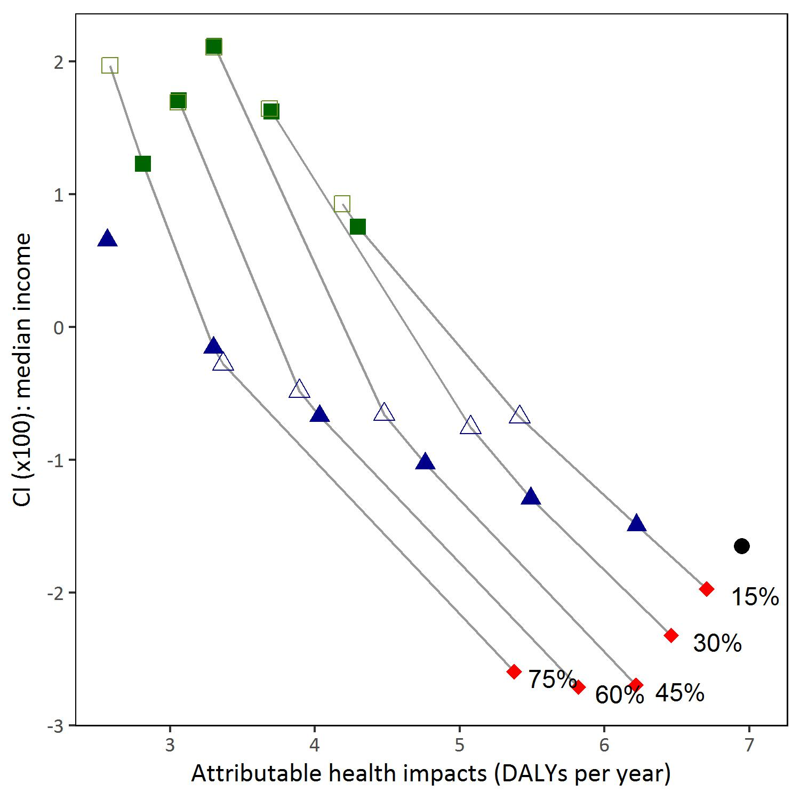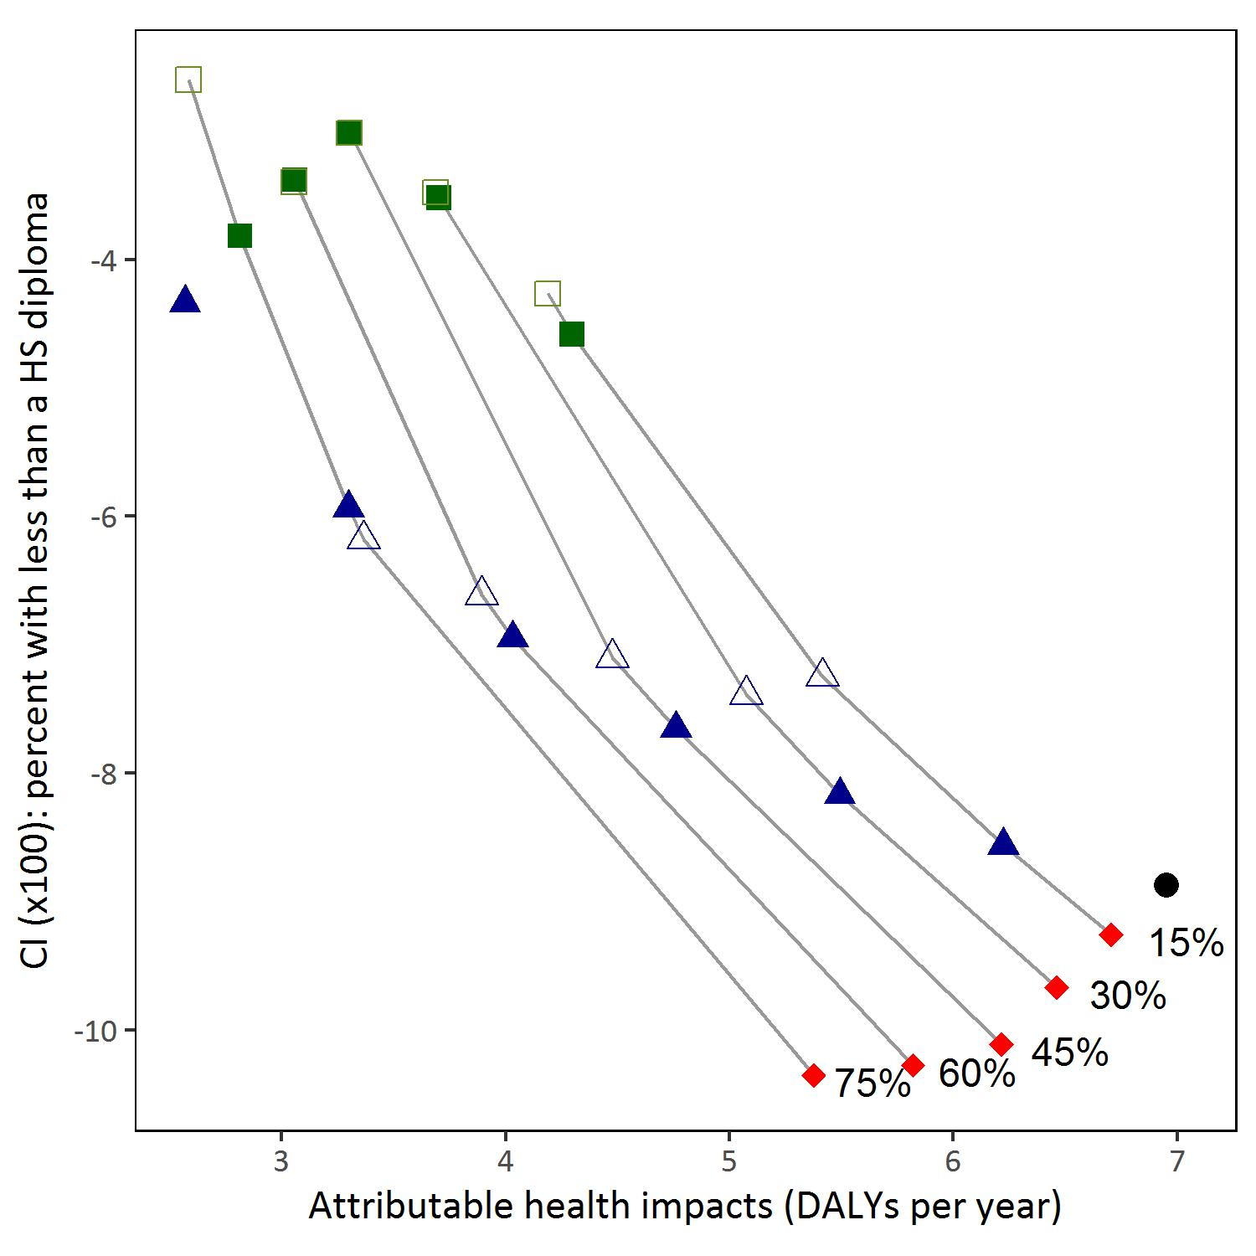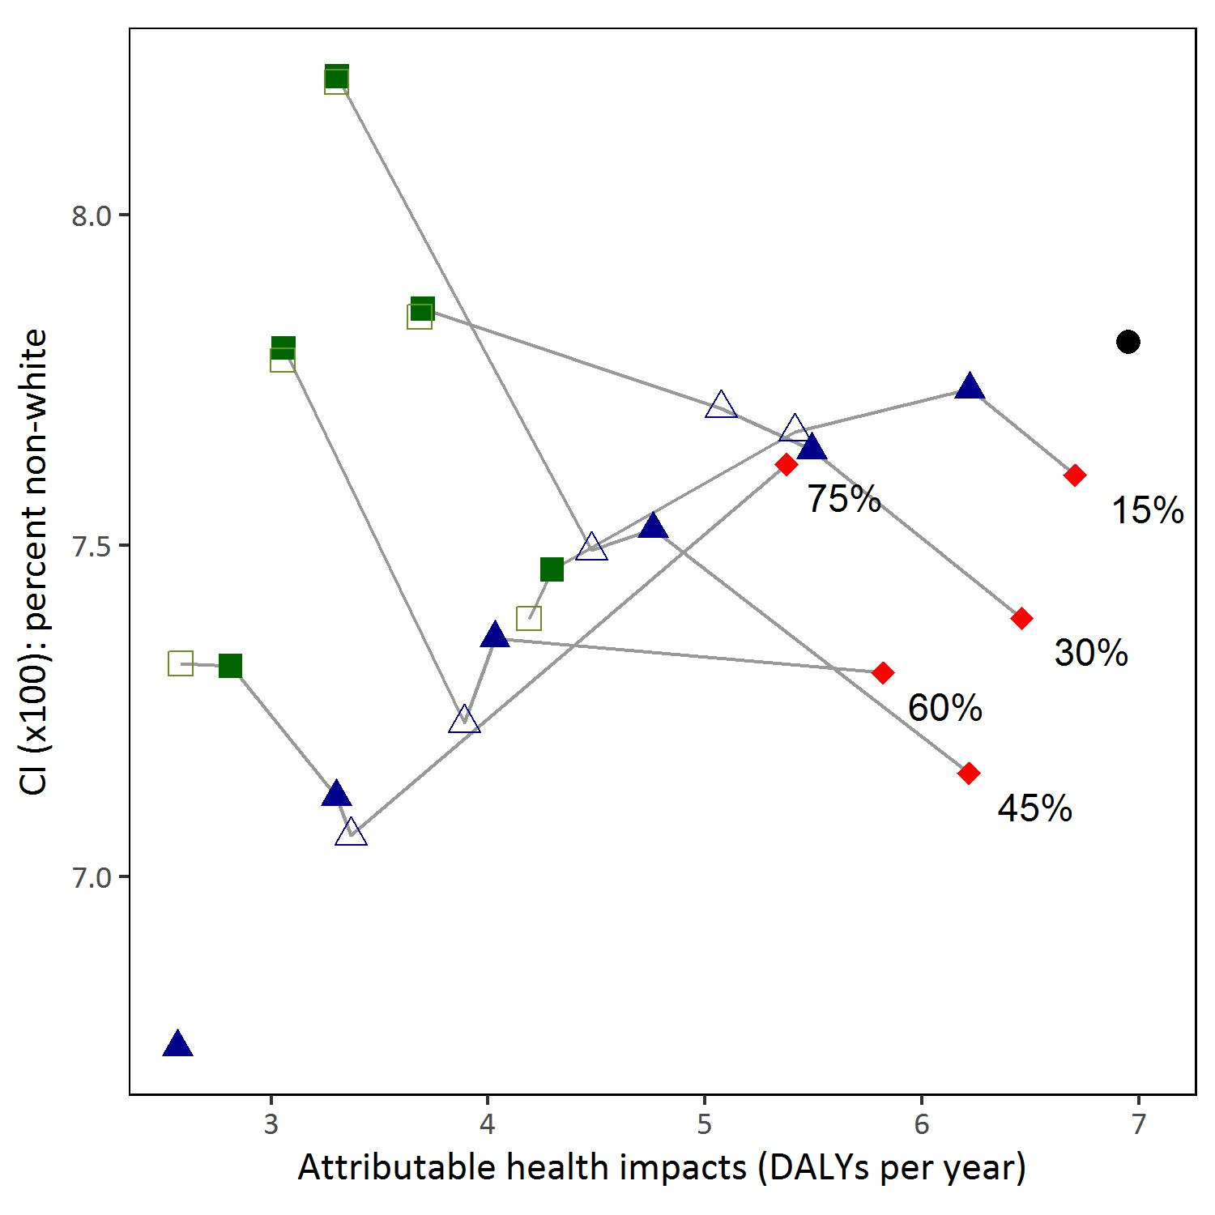

Supplemental Figure 5. Attributable health burden (DALYs/year) versus concentration index (CI) for each emission control alternative based on maximum allowable emissions and population subgroup. A CI equal to zero indicates perfect equality across census blocks. Negative CI values indicates the lower-ranked census block carries a disproportionate impact. Thus, alternatives that result in CI values closer to 0 are preferred.

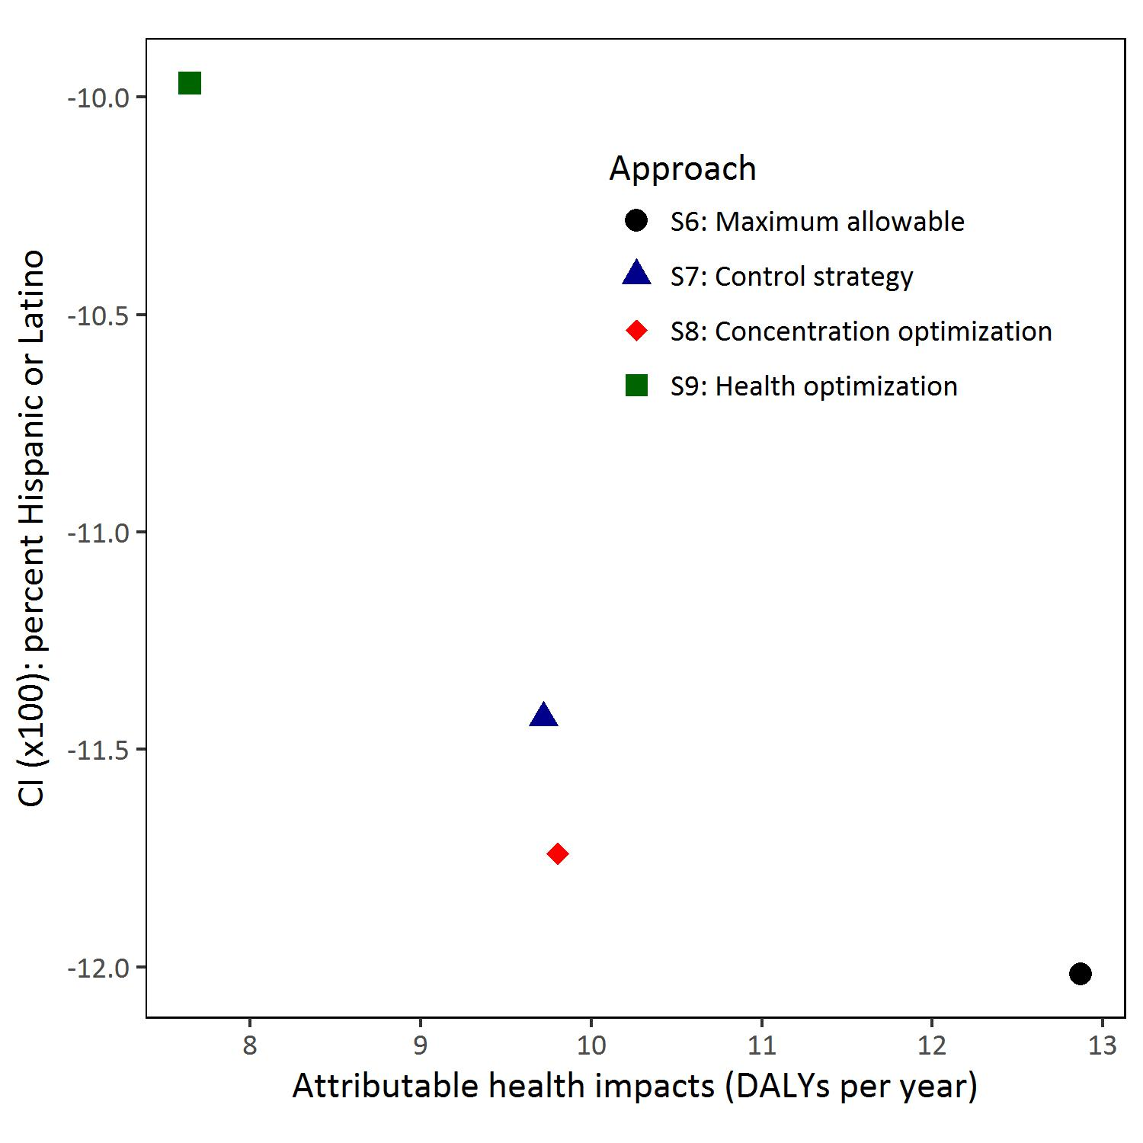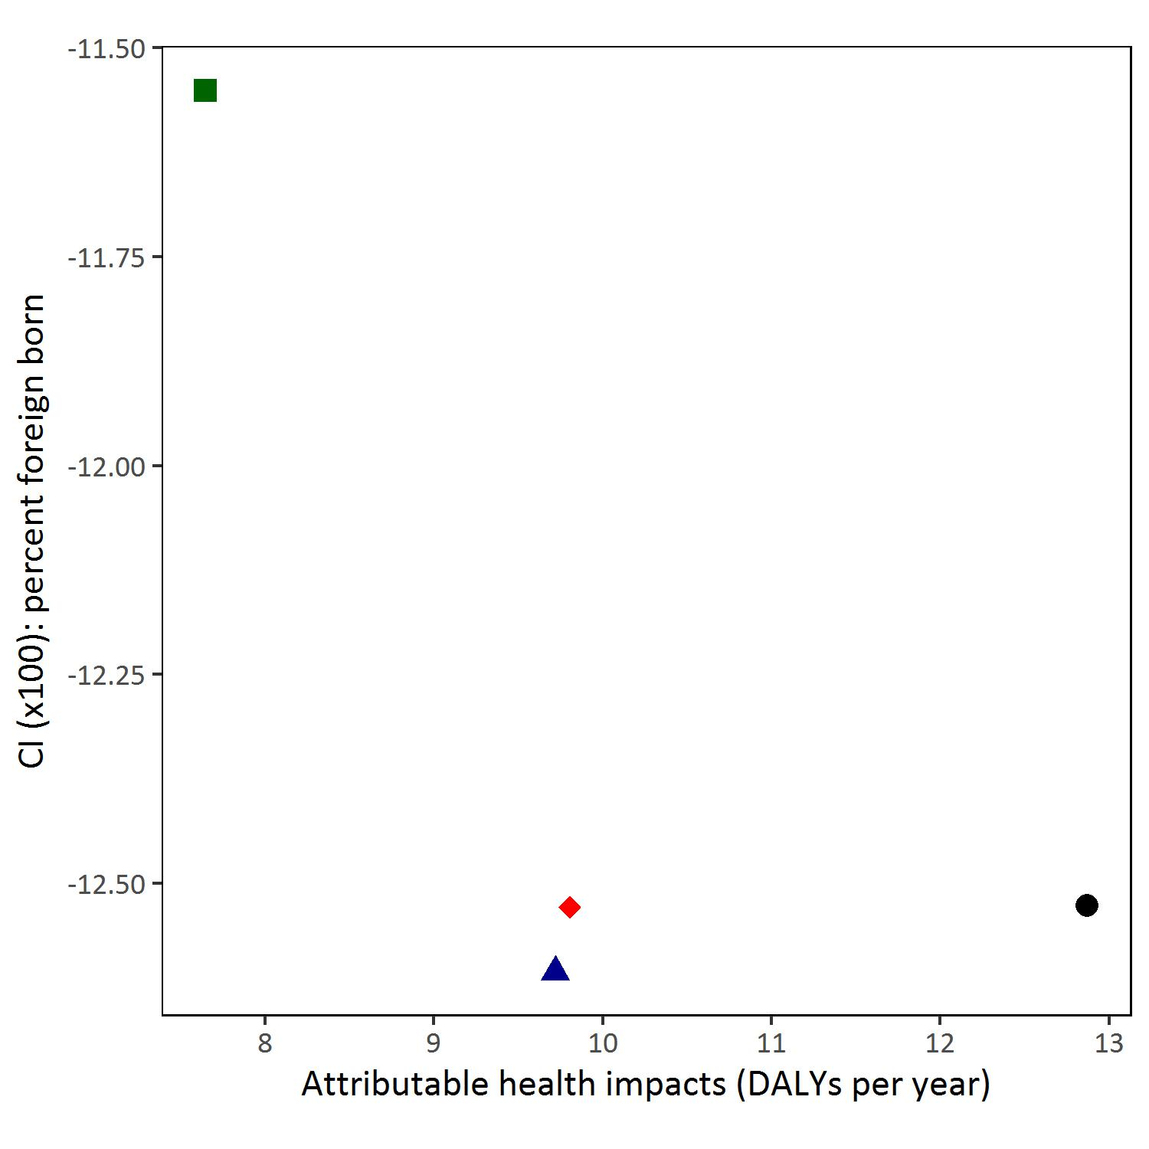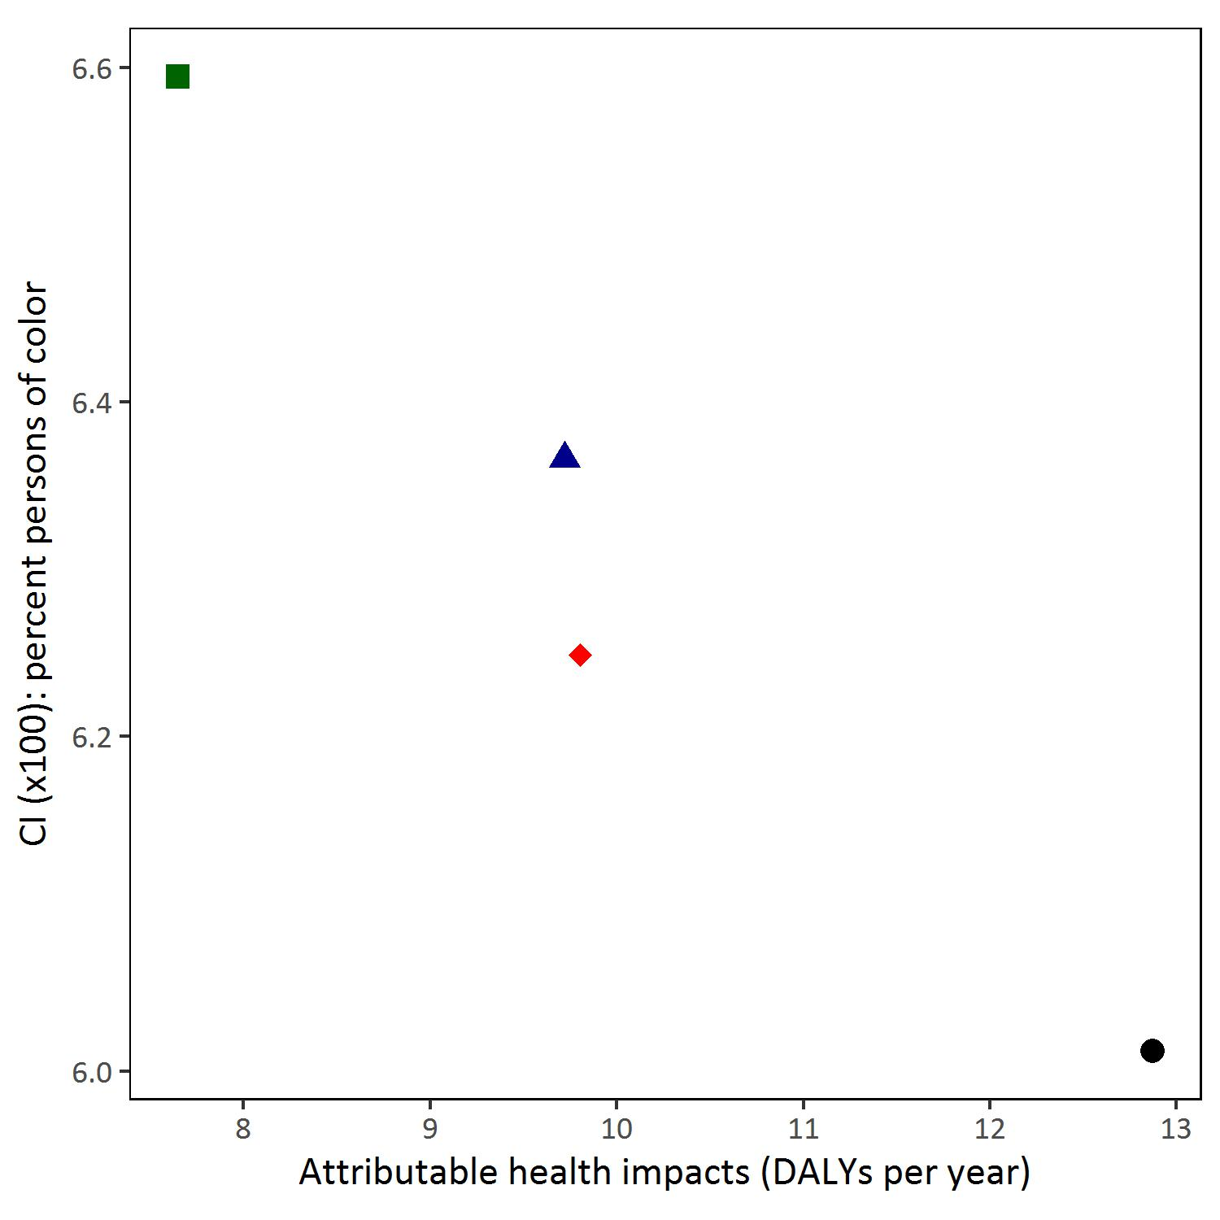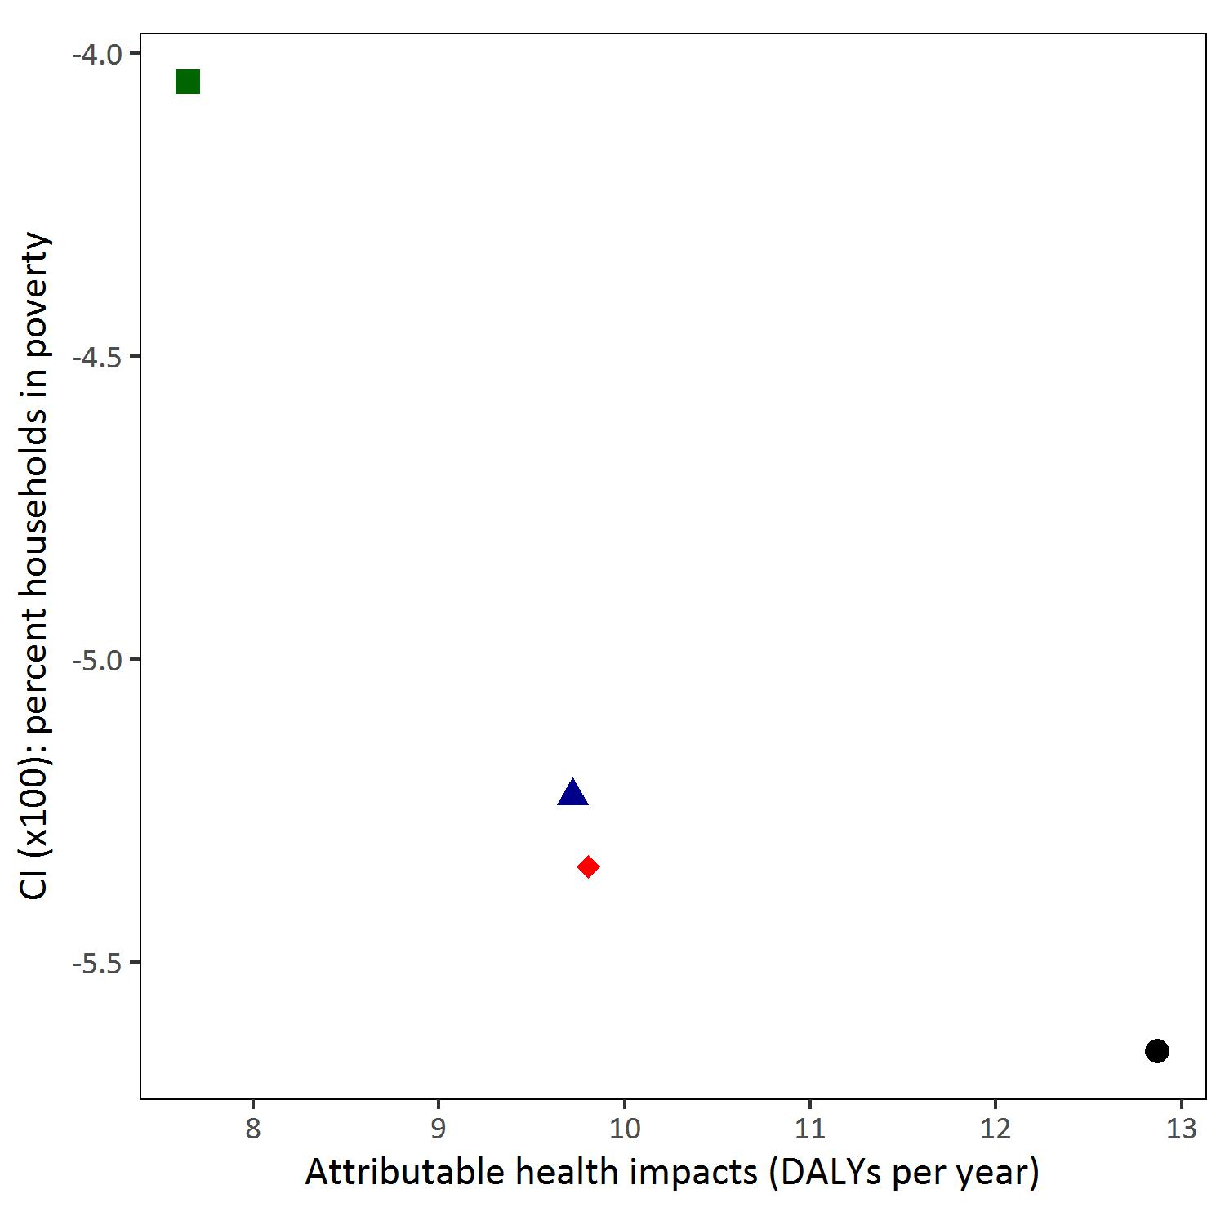

Supplemental Figure 5 (continued). Attributable health burden (DALYs/year) versus concentration index (CI) for each emission control alternative based on maximum allowable emissions and population subgroup. A CI equal to zero indicates perfect equality across census blocks. Negative CI values indicates the lower-ranked census block carries a disproportionate impact. Thus, alternatives that result in CI values closer to 0 are preferred.

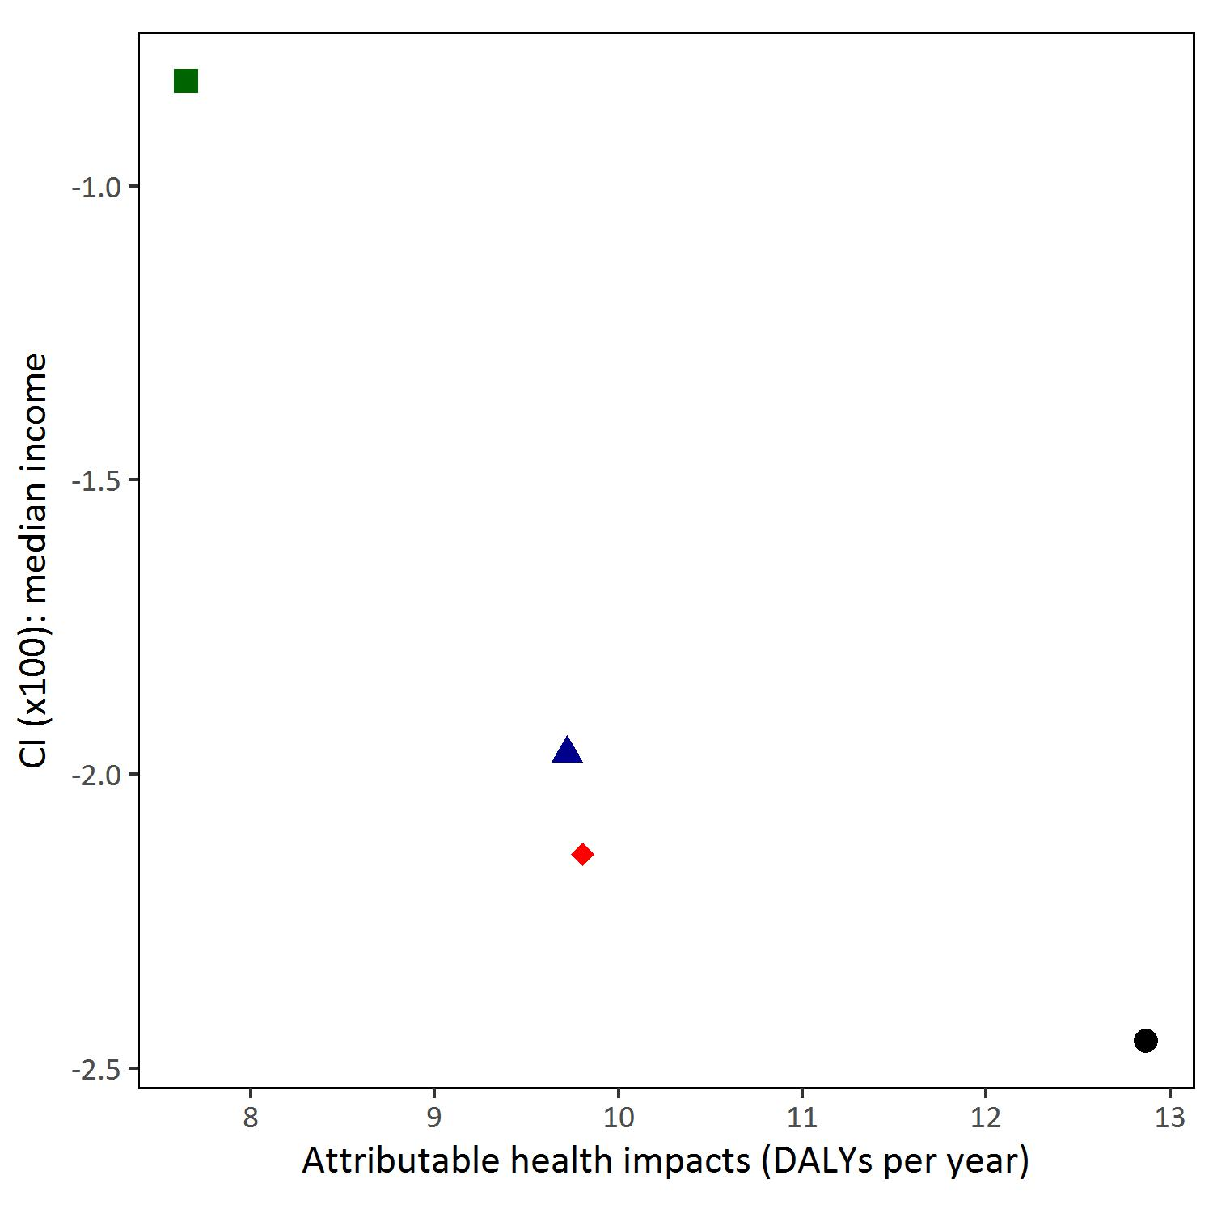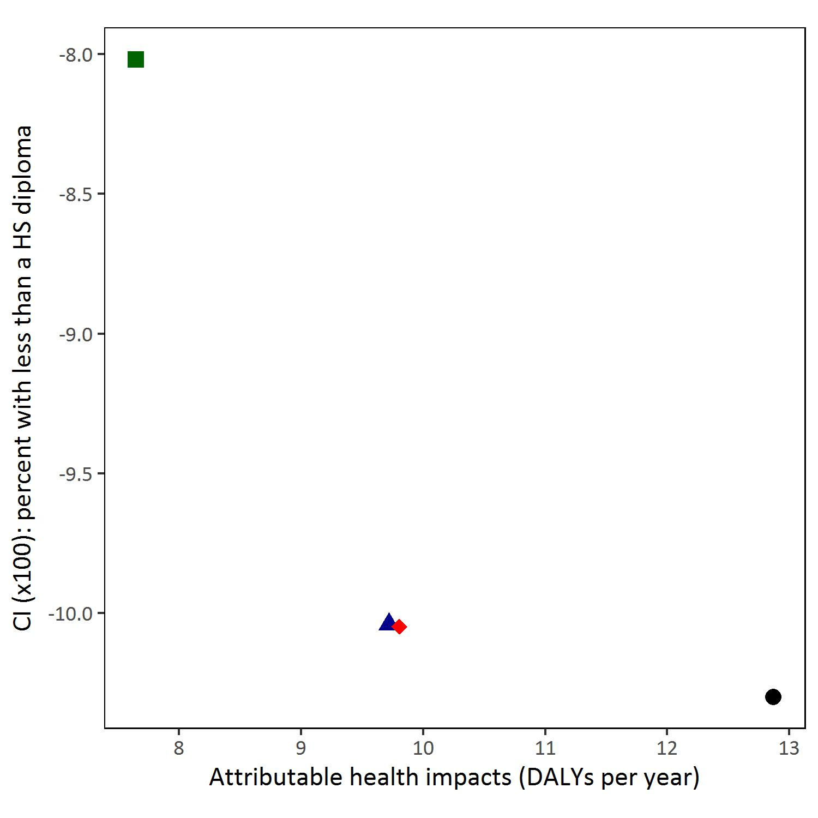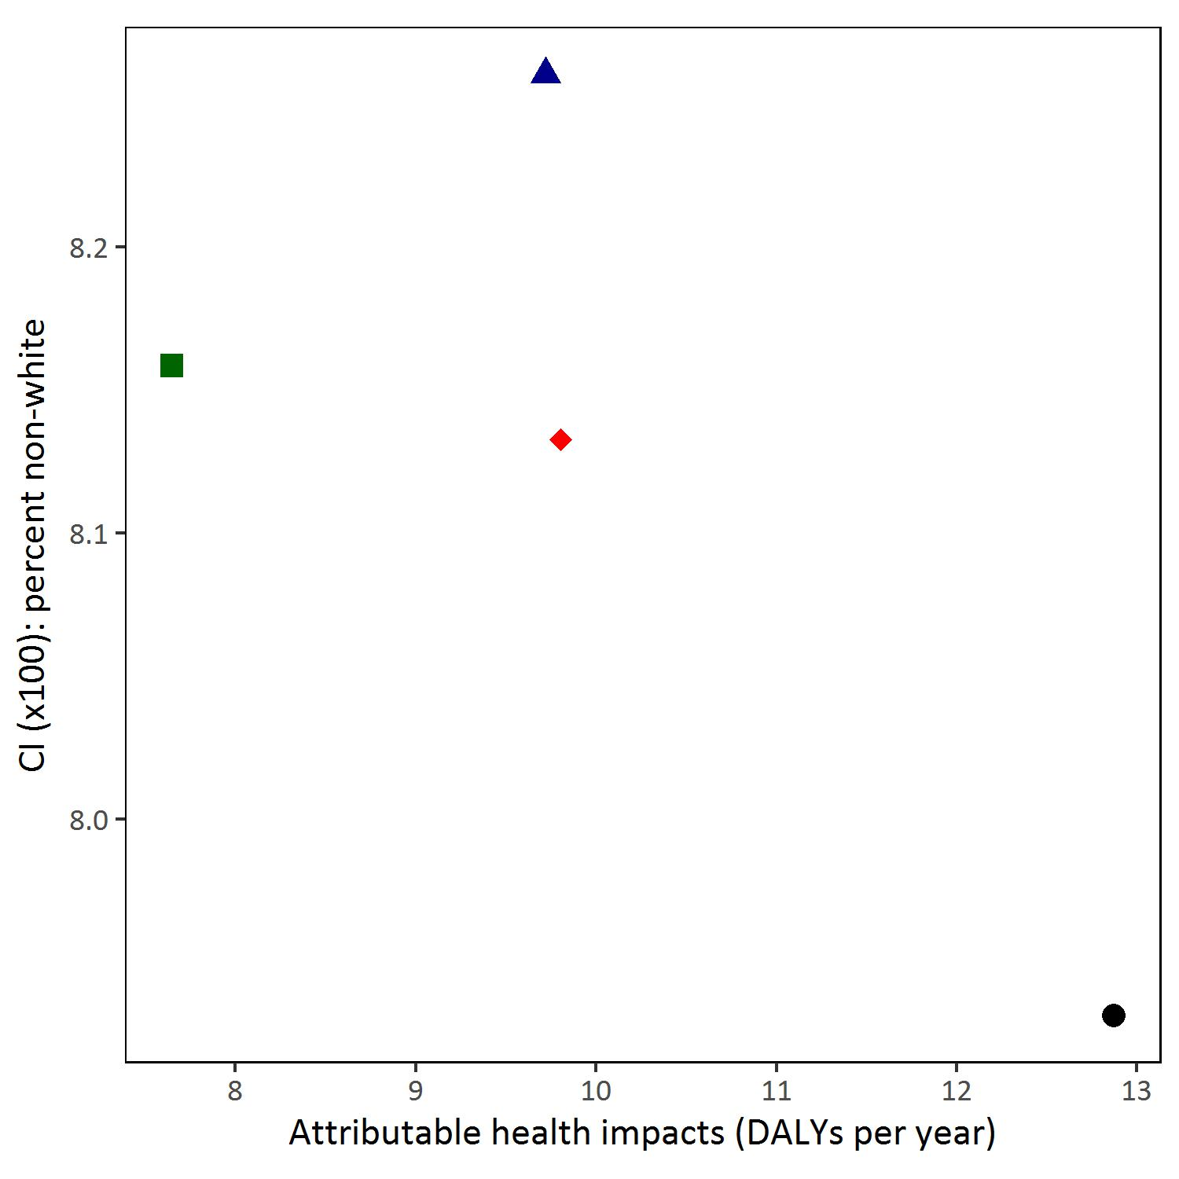

Supplemental Table 1. Adverse health outcomes, “at risk” population age groups, exposure metric, HIF form, and concentration response coefficients (and standard errors) included in the FRESH-EST health impact assessment database for SO2.

|  |  |  |  |  |  |
| --- | --- | --- | --- | --- | --- |
| Outcome | Age Group | Metric | Form | CR (SE) | Reference |
| Asthma hospitalization | 0-64 years | 24 h average | Log-linear | 0.00203 (0.00259) | Sheppard, 2003 |
| COPD hospitalization | 65+ years | 24 h average | Log-linear | 0.02081 (0.01113) | Yang et al., 2005 |
| ED visit for asthma | 0-18 years | 24 h average | Log-linear | 0.00825 (0.00190) | Ito et al., 2007 |
| ED visit for asthma1 | 0-18 years | 24 h average | Log-linear | 0.00976 (0.00287) | Li et al., 2011 |
| Asthma symptom day | 6-14 years | 24 h average | Logistic | 0.00392 (0.00196) | Schildcrout et al., 2006 |
| Asthma symptom day1 | 6-14 years | 24 h average | Logistic | 0.01695 (0.00660) | Batterman et al., in prep. |

1 Denotes a Detroit-specific concentration-response coefficient.

Supplemental Table 2. Adverse health outcomes, disability weights (DW), duration (D, years), and monetized values (2010$) included in the FRESH-EST health impact assessment database for SO2.

|  |  |  |  |  |  |  |
| --- | --- | --- | --- | --- | --- | --- |
| Outcome | DW  (--) | D  (years) | Value  (2010$) | D  Reference | DW Reference | Value Reference |
| Asthma hospitalization | 0.64 | 0.009 | 16,000 | de Hollander et al., 1999 | CDC, 2012 | US EPA, 2012 |
| COPD hospitalization | 0.64 | 0.012 | 36,000 | de Hollander et al., 1999 | CDC, 2012 | US EPA, 2012 |
| ED visit for asthma | 0.51 | 0.003 | 430 | de Hollander et al., 1999 |  | US EPA, 2012 |
| Asthma symptom day | 0.22 | 0.005 | 58 | de Hollander et al., 1999 |  | US EPA, 2012 |

Supplemental Table 3. Annual health impacts (95% confidence interval)a for residents of Detroit and downriver cities attributable to baseline emissions of SO2.

|  |  |  |
| --- | --- | --- |
| Outcome | Age Group | Attributable impacts per year |
| Asthma hospitalization (cases) | 0- 64 years | 7 (0 – 22) |
| COPD hospitalization (cases) | ≥ 65 years | 60 (0 – 120) |
| Asthma ED visit (cases) | 0 – 17 years | 95 (50 – 140) |
| Asthma ED visit, Detroit CR (cases)b | 0 – 17 years | 110 (50 – 170) |
| Asthma exacerbation (cases)c | 6 – 14 years | 6,100 (0 – 12,000) |
| Asthma exacerbation, Detroit CR (cases)b,c | 6 – 14 Years | 26,000 (6,000 – 46,000) |
| TotalDALYsd (years) |  | 7 (0 – 14) |
| Total monetized impactd (1,000’s 2010$) |  | 2,700 (0 – 5,500) |

a Number of attributable cases to two significant figures. Confidence intervals (CI) estimated using the 95% CI of the CR coefficient. The lower bound of the 95% CI is truncated at zero.

b These estimates use a CR coefficient drawn from a study set in Detroit, MI.

c An asthma exacerbation is defined as a day with cough, wheeze, and/or shortness of breath.

d Total DALYs and monetized impact metrics exclude outcomes for which a Detroit-specific CR is used.

Abbreviations: COPD: Chronic obstructive pulmonary disease; CR: concentration-response coefficient; DALYs: disability-adjusted life years

Supplemental Table 4. Total health burden (DALYs), Atkinson index and concentration index values (× 100) for annual health impact risk (measured as risk of a DALY per year) due to point source SO2 emissions for each reduction strategy. Percent difference between the strategy and the base case in parentheses. Negative percent differences indicate an increase relative to base case.

|  |  |  |  |  |  |  |  |  |  |  |  |
| --- | --- | --- | --- | --- | --- | --- | --- | --- | --- | --- | --- |
|  |  |  | | Concentration Index (× 100) | | | | | | | |
| Strategy | % Reduction | DALYs/year | Atkinson Index | Percent nonwhite | Percent Hispanic or Latino | Percent with less than a high school diploma | Median income (2014$) | Percent of households with income below poverty level | Percent of the population that is persons of color | Percent of the population that is foreign born |
| S0 | 0 | 7.0 (*) | 0.136 (*) | 7.8 (*) | -11.2 (*) | -8.9 (*) | -1.7 (*) | -4.8 (*) | 6.1 (*) | -11.7 (*) |
| S1 | 15 | 6.2 (10.5) | 0.134 (1.3) | 7.7 (0.9) | -10.9 (2.3) | -8.6 (3.5) | -1.5 (9.6) | -4.6 (3.6) | 6.1 (0.4) | -11.4 (1.9) |
| S1 | 30 | 5.5 (21.0) | 0.132 (2.9) | 7.6 (2.1) | -10.6 (5.3) | -8.2 (8.0) | -1.3 (21.8) | -4.4 (8.0) | 6.0 (0.8) | -11.2 (4.3) |
| S1 | 45 | 4.8 (31.5) | 0.129 (4.8) | 7.5 (3.6) | -10.2 (9.2) | -7.7 (13.8) | -1.0 (37.7) | -4.1 (13.9) | 6.0 (1.4) | -10.8 (7.4) |
| S1 | 60 | 4.0 (42.0) | 0.126 (7.2) | 7.4 (5.7) | -9.6 (14.6) | -6.9 (21.7) | -0.7 (59.3) | -3.7 (21.9) | 5.9 (2.3) | -10.3 (11.6) |
| S1 | 75 | 3.3 (52.5) | 0.122 (10.3) | 7.1 (8.8) | -8.7 (22.3) | -5.9 (33.1) | -0.2 (90.6) | -3.2 (33.3) | 5.9 (3.6) | -9.6 (17.7) |
| S1 | 90 | 2.6 (63.1) | 0.117 (14) | 6.7 (13.6) | -7.3 (34.4) | -4.3 (51.1) | 0.7 (139.6) | -2.3 (51.3) | 5.7 (5.6) | -8.5 (27.4) |
| S2 | 15 | 6.7 (3.5) | 0.136 (-0.7) | 7.6 (2.6) | -11.3 (-0.8) | -9.3 (-4.3) | -2.0 (-19.6) | -5.1 (-7.2) | 5.8 (3.9) | -11.7 (-0.5) |
| S2 | 30 | 6.5 (7.1) | 0.138 (-1.5) | 7.4 (5.3) | -11.4 (-1.7) | -9.7 (-8.9) | -2.3 (-40.7) | -5.5 (-15.0) | 5.6 (8.0) | -11.8 (-1.0) |
| S2 | 45 | 6.2 (10.6) | 0.139 (-2.5) | 7.2 (8.3) | -11.5 (-2.6) | -10.1 (-14) | -2.7 (-63.5) | -5.9 (-23.4) | 5.3 (12.5) | -11.8 (-1.6) |
| S2 | 60 | 5.8 (16.3) | 0.140 (-3.6) | 7.3 (6.4) | -11.7 (-4.6) | -10.3 (-15.8) | -2.7 (-64.4) | -5.9 (-23.6) | 5.4 (10.7) | -12.0 (-3.2) |
| S2 | 75 | 5.4 (22.7) | 0.142 (-4.9) | 7.6 (2.4) | -12.0 (-7.3) | -10.4 (-16.7) | -2.6 (-57.3) | -5.7 (-20.7) | 5.7 (6.2) | -12.3 (-5.2) |
| S3 | 15 | 4.3 (38.2) | 0.119 (12.0) | 7.5 (4.4) | -8.2 (27.0) | -4.6 (48.4) | 0.8 (145.8) | -2.2 (53.5) | 6.4 (-4.7) | -9.2 (21.2) |
| S3 | 30 | 3.7 (46.8) | 0.118 (12.6) | 7.9 (-0.6) | -7.7 (31.1) | -3.5 (60.3) | 1.6 (198.3) | -1.3 (72.9) | 6.9 (-13) | -8.9 (24.0) |
| S3 | 45 | 3.3 (52.5) | 0.119 (12.3) | 8.2 (-5.1) | -7.7 (31.6) | -3.0 (66.1) | 2.1 (228.3) | -0.8 (84.2) | 7.2 (-19.3) | -8.8 (24.4) |
| S3 | 60 | 3.1 (56.0) | 0.118 (12.8) | 7.8 (0.1) | -7.6 (32.4) | -3.4 (61.9) | 1.7 (203.5) | -1.2 (75.0) | 6.8 (-12.4) | -8.7 (25.2) |
| S3 | 75 | 2.8 (59.5) | 0.117 (13.4) | 7.3 (6.3) | -7.5 (33.3) | -3.8 (57.0) | 1.2 (174.4) | -1.7 (64.2) | 6.3 (-4.2) | -8.6 (26.2) |
| S4 | 15 | 5.4 (22.1) | 0.128 (5.7) | 7.7 (1.7) | -9.8 (12.5) | -7.2 (18.3) | -0.7 (58.9) | -3.8 (20.7) | 6.2 (-2.0) | -10.7 (8.0) |
| S4 | 30 | 5.1 (27.0) | 0.128 (5.2) | 7.7 (1.3) | -10.0 (10.8) | -7.4 (16.7) | -0.8 (54.2) | -3.8 (19.5) | 6.2 (-2.1) | -10.8 (7.3) |
| S4 | 45 | 4.5 (35.6) | 0.127 (6.6) | 7.5 (4.0) | -9.5 (14.7) | -7.1 (20.0) | -0.7 (60.1) | -3.7 (21.2) | 6.0 (0.4) | -10.5 (9.8) |
| S4 | 60 | 3.9 (44.0) | 0.124 (8.6) | 7.2 (7.4) | -9.0 (19.8) | -6.6 (25.5) | -0.5 (70.7) | -3.6 (24.9) | 5.9 (3.1) | -10.1 (13.5) |
| S4 | 75 | 3.4 (51.6) | 0.122 (9.9) | 7.1 (9.6) | -8.5 (23.7) | -6.2 (30.4) | -0.3 (83.1) | -3.4 (29.5) | 5.8 (4.7) | -9.7 (16.5) |
| S5 | 15 | 4.2 (39.7) | 0.118 (12.7) | 7.4 (5.4) | -7.8 (29.9) | -4.3 (51.9) | 0.9 (156.2) | -2.0 (57.1) | 6.3 (-4.4) | -8.9 (23.2) |
| S5 | 30 | 3.7 (47.0) | 0.118 (12.7) | 7.8 (-0.5) | -7.7 (31.5) | -3.5 (60.8) | 1.6 (199.7) | -1.3 (73.4) | 6.9 (-12.9) | -8.8 (24.2) |
| S5 | 45 | 3.3 (52.5) | 0.119 (12.3) | 8.2 (-5.0) | -7.6 (31.7) | -3.0 (66.0) | 2.1 (227.9) | -0.8 (84.0) | 7.2 (-19.2) | -8.8 (24.4) |
| S5 | 60 | 3.1 (56.1) | 0.118 (12.9) | 7.8 (0.3) | -7.6 (32.5) | -3.4 (61.7) | 1.7 (202.6) | -1.2 (74.7) | 6.8 (-12.1) | -8.7 (25.3) |
| S5 | 75 | 2.6 (62.8) | 0.116 (14.7) | 7.3 (6.2) | -6.7 (40.5) | -2.6 (70.7) | 2.0 (219.4) | -0.9 (80.7) | 6.5 (-7.0) | -8.0 (31.7) |

* Percent difference is relative to the base case (So)

Supplemental Table 5. Summary statistics of block level daily mean and “peak” (4th highest 1-hour daily maximum) concentrations (ppb) at non-fenceline receptors for the SIP maximum allowable case (S6), the SIP control strategy (S7), and the two optimized alternatives.

|  |  |  |  |  |  |  |  |  |  |
| --- | --- | --- | --- | --- | --- | --- | --- | --- | --- |
|  | Block-level daily mean concentrations at indicated percentile | | | | | | | |  |
| Strategy | Min | 25th | 50th | Mean | 75th | 95th | 99th | Max | Peak |
| SIP max. allowable (S6) | 0 | 0.2 | 0.8 | 2.2 | 3.1 | 8.4 | 13.2 | 40.8 | 173.2 |
| SIP control strategy (S7) | 0 | 0.3 | 0.8 | 1.6 | 2.3 | 5.5 | 8.3 | 23.3 | 111.4 |
| Concentration opt (S8) | 0 | 0.2 | 0.7 | 1.6 | 2.5 | 6.1 | 9.1 | 24.5 | 106.7 |
| Health opt (S9) | 0 | 0.1 | 0.5 | 1.3 | 1.9 | 4.7 | 7.1 | 20.5 | 115.3 |

Supplemental Table 6. Total health burden, Atkinson index (epsilon = 0.75), and concentration index values (× 100) for health impact risk (measured as risk of a DALY per year) for the SIP strategies. Percent difference between the strategy and the maximum allowable case (S6) in parentheses. Negative percent differences indicate an increase relative to base case.

|  |  |  |  |  |  |  |  |  |  |
| --- | --- | --- | --- | --- | --- | --- | --- | --- | --- |
|  |  | | Concentration Index (× 100) | | | | | |  |
| Strategy | DALYs/year | Atkinson index | Percent nonwhite | Percent Hispanic or Latino | Percent with less than a high school diploma | Median income (2014$) | Percent of households with income below poverty level | Percent of the population that is persons of color | Percent of the population that is foreign born |
| S6 | 12.9 (*) | 0.143 (*) | 7.9 (*) | -12.0 (*) | -10.3 (*) | -2.5 (*) | -5.6 (*) | 6.0 (*) | -12.5 (*) |
| S7 | 9.7 (24.5) | 0.142 (1.0) | 8.3 (-4.2) | -11.4 (4.9) | -10.0 (2.5) | -2.0 (19.9) | -5.2 (7.5) | 6.4 (-5.9) | -12.6 (-0.6) |
| S8 | 9.8 (23.8) | 0.142 (0.9) | 8.1 (-2.5) | -11.7 (2.3) | -10.0 (2.5) | -2.1 (12.9) | -5.3 (5.4) | 6.2 (-3.9) | -12.5 (-0.0) |
| S9 | 7.6 (40.6) | 0.133 (7.3) | 8.2 (-2.9) | -10.0 (17) | -8.0 (22.2) | -0.8 (66.5) | -4.0 (28.3) | 6.6 (-9.7) | -11.6 (7.8) |

* Percent difference relative to the base case S6.

Supplemental Table 7. Total health burden (DALYs), Atkinson index and concentration index values (× 100) for annual health impact risk (measured as risk of a DALY per year) due to point source SO2 emissions in Detroit, MI and nearby downriver cities. Results are presented for the entire study area at the block level, the entire study area at the ZIP code level, and the subset of the census blocks that are within the non-attainment area (see Figure 1 in the original manuscript). Percent difference between the sensitivity analysis and the blocks-level analysis in parentheses.

|  |  |  |  |  |  |  |  |  |  |
| --- | --- | --- | --- | --- | --- | --- | --- | --- | --- |
|  |  | | Concentration Index (× 100) | | | | | | |
| Spatial Scale | DALYs/year | Atkinson index | Percent nonwhite | Percent Hispanic or Latino | Percent with less than a high school diploma | Median income (2014$) | Percentage of households with income below poverty level | Percentage of the population that is persons of color | Percentage of the population that is foreign born |
| Blocks | 6.95 | 0.14 | 7.8 | -11.2 | -8.9 | -1.7 | -4.8 | 6.1 | -11.7 |
| ZIP Codes | 7.5 (7.4) | 0.1  (-137.6) | 7.4  (-5.3) | -13.1 (14.5) | -14.1 (36.9) | -2.4  (29.8) | -5.7  (17.0) | 4.9  (-23.8) | -10.9  (-7.1) |
| NA zone blocks | 3.7  (-88.4) | 0.1  (-31.9) | -10.3 (175.8) | -11.8  (5.1) | -12.8 (30.8) | -10.1 (83.6) | -12.2 (61.2) | -11.9 (150.9) | -10.2  (-13.9) |

# 3. References

Batterman, S.A., Lewis, T., Robins, T., Mentz, G., Milando, C.W., Mukherjee, B., n.d. Effects of SO2 exposures below the national ambient air quality standards in a cohort of children with asthma in Detroit, Michigan Manuscript in preparation.

Centers for Disease Control and Prevention [CDC], 2012. National Hospital Discharge Survey 2010. Selected Data Tables [WWW Document]. URL http://www.cdc.gov/nchs/nhds/nhds_tables.htm#number (accessed 12.2.14).

de Hollander, A.E., Melse, J.M., Lebret, E., Kramers, P.G., 1999. An aggregate public health indicator to represent the impact of multiple environmental exposures. Epidemiol. Camb. Mass 10, 606–617.

DeGuire, P., Cao, B., Wisnieski, L., Strane, D., Wahl, R., Lyon-Callo, S., Garcia, E., 2016. Detroit: The current status of the asthma burden. Michigan Department of Health and Human Services.

Hubbell, B.J., Fann, N., Levy, J.I., 2009. Methodological considerations in developing local-scale health impact assessments: balancing national, regional, and local data. Air Qual. Atmosphere Health 2, 99–110. doi:10.1007/s11869-009-0037-z

Ito, K., Thurston, G.D., Silverman, R.A., 2007. Characterization of PM2.5, gaseous pollutants, and meteorological interactions in the context of time-series health effects models. J. Expo. Sci. Environ. Epidemiol. 17 Suppl 2, S45-60. doi:10.1038/sj.jes.7500627

Li, S., Batterman, S., Wasilevich, E., Wahl, R., Wirth, J., Su, F.-C., Mukherjee, B., 2011. Association of daily asthma emergency department visits and hospital admissions with ambient air pollutants among the pediatric Medicaid population in Detroit: Time-series and time-stratified case-crossover analyses with threshold effects. Environ. Res. 111, 1137–1147. doi:10.1016/j.envres.2011.06.002

Michigan Department of Health and Human Services [MDHHS], 2016. Michigan Asthma Surveillance, Data and Reports [WWW Document]. URL http://www.michigan.gov/mdhhs/0,5885,7-339-71550_5104_5279-213824--,00.html (accessed 2.8.16).

Murray, C.J., 1994. Quantifying the burden of disease: the technical basis for disability-adjusted life years. Bull. World Health Organ. 72, 429–445.

Schildcrout, J.S., Sheppard, L., Lumley, T., Slaughter, J.C., Koenig, J.Q., Shapiro, G.G., 2006. Ambient Air Pollution and Asthma Exacerbations in Children: An Eight-City Analysis. Am. J. Epidemiol. 164, 505–517. doi:10.1093/aje/kwj225

Sheppard, L., 2003. Ambient air pollution and noneldery asthma hospital admissions in Seattle, Washington, 1987-1994. In: Revised Analyses of Time-Series Studies of Air Pollution and Health. Special Report.

US Census Bureau, 2015. TIGER/Line® with Selected Demographic and Economic Data [WWW Document]. URL http://www.census.gov/geo/maps-data/data/tiger-data.html (accessed 7.2.15).

US Census Bureau, 2014. 2010-2014 American Community Survey (ACS) 5-year Estimates [WWW Document]. URL https://www.census.gov/programs-surveys/acs/ (accessed 10.6.16).

US Environmental Protection Agency [US EPA], 2015. BenMAP User’s Manual. Research Triangle Park, NC.

US Environmental Protection Agency [US EPA], 2012. Regulatory Impact Analysis for the Final Revisions to the National Ambient Air Quality Standards for Particulate Matter. Office of Air Quality Planning and Standards, Research Triangle Park, NC.

US Environmental Protection Agency [US EPA], 2010. Guidelines for Preparing Economic Analyses.

US Environmental Protection Agency [US EPA], 2008. Integrated Science Assessment (ISA) for Sulfur Dioxide (Health Criteria). National Center for Environmental Assessment, Washington, DC.

Yang, Q., Chen, Y., Krewski, D., Burnett, R.T., Shi, Y., McGrail, K.M., 2005. Effect of short-term exposure to low levels of gaseous pollutants on chronic obstructive pulmonary disease hospitalizations. Environ. Res. 99, 99–105. doi:10.1016/j.envres.2004.09.014