Supporting Information for:
Quantification of Hypoglycin A and Methylenecyclopropylglycine in Human Plasma by HPLC-MS/MS
Aimee A. Sanford;¹ Samantha L. Isenberg;² Melissa D. Carter;^{2*} Mike A. Mojica;³ Thomas P. Mathews;³ Sarah Laughlin;¹ Jerry D. Thomas;² James L. Pirkle;² Rudolph C. Johnson²

¹Oak Ridge Institute for Science and Education, Atlanta, GA
²Division of Laboratory Sciences, National Center for Environmental Health, Centers for Disease Control and Prevention, Atlanta, GA
³Battelle Memorial Institute at the Centers for Disease Control and Prevention, Atlanta, GA

*Correspondence to: Melissa D. Carter, PhD, Division of Laboratory Sciences, Centers for Disease Control and Prevention, Atlanta, GA 30341, USA. Email: melissa.carter@cdc.hhs.gov

Table of Contents
Figure S1. Sample Preparation Workflow………………………………………………………S2
Figure S2. Chromatographic Separation of MCPG………………………………………..……S3

Figure S1: Sample preparation workflow.

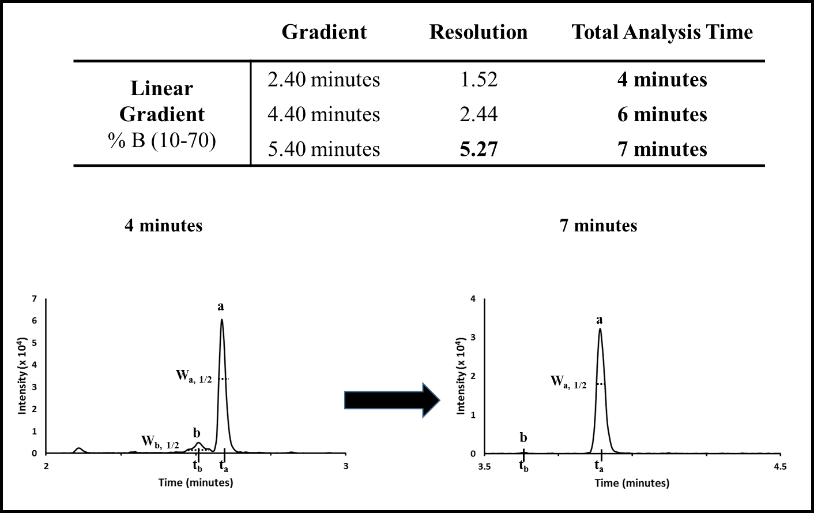
Figure S2. Chromatographic separation of MCPG. Initial method development revealed an isobaric interference (b) near the MCPG (100 ng/mL) peak (a). The linear gradient was varied to increase the resolution (R$=\frac{1.18 (t_{a}-t_{b})}{W_{a{,1/}_{2}}+ W_{b{,1/}_{2}}})$ of MCPG. Here:$t_{a} and t_{b}$ represent peak retention times and $W_{a{,1/}_{2}} and{ W}_{b{,1/}_{2}}$represent the peak-widths at 50% of the peak height. The final gradient led to a 247% improvement in resolution (R=5.27).

