Incidence of Primary Liver Cancer in American Indians and Alaska Natives, US, 1999-2009

Stephanie C. Melkonian, PhD¹; Melissa A. Jim, MPH¹ ; Brigg Reilley, MPH² ; Jennifer Erdrich, MD MPH³; Zahava Berkowitz, MSc, MSPH⁴ ;Charles L. Wiggins, PhD, MSPH⁵ ; Donald Haverkamp,MPH¹ ; Mary C. White, ScD⁴

Author Affiliations ¹ Division of Cancer Prevention and Control, Centers for Disease Control and Prevention, Albuquerque, New Mexico; ² Northwest Portland Area Indian Health Board, Portland, OR, ³ Cedars-Sinai Medical Center, Department of Surgery, Los Angeles, California ⁴ Division of Cancer Prevention and Control, Centers for Disease Control and Prevention, Atlanta, Georgia; ⁵ New Mexico Tumor Registry, University of New Mexico Comprehensive Cancer Center, Albuquerque, New Mexico
Journal: Cancer Causes and Control

Supplementary Figure 1: States and Contract Health Service Delivery Area Counties by Indian Health Service Region
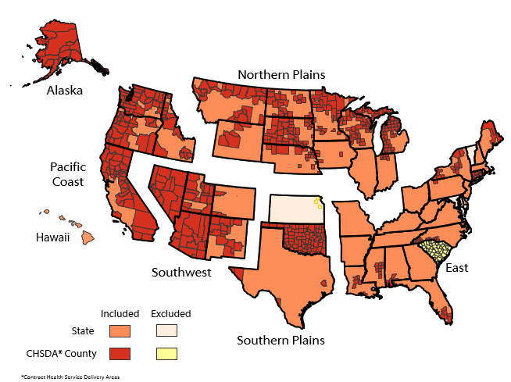

Supplementary Figures 2a and 2b

Figure 2a: Invasive liver cancer incidence rates for non-Hispanic American Indians/Alaska Natives (AI/AN) and non-Hispanic whites, CHSDA counties, United States, 1999-2009. Source: Central Cancer Registries in National Program of Cancer Registries of the Centers for Disease Control and Prevention and/or the Surveillance, Epidemiology, and End Results Program of the National Cancer Institute. Rates are per 100,000 persons and are age-adjusted to the 2000 US standard population (19 age groups Census P25-1130).

Figure 2b: Invasive liver cancer incidence rates for non-Hispanic American Indians/Alaska Natives (AI/AN) and non-Hispanic whites under the age of 60, CHSDA counties, United States, 1999-2009. Source: Central Cancer Registries in National Program of Cancer Registries of the Centers for Disease Control and Prevention and/or the Surveillance, Epidemiology, and End Results Program of the National Cancer Institute. Rates are per 100,000 persons and are age-adjusted to the 2000 US standard population (19 age groups Census P25-1130)

Supplementary Table 1: Prevalence of Liver Cancer Risk Factors in American Indians/Alaska Natives (BRFSS 1999-2009) by IHS region
 |  | %Yes
Gender | Region | Ever Smoker | Diabetes | Overweight/ Obesity | Binge Drinking | Hypertension
Female
 | Northern Plains | 59.8 | 12.4 | 63.0 | 13.8 | 28.7
 | Alaska | 65.0 | 6.0 | 67.9 | 15.2 | 29.0
 | Southern Plains | 51.2 | 12.2 | 60.9 | 8.6 | 30.1
 | Southwest | 33.7 | 13.3 | 66.4 | 8.9 | 24.1
 | Pacific Coast | 51.2 | 14.2 | 61.6 | 12.9 | 26.6
 | East | 64.5 | 11.6 | 55.6 | 9.1 | 30.0
 | Total US | 51.1 | 12.5 | 68.9 | 10.5 | 28.6
Male
 | Northern Plains | 72.1 | 13.6 | 69.9 | 27.5 | 31.1
 | Alaska | 73.7 | 5.3 | 69.9 | 22.7 | 28.0
 | Southern Plains | 59.5 | 14.2 | 71.6 | 24.2 | 32.7
 | Southwest | 49.5 | 15.6 | 72.3 | 21.4 | 25.3
 | Pacific Coast | 59.6 | 13.5 | 70.7 | 20.1 | 29.6
 | East | 51.1 | 10.6 | 66.2 | 23.2 | 29.7
 | Total US | 63.0 | 12.3 | 60.5 | 23.4 | 30.2
 | Pearson Correlation Coefficient (P-value)* | 0.32 (0.31) | 0.29 (0.35) | 0.79 (0.002) | 0.84 (0.001) | 0.23 (0.46)
BRFSS= Behavior Risk Factor Surveillance System, IHS = Indian Health Service
*Pearson Correlation Coefficient represents correlation between population level risk factor prevalence data and liver cancer incidence rates

Supplementary Table 2: Percent Individuals Responding "Yes" to question " I did not see a doctor in the past 12 months because of cost" (BRFSS 1999-2009) by IHS region
 |  | %Yes
Gender | Region | AI/AN | White
Both Genders
 | Northern Plains | 18.5 | 8.9
 | Alaska | 13.5 | 12.4
 | Southern Plains | 18.5 | 12.4
 | Southwest | 16.8 | 10.7
 | Pacific Coast | 15.4 | 10.5
 | East | 21.6 | 10.6
 | Total US | 18.8 | 10.4
Female
 | Northern Plains | 21.1 | 10.4
 | Alaska | 14.2 | 15.1
 | Southern Plains | 22.8 | 15.6
 | Southwest | 18.6 | 12.7
 | Pacific Coast | 18.1 | 12.5
 | East | 23.9 | 12.5
 | Total US | 21.3 | 12.3
Male
 | Northern Plains | 16.0 | 7.4
 | Alaska | 12.9 | 10.0
 | Southern Plains | 14.6 | 9.2
 | Southwest | 15.0 | 8.8
 | Pacific Coast | 12.6 | 8.5
 | East | 19.9 | 8.6
 | Total US | 16.7 | 8.5
BRFSS= Behavior Risk Factor Surveillance System, IHS = Indian Health Service

