Online-Only Supplementary Material

Supplement to: Kahn HS, Cheng YJ. Comparison of adiposity indicators associated with fasting-state insulinemia,
triglyceridemia, and related risk biomarkers in a nationally representative, adult population.

- Figure S1

- Tables S1 and S2

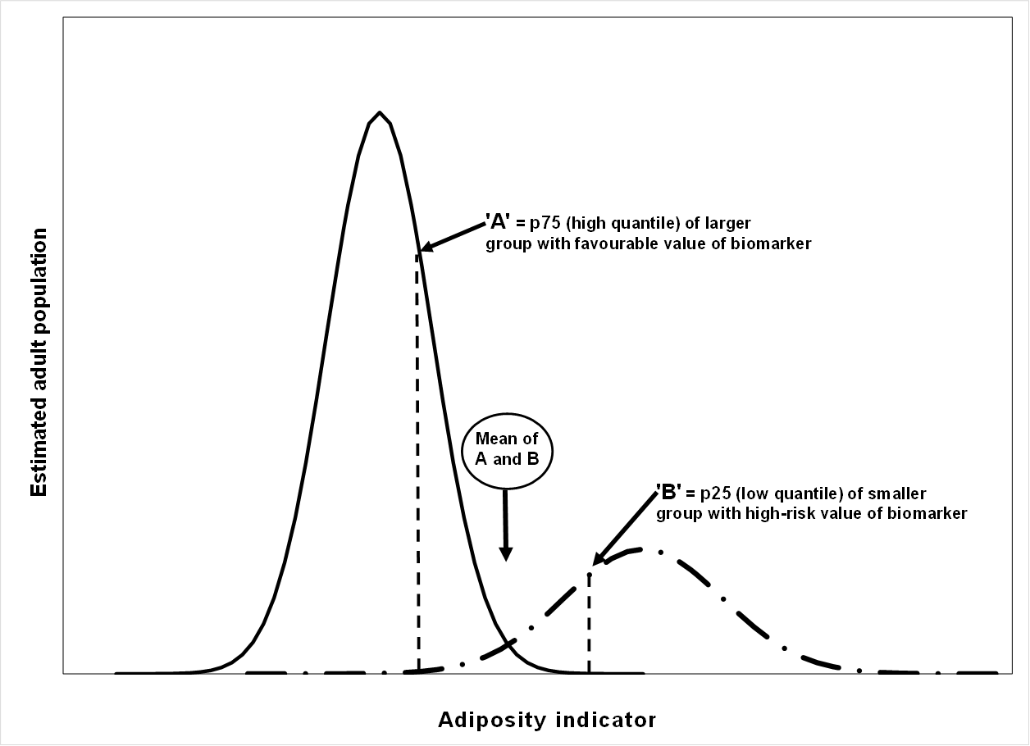

Figure S1 -- Example of threshold estimation for an adiposity indicator (SADHtR, WHtR, or BMI) to categorize adult sub-populations according to high-risk biomarker status (25% of persons denoted by broken line) or more favorable biomarker status (75% of persons denoted by solid line). An estimated adiposity threshold is the mean of adiposity values A and B.
Table S1. Thresholds of SADHtR, WHtR, and BMI for identifying a high-risk group (most adverse 25%) of five outcome biomarkers.

To estimate the adiposity thresholds in these examples, we first identified the 75th percentile of each biomarker in the represented adult population. Then we used these biomarker values as the cutoffs for dichotomizing the population into a high-risk group (the most adverse 25%) and a favorable-risk group (the less adverse 75%) with regard to the biomarker of interest.

For the high-risk group and the favorable-risk group we calculated the separate distributions (p25, p50 [median], and p75) of the three adiposity indicators under comparison (SADHtR, WHtR, and BMI).

Note that:

- For the insulin-based biomarkers (fasting insulin, HOMA-IR) the difference between medians was approximately 0.03 for SADHtR, 0.11 for WHtR, and 7.1 kg/m² for BMI.

- For the lipid-based biomarkers that serve as proxy variables for insulin resistance (fasting triglycerides, triglycerides/HDLc, TyG index) there was a smaller difference between median adiposity values of approximately 0.02 for SADHtR, 0.06 for WHtR, and 3.8 kg/m² for BMI. That is, for these lipid-based biomarkers there was a greater degree of overlap for the adiposity indicators.

As illustrated in Figure S1 (above), each adiposity threshold was calculated as the mean of the upper-quartile cut point (‘A’) for the favorable group and the lower-quartile cut point (‘B’) for the adverse group.

 |  |  | Group with biomarker in favorable 75% |  |  | Mean of 'A' and 'B' | Uncertainty* of the mean | Group with biomarker in most adverse 25%
 |  | Distributions of adiposity indicators within the two groups: => | p25 | p50  median | p75 ['A'] | - - - | - - - | p25 ['B'] | p50  median | p75
SADHtR | Insulin-based biomarkers
 | Fasting insulin † |  | 0.1096 | 0.1241 | 0.1392 | 0.1397 | 0.72% | 0.1402 | 0.1542 | 0.1741
 | HOMA-IR, insulin resistance † |  | 0.1096 | 0.1239 | 0.1388 | 0.1401 | 1.79% | 0.1413 | 0.1555 | 0.1757
 | Lipid-based biomarkers
 | Fasting triglycerides ‡ |  | 0.1103 | 0.1261 | 0.1450 | 0.1366 | 12.30% | 0.1282 | 0.1445 | 0.1620
 | Triglycerides/HDLc, proxy insulin resistance ‡ |  | 0.1100 | 0.1254 | 0.1447 | 0.1373 | 10.78% | 0.1299 | 0.1460 | 0.1631
 | Fasting TyG Index, proxy insulin resistance ‡ |  | 0.1101 | 0.1252 | 0.1440 | 0.1371 | 10.07% | 0.1302 | 0.1469 | 0.1637
WHtR | Insulin-based biomarkers
 | Fasting insulin † |  | 0.5041 | 0.5557 | 0.6091 | 0.6054 | 1.24% | 0.6016 | 0.6621 | 0.7266
 | HOMA-IR, insulin resistance † |  | 0.5040 | 0.5544 | 0.6072 | 0.6066 | 0.21% | 0.6059 | 0.6652 | 0.7327
 | Lipid-based biomarkers
 | Fasting triglycerides ‡ |  | 0.5065 | 0.5629 | 0.6250 | 0.5962 | 9.68% | 0.5673 | 0.6204 | 0.6871
 | Triglycerides/HDLc, proxy insulin resistance ‡ |  | 0.5056 | 0.5621 | 0.6238 | 0.5967 | 9.08% | 0.5696 | 0.6247 | 0.6936
 | Fasting TyG Index, proxy insulin resistance ‡ |  | 0.5055 | 0.5608 | 0.6217 | 0.5986 | 7.72% | 0.5755 | 0.6288 | 0.6936
BMI | Insulin-based biomarkers
 | Fasting insulin † |  | 23.25 | 26.43 | 29.73 | 29.59 | 0.92% | 29.46 | 33.49 | 38.89
 | HOMA-IR, insulin resistance † |  | 23.24 | 26.41 | 29.71 | 29.63 | 0.57% | 29.54 | 33.59 | 38.80
 | Lipid-based biomarkers
 | Fasting triglycerides ‡ |  | 23.43 | 26.88 | 31.11 | 29.07 | 14.04% | 27.03 | 30.41 | 34.67
 | Triglycerides/HDLc, proxy insulin resistance ‡ |  | 23.38 | 26.73 | 31.02 | 29.31 | 11.61% | 27.61 | 30.66 | 35.46
 | Fasting TyG Index, proxy insulin resistance ‡ |  | 23.38 | 26.70 | 30.94 | 29.25 | 11.54% | 27.57 | 30.70 | 35.33

* Uncertainty = |(adiposity cut point ‘A’ – adiposity cut point ‘B’)| / mean value
† sample n=4251
‡ sample n=4353

Table S2 -- Stratification by ancestry (Blacks vs non-Blacks) showing risk ratios associated with a one-IQR increment of SADHtR, WHtR, or BMI for being in the most adverse 25% (group Q4) of five biomarkers
 |  | Black |  |  |  | non-Black
Biomarker |  | RR for adverse group of biomarker | 95% LL | 95% UL |  | RR for adverse group of biomarker | 95% LL | 95% UL
Fasting insulin | SADHtR | 4.18 | 3.23 | 5.42 |  | 5.97 | 5.11 | 6.98
 | WHtR | 3.46 | 2.80 | 4.28 |  | 5.16 | 4.48 | 5.93
 | BMI | 3.27 | 2.63 | 4.05 |  | 4.44 | 3.90 | 5.06
HOMA-IR, insulin resistance | SADHtR | 4.49 | 3.54 | 5.69 |  | 6.20 | 5.23 | 7.36
 | WHtR | 3.67 | 3.07 | 4.39 |  | 5.34 | 4.60 | 6.18
 | BMI | 3.27 | 2.70 | 3.96 |  | 4.18 | 3.69 | 4.74
Fasting triglycerides | SADHtR | 1.52 | 1.28 | 1.80 |  | 2.18 | 1.93 | 2.47
 | WHtR | 1.39 | 1.19 | 1.62 |  | 1.94 | 1.71 | 2.21
 | BMI | 1.25 | 1.10 | 1.41 |  | 1.70 | 1.52 | 1.90
Triglycerides/HDLc, proxy insulin resistance | SADHtR | 1.98 | 1.69 | 2.30 |  | 2.53 | 2.27 | 2.83
 | WHtR | 1.75 | 1.53 | 2.02 |  | 2.30 | 2.05 | 2.58
 | BMI | 1.55 | 1.37 | 1.75 |  | 1.98 | 1.80 | 2.18
Fasting TyG Index, proxy insulin resistance | SADHtR | 1.62 | 1.38 | 1.92 |  | 2.34 | 2.13 | 2.57
 | WHtR | 1.50 | 1.28 | 1.75 |  | 2.09 | 1.90 | 2.30
 | BMI | 1.32 | 1.16 | 1.51 |  | 1.79 | 1.65 | 1.95

________________________________________________________________________________________________________________
All models were adjusted for age (in 7 decades). Models for fasting insulin and HOMA-IR were adjusted also for use of insulin and oral anti-glycemic medication. Models for triglycerides and Tg/HDLc were adjusted also for sex. Models for TyG index were adjusted also for sex and use of insulin and oral anti-hyperglycemic medication.

