Experimental and modeling study of visible light responsive photocatalytic oxidation (PCO) materials for toluene degradation

Lexuan Zhong¹, James J. Brancho², Stuart Batterman^{1*}, Bart M. Bartlett², Christopher Godwin¹
¹ Environmental Health Sciences, University of Michigan, Ann Arbor, MI, USA
² Chemistry, University of Michigan, Ann Arbor, MI, USA
Mar. 12, 2017

*Corresponding email: stuartb@umich.edu
M6075 SPH II, 1415Washington Heights, Ann Arbor, MI 48109-2029, USA
Tel: 734/763-2417 E-mail: stuartb@umich.edu

Supplemental Materials
Supplemental Table S1 | ATD and GC/MS operating parameters.
Supplemental Table S2 | Experimental conditions
Supplemental Figure S1 | Comparison of PCO and regeneration performance for three coatings challenged by 3.8 mg/m³ toluene at 25% RH and 0.2 L/min with BLB (7.5 W/m²).
Supplemental Figure S2 | Loss masses and loss percentages for three coatings at peeling-off speeds of 2.5 cm/s and 0.25 cm/s.
Supplemental Figure S3 | Toluene concentrations at upstream and downstream and formaldehyde generation during adsorption and PCO of toluene.
Supplemental Figure S4 | PXRD pattern of TiNbON catalysts
Supplemental Figure S5 | Schematic diagram of the control volume in the cross-section of the PCO reactor.
Supplemental Figure S6 | Overall model predictions vs. experimental results for the models of LH-1 and LH-2.

Supplemental Table S1. ATD and GC/MS operating parameters.
Step | Parameter | Value
Auto-thermal desorption | ATD purge time | 1.0 min
 | ATD inject time | 1.0 min
 | ATD desorption temperature | 200.0°C
 | ATD desorb time | 5.0 min
 | Cryo-Trap cool temperature | -140°C
 | Cryo-Trap cool time | 7.3 min
 | Cryo-Trap heat temperature | 250°C
 | Cryo-Trap heat time | 5.0 min
GC separation | Carrier gas | Helium, 1 mL/min, velocity at 25 cm/sec
 | Injector | Split, temperature at 230°C, split ratio:8:1
 | Column | DB-VRX (J&W Scientific)  60 m x 0.25 mm, 1.4 um film thickness
 | Oven temperature program | 45°C hold for 10 min; 8°C /min to 140°C, hold for 10 min; 30°C /min to 225°C hold for 13 min.
MS | Mass type | Scan
 | Low mass | 29 AMU
 | High mass | 270 AMU
 | MS quad temp | 150°C
 | MS source | 230°C
 | Scan rate | 3 scan/sec
 | Step size | 0.1 AMU

Supplemental Table S2. Experimental conditions.
Parameter | Experimental conditions
VOC | Toluene
Inlet concentration (mg/m³) | 3.8, 7.5, 18.8
Air flow rate (L/min) | 0.2, 1.0, 2.0
Air velocity (mm/s) | 7.8, 39.2, 78.4
Resident time (s) | 1.3, 6.5, 13
RH (%) | 25, 50, 65
Irradiance (W/m²) | 42, 64, 95
Temperature (°C) | 21-22

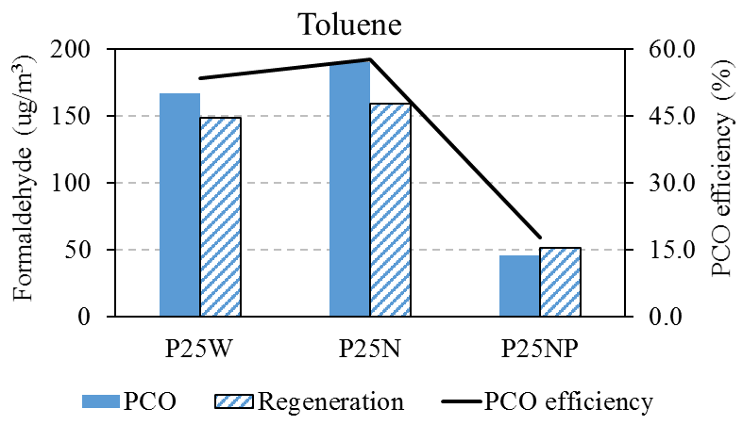
Supplemental Figure S1: Comparison of PCO and regeneration performance for three coatings challenged by 3.8 mg/m³ toluene at 25% RH and 0.2 L/min with BLB (7.5 W/m²). Note: P25W stands for P25 mixing with water containing 0.1 ml acetylacetone; P25N stands for P25 mixing with n-methyl pyrrolidone (NMP); P25NP stands for P25 mixing with NMP and additional polyvinylidine fluoride (PVDF; 25 mg for 5%).

The adhesion strength of P25W, P25N, and P25NP on the aluminum pieces was carried out by peeling-off tests. The results indicate that P25W has poorest adhesions at two peeling speeds and P25NP has a slightly better bonding than P25N to the surfaces.
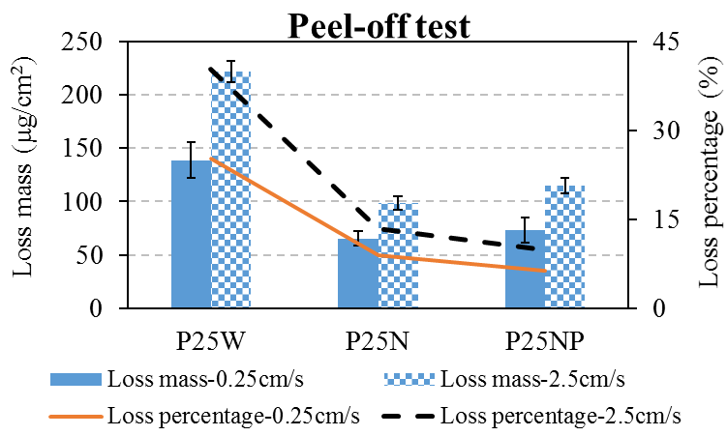
Supplemental Figure S2: Loss masses and loss percentages for three coatings at peeling-off speeds of 2.5 cm/s and 0.25 cm/s.

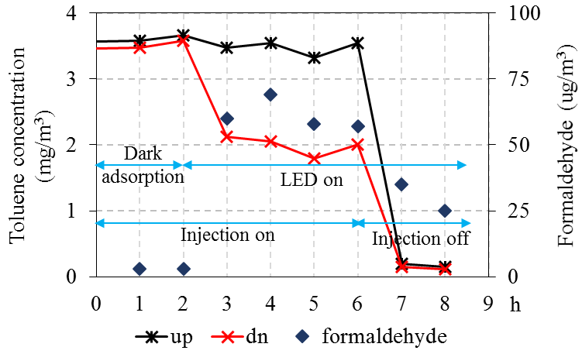
Supplemental Figure S3. Toluene concentrations at upstream and downstream and formaldehyde generation during adsorption and PCO of toluene (inlet toluene=3.8 mg/m³, 25%RH, I=95W/m²).

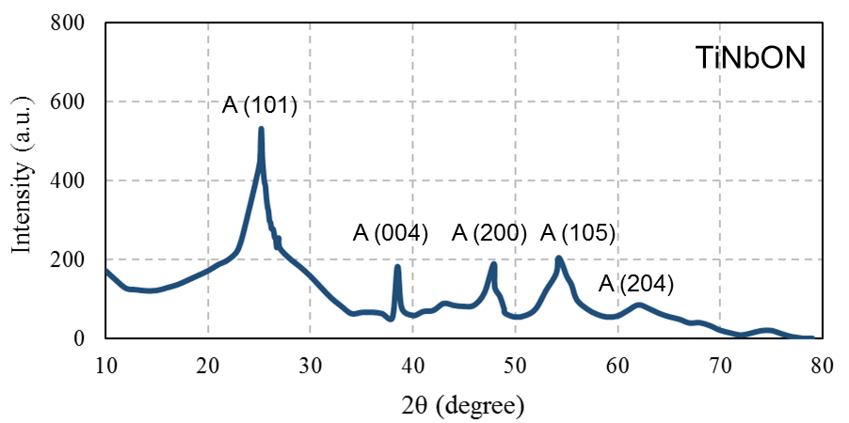
Supplemental Figure S4. PXRD pattern of TiNbON catalysts

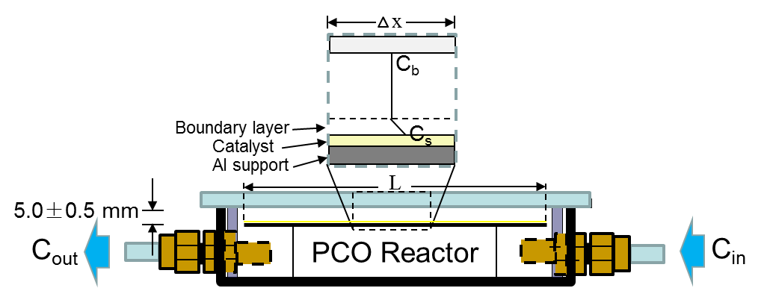
Supplemental Figure S5. Schematic diagram of the control volume in the cross-section of the PCO reactor

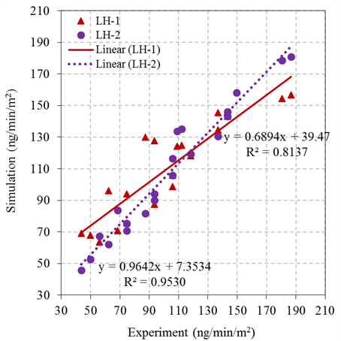
Supplemental Figure S6. Overall model predictions vs. experimental results for the models of LH-1 and LH-2.

