Supplemental Figure 3a. Number of IS256 elements in C1 genomes over time

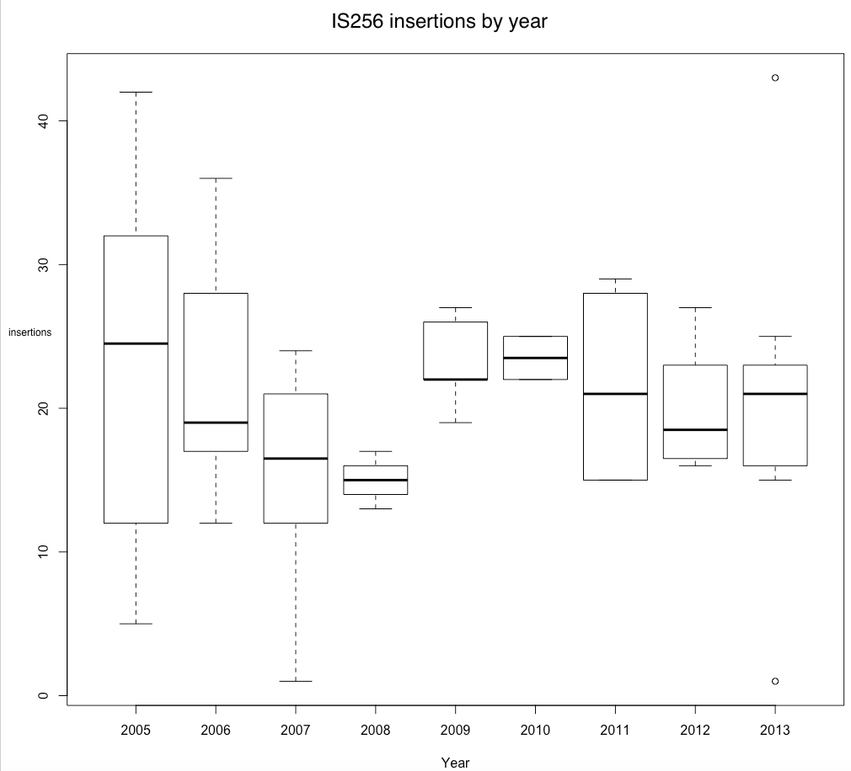

Supplemental Figure 3b. Sites for insertion of IS256 on the 2395 chromosome.

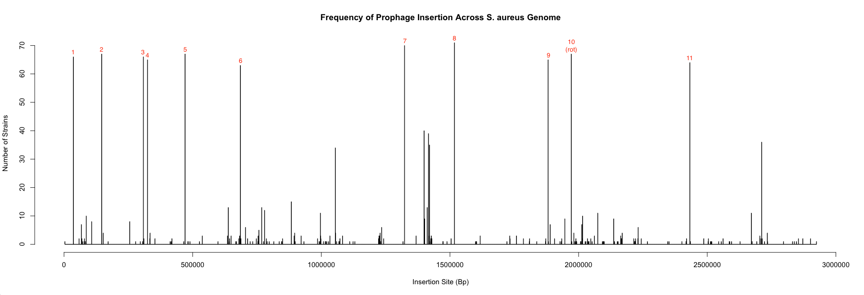
X-axis is the coordinate position on the MRSA 2395 chromosome.

