Supplemental Figure 2a. Antibiotic resistances by year all strains

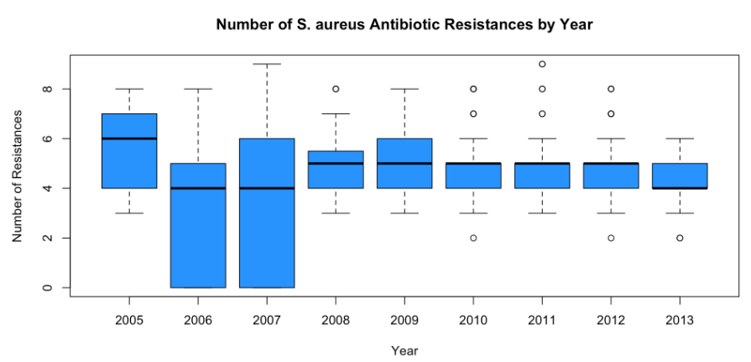

Supplemental Figure 2b. Antibiotic resistances by year by USA500 clade

