**Supporting Information**

**Characterization of Chemical Contaminants Generated by a Desktop Fused Deposition Modeling 3-Dimensional Printer**

Aleksandr B. Stefaniaka,*,Ryan F. LeBoufa, Jinghai Yib, Jason Hama, Timothy Nurkewiczb, Diane Schwegler-Berrya, Bean T. Chena, J. Raymond Wellsa, Matthew G. Dulinga, Robert B. Lawrencea, Stephen B. Martin, Jr.a, Alyson R. Johnsona, M. Abbas Virjia

a National Institute for Occupational Safety and Health, Morgantown, WV, USA 26505 ([RLeBouf@cdc.gov](mailto:RLeBouf@cdc.gov), [JHam1@cdc.gov](mailto:JHam1@cdc.gov), [DSchwegler-Berry@cdc.gov](mailto:DSchwegler-Berry@cdc.gov), [TChen@cdc.gov](mailto:TChen@cdc.gov), [MDuling@cdc.gov](mailto:MDuling@cdc.gov), [RLawrence@cdc.gov](mailto:RLawrence@cdc.gov), [SMartin1@cdc.gov](mailto:SMartin1@cdc.gov), [AJohnson13@cdc.gov](mailto:AJohnson13@cdc.gov), [MVirji@cdc.gov](mailto:MVirji@cdc.gov), [AStefaniak@cdc.gov](mailto:AStefaniak@cdc.gov))

b Center for Cardiovascular and Respiratory Sciences and Department of Physiology and Pharmacology, West Virginia University School of Medicine, Morgantown, WV 26506 ([jiyi@hsc.wvu.edu](mailto:jiyi@hsc.wvu.edu), [tnurkiewicz@hsc.wvu.edu](mailto:tnurkiewicz@hsc.wvu.edu))

*Author to whom correspondence should be sent

Aleksandr B. Stefaniak, PhD, CIH

National Institute for Occupational Safety and Health

Division of Respiratory Diseases

1095 Willowdale Road

Morgantown, WV 26505

Tel.: +1-304-285-6302

Fax: +1-304-285-5820

E-mail: [AStefaniak@cdc.gov](mailto:AStefaniak@cdc.gov)

Number of pages: 16

Number of figures: 6

Number of tables: 1

# Materials and Methods

## Sample preparation and gas chromatography-mass spectrometry analyses

Canister samples were prepared and analysed as described previously (1). Canisters were concentrated prior to analysis using an autosampler (Model 7016CA, Entech Instruments, Inc., Simi Valley, CA) with a 100 °C transfer line attached to a pre-concentrator (Model 7200, Entech). The pre-concentrator was coupled with a 6890N/5973N GC-MS system (Agilent Technologies, Inc., Santa Clara, CA) with a RTX-1 capillary column 60 m long x 0.32 mm ID x 1 mm film thickness (Restek Corporation, Bellefonte, PA). Pre-concentration conditions were: modified cold trap dehydration; module 1 (empty) at -20 °C, desorbed at 10 °C, and baked at 150 °C for 7 min; module 2 (glass beads) focused at -80 °C, desorbed at 180 °C, and baked at 190 °C; and module 3 (focuser) focused at -150 °C. GC conditions were: oven temperature program set to 35 °C for 2 min, followed by 8 °C min-1 ramp to 170 °C, then 20 °C min-1 ramp to a final temperature of 220 °C, which was held for 3 min; injector temperature was set to 250 °C with a 20:1 split (split flow 20.2 mL/min); detector temperature was 280 °C; and column flow rate was set to 1 mL min-1. Mass spectrometer analysis conditions were: scan mode 35–350 amu; threshold at 150; scan speed at 2.84 scans s-1; solvent delay to 4.5 min; source temperature at 230 °C; and, quadrapole temperature at 150 °C. A one-point calibration check standard (10 ppb) and instrument blank (UHP nitrogen gas) were analyzed with each set of samples within a 24-hour period. MSD Chemstation D.02.00.275 (Agilent Technologies, Inc.) was used for data acquisition. Chromatograms were integrated and the resulting data were transferred to spreadsheets for subsequent blank correction and data handling prior to statistical analysis; final concentrations were calculated based on the response of the closest internal standard (bromochloromethane, 1,4-difluorobenzene, and chlorobenzene-d5). All quantitative measurement results were background corrected for the concentration of VOCs measured inside the chamber during the pre-operating phase. Additionally, the full chromatograms were screened for tentative identification of compounds using the National Institute for Standards and Technology 2011 mass spectral database with a chemical match determined based on a 75% quality factor. A quality factor of 75% was chosen to ensure that we did not errantly dismiss compound identities based on noisy spectrum. Identified compounds were reported when their responses exceeded that of background samples.

For all carbonyl bubbler samples, after collection, the water was decanted into 40 mL vials, then derivatized with 100 L aqueous 250 mM O-tert-butylhydroxylamine hydrochloride (TBOX, Sigma Aldrich, St. Louis, MO) and placed in a heated water bath at 70 oC for 2 hours. After removing the vial from the water bath and allowing to cool to room temperature, 0.5 mL of toluene was added to the vial. The vial was then shaken for 30 seconds and allowed to separate into a toluene layer and aqueous layer. Then 100 L of the toluene layer was removed with a pipette and placed in a 2 mL autosampler vial with a 100 L glass insert (Resetk, Bellefonte, PA). Then 1 L of the TBOX-derivatized extract was analyzed using a Varian (Palo Alto, CA) 3800/Saturn 2000 GC-MS system operated in the electron impact (EI) mode. Full-scan EI ionization spectra were collected from m/z 40-650. Compound separation was achieved by an Agilent (Santa Clara, CA) HP-5MS (0.25 mm I.D., 30 m long, 0.25 µm film thickness) column and the following GC oven parameters: 40 oC for 2 min, then 5 oC min-1 to 200 oC, then 25 oC min-1 to 280 oC and held for 5 min. One µL of each sample was injected in the splitless mode, and the GC injector was returned to split mode 1 min after sample injection, with the following injector temperature parameters: 130 oC for 2 min then 200 oC min-1 to 300 oC and held for 10 min. The Saturn 2000 ion trap mass spectrometer was tuned using perfluorotributylamine (FC-43).

## Data analysis

Unit specific emission rates (SERu) were calculated from the TVOC and ozone data for the 3-D and laser printers in accordance with RAL-UZ-171: Test Method for the Determination of Emissions from Hardcopy Devices (2). For TVOC, the emission rate during printing is calculated from the beginning of the print phase (from start to end of print job) until one air exchange has occurred in the post-operating phase (print job ended, printer on):



For ozone, the emission rate is determined from the increase in concentration during the initial printing phase (before end of print job) to minimize loss by chemical reactions with air constituents. Data points used represent the measurement interval that provided the greatest slope for the interval:



# Results and Discussion

## Identification of carbonyl compounds

Carbonyl compounds were formed during the print and post-print phase emissions for all the printers investigated. An example chromatogram is provided in the main text and a mass spectrum for 4-oxopentanal formed during 3-D printing with natural color ABS filament is shown as Figure S2.

## Identification of individual VOCs

Various aldehydes, alkanes, alkenes, aromatics, cycloalkanes, dienes, halogenated compounds, ketones, nitriles, organic acids, organic lead, and silanes were detected during printing operations. Figure S3 shows compounds qualitatively identified by spectral matching. Note that this figure shows the presence or absence of compounds only and does not represent concentrations. No single compound was common to all printers. Silanes were frequently identified in air during 3-D and laser printing. The presence of high-boiling siloxanes is of interest because Wensing et al. hypothesize that the formation of printer UFP aerosol is significantly influenced by semi-volatile organic compounds such as siloxanes which likely originate from heating of the laser printer fuser unit (3); however, we cannot rule out that the silanes we observed in our samples were from GC column bleed.

## Elemental composition of airborne particulate

No particles were observed during inspection of filter samples collected during the pre-operating phase. Figure S4 shows electron micrographs of particles emitted while printing with different colors of ABS filament. Replicate samples were collected for each combination of filament type and color and the morphology of visualized particles was consistent among samples. For simplicity, only representative particles from the samples are shown in the figure. Particles in chamber air during printing with natural color were solid with elongated shape and diameters of ~1 to 2 µm as well as agglomerates of nanoscale particles (Figure S4a). For blue ABS, nanoparticles having smooth spherical morphology and diameters less than 200 nm were visible as clusters, some of which had a branched structure and micronscale (Figure S4b). When printing with red ABS, airborne particles had ellipsoid morphology and lengths (long axis) that were on the order of a few hundred nanometers (Figure S4c). Particles in air during printing with black ABS were discrete spherical submicron and nanoscale particles (Figure S4d). Elemental analysis revealed that captured particles from printing with natural, blue, and red color ABS contained chromium (Cr) and nickel (Ni). Other elements identified in particles, but not consistently among all filament ABS filament colors, included magnesium (Mg), silicon (Si), sodium (Na), chlorine (Cl), calcium (Ca), aluminium (Al) and sulphur (S). Figure S5 shows electron micrographs of particles emitted while printing with different colors of PLA filament. All particles were discrete spheroidal particles with nanoscale diameters. With exception of true red, all particles contained iron (Fe). Steinle also reported that a nanoscale particle collected during 3-D printing contained Fe though that study did not specify if the particle was from printing with PLA or ABS filaments (4). Previous studies have reported that particles emitted from laser printers using monochrome toner contained all of these same elements as observed for the 3-D printing (5-10). In those studies, Cr, Na, Si, and S were attributed to pigments and additives (5-7).

Figure S6 shows differences in morphology and composition of particles collected in chamber air during laser printing. For the HP2055dn printer, particles were elongated with micrometer-scale diameters (~3 to 5 µm) though agglomerates of spherical nanoscale particles were also identified (see inset). Chromium and S were identified in particles collected on filters during printing with the HP2055dn. Particles collected in chamber air during printing with the HP2600 laser printer were round smooth spheres with diameters ~2 µm.

## Comparison of particulate emission rates between 3-D and laser printers

In addition to monitoring chamber air for TVOCs, individual VOCs, gas-phase carbonyls, and particulate for off-line microscopy analysis we also used real-time instruments to characterize particulate size distribution, number concentration, and mass concentration during laser printing. Briefly, particle size and number concentration were measured using complementary instruments to cover the nanoscale to the micronscale: 14.6 nm to 0.66 µm using a scanning mobility particle sizer (SMPS, Model 3910, TSI Inc., Shoreview, MN) and >0.65 to 20 µm using a GRIMM optical particle counter (Model 1.108, GRIMM Aerosol Technik GmbH & Co. Ainring, Germany). Particle size was measured over the range 24 nm to 9.38 μm using an electrical low-pressure impactor (ELPI Classic, Dekati Ltd., Tampere, Finland). Total particle mass concentration was measured using a DustTrak DRX aerosol monitor (Model 8534, TSI Inc.). The inlets of the sampling probes were placed side-by-side and at similar locations to the probes for the gas samplers inside the chamber.

The time required to print an object using the 3-D printer differed from the time required to print a standard monochrome template using the laser printers. As such, to permit comparison between device types, we calculated real-time particle emission rates (PER) which normalize emissions to time. PER from the printers were calculated using a box-model. Details of the model derivation were given previously by Yi et al. and are only briefly summarize here. To calculate PER, we assumed the following (11):

1. the particle concentration in the test chamber before printing phase is negligible compared to that of emitted particles (a vacuum leak test shows the leak rate = 0.05 L min-1, ~0.2% of 25 L min-1 air flow through the chamber);
2. the deposition of the particles on the inner surfaces of this chamber is negligible;
3. the particles are not broken up in the chamber and sampling tubing;
4. the particles do not agglomerate in the chamber and sampling tubing; and
5. the particle concentration is uniform in the chamber (as noted in the main text).

If we look at an incremental time period, *Δt*, a change in the particle number ( ) equates to the particles emitted by the printer () minus the particles removed by the sampling air flow (, i.e.,



*(1)*



where, *t* = time, sec.

*Δt* = time difference between two successive data points, sec;

*C(t+Δt)* = particle number concentration at (t+Δt), particles cm-3;

*C(t)* = particle number concentration at (t), particles cm-3;

*V* = chamber volume, cm3;

*PER(t)* = real-time particle emission rate at (t), particles sec-1;

*C(mean)* = mean particle concentration between (t) and (t + Δt), particles cm-3;

*Q(t)* = sampling air flow rate at (t), cm3 sec-1.

The air exchange rate in the chamber is given by *.* And by substitution and rearranging, PER can be calculated as:



*(2)*



Equation *(2)* can be used to calculate PER for any real-time particle concentration data (number, mass, etc.). Yi et al. calculated PER values using their box model and the method described in RAL-UZ-171 (2, 11). An important difference in these methods is that the RAL calculation includes a particle loss coefficient, β, whereas Yi et al. assumed particle losses in the chamber were negligible. Values of β calculated using the RAL-UZ-171 model were on the order of 10-4, supporting the validity of our assumption and calculated PER values agreed within 8% between methods.

Table S1 summarizes PER valuesfrom the laser printers (this study) and 3-D printer (11). In general, the laser printers had significantly higher emissions of larger particles (diameter > 0.65 µm) as measured using a GRIMM optical particle counter (from highest to lowest): HP2055dn (80 pages) > HP2600 (80 pages) > all colors of ABS and PLA filaments. Previously, we reported that UFPs emitted by a FDM 3-D printer have high probability of depositing in the lung alveoli (11) and it is well known that UFPs and their constituents that reach this deep into the lung can cause strong inflammatory responses (12), e.g., via transition-metal-mediated reactive oxygen species generation. A detailed comparison of PER values and yield values among 3-D printer studies was given previously by Yi et al. and the reader is referred to that publication for more information (11). On a mass basis, the PER (µg min-1) were similar, i.e., HP2600 (80 pages) ≈ HP2055dn (80 pages) ≈ all colors of ABS and PLA filaments.

# References

1 **LeBouf, R.F., A.B. Stefaniak, and M.A. Virji:** Validation of evacuated canisters for sampling volatile organic compounds in healthcare settings. *J. Environ. Monit. 14(3)*: 977-983 (2012).

2 **Bundesanstalt für Materialforschung und-prüfung (BAM):** *Basic Criteria for Award of the Environmental Lable: Office Equipment with Printing Function (Printers, Copiers, Multifunction Devices)* (RAL-UZ-171). [Standard] St, Augustin, Germany: BAM, 2012.

3 **Wensing, M., T. Schripp, E. Uhde, and T. Salthammer:** Ultra-fine particles release from hardcopy devices: Sources, real-room measurements and efficiency of filter accessories. *Sci. Total Environ. 407(1)*: 418-427 (2008).

4 **Steinle, P.:** Characterization of emissions from a desktop 3D printer and indoor air measurements in office settings. *J. Occup. Environ. Hyg.* *13(2)*: 121-132 (2016).

5 **Barthel, M., V. Pedan, O. Hahn, M. Rothhardt, H. Bresch, O. Jann et al.:** XRF-analysis of fine and ultrafine particles emitted from laser printing devices. *Environ. Sci. Technol. 45(18)*: 7819-7825 (2011).

6 **Castellano, P., S. Canepari, R. Ferrante, and N. L'Episcopo:** Multiparametric approach for an exemplary study of laser printer emissions. *J. Environ. Monit. 14(2)*: 446-454 (2012).

7 **Morawska, L., C. He, G. Johnson, R. Jayaratne, T. Salthammer, H. Wang et al.:** An investigation into the characteristics and formation mechanisms of particles originating from the operation of laser printers. *Environ. Sci. Technol. 43(4)*: 1015-1022 (2009).

8 **Pirela, S.V., G.A. Sotiriou, D. Bello, M. Shafer, K.L. Bunker, V. Castranova et al.:** Consumer exposures to laser printer-emitted engineered nanoparticles: A case study of life-cycle implications from nano-enabled products. *Nanotoxicology 9(6)*: 760-768 (2015).

9 **Salthammer, T., T. Schripp, E. Uhde, and M. Wensing:** Aerosols generated by hardcopy devices and other electrical appliances. *Environ. Pollut. 169*: 167-174 (2012).

10 **Wang, Z.M., J. Wagner, and S. Wall:** Characterization of laser printer nanoparticle and VOC emissions, formation mechanisms, and strategies to reduce airborne exposures. *Aerosol Sci. Technol. 45(9)*: 1060-1068 (2011).

11 **Yi, J., LeBouf R..F, Duling M.G., Nurkiewicz T., Chen B.T., Schwegler-Berry D. et al.:** Emission of particulate matter from a desktop three-dimensional (3-D) printer. *J. Toxicol. Environ. Health A 79*: 453-465 (2016).

12 **Oberdorster, G.:** Pulmonary effects of inhaled ultrafine particles. *Int. Arch. Occup. Environ. Health 74(1)*: 1-8 (2001).

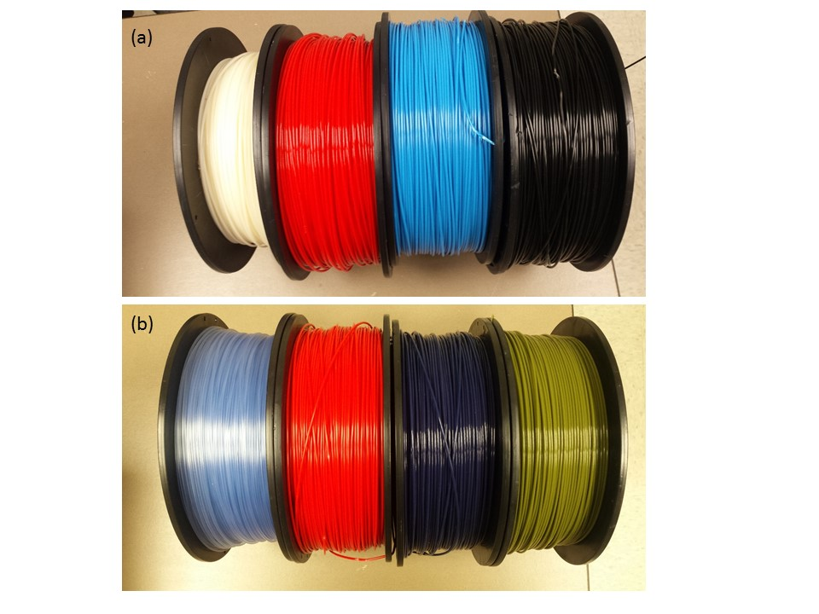

FIGURE S1. (a) ABS filament colors (from left to right): natural, red, blue, and black; (b) PLA filament colors (from left to right): transparent blue, red, ocean blue, and army green.

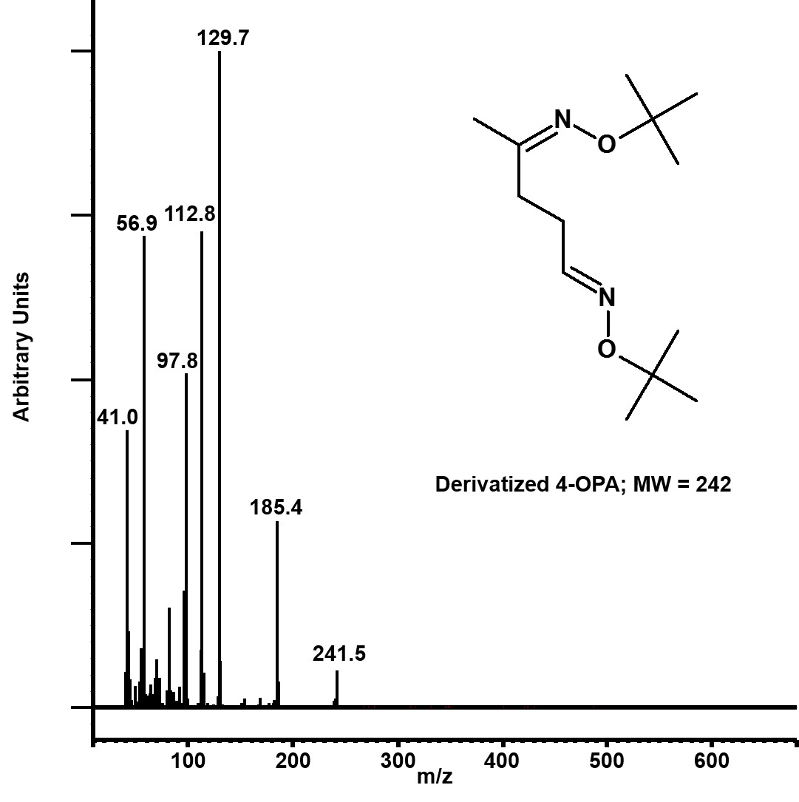

FIGURE S2. Mass spectrum of TBOX-derivatized 4-oxopentanal.

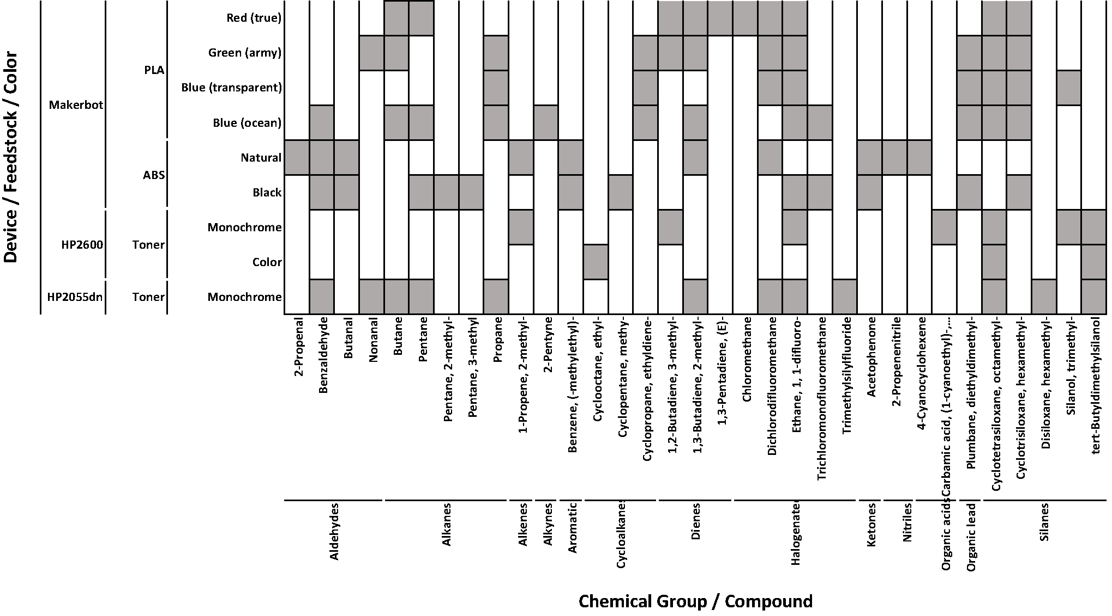

FIGURE S3. Qualitatively identified compounds in 3-D and laser printing emissions for all combinations of device and thermoplastic tested.

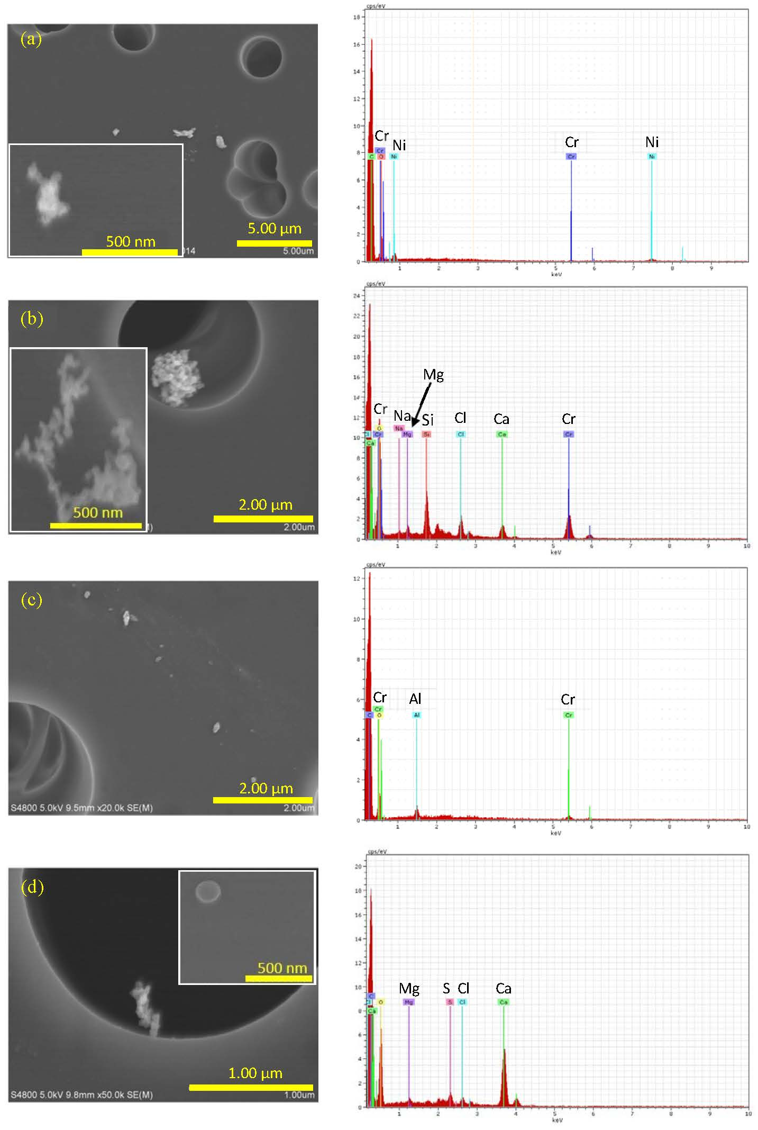

FIGURE S4. Morphology and elemental composition of ultrafine particles emitted by the desktop 3-D printer using different colors of ABS filament [note that scale bars differ among images]: (a) natural, (b) blue, (c) red, and (d) black.

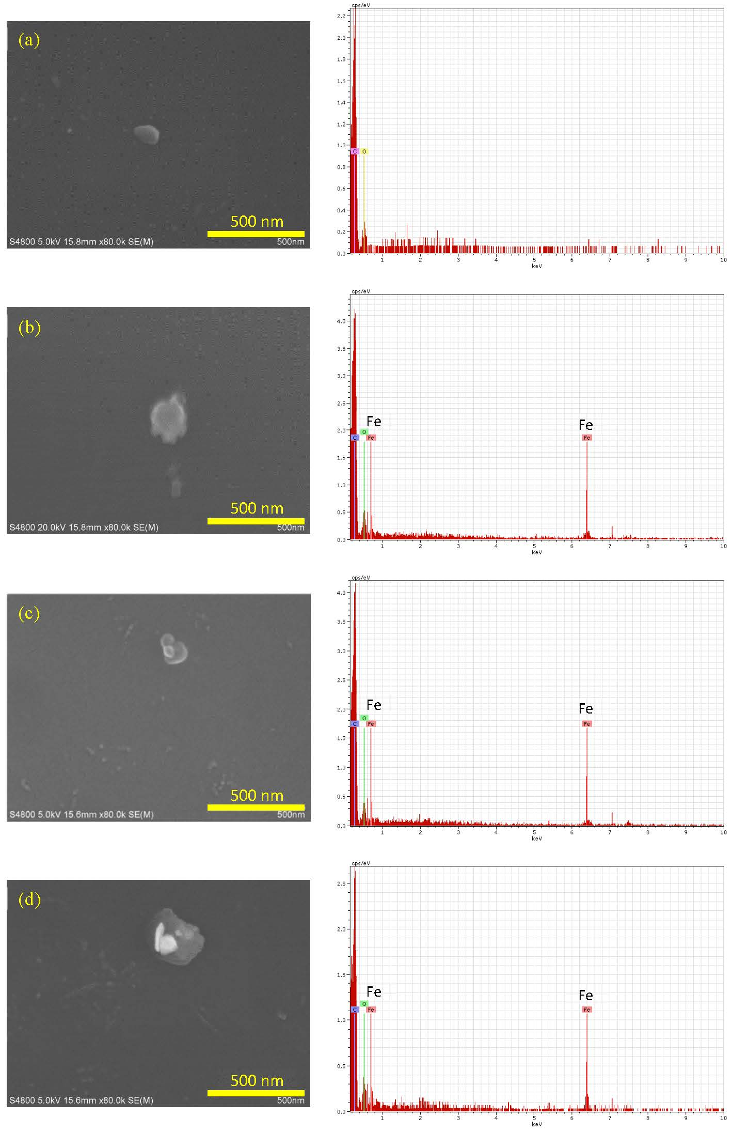

FIGURE S5. Morphology and elemental composition of ultrafine particles emitted by the desktop 3-D printer using different colors of PLA filament: (a) true red, (b) army green, (c) ocean blue, and (d) transparent blue.

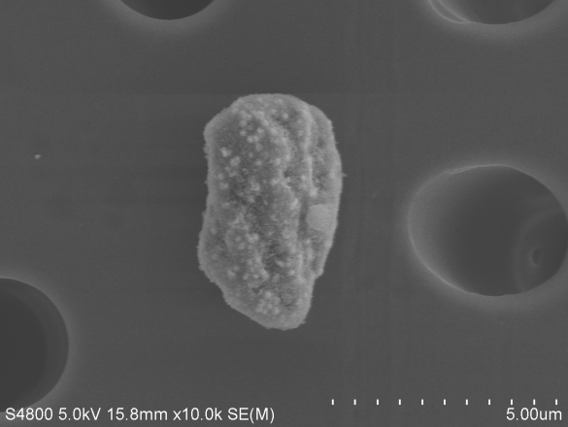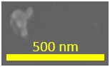

(a)

5.00 µm

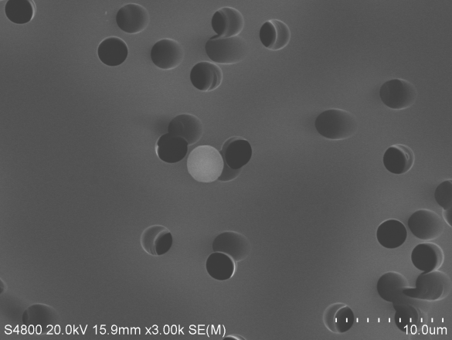

(b)

10.0 µm

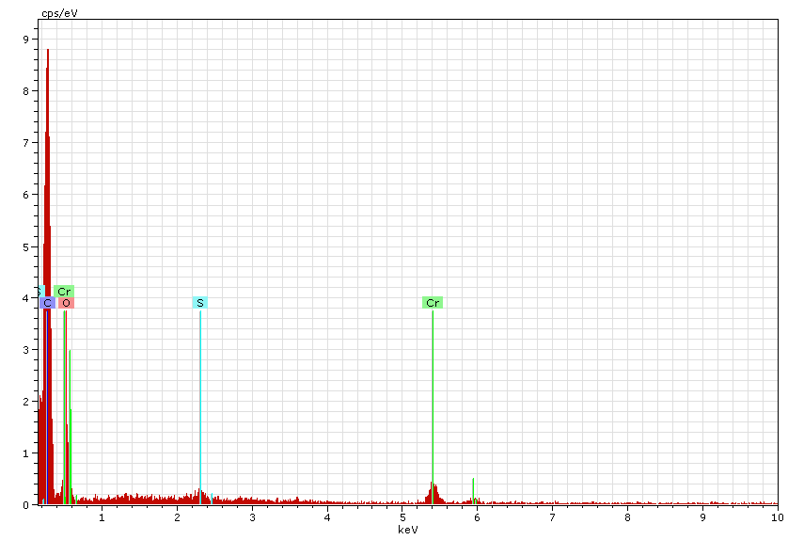

Cr

Cr

S

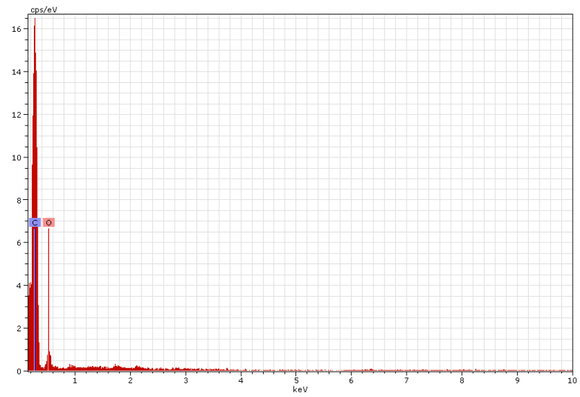

FIGURE S6. Morphology and elemental composition of micrometer-scale particles generated by the laser printers: (a) HP2055dn, (b) HP2600 [note different scale bar between images].

TABLE S1.Average Geometric Mean Particle Size and Particle Emission Rates (PER) for 3-D and Laser Printers

|  |  |  |  |  |
| --- | --- | --- | --- | --- |
|  |  |  | Average ± standard deviation PER | |
| Printer | Consumable | Print job | GRIMM  (# >0.65 µm min-1) | DustTrak  (µg min-1) |
| HP2055dn | Monochrome toner | 80 pages @ 5% | 1.2 ± 0.1 x 1010 | 11.3 ± 4.9 |
| HP2600 | Monochrome toner | 80 pages @ 5% | 5.6 x 109 | 3.6 ± 2.5 |
| 3-D1 | ABS natural | 3 combs | 7.0 x 105 | 12.9 ± 7.0 |
|  | ABS blue | 2 combs | 7.0 ± 0.0 x 104 | 5.6 ± 0.2 |
|  | ABS red | 2 combs | 3.6 ± 0.2 x 104 | 2.9 ± 0.3 |
|  | ABS black | 2 combs | 6.5 ± 0.0 x 104 | 0.8 ± 0.2 |
|  | PLA true red | 4 combs | 4.7 ± 1.7 x 105 | 2.7 ± 0.7 |
|  | PLA army green | 4 combs | 4.5 ± 1.2 x 105 | 2.1 ± 0.2 |
|  | PLA ocean blue | 4 combs | 6.9 ± 2.3 x 105 | 3.5 ± 1.1 |
|  | PLA transparent blue | 4 combs | 6.6 ± 2.4 x 105 | 2.5 ± 0.1 |

1 Data from (11), ABS = acrylonitrile butadiene styrene, PLA = polylactic acid