Environmental Exposure | Item | Coding
Neighborhood belonging | Please tell me if you strongly agree, agree, disagree, or strongly disagree with the following statement: I feel that I belong and am a part of my neighborhood. | Proportion reporting strongly agree or agree
Neighborhood improvement | Have people in your neighborhood ever worked together to improve the neighborhood? For example, through a neighborhood watch, creating a community garden, building a community playground, or participating in a block party. | Proportion yes
Neighbors help each other | Using the following scale (always, often, sometimes, never), please rate how likely people in your neighborhood are willing to help their neighbors with routine activities such as picking up their trash cans, or helping to shovel snow. | Proportion reporting always or often
Trust among neighbors | Please tell me if you strongly agree, agree, disagree or strongly disagree with the following statement: Most people in my neighborhood can be trusted. | Proportion reporting strongly agree or agree
Participation in neighborhood organizations | How many local groups or organizations in your neighborhood do you currently participate in such as social, political, religious, school-related, or athletic organizations? | # of organizations
Stress experienced in past year | Using a scale from 1 to 10, where 1 means “no stress” and 10 means “an extreme amount of stress”, how much stress would you say you have experienced during the past year? | Visual analog scale, range 1-10
Violence victimization in past year | Thinking about the past year, have you been subject to any kind of physical violence by friends, family members or strangers such as being shoved, slapped, beaten, forced into sexual activity or threatened, or hurt with a knife or gun? | Proportion yes
Firearms in or around home | Are there any firearms, such as handguns, shotguns, or rifles in or around your home? | Proportion yes
Comparing residence-based to actual path-based methods for defining adolescents’ environmental exposures using granular spatial data
Supplementary Material

Supplementary Table 1: Philadelphia Health Management Corporation's Southeastern Pennsylvania Household Survey Neighborhood Resident Cohesion and Violence Exposure Items and Coding

Supplementary Figure 1: Scatterplots comparing environmental exposures measured at home address versus mean exposure across entire daily travel path among all control participants
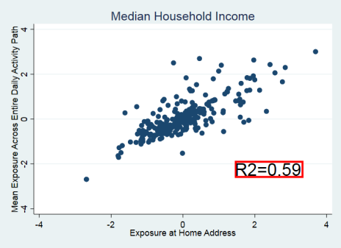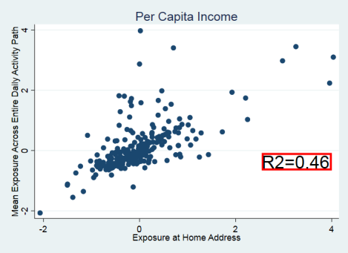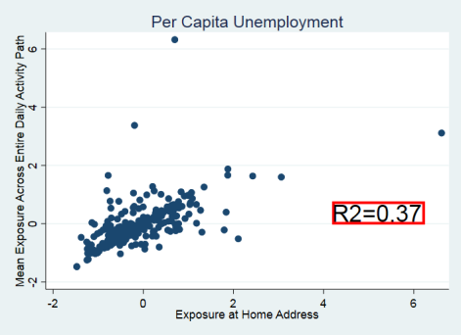
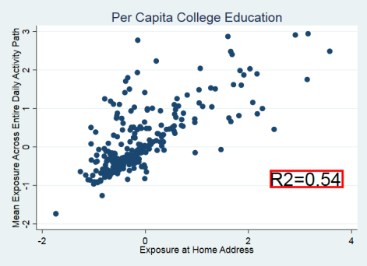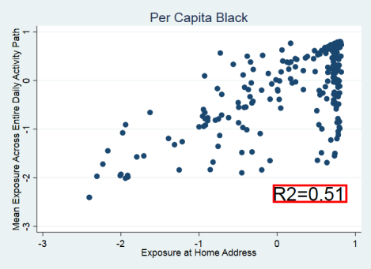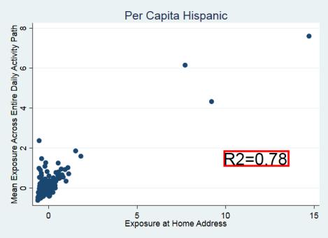
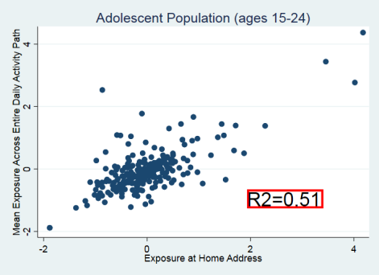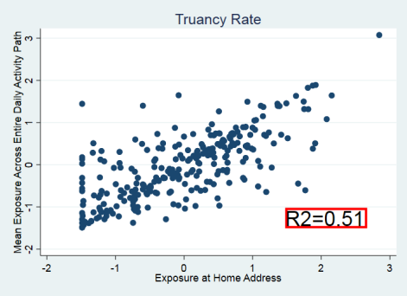
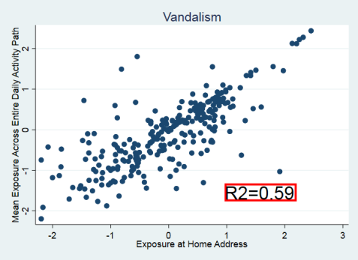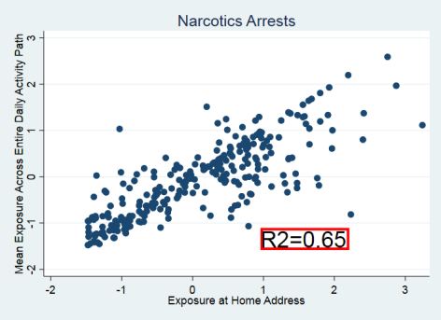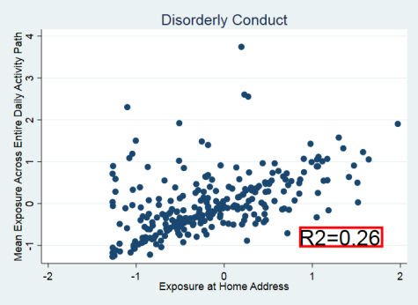
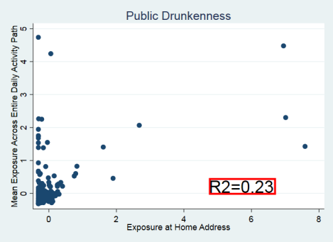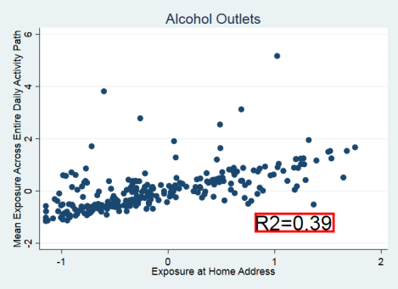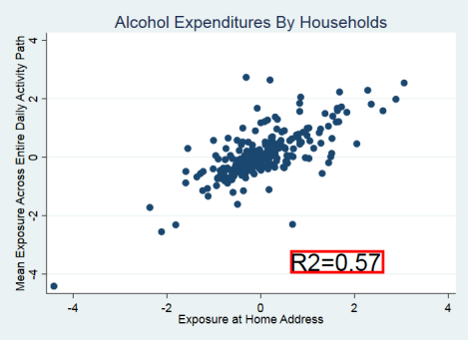
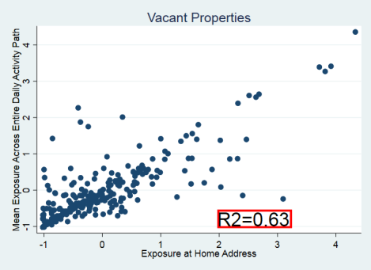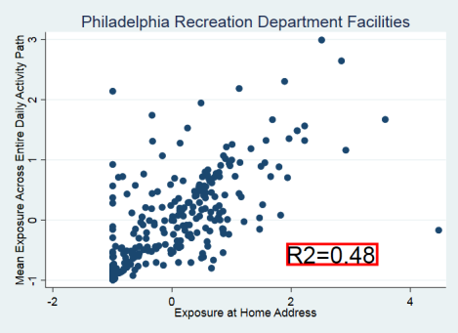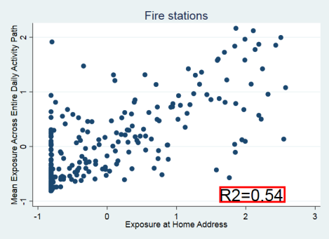
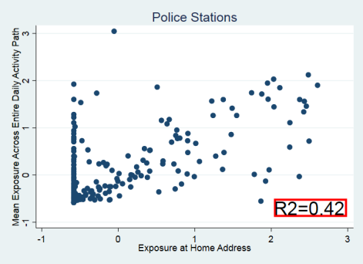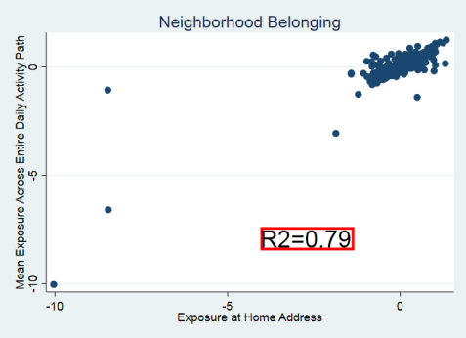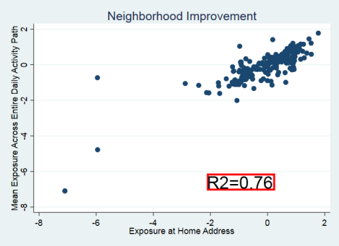
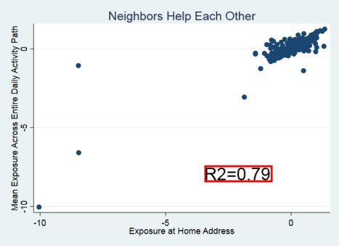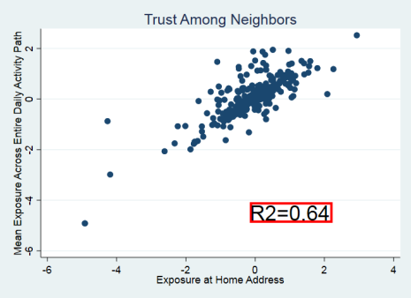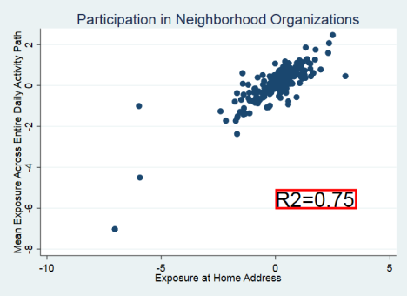
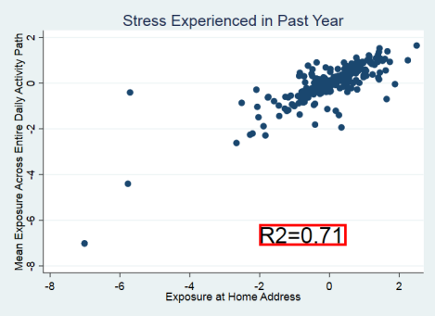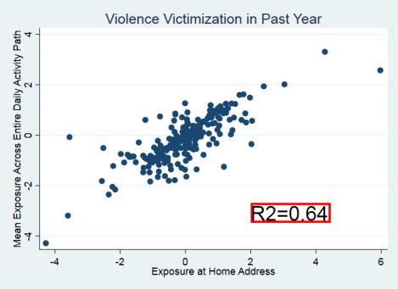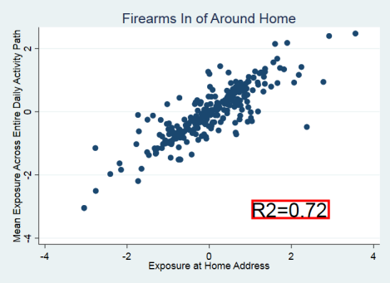
Per capita values refer to the number of residents per 1,000 residents

