**Title: Current asthma and asthma-like symptoms among workers at a Veterans Administration Medical Center**

Laura Kurth a, Mohammed Abbas Virji a, Eileen Storey a, Susan Framberg b, Christa Kallio b, Jordan Fink b, Anthony Scott Laney a

a Respiratory Health Division, National Institute for Occupational Safety and Health, Morgantown, WV, USA

b Clement J. Zablocki VA Medical Center, Milwaukee, WI, USA

**Supplementary Results**

Demographic and occupational characteristics for participants in all buildings (n=562) indicate the mean age of all participants was 46.7 years (SD=11.6) and most were female (77.1%), white (89.5%), never smokers (60.2%), and worked more than four days per week (82.9%) (Supplement Table I). Age distributions of participants in Buildings A­–D varied from the age distributions in the main hospital and total sample. In Building B, 30.8% of participants were never smokers compared to 60.2% of all participants. Approximately 40.5% of participants working in other buildings or not reporting their primary work building worked or trained in healthcare for <1–7 years, which was high compared to participants in Buildings A–D or the hospital.

Supplement Table II shows the distributions of current asthma and asthma-like symptoms in the total sample. The prevalence of current asthma was highest in Building D (41.4%), a newer building housing inpatient rooms and outpatient services. The reported prevalence of current asthma was 2.35 (95% CI: 1.44–3.84) times higher in participants working in Building D compared to those in the main hospital (17.6%).

Of 276 participants with breathing problems reporting the status of these problems when away from work, 35.0% reported their breathing problems were better away from work (Supplement Table II). Among these participants reporting improved breathing problems away from work, 34.8% (n=32) were clinical nurses, 26.1% (n=24) were office and administrative support workers, 16.3% (n=15) were patient care workers, and the remaining 22.8% (n=21) had other occupations.

Of 271 participants with breathing problems responding, 32.5% (n=88) reported their breathing problems were so severe that they had to take time off work. Of 538 participants responding, 2.8% (n=15) reported they changed a job, job duties, or job location because the job affected their breathing (data not shown).

Supplement Table III shows workplace exposures and tasks reported by participants in other medical center buildings. Building A, an old building with offices and storage areas, had a high prevalence of any mold, dampness, and construction material exposure with the most common of these exposure being water damage (78.4%) and wet carpet (51.4%). Building B, a renovated building serving as a domiciliary and mental health outpatient clinics at the time of this survey, had lower prevalence of reported workplace exposures and tasks compared to most of the other buildings. Building C had a high prevalence of any mold, dampness, and construction material exposure (72.9%) while the prevalence of any cleaning and disinfecting product use was 16.7% and any cleaning or disinfecting tasks was 12.5%. Over half of participants in Building D, a newer building housing outpatient services, reported cleaning or disinfecting equipment, environmental, of fixed surfaces (69.0%), any cleaning and disinfecting product exposure (65.5%), and any cleaning or disinfecting tasks (69.0%).

Supplement Figure 1 presents PRs and 95% CI for upper chest, lower chest, and mixed symptoms groups by exposures and tasks and by PCA rotated factors for dampness and mold, construction material, and mixed exposures to chemicals.Participants reporting exposure to condensation (PR=1.93, [1.18–3.15]), wet carpet (PR=1.98, [1.22–3.23]), and removing or replacing interior materials (PR=2.02, [1.25–3.28]) had a significantly higher PRs of lower chest symptoms compared to participants not exposed. Participants cleaning or disinfecting surfaces (PR=1.74, [1.03–2.96]), exposed to a variety of mold, dampness, and construction material exposures, exposed to detergent (PR=1.93, [1.11–3.35]) and other chemicals (PR=1.93, [1.11–3.35]), cleaning surfaces (PR=1.85, [1.11–3.08]), cleaning spills or blood (PR=1.98, [1.22–3.22]), and floor cleaning and maintenance (PR=2.64, [1.29–4.37]) had significantly higher PRs of mixed symptoms compared to those not exposed. Participants using chemicals in laboratory or patient/chemical preparation areas (PR=2.10, [1.03–4.31]), exposed to mold growth (PR=2.08, [1.14–3.80]), detergent (PR=1.89, [1.09–3.28]), other chemicals (PR=2.19, [1.31–3.65]), and other cleaning or disinfecting tasks (PR=2.00, [1.06–3.78]) had a significantly higher PRs of upper chest symptoms compared to those not exposed. The dampness and mold, water damage, and construction exposure PCA factors had significantly elevated PRs of participants with lower chest symptoms; the dampness and mold, water damage, and sterilizing, cleaning chemicals mixed exposure PCA factors had significantly elevated PRs of mixed symptoms; and the water damage PCA factor had a significantly higher PR of participants with upper chest symptoms.

**Supplement TABLE I. Demographic and Occupational Characteristics Overall and by Building (n=562)**

|  |  |  |  |  |  |  |  |
| --- | --- | --- | --- | --- | --- | --- | --- |
|  | **All buildings N (%)** | **Building A N (%)** | **Building B N (%)** | **Building C N (%)** | **Building D N (%)** | **Other buildings or missing N (%)** | **Hospital N (%)** |
| Total | 562 | 37 (6.6) | 14 (2.5) | 48 (8.5) | 29 (5.2) | 87 (15.5) | 347 (61.7) |
| Age quartile |  |  |  |  |  |  |  |
| 21–37 years | 137 (24.4) | 6 (16.2) | 1 (7.1) | 12 (25.0) | 3 (10.3) | 26 (29.9) | 89 (25.7) |
| 38–49 years | 145 (25.8) | 16 (43.2) | 6 (42.9) | 5 (10.4) | 7 (24.1) | 21 (24.1) | 90 (25.9) |
| 50–56 years | 157 (27.9) | 7 (18.9) | 1 (7.1) | 16 (33.3) | 13 (44.8) | 26 (29.9) | 94 (27.1) |
| 57–73 years | 123 (21.9) | 8 (21.6) | 6 (42.9) | 74 (21.3) | 6 (20.7) | 14 (16.1) | 74 (21.3) |
| Sex | * | * | * | * | * | * | * |
| Female | 433 (77.1) | 29 (78.4) | 11 (78.6) | 34 (70.8) | 21 (72.4) | 67 (77.0) | 271 (78.1) |
| Male | 129 (23.0) | 8 (21.6) | 3 (21.4) | 14 (29.2) | 8 (27.6) | 20 (23.0) | 76 (21.9) |
| Race1 | * | * |  | * | * | * | * |
| White | 494 (89.5) | 34 (91.9) | 9 (69.2) | 44 (93.6) | 24 (82.8) | 71 (84.5) | 312 (91.2) |
| Other2 | 58 (10.5) | 3 (8.1) | 4 (30.8) | 3 (6.4) | 5 (17.2) | 13 (15.5) | 30 (8.8) |
| Smoking status1 | * | * |  | * | * | * | * |
| Never smoker | 333 (60.2) | 21 (56.8) | 4 (30.8) | 31 (64.6) | 18 (62.1) | 49 (60.5) | 210 (60.9) |
| Former smoker | 154 (27.9) | 12 (32.4) | 6 (46.2) | 14 (29.2) | 6 (20.7) | 20 (24.7) | 96 (27.8) |
| Current smoker | 66 (11.9) | 4 (10.8) | 3 (23.1) | 3 (6.3) | 5 (17.2) | 12 (14.8) | 39 (11.3) |
| Seniority quartile1 |  |  |  |  |  | * |  |
| <1–7 years | 147 (26.4) | 5 (13.9) | 3 (21.4) | 12 (25.0) | 6 (20.7) | 34 (40.5) | 87 (25.1) |
| 8–19 years | 137 (24.6) | 12 (33.3) | 2 (14.3) | 11 (22.9) | 4 (13.8) | 20 (23.8) | 88 (25.4) |
| 20–29 years | 136 (24.4) | 11 (30.6) | 5 (35.7) | 11 (22.9) | 10 (34.5) | 13 (15.5) | 86 (24.9) |
| 30–50 years | 137 (24.6) | 8 (22.2) | 4 (28.6) | 14 (29.2) | 9 (31.0) | 17 (20.2) | 85 (24.6) |
| Days per week working1 | * | * | * | * | * | * | * |
| ≤4 days | 94 (17.1) | 8 (22.2) | 2 (14.3) | 10 (20.8) | 4 (13.8) | 19 (23.2) | 51 (14.9) |
| >4 days | 457 (82.9) | 28 (77.8) | 12 (85.7) | 38 (79.2) | 25 (86.2) | 63 (76.8) | 291 (85.1) |

N, number

1In all participants, demographic and occupational data were missing for race (n=10), smoking status (n=9), seniority (n=5), and days per week working (n=11). Demographic and occupational characteristics by building may not add up to the total number in the building due to missing values. 2 “Other” race category includes African American, Asian, American Indian or Alaska Native, Native Hawaiian or other Pacific Islander, and other; *p- value <0.05 based on Pearson’s chi-square or Fisher’s exact test.

**Supplement TABLE II. Prevalence of Current Asthma and Asthma-like Symptoms Overall and by Building**

|  |  |  |  |  |  |  |  |
| --- | --- | --- | --- | --- | --- | --- | --- |
|  | **All buildings N (%)**  **n=562** | **Building A N (%)**  **n=37** | **Building B N (%)**  **n=14** | **Building C N (%)**  **n=48** | **Building D N (%)**  **n=29** | **Other buildings or missing N (%) n=87** | **Hospital N (%)**  **n=347** |
| Current asthma | 103 (18.3) | 6 (16.2) | 3 (21.4) | 4 (8.3) | 12 (41.4) | 17 (19.5) | 61 (17.6) |
| Positive allergic status1 | 418 (74.4) | 27 (73.0) | 8 (57.1) | 33 (68.8) | 23 (79.3) | 65 (74.7) | 221 (63.7) |
| Asthma-like symptoms, past 12 months |  |  |  |  |  |  |  |
| Wheeze | 201 (35.8) | 17 (46.0) | 5 (35.7) | 13 (27.1) | 11 (37.9) | 32 (36.8) | 123 (35.5) |
| Chest tightness, awoken with | 105 (18.7) | 7 (18.9) | 3 (21.4) | 4 (8.3) | 8 (27.6) | 13 (14.9) | 70 (20.2) |
| Shortness of breath at rest | 111 (19.8) | 12 (32.4) | 5 (35.7) | 3 (6.3) | 7 (24.1) | 20 (23.0) | 64 (18.4) |
| Shortness of breath after exercise | 114 (20.3) | 5 (13.5) | 1 (7.1) | 5 (10.4) | 3 (10.3) | 21 (24.1) | 79 (22.8) |
| Shortness of breath, awoken by | 68 (12.1) | 6 (16.2) | 4 (28.6) | 2 (4.2) | 4 (13.8) | 7 (8.1) | 45 (13.0) |
| Asthma-like symptoms, past 4 weeks |  |  |  |  |  |  |  |
| Wheeze | 107 (19.0) | 8 (21.6) | 4 (28.6) | 7 (14.6) | 8 (27.6) | 18 (20.7) | 62 (17.9) |
| Chest tightness, awoken with | 51 (9.1) | 4 (10.8) | 0 (0.0) | 2 (4.2) | 5 (17.2) | 6 (6.9) | 34 (9.8) |
| Shortness of breath at rest | 63 (11.2) | 5 (13.5) | 2 (14.3) | 1 (2.1) | 3 (10.3) | 14 (16.1) | 38 (11.0) |
| Shortness of breath after exercise | 66 (11.7) | 3 (8.1) | 0 (0.0) | 1 (2.1) | 1 (3.5) | 12 (13.8) | 49 (14.1) |
| Shortness of breath, awoken by | 31 (5.5) | 5 (13.5) | 1 (7.1) | 0 (0.0) | 0 (0.0) | 3 (3.5) | 22 (6.3) |
| Symptom groups |  |  |  |  |  |  |  |
| No/low symptoms | 308 (54.8) | 17 (46.0) | 7 (50.0) | 34 (70.8) | 13 (44.8) | 44 (50.6) | 193 (55.6) |
| Upper chest symptoms | 86 (15.3) | 5 (13.5) | 2 (14.3) | 6 (12.5) | 7 (24.1) | 15 (17.2) | 51 (14.7) |
| Lower chest symptoms | 76 (13.5) | 2 (5.4) | 2 (14.3) | 3 (6.3) | 4 (13.8) | 12 (13.8) | 53 (15.3) |
| Mixed symptoms | 92 (16.4) | 13 (35.1) | 3 (21.4) | 5 (10.4) | 5 (17.2) | 16 (18.4) | 50 (14.4) |
| Breathing problems2 | 276 (49.1) | 22 (59.5) | 9 (64.3) | 19 (39.6) | 17 (58.6) | 43 (49.4) | 166 (47.8) |
| Improved away from work | 92 (35.0) | 9 (40.9) | 4 (44.4) | 7 (41.2) | 3 (18.8) | 8 (20.0) | 61 (38.4) |

N, number

1Positive allergic status was defined as at least one of the following reported conditions: atopic dermatitis, allergic eye symptoms, or seasonal allergic rhinitis.

2In all participants, 13 participants were missing data for status of breathing problems when away from work. The percentage for Improved away from work is calculated using the number with breathing problems reporting the status of breathing problems when away from work as the denominator specific to each column.

**Supplement TABLE III. Prevalence of Workplace Exposures and Tasks in Current Job**1 **by Building**

|  |  |  |  |  |  |  |  |
| --- | --- | --- | --- | --- | --- | --- | --- |
|  | **All buildings N (%)**  **n=562** | **Building A N (%)**  **n=37** | **Building B N (%)**  **n=14** | **Building C N (%)**  **n=48** | **Building D N (%)**  **n=29** | **Other buildings or missing N (%) n=87** | **Hospital N (%)**  **n=347** |
| Sterilize or disinfect medical instruments | 24 (4.3) | 0 (0.0) | 0 (0.0) | 1 (2.1) | 1 (3.5) | 4 (4.6) | 18 (5.2) |
| Clean or disinfect equipment, environmental, or fixed surfaces | 249 (44.3) | 8 (21.6) | 4 (28.6) | 8 (16.7) | 20 (69.0) | 32 (36.8) | 177 (51.0) |
| Use chemicals in laboratory or patient/chemical preparation areas | 23 (4.1) | 0 (0.0) | 0 (0.0) | 1 (2.1) | 0 (0.0) | 4 (4.6) | 18 (5.2) |
| Use chemicals, adhesives, antiseptics, alcohols, or solvents on patients | 153 (27.2) | 2 (5.4) | 2 (14.3) | 9 (18.8) | 10 (34.5) | 19 (21.8) | 111 (32.0) |
| Administer aerosolized medications to patients | 51 (9.1) | 1 (2.7) | 2 (14.3) | 1 (2.1) | 4 (13.8) | 6 (6.9) | 37 (10.7) |
| Mold, dampness, construction material exposure (any) | 368 (65.5) | 31 (83.8) | 6 (42.9) | 35 (72.9) | 13 (44.8) | 36 (41.4) | 247 (71.2) |
| Water damage | 258 (45.9) | 29 (78.4) | 6 (42.9) | 24 (50.0) | 4 (13.8) | 25 (28.7) | 170 (49.0) |
| Condensation | 123 (21.9) | 15 (40.5) | 2 (14.3) | 17 (35.4) | 2 (6.9) | 14 (16.1) | 73 (21.0) |
| Wet carpet | 125 (22.2) | 19 (51.4) | 1 (7.1) | 12 (25.0) | 4 (13.8) | 15 (17.2) | 74 (21.3) |
| Mold growth | 55 (9.8) | 7 (18.9) | 1 (7.1) | 4 (8.3) | 2 (6.9) | 9 (10.3) | 32 (9.2) |
| Mold, mildew, musty odor | 121 (21.5) | 16 (43.2) | 2 (14.3) | 15 (31.3) | 2 (6.9) | 12 (13.8) | 74 (21.3) |
| Renovation or construction | 266 (47.3) | 12 (32.4) | 3 (21.4) | 26 (54.2) | 11 (37.9) | 25 (28.7) | 189 (54.5) |
| Painting | 237 (42.2) | 10 (27.0) | 2 (14.3) | 21 (43.8) | 8 (27.6) | 22 (25.3) | 174 (50.1) |
| Removing/replacing interior materials | 209 (37.2) | 11 (29.7) | 2 (14.3) | 23 (47.9) | 5 (17.2) | 21 (24.1) | 147 (42.4) |
| Cleaning and disinfecting products (any) | 240 (42.7) | 7 (18.9) | 4 (28.6) | 8 (16.7) | 19 (65.5) | 31 (35.6) | 171 (49.3) |
| Alcohol | 149 (26.5) | 3 (8.1) | 2 (14.3) | 4 (8.3) | 11 (37.9) | 18 (20.7) | 111 (32.0) |
| Bleach | 103 (18.3) | 1 (2.7) | 0 (0.0) | 4 (8.3) | 5 (17.2) | 16 (18.4) | 77 (22.2) |
| Glass cleaner | 43 (7.7) | 3 (8.1) | 1 (7.1) | 3 (6.3) | 2 (6.9) | 5 (5.8) | 29 (8.4) |
| Detergent | 70 (12.5) | 2 (5.4) | 1 (7.1) | 3 (6.3) | 5 (17.2) | 8 (9.2) | 51 (14.7) |
| Quaternary ammonium compounds | 156 (27.8) | 4 (10.8) | 1 (7.1) | 5 (10.4) | 11 (37.9) | 24 (27.6) | 111 (32.0) |
| Other chemicals2 | 68 (12.1) | 1 (2.7) | 2 (14.3) | 0 (0.0) | 5 (17.2) | 8 (9.2) | 52 (15.0) |
| Cleaning or disinfecting tasks (any) | 233 (41.5) | 6 (16.2) | 4 (28.6) | 6 (12.5) | 20 (69.0) | 29 (33.3) | 168 (48.4) |
| Clean equipment and environmental surfaces | 221 (39.3) | 6 (16.2) | 4 (28.6) | 4 (8.3) | 20 (69.0) | 28 (32.2) | 159 (45.8) |
| Clean spills or blood | 118 (21.0) | 0 (0.0) | 1 (7.1) | 1 (2.1) | 9 (31.0) | 14 (16.1) | 93 (26.8) |
| Clean bathroom | 22 (3.9) | 0 (0.0) | 1 (7.1) | 0 (0.0) | 1 (3.5) | 4 (4.6) | 16 (4.6) |
| Spraying products | 52 (9.3) | 2 (5.4) | 1 (7.1) | 1 (2.1) | 3 (10.3) | 5 (5.8) | 40 (11.5) |
| Floor cleaning and maintenance | 53 (9.4) | 0 (0.0) | 1 (7.1) | 3 (6.3) | 3 (10.3) | 6 (6.9) | 40 (11.5) |
| Other tasks | 34 (6.1) | 0 (0.0) | 0 (0.0) | 1 (2.1) | 5 (17.2) | 7 (8.1) | 21 (6.1) |

1 Workplace exposures or tasks are reported for current job. Dampness and mold, construction material exposure are reported for the two year period prior to the survey. 2Other chemicals include formaldehyde, hydrogen peroxide, acid, ammonia, phenolics, floor wax stripper, ethylene oxide, glutaraldehyde, ortho-phthalaldehydes, peracetic acid, and enzymatic cleaners.

**Supplement Figure 1. Prevalence ratios (95% CI) of symptoms by workplace exposure and tasks, (n=562)**

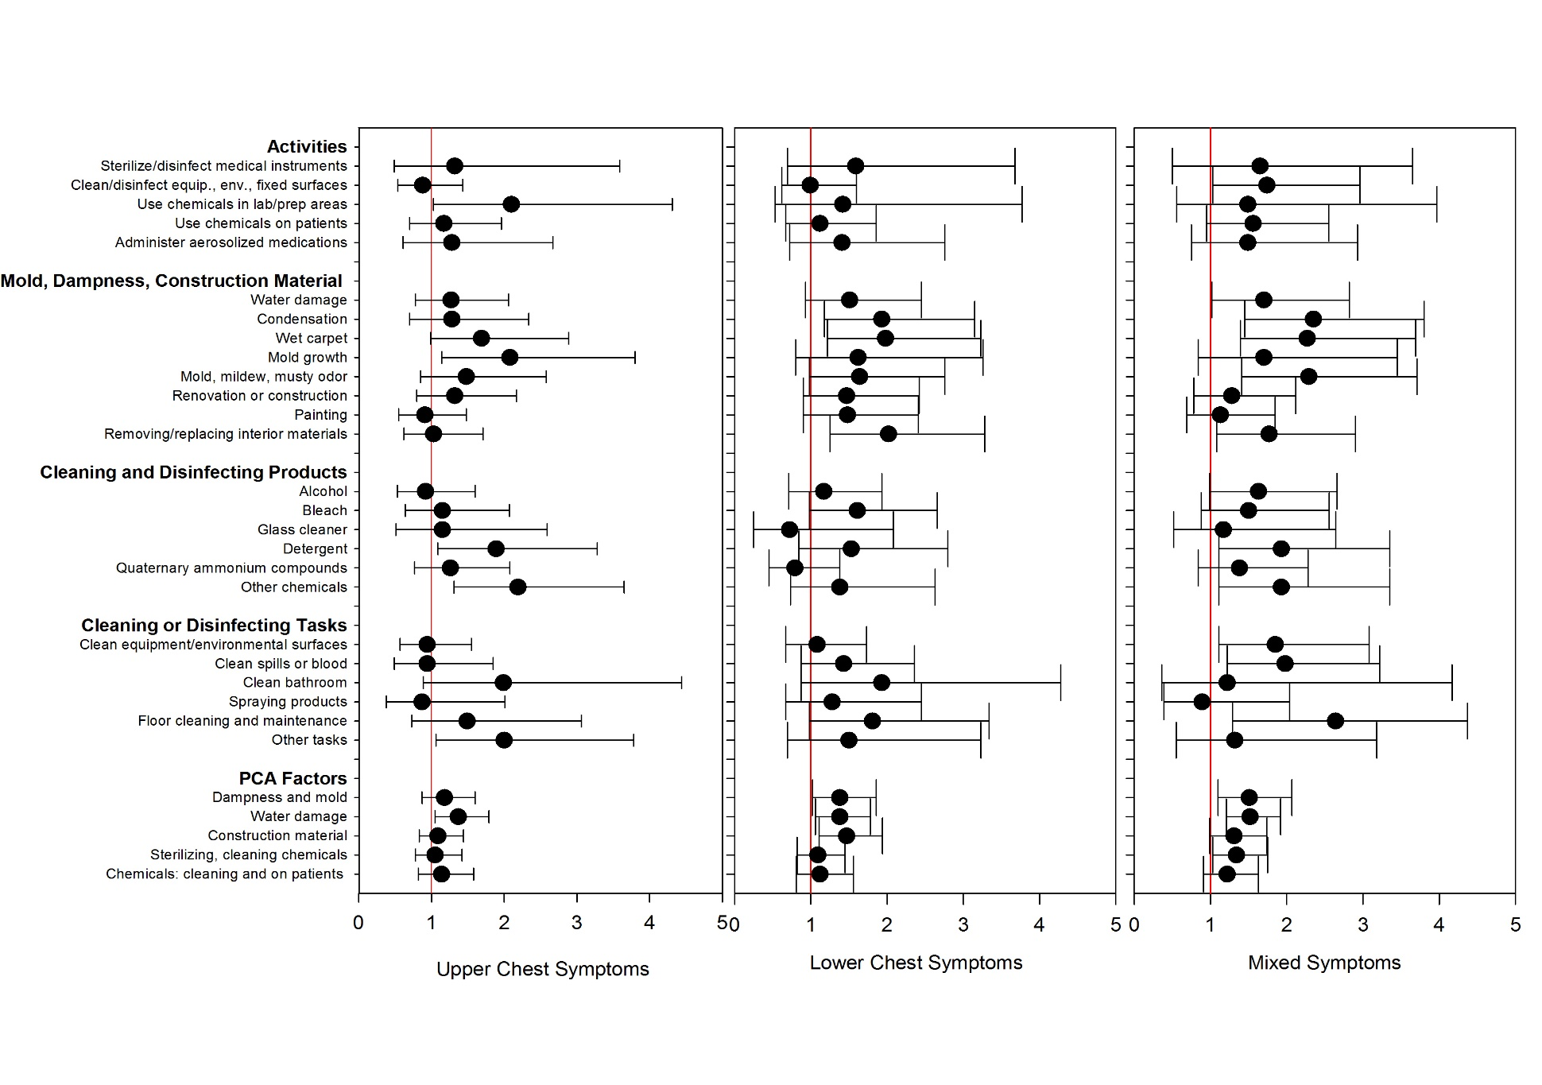

PCA, Principal components analysis