Supplemental Material

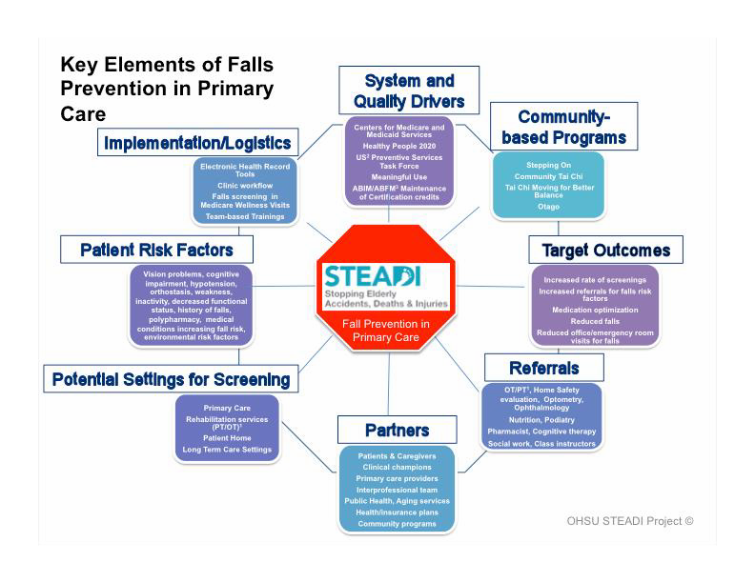
Supplemental Figure I. Key Elements of Falls Prevention in Primary Care
Footnotes:
- Physical therapy/occupational therapy
- United States
- American Board of Internal Medicine/American Board of Family Medicine
1

Supplemental Figure II. STEADI Electronic Health Record Tools—Provider Note Templates for high risk, low risk, and deferred visits, Doc flowsheet, and SmartSet

STEADI Provider Note Template—High Risk
Provider note template for high risk patients is included in the STEADI SmartSet or can be accessed using the “high risk dot phrase”: .FALLSEVALUATIONAND ASSESSMENT. Call out boxes include options from which the provider can select pre-written text. Three asterisks (***) indicate that a provider can add free-text.
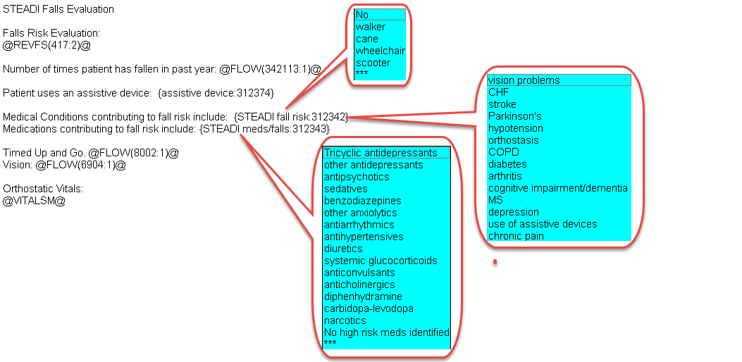

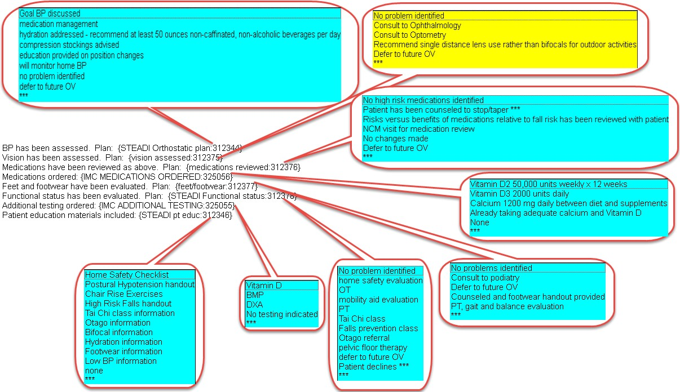

STEADI Provider Note Template—Low Risk
Provider note template for low risk patients is included in the STEADI SmartSet or can be accessed using the “low risk dot phrase”: FALLSLOWRISKSTATEMENT

STEADI Provider Note Template—Defer Statement
Provider note template for deferred STEADI evaluations is included in the STEADI SmartSet or can be accessed using the “defer dot phrase”: FALLSDEFER

STEADI Doc Flowsheet
Used by medical assistant to record results of the Stay Independent self-assessment questionnaire, Timed Up and Go (TUG) test, Vision test, and Orthostatic Blood Pressure Measurements.
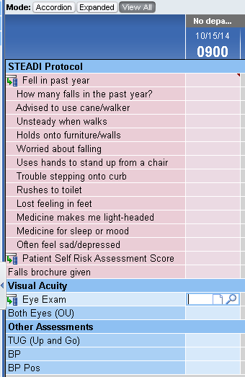

STEADI SmartSet
An all-in-one order sets, the STEADI Smartset provides easy access to the note templates, relevant orders, associated diagnoses, CPT II codes, and all of the patient education materials in a single location within the EHR.
