Supplemental Figure S1. Participant Flow Diagram in the SEARCH Food Insecurity study.

Data available for analysis:
- Food insecurity prevalence, n = 269
- Primary adjusted analyses, n = 226
Excluded (Eligible, total n = 63)
- Missing data for food insecurity, n = 16
- Missing data for HbA_{1c}, n = 36*
- Missing data for food insecurity and HbA_{1c}, n = 4
- Missing data for any covariate, n = 7*

*These participants’ data were retained for the calculation of food insecurity prevalence, n = 43
Total Recruited
n = 289
Excluded (Eligible, total n = 116)
- Not recruited or refused
Registry or Cohort SEARCH visit
Washington or South Carolina sites
November 2013 to June 2015
Participants with type 1 diabetes
n = 405
Supplemental Figure S2. Mean estimates of HbA_{1c} by food security categories in the SEARCH Food Insecurity study, predicted by the fully adjusted linear regression model.
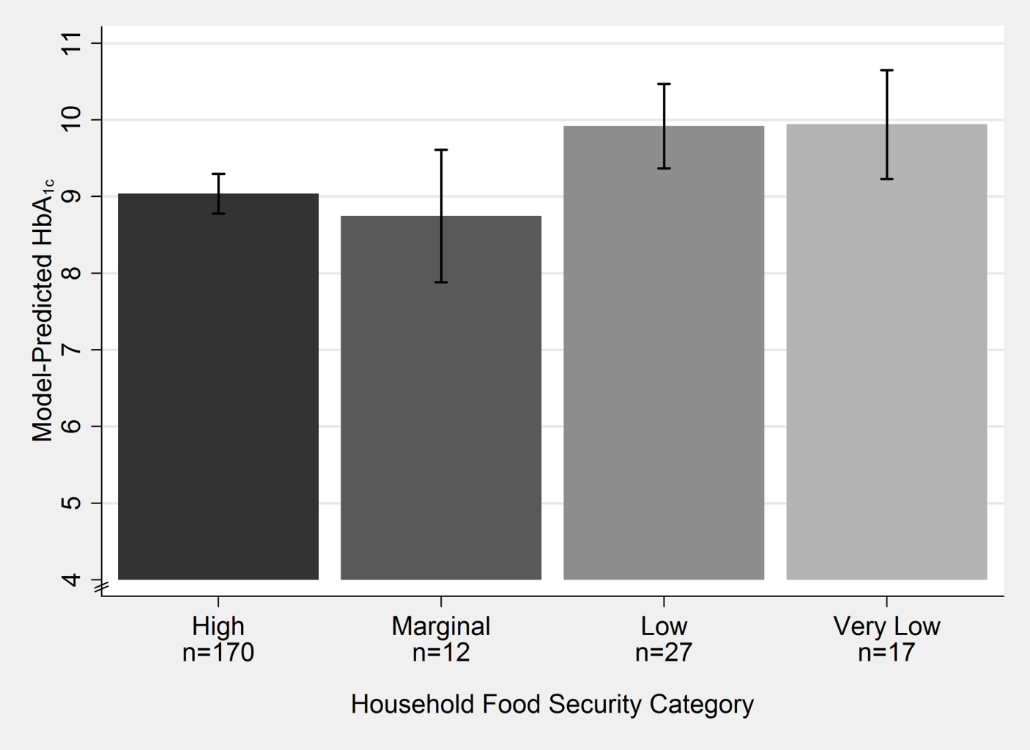
*Comparisons among food security groups were all p>0.05. Food Insecurity is inclusive of Low and Very Low Food Security categories, while Food Security is inclusive of High and Marginal Food Security categories as defined by the US Department of Agriculture.

