Web Material

Web Figure 1.
A) Percentage of Visits for Influenza-Like Illness (ILI) and Corresponding Intensity Thresholds, Children Aged <25 Years, by Surveillance Week and Season, U.S. Outpatient Influenza-Like Illness Surveillance Network (ILINet), United States, 2003–04 Through 2015–16 Influenza Seasons
B) Rate of Laboratory-Confirmed Influenza Hospitalization per 100,000 Population and Corresponding Intensity Thresholds, Children Aged <18 Years, by Surveillance Week and Season, the US Influenza Hospitalization Network (FluSurv-NET), United States, 2005–06 Through 2015–16 Influenza Seasons
C) Percentage of All Deaths Due to Pneumonia and Influenza and Corresponding Intensity Threshold, Children Aged <25 Years, by Surveillance Week and Season, 122 Cities Mortality Reporting System, United States, 2003–04 Through 2015–16 Influenza Seasons
D) Percentage of All Deaths Due to Pneumonia and Influenza and Corresponding Intensity Threshold, Children Aged <18 Years, by Surveillance Week and Season, National Center for Health Statistics Mortality Surveillance System, United States, 2003–04 Through 2015–16 Influenza Seasons

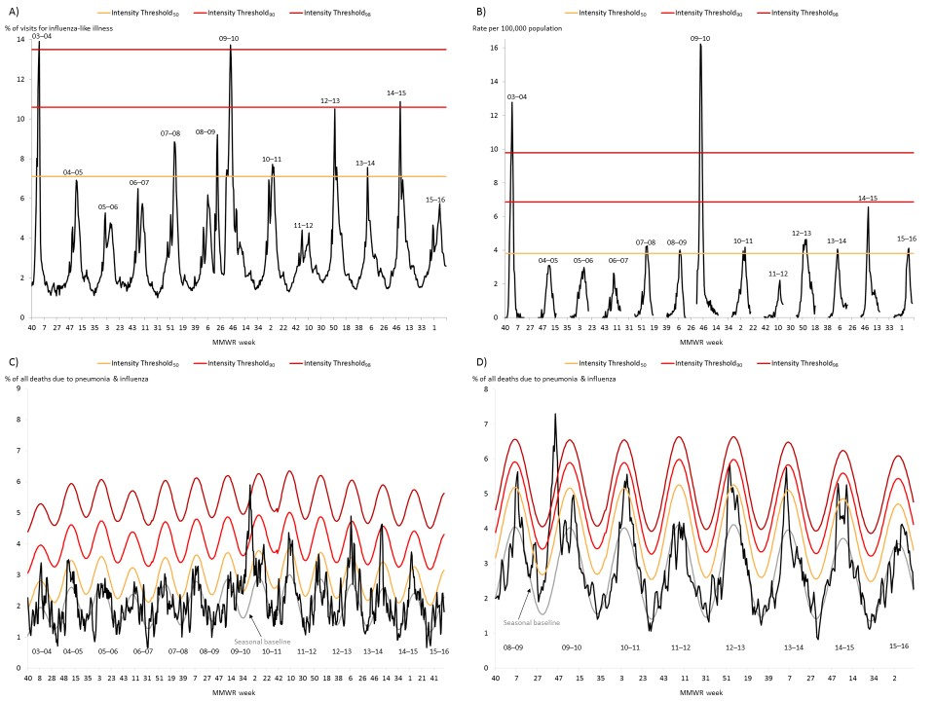

Web Figure 2.
A) Percentage of Visits for Influenza-Like Illness (ILI) and Corresponding Intensity Thresholds, Adults Aged 25–64 Years, by Surveillance Week and Season, U.S. Outpatient Influenza-Like Illness Surveillance Network (ILINet), United States, 2003–04 Through 2015–16 Influenza Seasons
B) Rate of Laboratory-Confirmed Influenza Hospitalization per 100,000 Population and Corresponding Intensity Thresholds, Adults Aged 18–64 Years, by Surveillance Week and Season, the US Influenza Hospitalization Network (FluSurv-NET), United States, 2005–06 Through 2015–16 Influenza Seasons
C) Percentage of All Deaths Due to Pneumonia and Influenza and Corresponding Intensity Threshold, Adults Aged 25–64 Years, by Surveillance Week and Season, 122 Cities Mortality Reporting System, United States, 2003–04 Through 2015–16 Influenza Seasons
D) Percentage of All Deaths Due to Pneumonia and Influenza and Corresponding Intensity Threshold, Adults Aged 18–64 Years, by Surveillance Week and Season, National Center for Health Statistics Mortality Surveillance System, United States, 2003–04 Through 2015–16 Influenza Seasons

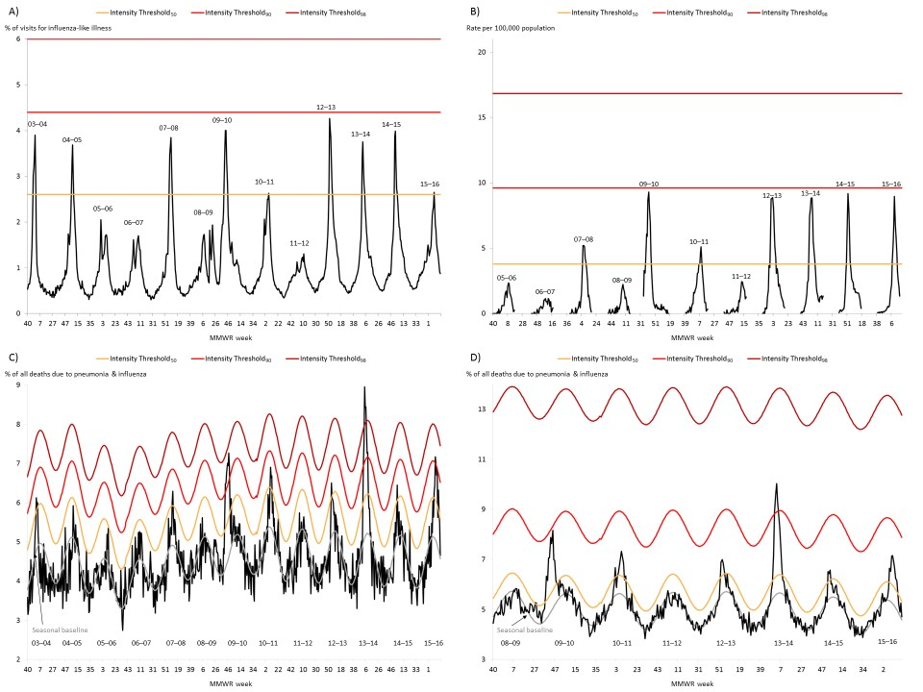

Web Figure 3.
A) Percentage of Visits for Influenza-Like Illness (ILI) and Corresponding Intensity Thresholds, Adults Aged >64 Years, by Surveillance Week and Season, U.S. Outpatient Influenza-Like Illness Surveillance Network (ILINet), United States, 2003–04 Through 2015–16 Influenza Seasons
B) Rate of Laboratory-Confirmed Influenza Hospitalization per 100,000 Population and Corresponding Intensity Thresholds, Adults Aged >64 Years, by Surveillance Week and Season, the US Influenza Hospitalization Network (FluSurv-NET), United States, 2005–06 Through 2015–16 Influenza Seasons
C) Percentage of All Deaths Due to Pneumonia and Influenza and Corresponding Intensity Threshold, Adults Aged >64 Years, by Surveillance Week and Season, 122 Cities Mortality Reporting System, United States, 2003–04 Through 2015–16 Influenza Seasons
D) Percentage of All Deaths Due to Pneumonia and Influenza and Corresponding Intensity Threshold, Adults Aged >64 Years, by Surveillance Week and Season, National Center for Health Statistics Mortality Surveillance System, United States, 2003–04 Through 2015–16 Influenza Seasons

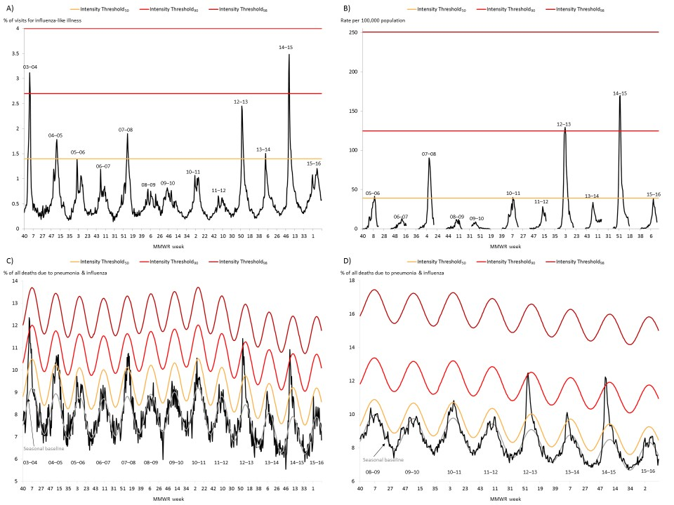
Web Figure 4.
Percentage of Visits for Influenza-Like Illness (ILI) Aligned by the Start Week of the Season, by Seasonal Intensity Classification, U.S. Outpatient Influenza-Like Illness Surveillance Network (ILINet), United States, 2003–04 Through 2015–16 Influenza Seasons

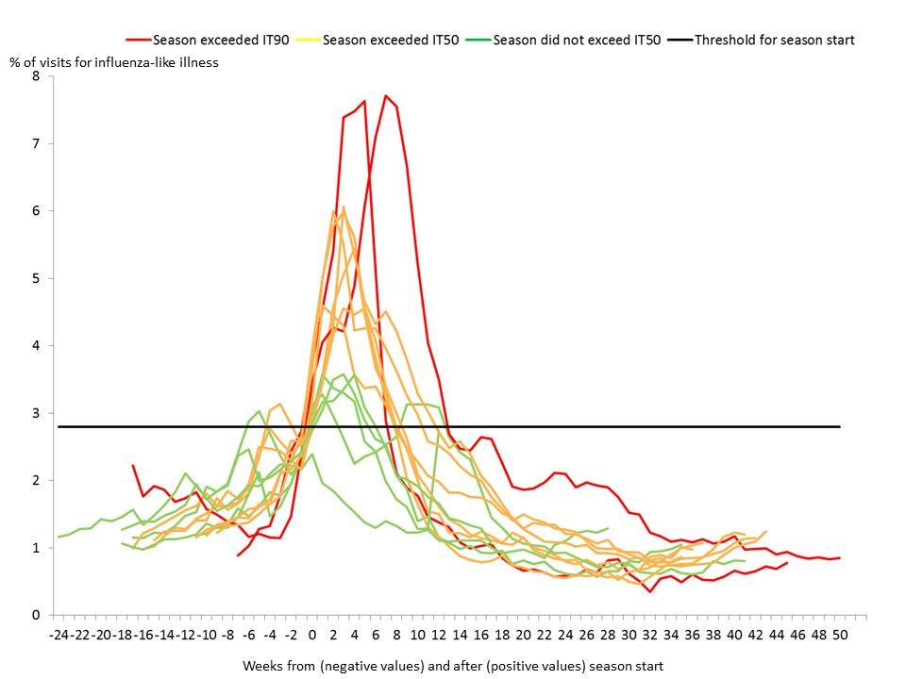
Web Table 1. Influenza Season Severity Classifications, by Season and Age Group, United States, 2003–04 to 2015–16 influenza seasons.
Season | Child | Adults | Older Adults | Overall
2003–04 | Very High | Moderate | High | High
2004–05 | Low | Moderate | Moderate | Moderate
2005–06 | Low | Low | Low | Low
2006–07 | Low | Low | Low | Low
2007–08 | Moderate | Moderate | Moderate | Moderate
2008–09 | Low | Low | Low | Low
2009–10 | Very High | Moderate | Low | Moderate
2010–11 | Moderate | Moderate | Moderate | Moderate
2011–12 | Low | Low | Low | Low
2012–13 | Moderate | Moderate | High | Moderate
2013–14 | Moderate | Moderate | Moderate | Moderate
2014–15 | Moderate | Moderate | High | High
2015–16 | Low | Moderate | Low | Moderate

Web Figure 5
Cumulative Rate of Laboratory-Confirmed Influenza Hospitalization per 100,000 Population and Seasonal Intensity Classification, by Season, FluSurv-NET, United States, 2005–06 Through 2015–16 Influenza Seasons

