Radiation Protection Program Review Calendar Year 2016
Environmental Health & Safety
Section Topic Page
SECTION 1: DRIVERS FOR THE RADIATION SAFETY PROGRAM 1
SECTION 2: EXECUTIVE SUMMARY 2
SECTION 3: PURPOSE AND SCOPE 3
SECTION 4: RADIATION SOURCE USE REVIEW FOR UTHEALTH 3
SECTION 5: ALARA AND DOSIMETRY REVIEW 4
SECTION 6: REGULATORY & LICENSING REVIEW 6
SECTION 7: COMPLIANCE ACTIVITIES 8
SECTION 8: TRAINING ACTIVITY REVIEW 8
SECTION 9: RADIOACTIVE WASTE DISPOSAL REVIEW 9
SECTION 10: SECURITY REVIEW† 10
†We request that the Section 10: Security Review be withheld from Public Disclosure under Texas Government Code Section 552.101.

Section 1: Drivers for the Radiation Safety Program
The Radiation Safety Program (RSP) resides within the Environmental Health & Safety department of The University of Texas Health Science Center at Houston (UTHealth). The fundamental objective of the RSP is to ensure the safety of UTHealth faculty, staff, and students while enjoying the scientific benefits available through the use of radioactive materials and radiation-producing machines. Equally important is the need for protecting the general public and the environment from avoidable additional radiation exposure and contamination as the result of permitted activities at UTHealth.

The RSP consists of a Radiation Safety Officer (RSO), a RSP Manager and four Radiation Safety Specialists. The broad scope use of radioactive material, and consolidated x-ray and laser use play an important supporting role in efficient accomplishment of UTHealth’s mission of educating health science professionals, discovering and translating advances in biomedical and social sciences and modeling the best practices in clinical care and public health. The RSP is driven by the research enterprise currently consisting of 138 authorized users of radioactive material, 427 radiation workers (radioactive permits at UTHealth) and one clinical area for diagnostic uses of radioactive material. The RSP also supports diagnostic clinical, veterinary and research uses of 131 x-rays and 74 lasers driven by the McGovern Medical School and School of Dentistry’s use of these devices. Although we are experiencing a decrease in the research use, we have simultaneously expanded the clinical enterprise within UT Physicians consisting of 5 lasers on two sites and 38 x-ray units on 28 sites across the greater Houston area. Additionally, the RSP provides dosimetry services to UTHealth employees and medical residents working with radiation under Memorial Hermann Hospital’s radiation permits and potentially elsewhere.

This review is specifically for UTHealth, however, select information has been included and underlined if it is not directly related to UTHealth.
UTHealth | UT Physicians | Memorial Hermann Hospital
Broad License L02###,  Cyclotron in Storage License L03###,  X-ray Registration R10###  Laser Registration Z008## | Radioactive Material License L05###  X-ray Registration R2###  Laser Registration Z018## | Radioactive Material License L00###  X-ray Registration R00###

Section 2: Executive Summary
During calendar year 2016 (CY2016), individuals working with sources of radiation under the auspices of UTHealth carried out biomedical research and clinical activities while maintaining a high level of safety. The major indicators of the level of safety include compliance with the local and state dosimetry limits, compliance with state safety regulations, the number of individuals trained and incidents involving radiation. The Radiation Protection Program Review describes these major indicators.

Important Milestones during CY2016
- Three inspections in 2016 by the Texas DSHS - Radiation Control (RC) resulting in no regulatory violations. The three inspections in 2016 consisted of one for the broad radioactive material license on the TMC campus, one security inspection and one x-ray inspection. In addition, the Radiation Safety Program assisted with eight x-ray inspections and one radioactive material inspection by the Texas RC for UT Physicians in 2016. Three of the eight x-ray inspections for UT Physicians were unannounced.
- No students, employees or medical residents exceeded their regulatory dose limits for radiation exposures.
- Implemented new Texas rules (effective March 2016) for Physical Protection of Category 1 and 2 Quantities of Materials (Increased Controls) impacting Radiation Safety Program oversight, access authorization plan, the security plan and features. These additional oversight mechanisms required additional radiation safety staff time and coordination with UT Police.
- UTHealth Mobile Streak Unit’s photograph was featured on the front page of the Health Physics Journal of the Operational Radiation Safety supplement in May of 2016 for the article entitled “Radiation Monitoring Results from the First Year of Operation of a Unique Ambulance-based Computed Tomography Unit for the Improved Diagnosis and Treatment of Stroke Patients by Gutiérrez, Emery, Parker, Jackson & Grotta. 110, S2, May 2016.
- EH&S maintained radiation regulatory compliance while providing oversight for 7 permits for radioactive materials, lasers and x-rays at both UTHealth and UT Physicians.
- RSP transitioned to fully electronic dosimetry records from its dosimetry vendor Landauer.
- Broad license was renewed in its entirety until January 31, 2026 after full review from the application submitted in December of 2009.
- Cyclotron license for the possession of activated components was renewed in its entirety till June 30, 2025, however condition 17 to provide logistical and planning efforts by August 31, 2018, and complete facility decommissioning by August 31, 2021 was imposed by Texas RC.
- UTHealth x-ray registration renewal application was submitted on November 8, 2016.
- EH&S participated in a handheld portable x-ray unit feasibility study with faculty of the School of Dentistry. Results were presented at the International Association for Dental Research on June 24, 2016 in Seoul, Korea.
- Performed baseline measurements within the Texas Medical Center for routine background radiation levels geographically positioned using the Polimaster device.

Anticipated Future Areas of Need for Radiation Safety Resources
- Strategic planning and funding are needed to complete stepped requirements including decommissioning of the cyclotron unit and activated components by August 31, 2021. Additionally, the potential degradation of key safety services, the impact to the University including the McGovern Medical School Building loading dock and the impact to radioactive material stored within the cyclotron vault are being considered.
- Texas DSHS Radiation Control has implemented routine unannounced inspections for x-ray machines. Radiation Safety will continue to work with the clinics to ensure they have sufficient records available for inspection.
- The RSP plans to enhance basic radiation safety training and include x-ray and laser safety training into current Human Resources learning management training system.
- Continued transition of routine safety records to electronic means such as contamination and safety surveys.
- Continued growth in highly complex research requiring multiple safety committee reviews
- To assist UTHealth residents, faculty and staffing working with radiation at Memorial Hermann Hospital and potentially other locations, EH&S has taken responsibility for the hand delivery and pick up on the dosimetry devices that takes a substantial amount of time for the monthly distribution. Additional EH&S time is spent when these individuals are not returning their badges in a timely fashion. The oversight for the dosimetry program for this group will continue to utilize a sizable amount of time for distribution, collection, and monitoring.

Section 3: Purpose and Scope
Purpose
Each entity authorized by the Texas Department of State Health Services, Radiation Control to use sources of radiation is required to review the content and implementation of the radiation protection program at intervals not to exceed 12 months per 25TAC§289.202(e)(3). This program review requirement is applicable for Texas UTHealth Radioactive Material Licenses L02### and L03###, Certificate of X-ray Registration R10###, and Certificate of Laser Registration Z008##.

All items contained in this annual report for UTHealth are reviewed during regularly scheduled Radiation Safety Committee (RSC) meetings. In fact, the Radiation Safety Program was pragmatically reviewed 9 times during CY2016 at RSC meetings throughout the year. This report is intended to summarize the results for dissemination during the February 2017 RSC meeting or the next regularly scheduled meeting.

Scope
This program review outlines the significant occurrences during CY2016 for the UTHealth RSC and UTHealth management. All documents and data contained in this report excluding Section 10: Security Review are available upon request at the Environmental Health & Safety office (713-500-8100). We request Section 10: Security Review be withheld from Public Disclosure under Texas Government Code Section 552.101 for the protection of security sensitive information contained within.

Section 4: Radiation Source Use Review for UTHealth

Permit | Type | Use Review as of Dec 31, 2016
License L02774 | Broad License, Radioactive Material | 138 Authorized Users (PIs)  264 mCi unsealed radioactive material  159 radioactive material laboratories
License L03685 | Cyclotron in Storage | Decay in storage of cyclotron unit and activated components
Registration Z00853 | Lasers | 74 Class 3B and Class 4 Lasers  31 open beam class 3B and 4 lasers  43 imbedded class 3B and 4 lasers in class 1 laser systems
Registration R10908 | X-rays | 131 x-ray units in use on registration  109 dental x-ray units on registration, including 86 at SOD, 6 at Greenspoint, 2 at OCB on Van, 6 at HMC, 2 at Smith  1 PET/CT machine, 1 Ambulance with a CT  2 radiographic unit, including 1 bone densitometers  7 veterinary units  10 minimal threat including: 8 cabinet dental x-ray machines, 1 x-ray irradiator, & 1 cabinet x-ray machine for veterinary use  1 Industrial including: 1 surgical skills  5 electron microscopes exempt from registration
Not Applicable | MRI / NMR | 3 units including:  1 for clinical MRI, 1 veterinary research MRI, 1 research NMR

Section 5: ALARA and Dosimetry Review

External Dosimetry
UTHealth routinely monitors personnel for radiation use on campus in accordance with the Texas regulations. For administrative purposes, the individuals issued monthly external dosimeters are considered “likely to exceed 10%” of the annual limits. The individuals issued quarterly external dosimeters are considered not “likely to exceed 10%” of the annual limits based on dosimetry provided for others performing similar tasks.

Starting in January 2009, UTHealth provides badges for UTHealth employees, medical residents and students working at Memorial Hermann Hospital and potentially other facilities. The specific programs including Cardiology & Diagnostic Faculty, Fellows & Residents using x-rays were identified as higher frequency users of radiation and an ALARA level of 10% (or 500 mrem) per month was assigned to these groups. An effective dose correction factor of 0.3 was applied to cardiology and faculty, fellows and residents wearing lead aprons utilizing x-ray machines per 25TAC§289.202(f)(5).

Dosimetry Review by Calendar Years
 | 2014 | 2015 | 2016 | Comments for 2016
Exceeded Regulatory Limit | 0 | 0 | 0
Exceeded 10% of Regulatory Limit | 0  14 | 0  14 | 0  14 | 0 at UTHealth  14 at MHH
Exceeded 10% of Declared Pregnancy Limit | 1  1 | 0  0 | 0  0 | 0 at UTHealth  0 at MHH
Exceeded ALARA of 125 mrem in a single monitoring period | 0 | 0 | 0 | 0 at UTHealth
Exceeded MHH Special X-ray Group ALARA of 500 mrem in a single monitoring period | 0 | 0 | 0 | 0 at MHH
Individuals Badged Monthly | 59 | 55 | 44 | UTHealth
Memorial Hermann Hospital Permit / UTHealth Individuals | 279 | 310 | 310 | MHH
Individuals Monitors Badged Quarterly | 354¥ | 196 | 142 | UTHealth
Total Individuals Badged | 692* | 561 | 496
Area Monitors | * | 180 | 189 | UTHealth

Gray and underlined designates occupational dose at Memorial Hermann Hospital permit.
¥In 2014, the total individuals badged quarterly also included the number of area monitors. In 2015 and 2016, the distribution of individuals and area monitors badged quarterly are shown.

10% of Regulatory Limit
All of the 14 individuals that exceeded 10% of the occupational dose limit were utilizing the radiation under the Memorial Hermann Hospital permit(s). No individuals working under UTHealth permits exceeded 10% of the occupational dose limit. The cumulative calendar year doses by partial participant number and group are provided. The dosimetry records of the Memorial Hermann individuals will continue to be monitored closely and those exceeding 10% of the cumulative year to date are communicated at least quarterly to MHH Radiation Safety through their MHH RSC via their RSO.

 | CY2016
Group | Deep Dose  Assigned  mrem | Lens Dose  mrem | Shallow Dose  mrem | Exceeded 10% in CY2015 | If Yes, DDE in CY2015 mrem
Anesthesiology | 457 | 1,531 | 1,519
Cardiology Fellow | 489 | 1,631 | 1,630 | Yes | 913
Cardiovascular Surgery | 515 | 1,708 | 1,670 | Yes | 1,125
Cardiovascular Surgery | 543 | 1,808 | 1,773
Diagnostic Faculty | 549 | 1,834 | 1,823
Cardiology Faculty | 637 | 2,120 | 2,087
Cardiology Fellow | 771 | 2,572 | 2,538
Cardiology Faculty | 895 | 2,984 | 2,889 | Yes | 886
Cardiology Fellow | 897 | 2,991 | 2,937
Cardiology Fellow | 961 | 3,202 | 3,142 | Yes | 1,218
Cardiology Faculty | 1,018 | 3,398 | 3,361 | Yes | 1,296
Diagnostic Faculty | 1,134 | 3,775 | 3,659 | Yes | 931
Cardiovascular Surgery | 1,235 | 4,117 | 4,073 | Yes | 549
Cardiology Faculty | 1,444 | 4,813 | 4,722 | Yes | 1,736

ALARA Investigations
No individuals exceeded their ALARA investigation levels during a single monitoring period for CY2016. No ALARA communications to MHH Radiation Safety for their investigation of individuals working on Memorial Hermann’s permits were required in CY2016. The dosimetry records of the Memorial Hermann individuals will continue to be monitored closely and those exceeding 10% of the cumulative year to date are communicated at least quarterly to MHH Radiation Safety.

Declared Pregnancy Program
- 16 individuals were enrolled in the declared pregnancy program during CY2016 including 4 UTHealth employees working on Memorial Hermann’s permits.
- None of the declared pregnancy program participants exceeded the limits of 500 mrem per gestation period. No fetal monitors exceeded 50 mrem (10%) per gestation period. Within Memorial Hermann’s permits no fetal monitors exceeded 50 mrem per gestation.

Internal Dosimetry
During CY2016, the Radiation Safety Program conducted a total of 3 precautionary bioassays, including one thyroid bioassay and two urine bioassays. All bioassays were performed as pre-exposure baseline assays or screening on EH&S employees or researchers planning to utilize radioactive iodine. None of these bioassays indicated any radiation intake or uptake had occurred, including none exceeding 2% or 10% of any applicable dose limit. No bioassays were conducted as a result of a spill of radioactive material in a research laboratory. Currently three researchers have periods of actively working with high activities such that the RSC may require pre-operational thyroid bioassays for I-123 and I-125 use. Storage does not require bioassays. No other researchers have periods of actively working with high activities required by the Radiation Safety Manual.

Area Monitor Review
Of the area monitors issued in 2016, all area monitors assigned to assess the general public accessible dose were in compliance with the general public dose limit of 100 mrem in a year. Area monitors continue to be placed within the new School of Dentistry (SOD) building for the dental x-ray machines, although the monitoring frequency has been reduced from 2012. The area monitors within the cyclotron vault are not readily accessible to the general public. These cyclotron vault readings also do not represent occupational doses as the workers utilize limited time and increased distance from these area monitor locations. Monitors close to 100 mrem will continue to be monitored closely.
Notification for Individuals with Greater than 100 mrem in a Year.
Notifications will be sent via e-mail in the month of February 2017 for all individuals that exceeded 100 mrem cumulatively for 2016. This notification will be distributed after the RSC is informed of the need to communicate this information. 50 individuals exceeded 100 mrem cumulatively for 2016 with only 4 at UTHealth radiation permits.

Summary Dosimetry Results
Employee exposures to radiation and uses of radiation in research and clinical settings were maintained As Low As Reasonably Achievable (ALARA) during CY2016. At UTHealth, there were no individuals working under UTHealth permits in CY2016 who exceeded 10% of any particular employee annual dose limit. Fourteen UTHealth employees working under Memorial Hermann Hospital permit(s) in CY2016 exceeded 10% of the annual dose limit. No individuals exceeded the regulatory dose limit. No individuals in the declared pregnancy program exceeded 500 mrem/gestation.

Section 6: Regulatory & Licensing Review

Type of Permit | Broad License | Cyclotron in Storage | X-ray Machines | Lasers
Permit Number | License L02### | License L03### | Registration R10### | Registration Z008##
Expiration | January 31, 2026 | June 30, 2025  Imposed Decommission by Aug. 31, 2021 | Nov 30, 2016, Pending renewal, requested on November 8, 2016 | Jun 30, 2018
Amendments in CY | 2, Radiation Safety Committee change, renewal received | 2, request to amend decommission conditions | 3, increase dental x-rays at SOD, Separate MSU Ambulance and UTPB GPR into two sites, renewal requested | 0
Scope of Permit | Enables RSC to grant variable quantities of radioactive materials for education, research and clinical PET use | Storage of cyclotron unit and associated activated components | Possess and operate radiation-producing devices for dental, veterinary, medical, and research use | Possess and operate Class 3B and 4 Lasers for research and medical use
Biennial Permit Fee | $40,794 | $3,533 | $8,848 | $236

Cyclotron Decommissioning
On August 4, 2015, Texas DSHS renewed the license L03### and imposed the license condition to complete facility decommissioning by August 31, 2018. On December 16, 2015, UTHealth requested the facility decommissioning requirement be removed or amended. In processing the December 2015 amendment request, representatives of Environmental Health & Safety and Legal Affairs attended an informal hearing on June 29, 2016 in Austin, Texas. On November 15, 2016, the cyclotron license was amended to include the requirement for logistical and financial planning efforts and stepped requirements to be completed by August 31, 2018 and completion of facility decommissioning by August 31, 2021. On December 12, 2016, Dr. B###, the Chair of the Radiation Safety Committee sent a letter to M. T#### noting the importance of necessary financial planning for the UTHealth Cyclotron Facility Decommissioning to occur successfully.

Radiation Safety Manual and Supporting Documents
As needed, the UT Health Radiation Safety Manual is updated. The Radiation Safety Manual was updated in August of 2016 and made available through the EH&S website. Enhancements included updating the Texas DSHS Radiation Control Program website information. The Radiation Safety Program assists in the Operating & Safety procedures for UTHealth as well as UT Physicians for radiation producing devices.
Liquid or Solid Inventory
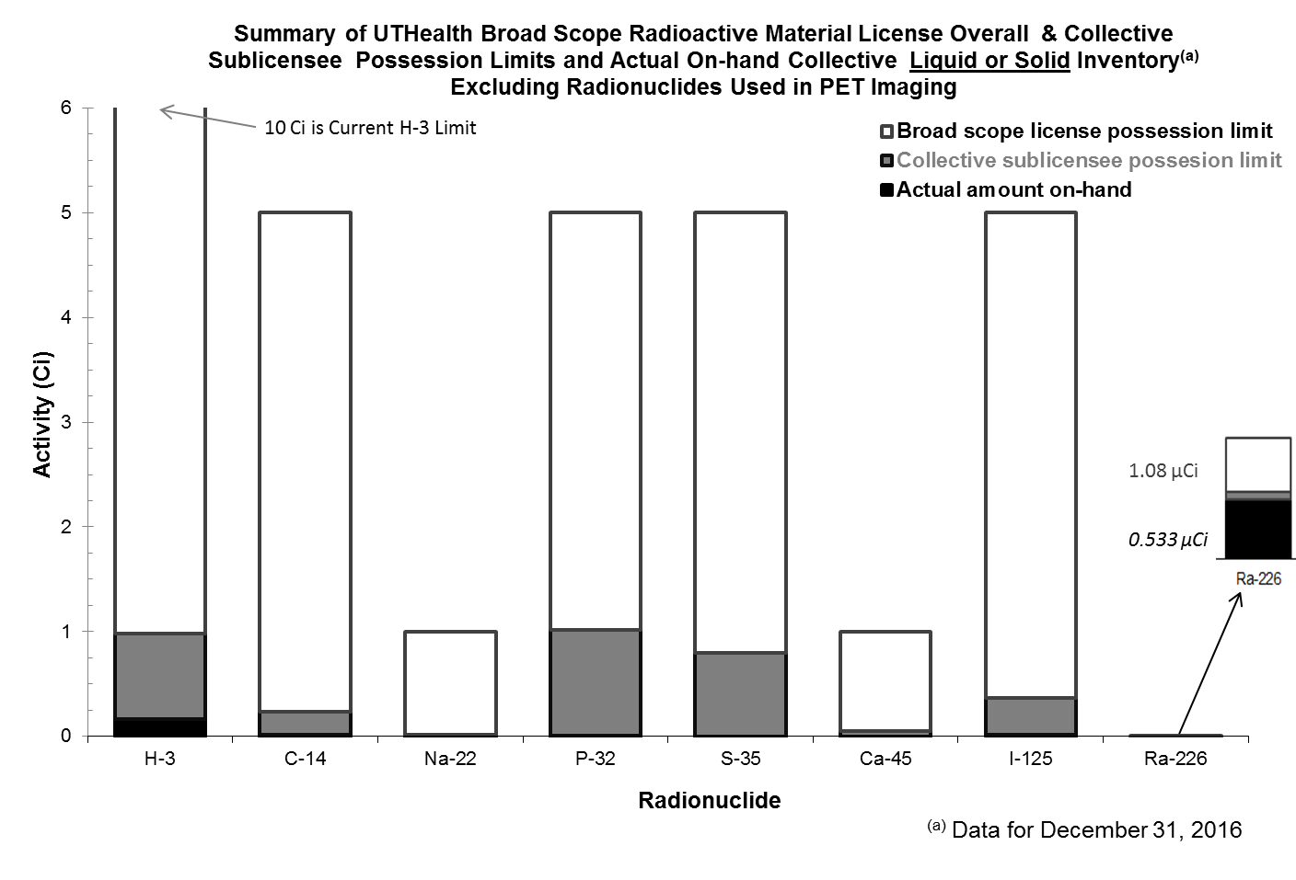
Sealed Sources
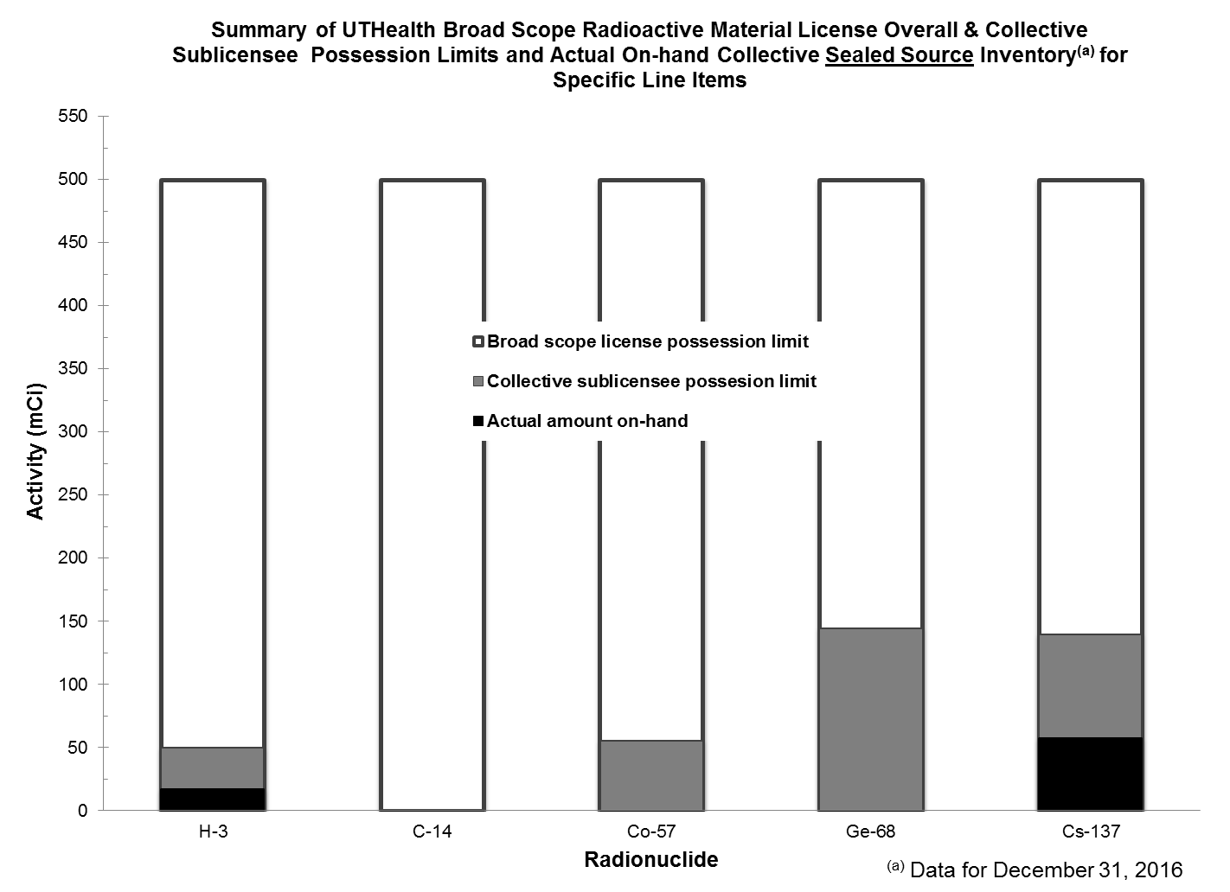

Section 7: Compliance Activities

Texas Department of State Health Services - Radiation Control
Results of recent routine inspections (2014 – 2016) by the Texas Department of State Health Services – Radiation Control are indicated. In August of 2016, Texas DSHS announced the recent return to the practice of conducting unannounced inspections of x-ray facilities.

Year | Inspection Date | Permit | Site / Building | Number of Notices of Violation
2014 | Jan. 23, 2014 | X-ray R10### | UTPB (GPR) | 0
 | Feb. 14, 2014 | X-ray R10### | UCT (Employee Health Services) | 0
 | Mar. 27, 2014 | X-ray R10### | Brownsville, CRU | 0
 | July 7, 2014 | Broad License L02### | TMC | 0
 | July 7, 2014 | Security L02### | TMC | 0
 | Oct. 21, 2014 | X-ray R10### | Greenspoint Dental | 0
2015 | Feb. 11, 2015 | X-ray R10### | MHH, PET Suite | 0
 | Feb. 11, 2015 | X-ray R10### | MSB / MSE | 0
 | Mar. 19, 2015 | Broad License L02### | South Campus (BBSB, SCRB3, SOD, site 007) | 0
 | Apr. 22, 2015 | X-ray R10### | SRB | 0
2016 | Nov. 11, 2016 | X-ray R10### | OCB Vans (Remote) | 0
 | Dec. 16-19, 2016 | Broad License L02### | TMC | 0
 | Dec. 16-19, 2016 | SecurityL02### | TMC | 0

Radiation Protocol Sub-Committee for CT Systems (R10###) and FGI Procedures (R2####)
The Radiation Protocol Sub-Committee met in 2016 on April 26, 2016 and November 8, 2016. The minutes were reviewed by Radiation Control on January 4, 2017 for the X-ray inspection of the Mobile Stroke Unit (Ambulance containing a CT).

Section 8: Training Activity Review
Radiation Safety Training
During CY2016, the Radiation Safety Program provided radiation safety training to 382 individuals within UTHealth and the community.

Course | Number Trained | Audience
Basic Radiation Safety Tr. (6 hr) ( 8 courses) | 55 | UTHealth, License
Radiation Safety Officer Course (40-hr) | 8 | Radiation safety professionals within local and national community
Radioactive Material Shipping Training | 5 | UTHealth, License
Radiation Safety Awareness | 0 | Those individuals only tangentially involved with radiation
Laser Safety Training | 1 | UTHealth, Registration
Resident Dosimetry & Radiation Training, either online or in-person | 26 | UTHealth residents & local community
X-ray Safety Training | 0 | UTHealth and local community
Radiation Safety for Law Enforcement | 98 | UT Police
Radiation Safety Conference Lectures | 128 | National audience
Other Radiation Safety Tr. | 61 | UTHealth, local community
Total | 382

Section 9: Radioactive Waste Disposal Review
During CY2016, UTHealth generated and processed the following radioactive waste as a result of research and clinical activities. Through compaction, vial shredding and other waste minimization techniques, the Environmental Protection Program was able to save tremendously through cost avoidance.

Radioactive Waste Review | Value for CY2015 | Value for CY2016
Radioactive waste generated | 274 ft³ | 227 ft³
Radioactive waste expenditures* | $0 | $1,200
Environmental Protection Program Savings | $49,850 | $43,850
*Not inclusive of supply or labor costs.

The RSC reviews the radioactive waste disposal program on a routine basis. The Committee strictly monitors the generation, storage, collection, processing, and ultimate disposal of radioactive waste at UTHealth.

The UTHealth Radiation Safety Officer has reviewed and approved this report prepared by the UTHealth EH&S Radiation Safety Program.

___Robert J. Emery________________________________ ___February 15, 2017_______

Robert J. Emery, DrPH, CHP, CIH, CSP, RBP, CHMM, ARM, CPP Date

