Supplemental Figure S6. fHBP surface expression levels for NmB isolates in the invasive isolate set (n=1814) by individual country as shown. A) US isolates (n=432). B) UK isolates (n=536). C) French isolates (n=244). D) Spanish isolates (n=346). E) German isolates (n=205). Isolates were binned based on their fHBP expression (MFI) in the MEASURE assay. The Y-axis represents the frequency of isolates in each binned group. Background denotes an MFI of less than 3 times the mouse IgG (negative control) MFI and/or an MFI of less than 100.
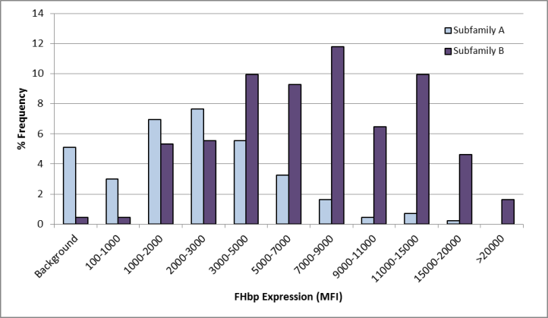
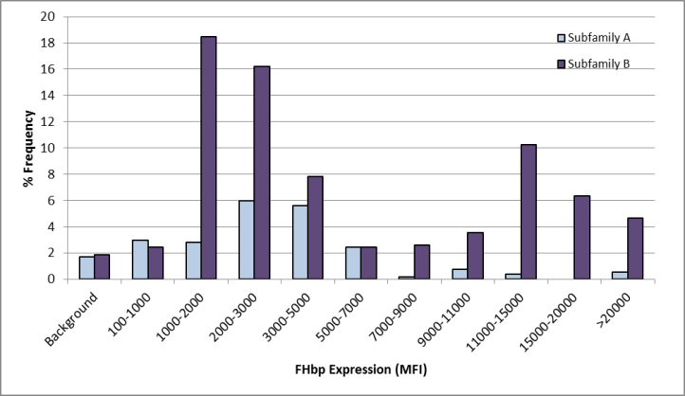
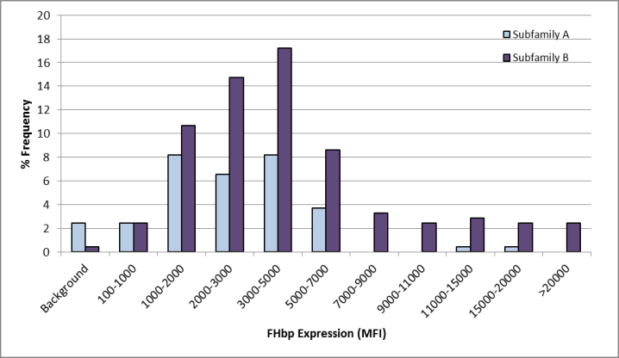
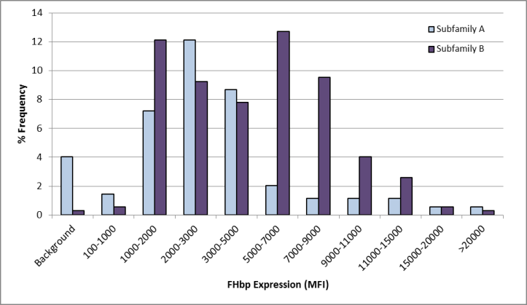
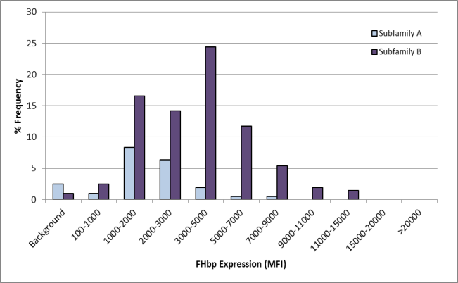
A.
C.
E.
D.
B.

