Kinetics of serological responses in critically ill patients hospitalized with influenza A(H1N1)pdm09 virus infection in Canada, 2009–2011

Supplemental Figure 1: Geometric mean hemagglutinin inhibition (HAI) antibody titers (A) and neutralizing antibody titers (B), with 95% confidence intervals, over time for 22 patients who did not receive corticosteroids, 5 patients who received low-dose corticosteroids, and 15 patients who received high-dose corticosteroids while hospitalized for critical illness with influenza A(H1N1)pdm09 virus infection — Canada, 2009–2011.*
(A)

(B)
* Size of dot is proportionate to the number patients with a blood draw in the time interval. Patients remained in the ‘no steroid’ group until the time-interval in which they received corticosteroids. Once a patient received low-dose corticosteroids (≤50mg prednisone equivalent per day), their data contributed to that group for the rest of follow-up or until the time interval in which they received high-dose corticosteroids. Once a patient received high-dose corticosteroids (>50mg prednisone equivalent per day), their data contributed to the ‘high-dose’ group for the rest of follow-up. Wilcoxon rank sum test comparing median HAI antibody titer between patients who received no corticosteroids to patients who received high-dose corticosteroids in each time interval: p-value = 0.74 at 0–10 days, p-value = 0.55 at 11–20 days, p-value = 0.70 at 21–30 days, p-value = 0.48 at 31–40 days, and p-value = >0.99 at >40 days from illness onset. Wilcoxon rank sum test comparing median neutralizing antibody titer between patients who received no corticosteroids to patients who received high-dose corticosteroids in each time interval: p-value = 0.82 at 0–10 days, p-value >0.99 at 11–20 days, p-value = 0.32 at 21–30 days, p-value = 0.93 at 31–40 days, and p-value = 0.35 at >40 days from illness onset.

Supplemental Figure 2: Hemagglutinin inhibition (HAI) antibody titers for patients with influenza A(H1N1)pdm09 virus infection who died, by timing of death from illness onset — Canada, 2009–2011.
A) Patients who died a short time (<18 days) from illness onset (patient #2, 3, and 5)
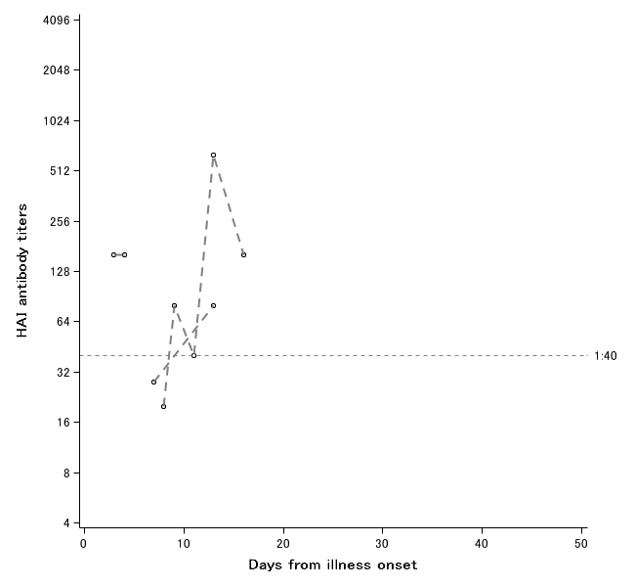

B) Patients who died ≥18 days from illness onset (patient #1, 4, 6, 7, and 8)
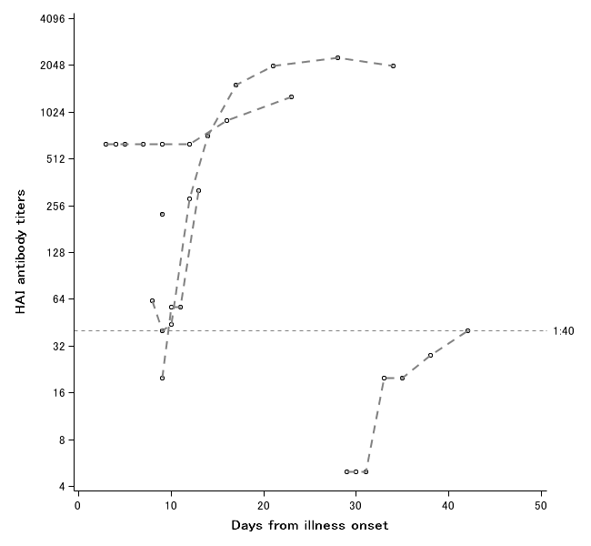

Supplemental Figure 3: Neutralizing antibody titers for patients with influenza A(H1N1)pdm09 virus infection who died, by timing of death from illness onset — Canada, 2009–2011.
A) Patients who died a short time (<18 days) from illness onset (patient #2, 3, and 5)
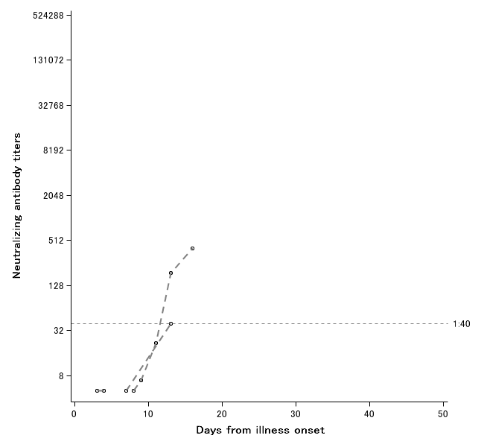

B) Patients who died ≥18 days from illness onset (patient #1, 4, 6, 7, and 8)
