Fig. S1. Gas Chromatography-Flame Ionization Detection of SRM 2378, Level 2, NIST-1 Method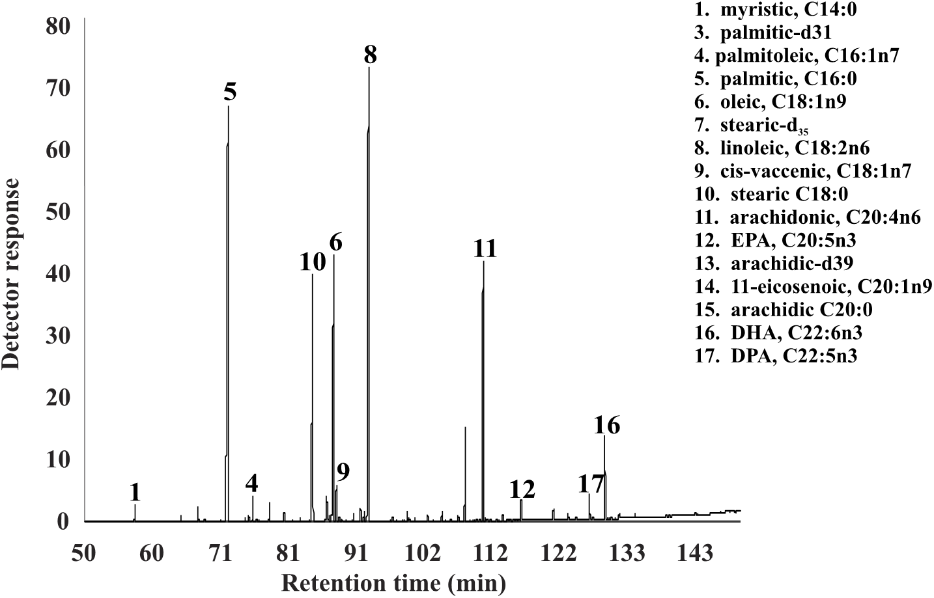
Fig. S2. GC/MS Total Ion Chromatogram of SRM 2378, Level 2, NIST-2 Method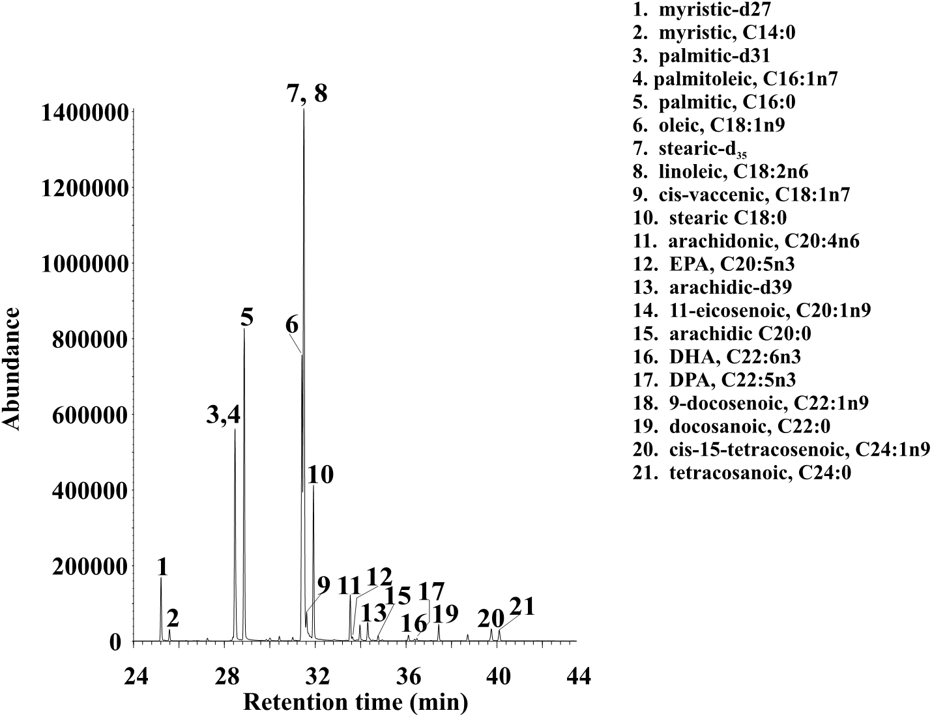
Fig. S3. GC/MS Total Ion Chromatogram of SRM 2378, Level 2, CDC Method
