Community Airborne Particulate Matter from Mining for Sand used as Hydraulic Fracturing Proppant

Thomas M. Petersa,*, Patrick T. O’Shaughnessya, Ryan Granta, Ralph Altmaiera, Elizabeth Swantona, Jeffrey Falka, David Osterberga, Edith Parkera, Nancy G. Wylanda, Sinan Sousan, Aimee Liz Starka, Peter S. Thornea

a The University of Iowa, Iowa City, IA

* Corresponding author: 145 N Riverside Drive, S331 CPHB, University of Iowa, Iowa City, IA, [thomas-m-peters@uiowa.edu](mailto:thomas-m-peters@uiowa.edu)

Submitted to Science of the Total Environment

The authors have no potential conflicts of interest to disclose.

Funding was provided through a supplemental grant to the Environmental Health Sciences Research Center at the University of Iowa from the National Institute for Environmental Health Sciences. The sponsor had no involvement in the study, writing of the report, and decision to submit the article for publication.

# Abstract

Field and laboratory studies were conducted to evaluate the impact of proppant sand mining and processing activities on community particulate matter (PM) concentrations. In field studies outside 17 homes within 800 m of sand mining activities (mining, processing, and transport), respirable (PM4) crystalline silica concentrations were low (<0.4 µg/m3) with crystalline silica detected on 7 samples (2% to 4% of mass). In long-term monitoring at 6 homes within 800 m of sand mining activities, the highest daily mean PM concentrations observed were 14.5 µg/m³ for PM2.5 and 37.3 µg/m³ for PM10, although infrequent (<3% of time), short-term elevated PM concentrations occurred when wind blew over the facility. In laboratory studies, aerosolized sand was shown to produce respirable-sized particles, containing 6% to 19% crystalline silica. Dispersion modeling of a mine and processing facility indicated that PM10 can exceed standards short distances (<40 m) beyond property lines. Lastly, fence-line PM and crystalline silica concentrations reported to state agencies were substantially below regulatory or guideline values, although several excursions were observed for PM10 when winds blew over the facility. Taken together, community exposures to airborne particulate matter from proppant sand mining activities at sites similar to these appear to be unlikely to cause chronic adverse health conditions.

# Keywords

Hydraulic fracturing, proppant sand, particulate matter, crystalline silica, sand mining, air pollution

# 1. Introduction

In modern hydraulic fracturing, ~1,600-m horizontal channels are drilled radially into shale rock formations from a ~3,500-m depth vertical shaft (Osborn et al., 2011). High pressure in the horizontal channel opens cracks into which a slurry of water, proppant, and other proprietary chemicals are pumped. Oil and/or gas in the shale then pushes the water and chemicals out of the cracks leaving the proppant in place to hold open the cracks and increase the longevity of a horizontal channel. Sand composed primarily of crystalline silica is commonly used as proppant because it is inexpensive, is spherical, and has a high compressive strength. Sand suitable for use in hydraulic fracturing is mined primarily from sandstone deposits in the Midwest US (Mt Simon, Wonewoc, Jordan, St. Peter formations) and in Texas (Hickory formation) (Benson and Wilson, 2005). Wisconsin leads in frac sand production with 62% of the US total production, due to sandstone near the surface that allows for crystalline silica extraction via surface mining (Miley, 2014).

The three main activities of industrial sand mining (mining, processing, and transportation) generate fugitive dust (Petavratzi et al., 2005). Surface mining consists of removing “overburden” (i.e. vegetation and topsoil) and extracting the underlying sandstone formation containing the silica sand (WDNR, 2012b). Sandstone from the mine is then taken to a processing plant where it is screened, washed, and dried to prepare it for transportation to the wellhead by truck, train, or barge. These processes impart mechanical energy to the granular material, which can generate airborne particulate matter (PM) directly or indirectly from wind blowing over storage piles (Watson et al., 2000). Fugitive emissions may impact the concentration of airborne particulate matter (PM) in communities surrounding sand mines. PM is regulated by the United States Environmental Protection Agency (EPA) through primary national ambient air quality standards (NAAQS): PM smaller than or equal to 10 µm in aerodynamic diameter (PM10); and PM smaller than or equal to 2.5 µm in aerodynamic diameter, or fine particles (PM2.5). PM10 includes fine and coarse particles with coarse particles defined having a diameter between 2.5 µm and 10 µm, PM10-2.5. The NAAQS for PM2.5 is 35 µg/m3 for a 24-hr averaging time (defined as the 98th percentile of PM over 3 years) and 15 µg/m3 for an annual averaging time (annual arithmetic mean, averaged over 3 years). The NAAQS for PM10 is 150 µg/m3 for a 24-hr averaging time (not to be exceeded more than once per year on average over 3 years).

Fugitive dust from sand facilities may also contain crystalline silica, which, when in the respirable size fraction (PM4), can penetrate into the distal airways and alveoli (Stahlhofen et al., 1980). The International Agency for Research on Cancer (IARC) has classified crystalline silica as a Group 1 carcinogen (IARC, 2012), and exposure to low-level crystalline silica can lead to the development of chronic silicosis (Leung et al., 2012). There is no federal regulation for ambient crystalline silica concentrations. However, California’s Office of Environmental Health Hazard Assessment (OEHHA) adopted a health-based, reference exposure level of 3 µg/m3 measured as PM4 (OEHHA, 2005). The Minnesota’s Environmental Quality Board (EQB) adopted this guideline level for sand mining and related activities (MEQB, 2013). The Minnesota Department of Health further clarified that the level should be applied as a yearly average concentration (MDH, 2017).

The goal of this work was to assess PM and respirable crystalline silica concentrations in communities near hydraulic fracturing proppant sand mining and processing facilities. Field studies were conducted to monitor PM at residential homes within 800 m of sand mining activities (mining, processing, and transport), including measurement of 48-hr respirable (i.e., PM4) crystalline silica concentrations and real-time (20-s) monitoring with co-located acquisition of wind speed and direction to attribute measured PM concentrations to specific sources. We conducted additional studies to help explain our findings from residential monitoring. Controlled laboratory tests were conducted to characterize the silica content of aerosolized proppant and unprocessed sand. Atmospheric dispersion modeling was conducted to evaluate whether concentrations of PM10 would potentially exceed EPA regulatory levels beyond the property line of a sand processing facility and an open-pit mine. Finally, we also summarized regulatory PM measurements from regional sites and at mines.

# 2. Experimental

## 2.1 Respirable (PM4) crystalline silica sampling at homes

We measured PM4 crystalline silica concentrations following NIOSH Method 7500 (NIOSH, 1994) outside of 17 residential homes within 800 m of the property line of facilities with active sand mining, processing, and/or transport in Trempealeau County, WI. These homes were selected randomly from a list of volunteering owners solicited through mail. Eligible homes were identified through publicly-available county property records. Sampling was conducted outside the home in a location mutually agreed upon by the investigator and the resident with the goal to sample as far away from trees and structures (e.g., shed, house) as feasible. Air was drawn with pumps (Omni 400, BGI by MesaLabs, Butler, NJ) at 4.2 L/min through PM4 samplers (GK2.69 cyclone, BGI by MesaLabs, Butler, NJ) held 1.5-m from the ground and fitted with PVC filters (37-mm, 5.0-µm pore, Cat No 225-5-37, SKC Inc., Eighty-Eight, PA) for a minimum of 48 h. Sampling at this height with a respirable sampler represented the potential exposure of a resident when outdoors. Wind speed and direction were monitored with equipment mounted on the same pole as the air sampler. Samples were analyzed first gravimetrically (NIOSH Method 0600) (NIOSH, 1994) and then for crystalline silica by XRD (NIOSH Method 7500) (NIOSH, 1994). These sampling and analysis methods were selected to provide a minimum reporting limit (defined as five times the minimum detectable level) for crystalline silica concentration of 0.4 µg/m3.

## 2.2 Long-term monitoring

Six sites were selected for real-time PM monitoring using the same criteria specified for crystalline silica air sampling above. Detailed information on these sites and sampling methodology are provided in Supplemental information, Section B. Briefly, three sites were near mines with onsite processing, two were near train trans-load/transportation facilities, and one was near a processing-only facility (Supplemental Information, SI, **Table S1**). At each site the monitoring equipment was set up as far from trees as possible and with a clear sightline to the nearest facility. The sampling time at each site averaged 17 days (range: 7-26). The overall sampling time frame (June 2014 - November 2014) aligned with the mining season. During the sampling time frame, typical summer and early fall weather conditions occurred.

An optical particle counter (OPC, Environmental Dust Monitor, Model EDM164, GRIMM Aerosols Technik, Ainring, Germany), positioned inside a trailer (SI, **Figure S1**), was used to measure PM10 and PM2.5. We selected this sampler because it provides highly temporally resolved PM concentrations for multiple size fractions. When relative humidity is greater than 50%, this sampler heats the sampled air to avoid positive bias from hygroscopic aerosols and to evaporate water droplets. A sampling head mounted 15 cm above the roof of the trailer was used to convey ambient aerosol to the OPC. External sensors mounted on a pole and attached to the side of the trailer were used to measure wind speed, wind direction, sound level, and motion. Wind speed and wind direction were measured with an ultrasonic anemometer (Model 85000, R.M. Young Company, Traverse, MI) mounted 3.7 m from the ground. A microcontroller was used to collect PM10 and PM2.5 from the OPC every 6 s and external sensor data every second. These measurements were averaged and logged to an SD card every 20 s.

MATLAB (8.3.0.532 R2014a, MathWorks, Natick, MA) was used to calculate PM10-2.5 (calculated by subtracting PM2.5 from PM10), categorize explanatory variables, and remove unreadable records due to short power outages at Site 3 for less than 30 min. For each site, mean daily (from 12:00 am to 11:59 pm) concentrations were calculated as the arithmetic mean of 20 s. data. Statistical software (Minitab 17, Minitab Inc., State College, PA) was used to generate probability plots of 20-s PM2.5 and PM10-2.5 data. A bimodal distribution of concentrations was observed on probability plots for all sites (SI, **Figure S2** for PM10-2.5 and SI, **Figure S3** for PM2.5). Thus, a breakpoint concentration, defined as the maximum curvature (represented with an arrow in SI, **Figure S2A**), was determined to separate the two modes. Conditional probability plots of PM data versus wind direction data were then generated for PM data above the breakpoint concentration and for values above the NAAQS following Kim and Hopke.

The local contribution to PM2.5 and PM10-2.5 was estimated for 5-min, 1-hr, workday, and 24-hr periods following Watson and Chow (Watson and Chow, 2001). Local PM was calculated as the concentration observed for that time period subtracted by a successive moving average.

## 2.3 Silica content of aerosolized mine and processed sand

Raw sand (unprocessed sand from a mine) was collected from a site associated with the Upper Cambrian Jordan sandstone formation in Wisconsin known in the hydraulic fracturing industry as “Northern White.” Proppant sands of four different mesh sizes (20/40, 30/50, 40/70, 100M) were also obtained from a proppant sand distributor.

To aerosolize the raw and proppant sands, 20.0 g of sand was weighed on a 4-place balance and placed in an acoustical dry aerosol generator/elutriator (ADAGE) system (Thorne, 1994). Dried, filtered, and compressed air flowed through the ADAGE system at 2.5 L/min into an enclosed chamber. Five samples of respirable dust from raw sand and each proppant type were collected with a respirable aluminum cyclone (SKC Inc., Eighty Four, PA) operating at 2.5 L/min for 60 min in accordance with the NIOSH Manual of Analytical Methods, Method 7500.The concentrations in the chamber were elevated to a level that would be expected to result in the majority of samples collected to exceed the limit of detection of Method 7500 (10 µg silica/filter sample) within the 60-min sampling period.

A total of 25 samples were collected on 5-μm-pore polyvinyl chloride (PVC) filters at 2.5 L/min using an SKC AirChek sampling pump (Model 22PCXR4, S/N 634006, SKC Inc, Eighty Four, PA). The sampling pump flow rate was calibrated before and after the sample collection period with a Gilibrator calibrator (S/N 1103045, Sensidyne, St Petersburg, FL. Filters from samples collected with the respirable cyclone were weighed before and after sample collection on a microbalance (Mettler Toledo XP-26, S/N 112122649, Mettler-Toledo LLC, Columbus, OH) following NIOSH Method 0600 (NIOSH, 1994) and then for crystalline silica by by x-ray diffraction (XRD) following NIOSH Method 7500 (NIOSH, 1994). Five g each of bulk, sieved raw sand (sieve sizes: 18/40, 40/60, 60/100, >100) and 5 g of each proppant type (sieve sizes: 20/40, 30/50, 40/70, 100M) were also analyzed by XRD for silica content. Additional cyclone filter samples were analyzed by scanning electron microscopy (SEM) with energy dispersive x-ray spectroscopy (EDS).

## 2.4 Atmospheric dispersion modeling

For purposes of visualizing the degree to which particulates may emenate from facilities associated with the frac sand industry in Wisconsin, air dispersion modeling was conducted for two sites: a processing plant and an open pit mine. The final evaluation of dispersion model results includes PM10 predicted by the model in addition to the background level of PM10. A background level of PM10 for the state of Wisconsin of 29.4 µg/m3 was used in this analysis (WDNR, 2014). Dispersion modeling was performed with the EPA-approved dispersion model, AERMOD, incorporated in a vendor-supplied software package (AERMOD ViewTM ver. 9.1.0, Lakes Environmental, Waterloo, Ontario). Modeling guidelines developed by the WDNR were followed (WDNR, 2015). Meteorological data, supplied by the WDNR (WDNR, 2016a), consisted of five years (2006 – 2010) of one-hour sets for sources within a region around the collecting meteorological station (Eau Claire, WI meteorological station). Upper-air meteorological data was measured at the St. Cloud Muncipal Airport.

The processing plant is located in Chippewa Falls, WI and represents a large facility dedicated to frac sand processing and shipping. In 2013, the plant consisted of sand dryers, product silos, a rail loadout area, truck receiving station, conveyers and stackers, material stockpiles and truck traffic on haul roads. Emissions for each of these potential sources of PM10 were obtained from a 2012 WDNR air emissions inventory summary report for the plant (WDNR, 2012a). Locations for the sources were determined from aerial photos. The photos did not show a plant fenceline, therefore the plant boundary was estimated from the plant structures and roadways, which represented the area within which the public would not be expected to be allowed access. A variety of emission source types were used when applying these PM10 sources to the dispersion model including: point (dryers, loadout and recieiving), area (conveyer and stackers), volume (product silos), and line (roads). At the time of the emissions inventory the stockpiles were uncovered and therefore represented a PM source from windblown dust. The two sand dryers utilized natural gas boilers which were not a source of PM but each dryer conveyed dried sand that produced PM. Baghouse filters were employed to control emissions during the conveying process as well as other point sources of dust emissions associated with the dryer building; the WDNR report therefore provided controlled PM emission rates from those sources. The report also mentions that watering trucks were used to suppress dust emissions from haul roads. All emission levels were reported for work schedule consisting of 24 hr/day, 7 days/wk, 365 days/yr.

The open pit mine is located in New Auburn, WI and was modeled as depicted from aerial photos obtained during 2014. PM emission sources within the mine consisted of a rock crusher, dryer, sand piles, open pits, and truck traffic on paved and unpaved haul roads. Emission rates for each of these potential sources of PM10 were obtained from a 2013 WDNR air emissions inventory summary report for the mine (WDNR, 2013). Control technologies to suppress PM emissions at this mine were not listed in the WDNR summary report. The USEPA and state air quality bureaus offer less guidance for modeling open pit mines and sand piles compared to the information they make available for modeling typical industrial sources. Therefore, additional guidance was obtained from a modeling document written for the sand and gravel industry to provide the most appropriate modeling options for those source types (Heinerikson et al., 2007). For example, this information was used to establish AERMOD source types for processes utilized in sand mines such as crushers (area source), sand piles (area source) and open pits (open pit source).

A receptor grid was established according to WDNR guidance (WDNR 2016b). The terrain option was utilized with terrain data obtained from the Shuttle Radar Topography Mission (STRM) available through the US Geological Survey (USGS, 2016). Given five years of meteorological data, the WDNR guidance is to model the 6th highest value for every grid node to mimic the standard requirement of no more than one excursion above the 150 µg/m3 limit per year on average over 3 years.

## 2.5 Evaluation of regulatory measurements

We analyzed publically-available PM2.5 and PM10 concentrations measured with federal reference or equivalent method samplers near or within the fenceline of facilities with sand mining activities. These measurements were either required or requested of the facility at the time of permit application by state agencies in Wisconsin and Minnesota. PM10 was measured at 16 monitoring stations from Nov 2010 to Sep 2015 (overall n = 3,395; WI n = 2,549; MN n = 846). Total suspended particulate (TSP; n = 286 from 2 locations with one location having monitors north and south of a mine), PM2.5 (n = 444 from 2 locations both having monitors north and south of a mine), and PM4 crystalline silica (n = 417 from 4 locations with 2 locations having monitors north and south of a mine) were measured as part of sampling required by the Minnesota Pollution Control Agency from Jul 2012 to Oct 2015.

# 3. Results

**3.1 Respirable (PM4) crystalline silica sampling at homes**

Respirable sampling was conducted over a 48-h at 17 residences near sand mines. The mean PM4 was 9.1 µg/m3 (St Dev = 2.6 µg/m3), ranging from 6.0 µg/m3 to 15 µg/m3. Crystalline silica (α-quartz) was detected above the method limit of detection on 7 of the 17 samples. Of those samples, quartz represented 2% to 4% of the mass. All PM4 crystalline silica concentrations were less than the minimum reporting level of 0.4 µg/m3, which is lower than the value of concern for chronic exposures adopted by CA and MN (3 µg/m3).

**3.2 Long-term monitoring**

Long-term air monitoring at homes near sand mining and processing operations revealed PM concentrations well below the NAAQS for PM2.5 and PM10 (**Table 1**). Mean concentrations observed throughout monitoring ranged from 6.5 µg/m3 (Site 6) to 10 µg/m3 (Site 4) for PM2.5 and from 11.1 µg/m3 (Site 3) to 19.8 µg/m3 (Site 5) for PM10. The highest 24-h mean concentrations were fairly similar between sites for PM2.5 (range: 11.4 µg/m3 at Site 1 to 14.5 µg/m3 at Site 2), whereas the range was larger for PM10 (range: 18.6 µg/m3 at Site 1 to 38.0 µg/m3 at Site 5).

Breakpoint concentrations in the probability plots for 20-s data ranged from 18 µg/m3 to 36 µg/m3 for PM2.5 and 22 µg/m3 to 45 µg/m3 for PM10-2.5 (**Table S2**). Most of the concentrations (99% or more) were below these levels. In some cases, concentraions above the breakpoint (i.e., peak concentrations) were related to mining activities when using wind data (**Figure 1** for PM10-2.5 and SI, **Figure S4** for PM2.5). For example at Site 1 (**Figure 1A**), PM10-2.5 was greater than the breakpoint concentration of 27 µg/m3 when winds were blowing over the mine. At Site 4 (**Figure 1D**), PM10-2.5 was also greater than the breakpoint concentration (23 µg/m3) most often when the wind was blowing over the mine but not other operations (processing or conveying) or from directions without mining activity.

**Table 1**. Summary of PM2.5 and PM10 observed during long-term monitoring.

|  |  |  |  |  |  |  |  |
| --- | --- | --- | --- | --- | --- | --- | --- |
| Site # | PM2.5* | | |  | PM10** | | |
| Mean (µg/m3) | Standard Deviation  (µg/m3) | Highest 24-h Mean (µg/m3) |  | Mean (µg/m3) | Standard Deviation  (µg/m3) | Highest 24-h Mean (µg/m3) |
| 1 | 7.7 | 2.8 | 11.4 |  | 14.7 | 3.9 | 19.2 |
| 2 | 7.0 | 3.6 | 14.5 |  | 17.8 | 8.4 | 37.3 |
| 3 | 6.8 | 3.1 | 13.5 |  | 11.1 | 4.4 | 18.6 |
| 4 | 10 | 1.8 | 13.6 |  | 18.4 | 2.9 | 23.2 |
| 5 | 7.8 | 3.2 | 13.3 |  | 19.8 | 9.1 | 38.0 |
| 6 | 6.5 | 3.0 | 11.8 |  | 16.8 | 9.0 | 37.0 |
| * NAAQS for PM2.5 is 35 µg/m3 for a 24-hr averaging time (defined as the 98th percentile of PM over 3 years)  ** NAAQS for PM10 is 150 µg/m3 for a 24-hr averaging time (not to be exceeded more than once per year on average over 3 years). | | | | | | | |

|  |  |  |
| --- | --- | --- |
| **A.** Site 1, PM10-2.5 > 27 µg/m3 | **B.** Site 2, PM10-2.5 > 41 µg/m3 | **C.** Site 3, PM10-2.5 22 µg/m3 |
| **D.** Site 4, PM10-2.5 > 23 µg/m3 | **E.** Site 5, PM10-2.5 > 45 µg/m3 | **F.** Site 6, PM10-2.5 > 41 µg/m3 |

**Figure 1.** Conditional probability plots for PM10-2.5 greater than the breakpoint concentrations (i.e., peak concentrations provided in panel caption) by site. The center represents the location of sampling trailer. Up indicates wind blowing from blowing from north. Red lines demark wind blowing over the labeled object or activity.

Maximum 24-hr local concentrations ranged from 0.5 µg/m3 to 4.1 µg/m3 for PM2.5 and 0.2 to 18 µg/m3 for PM10-2.5 (**Table 2**). These local contributions are low compared to NAAQS for PM2.5 (35 µg/m3) and also for coarse particles, which are regulated under the NAAQS for PM10 (150 µg/m3). As expected, the maximum local concentration increased as the averaging time was shortened, highlighting the fact that high concentrations do occur but over short duration.

**Table 2**. Summary of local maximum PM concentrations measured during real-time monitoring for different averaging periods (i.e., 5 min to 24 hr). Local contribution determined by subtracting the measured concentration from a rolling average concentration. Number of sampling days shown in parentheses below site number.

|  |  |  |  |  |  |  |  |
| --- | --- | --- | --- | --- | --- | --- | --- |
|  | **Averaging Time** | **Site 1**  **(n = 7 days)** | **Site 2**  **(21 days)** | **Site 3**  **(13 days)** | **Site 4**  **(8 days)** | **Site 5**  **(24 days)** | **Site 6**  **(26 days)** |
| **A. PM2.5, µg/m3** | | | | | | | |
|  | 24 hr | 0.5 | 1.4 | 1.1 | 0.7 | 4.1 | 1.1 |
| Work hrs | 0.5 | 2.3 | 0.8 | 0.9 | 5.3 | 1.8 |
| 1 hr | 12.5 | 5.2 | 5.0 | 4.1 | 18.9 | 7.2 |
| 5 min | 14.4 | 24.7 | 18.3 | 18.6 | 91.2 | 23.1 |
| **B. PM10-2.5, µg/m3** | | | | | | | |
|  | 24 hr | 3.5 | 9.8 | 1.8 | 6.1 | 20.1 | 15.8 |
| Work hrs | 2.4 | 15.8 | 2.5 | 2.5 | 26.5 | 29.6 |
| 1 hr | 30 | 83.3 | 15.2 | 62.6 | 149 | 142 |
| 5 min | 256 | 213 | 92.6 | 261 | 489 | 360 |

## 3.3 Silica content of aerosolized mine and processed sand

PM4 concentrations produced by aerosolizing raw sand were 18 times higher than concentrations produced by proppant sand (**Table 3**). In contrast, the percentage of crystalline silica in PM4 produced by proppant sand (mean = 19.0%) was 3.3 times higher than that in raw sand (mean = 5.7%; **Table 3**).

Table 3. PM4 concentration and silica composition of aerosolized raw mine and proppant sand.

|  |  |  |
| --- | --- | --- |
|  | Mean PM4  Concentration  (mg/m3) | Silica Composition  (%) |
| Raw (n=5) | 4.1 (SD = 2.20) | 5.7 (SD = 4.2) |
| Proppant (n=7) | 0.22 (SD = 0.17) | 19.0 (SD = 6.7) |

Photographs of the bulk raw and proppant sand and sand grain sizing results from the sieve analysis are provided in SI **Figure S5**. Silica content in bulk samples were similar for raw and proppant sand types, ranging between 59 – 88%. Therefore, given the results shown in **Table 3**, the PM4 size fraction of the bulk sand contained a much lower proportion of silica than non-respirable particles. The individual particle elemental composition of the PM4 particles collected after aerosolization in the chamber revealed that there were PM4 particles in both raw sand and proppant containing a high percentage of silicon and oxygen indicative of silicon dioxide, and therefore were assumed to be crystalline silica (representative spectra shown in Supplemental Information; SI, **Figure S6**). However, the large majority of PM4 particles displayed an elemental profile of the mineral feldspar, which contains silicon, oxygen, aluminum and potassium (SI, **Figure S6A**). It can be conjectured that feldspar (hardness = 6) was crushed into particles in the PM4 size fraction more easily than silicon dioxide (harness = 7) during the formation of the sandstone rock layer and therefore contributed a much larger percentage of all PM4 particles.

## 3.4 Atmospheric dispersion modeling

PM10 outside of the the boundaries of the processing plant determined with dispersion modeling were below the NAAQS (**Figure 2A**). In contrast, the dispersion model for the sand mine indicated that this site was capable of exceeding the NAAQS for PM10 within short distances beyond property lines. The 6th highest PM10 concentrations exceeded the NAAQS 40 meters from the mine (**Figure 2B**). .

**A.** Dispersion Model Output for the Chippewa Falls Processing Plant

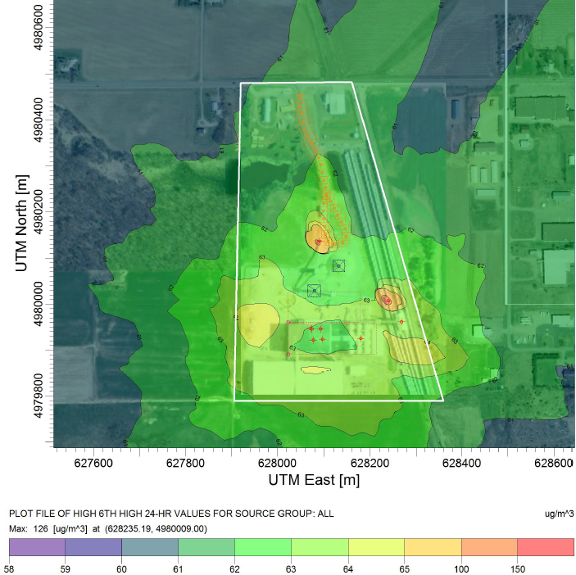

**B.** Dispersion Model Output for the New Auburn, Wisconsin Frac Sand Mine

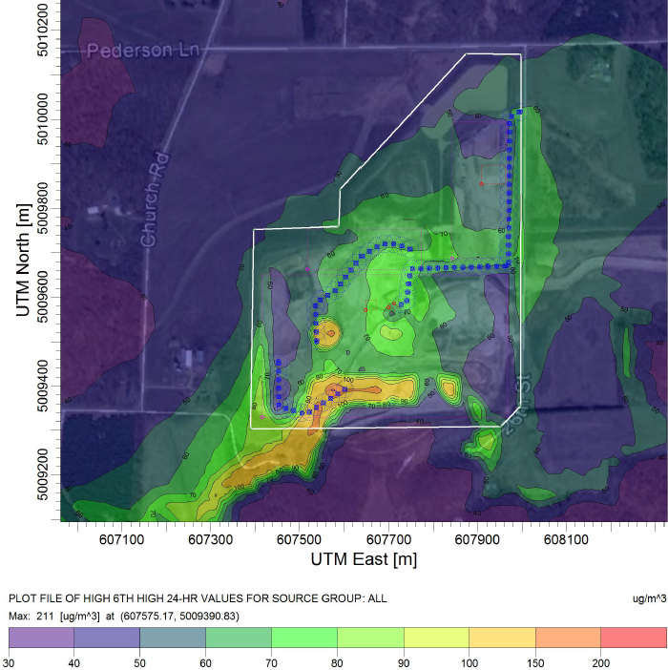

**Figure 2**. Atmospheric dispersion modeling results, showing the 6th highest PM10 concentrations resulting from: A) the Chippewa Falls, Wisconsin frac sand processing plant as it existed in 2013; and B) the New Auburn, Wisconsin frac sand mine as it existed in 2013. White line indicates plant property line.

## 3.5 Evaluation of regulatory measurements

Median PM concentrations measured by state agencies near facilities with sand mining activities were substantially below 24-hr regulatory standards or guideline values (**Figure 3**). No total suspended particulate measurements were above regulatory values (**Figure 3A**; Minnesota TSP standard of 260 µg/m3), and only 3 of 286 were higher than 150 µg/m3. Similarly, PM2.5 was below the NAAQS of 35 µg/m3 (**Figure 3C**; N = 444). For PM10 (**Figure 3B**), 2 (1 in WI and 1 in MN) of 3,395 measurements exceeded the PM10 NAAQS of 150 µg/m3. All but 7 of 212 24-hr PM4 crystalline silica mass concentrations observed at the Titan facility were higher than 3 µg/m3, the CA and MN guideline value for a one-year averaging period (**Figure 3D**). The MN EQB showed that these 7 concentrations occurred when winds were blowing over the site toward the samplers (MPCA, 2015).

|  |  |
| --- | --- |
| **A. total suspended particulate, TSP** | **B. PM10**    n ranged from 25 to 299; mean=154; SD = 71 |
| **C. PM2.5** | **D. Respirable Crystalline Silica** |

**Figure 3**. Summary of PM measurements required by state agencies near facilities with sand mining activities for TSP (Figure 3A); PM10 (Figure 3B); PM2.5 (Figure 3C); and PM4 crystalline silica (Figure 3D). The TITAN site near city name, MN had 7 of 212 samples exceeding the 3 µg/m3 silica guideline.

# Discussion

In this work, a variety of techniques converge to show that sand mining activities are able to produce peaks in community PM concentrations, albeit infrequently and over short durations. Elevated, short-term (5 min) PM2.5 and PM10-2.5 concentrations were more likely to occur when the wind was blowing from the sand facility (**Figure 1**), although these elevated concentrations occurred less than 3% of the sampling time. PM10-2.5 attributed to local sources were consistently high when averaged on short time scales. For example, the maximum local contribution to coarse particles can reach rather high levels at times (>200 µg/m3 for 5 of the 6 sites; **Table 3**). These infrequent peak concentrations may explain observed dust deposits that have caused concerns among community members. However, spikes in concentration such as these may also result from a variety of industrial, community, angricultural, and natural sources.

However, PM concentrations are low when averaged over time scales relevant to regulatory standards and guideline concentrations. When averaged over 24 hours, PM10 and PM2.5 concentrations observed with real-time instruments at residences within 800 m from the property line of facilities with active mining, processing, and/or transport were well below NAAQSs. Our atmospheric dispersion modeling results further emphasize the lack of PM10 levels far beyond plant or mine boundaries. Under the conditions modeled, PM10 concentrations did not exceed NAAQS levels beyond the processing plant boundary (**Figure 2A**) and beyond 40 m of the mine boundary (**Figure 2B**). It is worth noting that, since 2012 , the processing plant modeled has added an additional control by completely enclosing the material piles, which would be expected to further reduce PM10 concentrations beyond plant boundaries. Results from real-time monitoring are also consistent with filter-based PM monitoring near facilities with sand mining activities conducted in WI and MN. All PM2.5 and 99.9% (2 measurements of 3,395) of the PM10 concentrations were below NAAQS (**Figure 3**).

Similarly, crystalline silica in PM4 measured at homes for at least 48 hours (all <0.4 µg/m3) was well below the 3 µg/m3 guideline value adopted by CA and MN. When detected (7 of 17 samples), crystalline silica (as quartz) represented 2% to 4% of the total PM4 mass concentration. This low silica content observed in field samples is consistent with our , despite the bulk sand being mostly crystalline silica (>59% by mass), the crystalline silica content in aerosolized respirable particles was much lower (5.7% for raw and 19% by mass for proppant sand). The even lower crystalline silica content observed in the field is expected because ambient particles collected at a residence include particles from a wide variety of sources other than from a nearby sand facility.

Our observations are consistent with the work of others. Shiraki and Holmen (2002) found that PM10 (soil and quartz components) and PM2.5 (soil components only) were elevated immediately downwind (<300 m) of a stone crushing facility located in CA but not beyond that distance, consistent with our atmospheric dispersion modelling of the sand mine. The fact that Shiraki and Holmen had to employ short duration (2 hr to 10 hr) sampling to detect such differences is consistent with our finding that peaks in coarse particle concentrations can result for short duration but only when wind is blowing in the correct direction. Further, their finding of elevated quartz components in PM10 but not PM2.5 is consistent with our finding that the crystalline silica content of bulk sand is much greater than in the PM4 fraction. Our finding that PM4 crystalline silica concentrations were low (<0.4 µg/m3) is also consistent with other studies. Richards et al. (2009) found that several CA sand facilities did not contribute substantially to ambient crystalline silica concentrations of PM4. In WI, Richards and Brozell (2015) observed a geometric mean in PM4 crystalline silica concentrations at the fence line of sand-producing facilities of less than 10% of the CA and MN guideline value of 3 µg/m3 (n = 2128, 24-hr samples).

Our finding that the maximum local contribution to 24-h PM2.5 was less than 4.1 µg/m3 is seemingly at odds with the study of Walters et al. (2015). They observed 5 of 6 PM2.5 concentrations (sampling time = 8 h to 24 h) at different distances from two frac sand mines to be elevated compared to those measured with regional samplers (amount above regional PM2.5: 6.1 to 50.8 µg/m3). However, their samplers were positioned substantially closer to the facility (200 m or closer) than our monitors (within 800 m). Moreover, the greatest excursions were observed when the sampler was situated between two active mines. The maximum excursion over regional samplers (50.8 µg/m3) coincided with the shortest sample time (8 h) consistent with the importance of comparing PM values collected over similar averaging times.

The measurements supplied to WDNR from monitors in the vicinity of frac sand mines and processing plants (WDNR, 2016c) provide the most compelling evidence for the low PM10 concentrations expected downwind from these processes. PM10 monitors were placed in the vicinity of 19 frac sand sites. A total of 2,759 24-hr samples were taken during 2013 – 2016. The average concentration was 13 µg/m3 and the median concentration was 11 µg/m3. A single sample exceeded the PM10 standard with a measurement of 168 µg/m3. The distances between the monitoring sites and the closest frac sand site were not provided by the WDNR. However, a detailed map of monitoring sites was available (WDNR, 2016b) from which the distance from frac sand sites could be estimated by collocating the monitoring sites and frac sand sites with the assistance of Google maps. An analysis of a random sample of 6 of the 19 sites indicated that monitoring sites were located on property as close as possible to the frac sand sites but some at distances up to 150 m of the site property lines.

Our study had several limitations. In field measurements, we sampled only once for 48 h at each site for crystalline silica in PM4 and only a limited number of sites for long-term monitoring. In long-term monitoring, sources other than the nearby sand facility (e.g., gravel and sand driveways, unvegitated surfaces, and unpaved roads) may have contributed to elevated PM concentrations. We did not consider the impact of multiple adjacent frac sand operations on community exposures. Our sampling campaign was conducted in a single year (2014), and the industry in Western WI has expanded since then. In laboratory tests, we studied sand from a single mine, although raw sand may vary by geological formation and even within a formation. Moreover, we studied the sand as received despite the fact that water content may affect the respirable mass and silica crystalline concentrations released when aerosolized. Although the atmospheric dispersion modeling was conducted on a mine and processing facility typical of the region, facility-specific differences may impact levels of community PM exposure.

Taken together, this work suggests that inhalation of PM generated by activities from sand mining poses low risk for the development of adverse health effects among community members. The PM concentrations we observed in residential areas were consistently and substantially lower than the NAAQS. Similarly, respirable crystalline silica concentrations were substantially lower than guideline values established to protect the development of chronic silicosis.

# Acknowledgments

The authors thank the staff of Trempealeau County, WI Department of Public Health and Department of Land Management for assistance with our sampling campaign.

# Funding

This research was funded by the National Institute of Environmental Health Sciences through the University of Iowa Environmental Health Sciences Research Center, NIEHS/NIH P30 ES005605.

# References

Benson M, Wilson A. Frac Sand in the United States—A Geological and Industry Overview. <http://pubs.usgs.gov/of/2015/1107/>, Accessed 4/6/2017, 2005.

Heinerikson A, Goodman A, Harrison D, Pham M. Modeling Fugitive Dust Sources With AERMOD, Ver. 2.0, Trinity Consultants, Olathe, Kansas, Prepared for the National Stone, Sand & Gravel Association. 2007.

IARC. International Agency for Research on Cancer Monographs on the Evaluation of Carcinogenic Risks to Humans, <http://monographs.iarc.fr/ENG/Monographs/vol100C/>, Accessed 4/6/2017. 2012.

Kim E, Hopke PK. Comparison between Conditional Probability Function and Nonparametric Regression for Fine Particle Source Directions. Atmospheric Environment 2004; 38: 4667-4673.

Leung CC, Yu ITS, Chen W. Silicosis. The Lancet 2012; 379: 2008-2018.

MDH. Minnesota Department of Health. MDH Health-Based Guidance - Crystalline Silica. <http://www.health.state.mn.us/divs/eh/hazardous/topics/silica/silicaguidance.html>, Accessed 5/22/2017, 2017.

MEQB. Minnesota Environmental Quality Board. Report on Silica Sand. <https://www.eqb.state.mn.us/sites/default/files/documents/March%20Final%20Silica%20Sand%20report%20with%20award%20sticker.pdf>, Accessed 4/6/2017, 2013.

Miley W. Assessing the Silica (Frac) Sand Mining Environmental Regulatory Frameworks in Minnesota and Wisconsin: Who Has a Better Plan for Digging, the Gophers or Badgers? Hamline J. Pub. L. & Pol'y 2014; 35: 330-367.

MPCA. Minnesota Pollution Control Agency. Titan Lansing Transload Ambient Air Monitoring Data Report. <https://www.pca.state.mn.us/sites/default/files/g-13-03.pdf>, Accessed 4/6/2017, 2015.

NIOSH. National Institute of Occupational Safety and Health Manual of Analytical Methods. Edited by Schlect, P.C., and O'Connor, P.F. 1994.

OEHHA. Chronic toxicity summary: Silica (crystalline, respirable). <http://oehha.ca.gov/media/downloads/air/document/silicacrelfinal.pdf>, Accessed 4/6/2017, California Office of Environmental Health Hazard Assessment. 2005.

Osborn SG, Vengosh A, Warner NR, Jackson RB. Methane contamination of drinking water accompanying gas-well drilling and hydraulic fracturing. proceedings of the National Academy of Sciences 2011; 108: 8172-8176.

Petavratzi E, Kingman S, Lowndes I. Particulates from mining operations: A review of sources, effects and regulations. Minerals Engineering 2005; 18: 1183-1199.

Richards J, Brozell T. Assessment of Community Exposure to Ambient Respirable Crystalline Silica near Frac Sand Processing Facilities. Atmosphere 2015; 6: 960-982.

Richards JR, Brozell TT, Rea C, Boraston G, Hayden J. PM4 crystalline silica emission factors and ambient concentrations at aggregate-producing sources in California. Journal of the Air & Waste Management Association 2009; 59: 1287-1295.

Shiraki R, Holmén BA. Airborne respirable silica near a sand and gravel facility in central California: XRD and elemental analysis to distinguish source and background quartz. Environmental science & technology 2002; 36: 4956-4961.

Stahlhofen W, Gebhart J, Heyder J. Experimental determination of the regional deposition of aerosol particles in the human respiratory tract. The American Industrial Hygiene Association Journal 1980; 41: 385-398a.

Thorne PS. Experimental grain dust atmospheres generated by wet and dry aerosolization techniques. American journal of industrial medicine 1994; 25: 109-112.

USGS. National Elevation Dataset. Available at: <https://lta.cr.usgs.gov/NED>, Accessed 4/6/2017. United States Geological Survey, 2016.

Walters K, Jacobson J, Kroening Z, Pierce C. PM2.5 Airborne Particulates Near Frac Sand Operations. Journal of environmental health 2015; 78: 8.

Watson JG, Chow JC. Estimating middle-, neighborhood-, and urban-scale contributions to elemental carbon in Mexico City with a rapid response aethalometer. Journal of the Air & Waste Management Association 2001; 51: 1522-1528.

Watson JG, Chow JC, Pace TG. Fugitive dust emissions. Wiley: New York, 2000, pp. 117-135.

WDNR. Air Emissions Inventory Summary Report. FID: 609072860. Available at: <http://dnr.wi.gov/topic/AirPermits/Search.html>, Accessed 5/26/2017. Wisconsin Department of Natural Resources, Madison, WI, 2012a.

WDNR. Silica sand mining in Wisconsin. <http://dnr.wi.gov/topic/Mines/documents/SilicaSandMiningFinal.pdf>, Accessed 4/6/2017. Wisconsin Department of Natural Resources, 2012b.

WDNR. Air Emissions Inventory Summary Report. FID: 603106680. Available at: <http://dnr.wi.gov/topic/AirPermits/Search.html>, Accessed 5/26/2017. . Wisconsin Department of Natural Resources, Madison, WI, 2013.

WDNR. Guidance on Background Concentrations. <http://dnr.wi.gov/topic/AirPermits/documents/2014BackgroundConcentrationMemo.pdf>, Accessed 4/6/2017. Wisconsin Department of Natural Resources, 2014.

WDNR. Wisconsin Air Dispersion Modeling Guidelines. Publication Number: AM-528. Wisconsin Department of Natural Resources, Madison, WI, 2015.

WDNR. Air Dispersion Modeling. Available at: <http://dnr.wi.gov/topic/AirPermits/Modeling.html>, Accessed 4/6/2017. Wisconsin Department of Natural Resources, Madison, WI, 2016a.

WDNR. Air Monitoring Map For Industrial Sand Mine/Processing Plants: Interactive Map. Available at: <http://dnr.wi.gov/topic/Mines/AQSandMap.html>, Accessed 4/6/2017. Wisconsin Department of Natural Resources, 2016b.

**Supplemental Information**

Community Exposures to Airborne Particulate Matter Associated with Frac Sand Mining Activities

Thomas M. Petersa,*, Patrick O’Shaughnessya, Ryan Granta, Ralph Altmaiera, Elizabeth Swantona, Jeffery Falka, David Osterberga, Edith Parkera, Nancy Wylanda, Peter Thornea

# 

# Additional details on long-term real-time monitoring

Each site had unique characteristics that could affect community PM concentrations (**Table S1**). Site 1 was located at a residence surrounded by the property lines of the sand facility, containing mining, processing, and truck transportation. Site 2, a train loading facility, and Site 6, a processing facility, were located in the same city and had large identifiable open mounds of sand. At Site 3, monitoring was conducted 10 m away from a rail line with known sand transport. There are ~50 trains that pass by at a speed of ~72 Km/hr per day. Sites 4 and 5 were located near facilities with a combination of mining, processing, and transporting operations. Site 4 had identifiable separation between each type of operation within the facility.

At each site the monitoring equipment was set up as follows: as far away from trees as possible; near a power source; and with a clear sightline to the nearest facility. The sampling time at each site varied from one week to four weeks. The overall sampling time frame (June 2014 - November 2014) aligned with the mining season. During the sampling time frame, typical summer and early fall weather conditions were observed.

Monitoring equipment was positioned in a trailer (Wells Cargo Mini Wagon, Wells Cargo Inc., Elkhart, IN) as shown in **Figure S1**. An optical particle counter (OPC, Environmental Dust Monitor, Model EDM164, GRIMM Aerosols Technik, Ainring, Germany), positioned inside the trailer, was used to measure PM10 and PM2.5. A sampling head mounted 15 cm above the roof of the trailer was used to convey ambient aerosol to the OPC. External sensors mounted on a pole and attached to the side of the trailer were used to measure wind speed, wind direction, sound level, and motion. Wind speed and wind direction were measured with an ultrasonic anemometer (Model 85000, R.M. Young Company, Traverse, MI) mounted 3.7 m from the ground. Motion was detected and images were obtained with a weatherproof camera (613, Serial JPEG Camera with NTSC Video and IR LEDs, Adafruit Industries, New York City, NY). A small microphone (SEN-12642, SparkFun Sound Detector, SparkFun Electronics, Boulder, CO) was used to measure sound.

A microcontroller (Arduino Mega 2560 Rev 3, Adafruit, NY) with a data logging shield (Data Logging Shield, Adafruit, NY) running custom firmware was used to collect PM10 and PM2.5 from the OPC every 6 s and external sensor data every second. These measurements were averaged and logged to an SD card every 20 s. The camera was used to record images when motion was detected and sound was above a preset threshold. The sound level threshold was set using a potentiometer, and set to a percentage of the total output voltage of the microphone. The potentiometer threshold was set to 10%, which was low enough to capture a passing train.

Probability plots by site for all data are shown in **Figure S2** for PM10-2.5 and in **Figure S3** for PM2.5. The breakpoint concentrations and concentrations associated with 5th, 16th, 50th, 84th, and 95th percentiles are shown in **Table S2** for all sites. Breakpoint concentrations represent a division between two modes, with one mode associated with low concentrations and the other associated with higher values or “peaks.” Conditional probability plots for concentrations greater than the breakpoint concentrations (i.e., peak concentrations) are plotted by site in **Figure S4** for PM10-2.5 and in **Figure S5** for PM2.5.

**Additional results from laboratory characterization**

# Photographs and sieve analysis of the raw sand from the mine and processed proppant sand are shown in Figure S5. Representative spectra spectrum from energy dispersive spectroscopy are shown in Figure S6.

**Table S1**. Site and sampling information for long-term monitoring.

|  |  |  |  |  |
| --- | --- | --- | --- | --- |
| **Site #** | **Description of Facility Operations** | **Distance Between Sampling Site and Center of Facility (Meters)** | **Sampling Period (2014)** | **Site Observations** |
| 1 | Mining;  Processing;  Truck Transportation; | 454 | Aug 8 – Aug 15  7 days | Rural, Most facility activity to the west, Closest farm was to the Southwest |
| 2 | Trans-load with: Truck Transportation In;  Bucket Loading Train Transportation Out; | 188 | Sep 18 – Oct 9  21 days | Urban, Privacy wall between sampler and facility, Sand Dumped to the north of sampler at 350º |
| 3 | Passing Rail Transportation; | 9.8 | Jun 24 – Jul 7  13 days | Urban, Sampler location was in-between river and highly traveled road, ~50 trains per day |
| 4 | Mining;  Conveyor;  Processing;  Train Transportation Out; | Mining = 518  Conveyor = 747  Processing = 1463 | Jul 31 – Aug 8  8 days | Rural, Gravel driveway to the south of the sampler, Facility property line close but mining activities farther away |
| 5 | Mining;  Processing;  Train Transportation Out; | 1469 | Jul 7 – Jul 31  24 days | Rural, Sand Driveway next to the sampler, Located on a dairy farm |
| 6 | Truck In;  Processing; | 384 | Oct 9 – Nov 4  26 days | Urban, Location secluded within trees |

**Mean = 16.5 days**

**Range = 7 to 26**

**Table S2**. Breakpoint Values and Percentile Mass Concentrations µg/m³ by PM Metric and Site

|  |  |  |  |  |  |  |  |  |
| --- | --- | --- | --- | --- | --- | --- | --- | --- |
| Site | Break Value | |  | Mass Concentration Assigned With Given Percentile (µg/m³) | | | | |
| Mass Concentration (µg/m³) | Percentile |  | 5th | 16th | 50th | 84th | 95th |
| a. PM10-2.5 |  |  |  |  |  |  |  |  |
| 1 | 26.7 | 97.9 |  | 0.5 | 1.6 | 5.2 | 10.8 | 17.9 |
| 2 | 40.9 | 97.6 |  | 0.8 | 2.4 | 7.8 | 15.5 | 27.8 |
| 3 | 22.5 | 99.8 |  | 0.6 | 1.5 | 3.5 | 6.5 | 10.3 |
| 4 | 22.9 | 97.6 |  | 0.9 | 2.2 | 6.2 | 11.1 | 15.8 |
| 5 | 45.0 | 97.4 |  | 0.7 | 2.0 | 5.7 | 13.7 | 30.6 |
| 6 | 40.5 | 97.6 |  | 0.4 | 1.2 | 4.1 | 12.3 | 29.4 |
| b. PM2.5 |  |  |  |  |  |  |  |  |
| 1 | 18.7 | 99.7 |  | 2.6 | 4.1 | 6.9 | 11.9 | 15.6 |
| 2 | 22.0 | 99.4 |  | 1.9 | 3.0 | 6.7 | 13.1 | 17.1 |
| 3 | 19.7 | 99.5 |  | 1.3 | 2.6 | 6.1 | 10.8 | 15.3 |
| 4 | 23.1 | 99.9 |  | 5.7 | 6.5 | 9.9 | 13.6 | 15.2 |
| 5 | 35.6 | 99.0 |  | 1.7 | 2.9 | 6.4 | 11.2 | 17.0 |
| 6 | 19.8 | 99.6 |  | 1.4 | 2.4 | 6.0 | 10.5 | 13.0 |



**Figure S1**. Trailer with monitoring equipment deployed at each sampling site. The OPC, wind sensor, camera, and sound sensor sent data to the data logger, which logged values every 20 s. The wind sensor, camera, and sound sensor were attached to a pole to reduce any obstructions from the trailer body. The camera and sound sensor were not used in the analysis presented in this manuscript.

**A. all data**

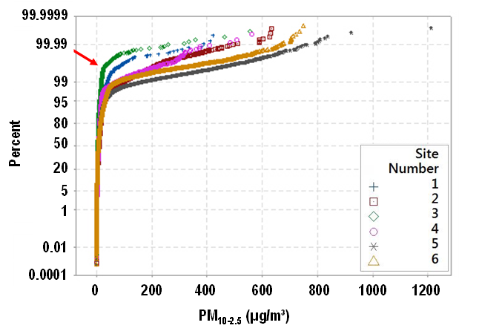

**B. for data >95th percentile**

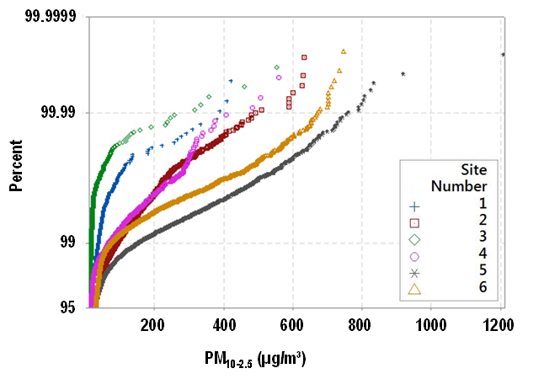

**Figure S2**. Probability plot of 20-s PM10-2.5 by site for: A) all data; and B) for data only >95th percentile.

**A. all data**



**B. for data >95th percentile**

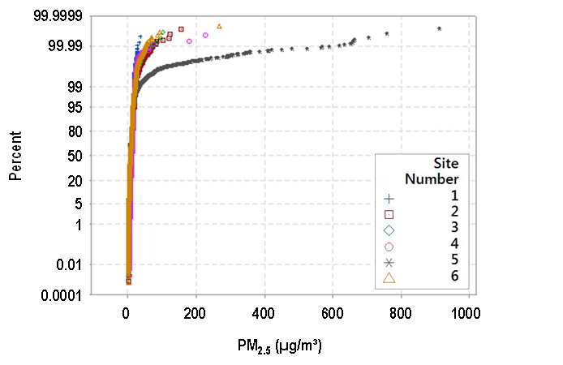

**Figure S3**. Probability plot of 20-sec PM2.5 by site for: A) all data; and B) for data only >95th percentile.

|  |  |  |
| --- | --- | --- |
| **A.** Site 1, PM2.5 > 19 µg/m3 | **B.** Site 2, PM2.5 > 22 µg/m3 | **C.** Site 3, PM2.5 > 20 µg/m3 |
| **D.** Site 4, PM2.5 > 23 µg/m3 | **E.** Site 5, PM2.5 > 36 µg/m3 | **F.** Site 6, PM2.5 > 20 µg/m3 |

**Figure S4.** Conditional probability plots for PM2.5 greater than the breakpoint concentrations (i.e., peak concentrations) for all sites. The center point represents the location of sampling trailer. Up indicates wind blowing from blowing from north. Red lines demark wind blowing over the labeled activity.

|  |  |
| --- | --- |
| **A. Mine Sand**  **U:\OEH Shared by All\O'Shaughnessy\Frac Mining Study\Size Characterization\Geology Photos\Mine Sand.tif**  **1 mm** |  |
| **B. Processed Sand – Proppant**  **U:\OEH Shared by All\O'Shaughnessy\Frac Mining Study\Size Characterization\Geology Photos\Proppant.tif** |  |

**Figure S5**. Photographs and sieve analysis of the: A) mine sand; and B) proppant sand.

**A. Raw Sand**

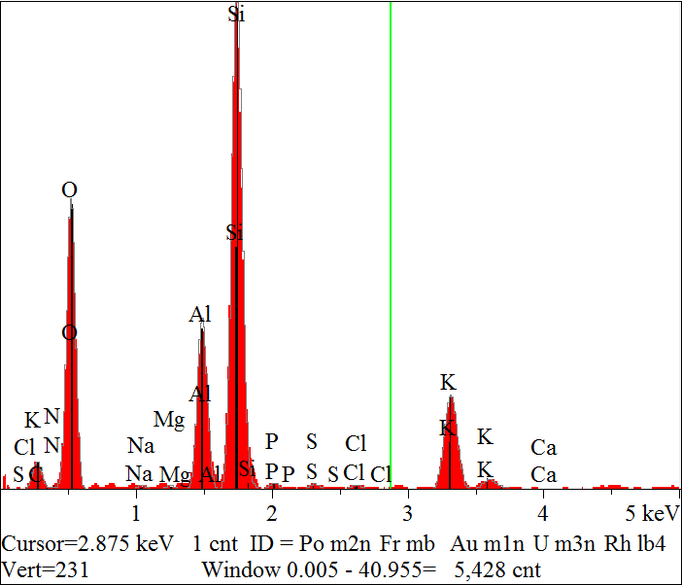

**B. Processed Sand – Proppant**

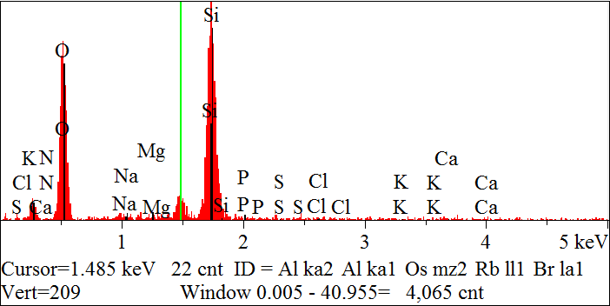

**Figure S6**. Energy dispersive spectrum for: A) raw sand; and B) processed sand.