Supporting Information
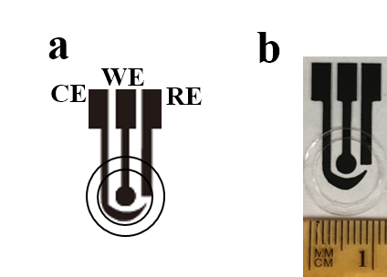
Figure S1. (a) Design drawing of a CSPE consisting of a counter electrode (CE), a working electrode (WE), and a reference electrode (RE) with a ring-shape packing tape to confine the sample droplet. (b) Photograph of a completed CSPE.

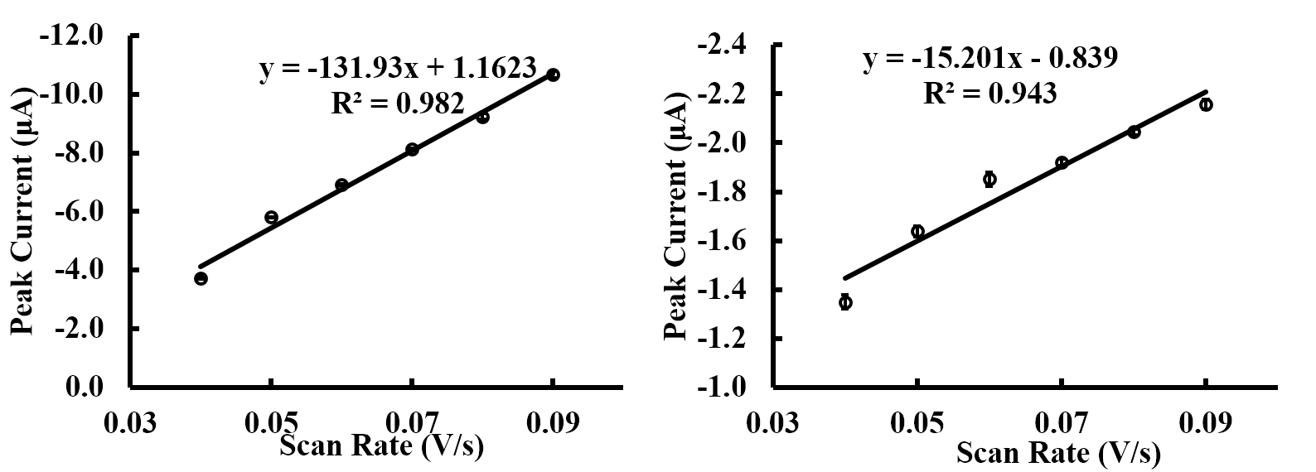
Figure S2. (a) Relationship between peak current and scan rate from Figure 2a for Co(II)DMG (n=3). (b) Relationship between peak current and scan rate from Figure 2c for Ni(II)DMG (n=3).

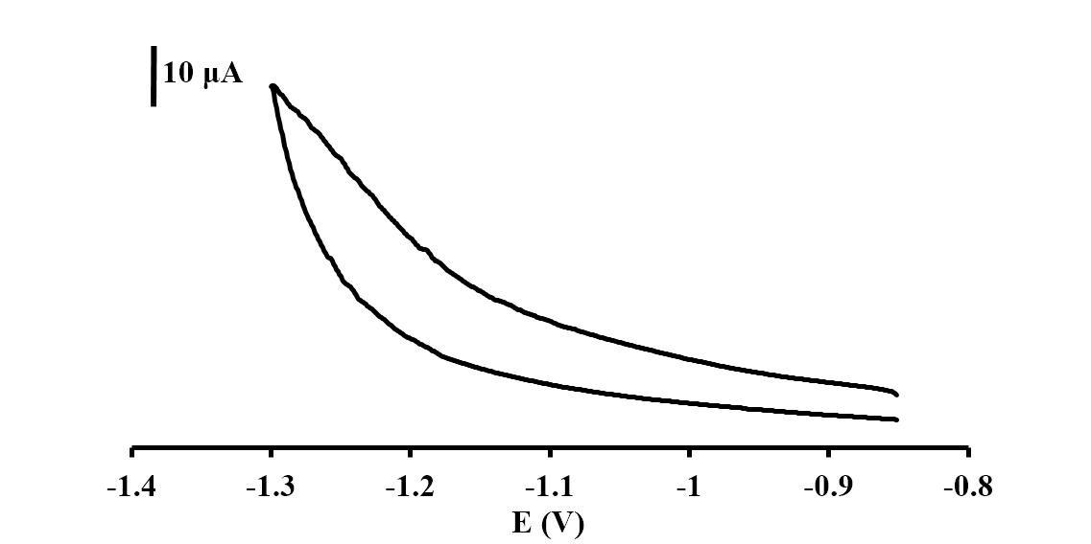
Figure S3. Cyclic voltammograms of 0.1 M ammonium buffer pH 9.0 containing 2 x 10⁻⁴ M DMG using Bi modified CSPE at 0.09 V s⁻¹ of scan rate

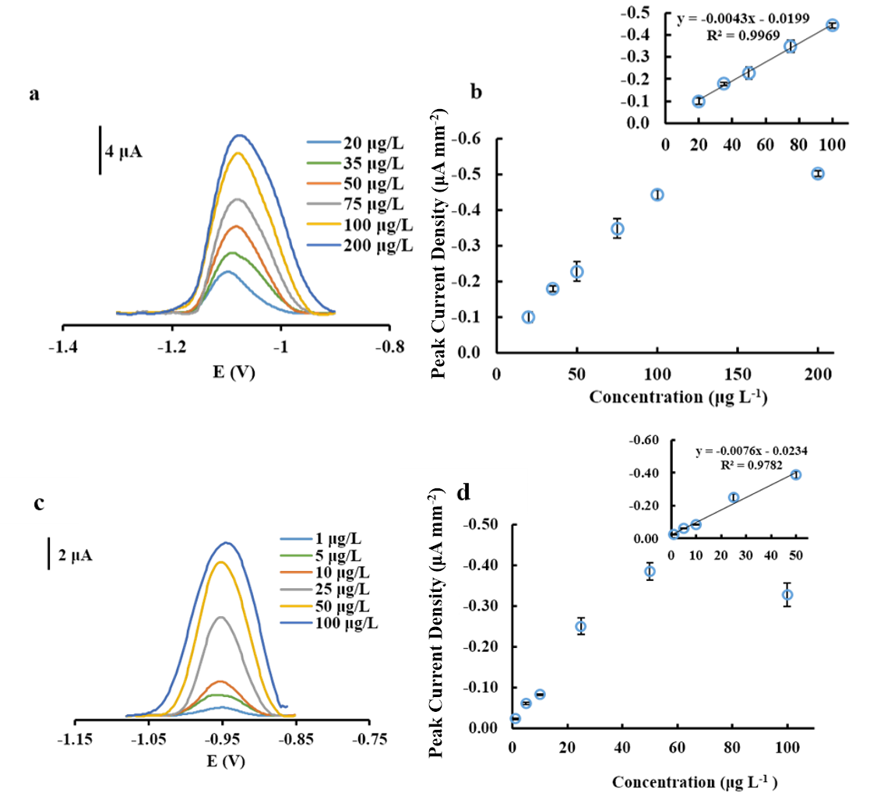
Figure S4. (a) Square-wave voltammograms of Co(II)DMG complex from 20-200 μg L⁻¹ using 120 s deposition time. (b) Representative calibration graph for Co(II)DMG complex using 120 s deposition time. Linear fit of calibration graph for Co(II)DMG complex using 120 s deposition time (b inset) (n=3). (c) Square-wave voltammograms of Co(II)DMG complex from 1-100 μg L⁻¹ using 240 s deposition time. (d) Representative calibration graph for Co(II)DMG complex using 240 s deposition time. Linear fit of calibration graph for Co(II)DMG complex using 240 s deposition time (d inset) (n=3).

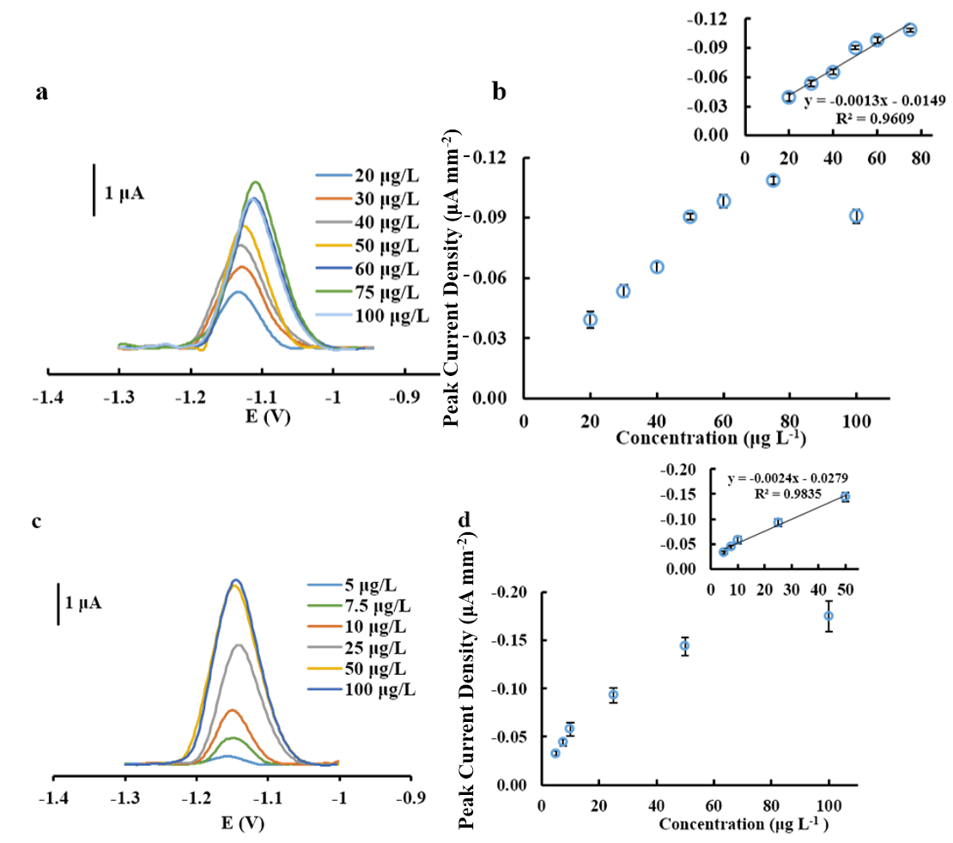
Figure S5. (a) Square-wave voltammograms of Ni(II)DMG complex from 20-100 μg L⁻¹ using 120 s deposition time. (b) Representative calibration graph for Ni(II)DMG complex using 120 s deposition time. Linear fit of calibration graph for Ni(II)DMG complex using 120 s deposition time (b inset) (n=3). (c) Square-wave voltammograms of Ni(II)DMG complex from 5-100 μg L⁻¹ using 240 s deposition time. (d) Representative calibration graph for Ni(II)DMG complex using 240 s deposition time. Linear fit of calibration graph for Co(II)DMG complex using 240 s deposition time (d inset) (n=3).

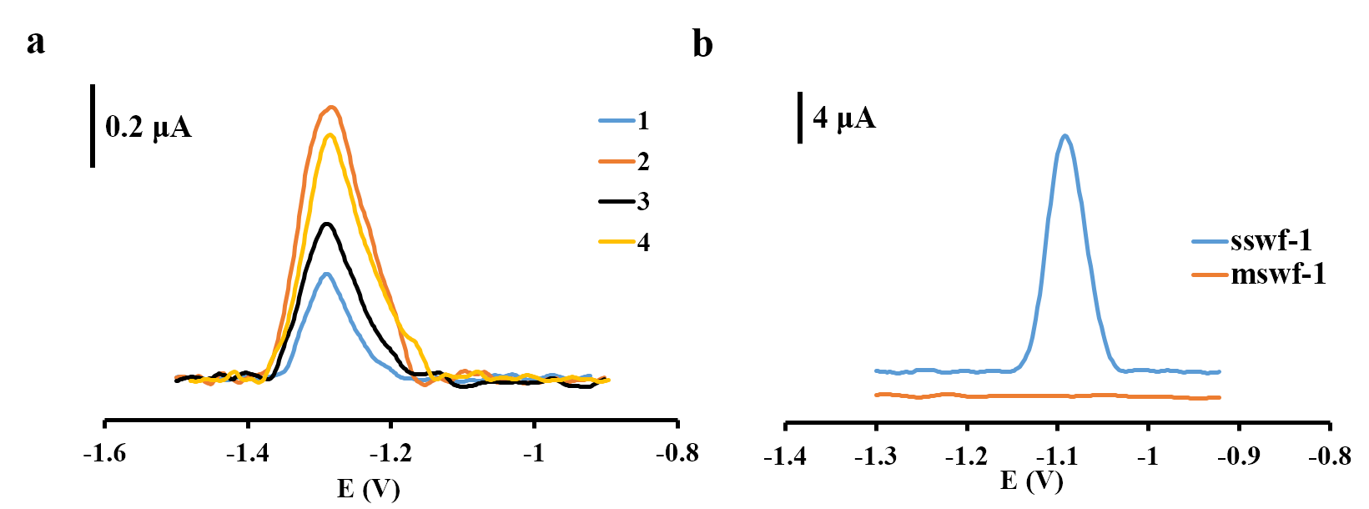
Figure S6. (a) Square-wave voltammograms of Co determination in aerosol samples. (b) Ni determination in welding fume samples (sswf-1 and mswf-1 certified reference materials).

Table S1. Mass of cobalt aerosol sampled onto 37mm filters
Cobalt Samples | Weight of Cobalt Aerosols (g)
1 | 4.361 x 10⁻⁵
2 | 1.246 x 10⁻⁴
3 | 6.611 x 10⁻⁵
4 | 9.736 x 10⁻⁵

Table S2. Aqua regia digestion
Sample (Certified Reference Material) | Mass of Samples (g) | Volume of Aqua Regia Solution (mL) | Volume of 2 M Sodium Bicarbonate (mL) | Volume of Water (mL)
SSWF-1 | 1.4 | 0.60 | 0.90 | 0.60
MSWF-1 | 1.2 | 0.46 | 0.90 | 0.74

