Simultaneous Detection of Dual Biomarkers from Humans Exposed to Organophosphorus Pesticides by Combination of Immunochromatographic Test Strip and Ellman Assay

Mingming Yang^{a, b#}, Yuting Zhao^{a#}, Limin Wang^{d}, Michael Paulsen^{c}, Christopher D. Simpson^{c}, Fengquan Liu^{b}, Dan Du^{a*}, Yuehe Lin^{a*}

ª School of Mechanical and Materials Engineering, Washington State University, Pullman, WA 99164, United States
^{b} Jiangsu Academy of Agricultural Sciences, Nanjing 210014, People’s Republic of China
^{c} Department of Environmental and Occupational Health Sciences, University of Washington, Seattle, WA 98195, United States
^{d} College of Plant Protection, Nanjing Agricultural University, Nanjing 210095, People’s Republic of China

# These authors contributed equally to this work.

Experimental section:
The principle of Ellman assay
The Ellman assay is the most commonly used method for measuring ChE activity. In the Ellman method, acetylthiocholine chloride or acetylthiocholine iodide is added as substrate and is hydrolyzed by ChE present in the sample to thiocholine. Then the thiocholine reacts with the Ellman reagent 5,5'-dithiobis-2-nitrobenzoic acid (DTNB) to form a 5-thio-2-nitrobenzoic acid (TNB) anion which absorbs at 412nm. Enzyme activity is positively correlated with absorbance of TNB [1].
The method for optimization of amount of BChE MAb and pH of AuNPs while preparing Au labeled BChE MAb
We used Horisberger et al. [2] protocol to optimize the concentration of BChE MAb (Figure S1 A) and pH of AuNPs (Figure S1 B). As shown in Figure S1(A), 30 μL of BChE MAb with different dilutions was added into 125 μL AuNPs and keep the resultant solution stabilizing for 5min. The absorbance of the solution at OD₅₂₈ was measured which assigned as OD₅₂₈(1). Then, after adding 10% NaCl solution, we measured the OD₅₂₈(2) of the resultant solution after one hour of stabilization. The decrease of the absorbance was obtained by subtracted OD₅₂₈(2) from OD₅₂₈(1), which was used to plot flocculation curve below. The results showed that at low concentration of BChE MAb, the absorbance decreased dramatically, and then tended to stabilize at 8 times dilution. Therefore, 8x times dilution was selected for AuNPs label. The optimization of pH was conducted by the same way. From Figure S1 B, pH 8.5 was the optimum pH for the conjugation of AuNPs and BChE MAb.
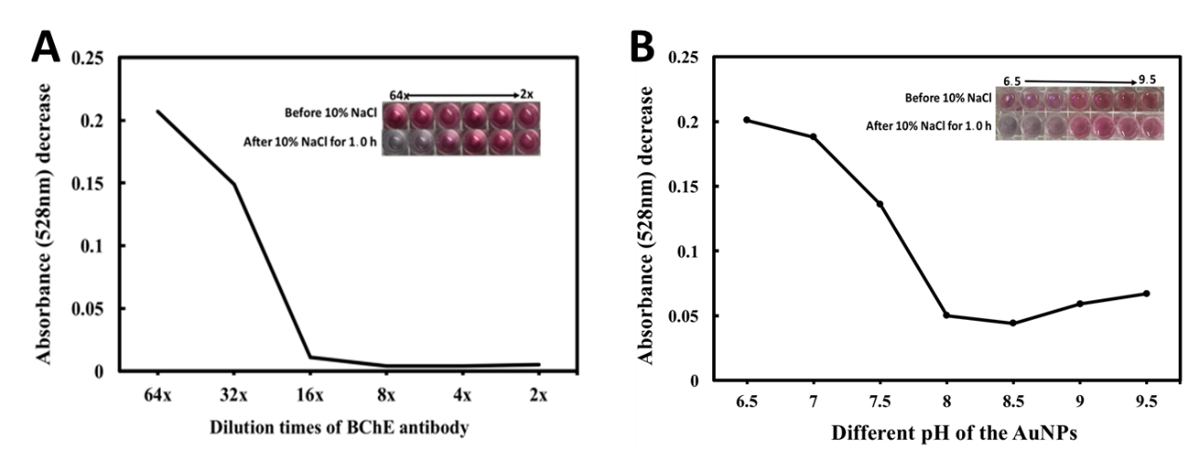
Figure S1 Optimization of amount of BChE MAb (A) and pH of AuNPs (B) while preparing Au labeled BChE MAb
Figure S2 The correlation between ICTs and Ellman assay for measurement of artificially prepared BChE samples.

Table S1 The Performance of ChE Enzyme Activity-Based Approaches Were Compared for Detection of OPs exposure
Biomarker | linear range | Detection Limit | Substrate Type | Samples | Reference
AChE enzyme activity and total amount of AChE | 0.05 to 10 nM | 0.02nM | SPE | Human red blood cells | 3
AChE activity | 0.05 to 5 nM | 0.02 nM | SPE | Human red blood cells | 4
BChE activity and total amount of BChE | 0.1 to 20 nM | 0.05 nM | SPE | Human Plasma Samples | 5
AChE enzyme activity | 0.1 to 10 nM | not mentioned | SPE | Human red blood cells | 6
BChE activity and total amount of BChE | 0.22 to 3.58 nM | 0.1 nM | Test Strip reader  / Microplate Reader | Human blood | This paper

(1) Ellman, G. L.; Courtney, K. D.; Andres, V., Jr.; Feather-Stone, R. M. Biochemical pharmacology 1961, 7, 88-95.
(2) Horisberger, M.; Rosset, J. Journal of the Histochemistry Society 1977, 4, 295.
(3) Du, D.; Wang, J.; Wang, L.; Lu, D.; Lin, Y. Analytical Chemistry, 2012, 84(3):1380-5.
(4) Ge, X.; Tao, Y.; Zhang, A.; Lin, Y.; Du, D. Analytical Chemistry, 2013, 85(20):9686-91.
(5) Du, D.; Wang, J.; Wang, L.; Lu, D.; Smith, J.; Timchalk, C.; Lin, Y. Analytical Chemistry, 2011, 83(10):3770.
(6) Chen, A.; Du, D.; Lin, Y. Environmental Science & Technology, 2012, 46(3):1828.

