SUPPORTING INFORMATION

Comparing on-road real-time simultaneous in-car and outdoor particulate and gaseous concentrations for a range of ventilation scenarios.
Anna Leavey¹, Nathan Reed¹, Sameer Patel¹, Kevin Bradley¹, Pramod Kulkarni², Pratim Biswas^{1*}

¹ Aerosol and Air Quality Research Laboratory, Department of Energy, Environmental & Chemical Engineering, Washington University in St. Louis, St. Louis, Missouri 63130, USA;
² CDC/NIOSH, Cincinnati, OH 45213, USA.

Submitted to Atmospheric Environment
March 1st, 2017

* To whom correspondence should be addressed:
Tel: +1-314-935-5548; Fax: +1-314-935-5464
E-mail address: pbiswas@wustl.edu

Pages: 13
Contents: One figure (S1); five tables (S1-S5)
Text: 4 pages

- Predictor variables
Table S1 presents the list of predictor variables collected in this study. Ambient pollutant conditions are represented by ambient NO_{x}, PM2.5 and CO concentrations measured at a fixed-site monitor and operated by NOAA’s National Climate Data Center (NCDC). Meteorological variables were collected from a weather station located at St Louis’ Lambert airport and operated by the US Environmental Protection Agency (USEPA). Traffic data (density, bus and trucks), time and directions, in addition to ventilation parameters (windows open, windows closed, fan on, AC on) were also collected due to their influence on outdoor pollutant concentrations and outdoor / in-car correlations. Road types and traffic speeds were also collected for future work, but were not included in the current analysis.

- Descriptive statistics
Data were averaged across the entire journey and results are presented in Table S2 in the Supplemental Information, which shows both arithmetic (AM) and geometric (GM) means, as well as the related standard deviations (SD/GSD) and the area under the curve. Indoor particle number concentrations tend to be lower than their outside counterparts demonstrating arithmetic means (AM) of 12975 (SD 7563) and 16819 (8698) pt/cm³, respectively. A similar pattern is observed for CO with mean concentrations of 1.09 (SD 2.43) ppm and 1.33 (SD 1.46) ppm for inside and outside, respectively. Whereas the vehicle seems to exert a protective effect for inside particle counts and CO, the opposite appears to be happening for both lung-deposited SA (in the alveolar region) and PM_{2.5} - each demonstrating higher mean indoor concentrations compared to their outside counterparts. In-car concentrations are effected by the air exchange rate of the vehicle cabin, which in turn is influenced by the ventilation parameters of the vehicle. Table S3 presents the mean area under the curve for all pollutants for all ventilation parameters. Lower mean concentrations are generally observed when the AC is running or the windows are closed. Higher in-car concentrations are observed when windows are open or when the fan is running. However, more rigorous analysis was performed in the regression sections of the main paper.

- Correlations
To test the degree of correlation, both Pearson’s product-moment correlation (r) (Table S4) and Spearman’s Rank correlation (r_{s}) (for non-parametric data) (Table S5) were conducted on the arithmetic means and areas under the curve for all metrics. Three things in particular were examined: 1) the indoor versus outdoor correlations for the same metric; 2) the outdoor versus outdoor correlations for different metrics; and 3) the indoor versus indoor correlations for the different metrics. Table S4 presents the results. All indoor and outdoor averages and areas under a curve were statistically positively correlated at the 95% confidence level for the same metrics. The highest correlations observed were for PM_{2.5} (r = 0.94, p= <0.001; r_{s} = 0.96, p = <0.001) and particle numbers (r = 0.82, p = <0.001; r_{s} = 0.81; p = <0.001), (results shown are on the arithmetic means), whereas lung-deposited SA demonstrated the lowest correlations of the 4 metrics, although still statistically significant (r = 0.28, p = 0.02; r_{s} = 0.42, p = 0.001). In general, outdoor correlations between the different metrics were higher than indoor correlations. This is probably because the measured outdoor concentrations do not have the additional complication of a vehicle cabin, which effects the air exchange rate and penetration of the pollutants into the vehicle, interfering, with various degrees of severity, with outdoor / in-car pollutant correlations, frequently depending on the pollutant metric. No clear patterns emerged when comparing indoor-to-indoor and outdoor-to-outdoor correlations: in general, outdoor lung-deposited SA demonstrated stronger correlations with the other metrics than indoor lung-deposited SA, whereas indoor correlations between particle numbers and a) PM_{2.5} and b) CO were higher than the outdoor correlations.

The Wilcoxon Signed Rank Test for non-parametric paired data was also conducted for all indoor / outdoor paired-pollutants. Tests were conducted on both the arithmetic means and total area under the curve. All pairs were statistically significantly different at the 99% confidence interval with all p-values <0.003. This demonstrates that while all inside / outside metrics of the same pollutant are highly correlated, they also come from distinctly different groups, thus highlighting the importance of examining exactly when and where these differences are most apparent to further elucidate how exposures during the daily commute can be reduced. The role of window position / ventilation will also be examined.

- Experimental Setup
Finally, Figure S1 presents some photos of the cars used as well as the instrument setup used in the study. The location of the 2 inlets are also highlighted.

- Self-pollution
The degree to which self-pollution occurs depends on many factors, including the age of the vehicle (older vehicles tend to have more leaks and joints and less efficient engine), position of vehicle body above the ground (a lower body position increases the penetration of freshly emitted pollutants), window position, ventilation system status, and what the car is doing (i.e. idling or driving). It may also depend on ambient weather conditions – as the speed and direction of the wind will dictate the direction of the vehicle emissions and whether they lead back into the vehicle. Both of the vehicles in this study were fairly new (4 and 2 years old) and thus fairly well-sealed. The lowest concentrations were observed when windows were closed, which reduces the likelihood that emissions were penetrating into the cabin directly from the engine. The only times that emissions were noticeably penetrating into the vehicle cabin was for the few seconds the vehicle was idling in a carport, and then during times the vehicle was reversing – which only occurred for a few seconds at the beginning of each commute. We consider this to be insignificant given that all analysis is based on the whole commute. The degree to which self-pollution was occurring while the vehicle was idling in traffic is difficult to ascertain, given that we were unable to separate the measurement vehicle from surrounding traffic, but no signs of self-pollution were observed when the vehicle was idling in an open parking lot. This latter consideration will be examined in more detail in a follow-up manuscript where instances of idling will be separated from the rest of data and reviewed. Finally, the 4 particle number instruments used isopropyl to operate. While this would have caused some alcohol contamination in-cabin, this would not have condensed to form nucleation particles nor to adsorb onto existing particles and thus the contribution to condensational growth is negligent.

List of Tables
Table S1: Predictor variables measured in the study
Table S2: Descriptive statistics of the measured outdoor pollutant concentrations
Table S3: Mean area under the curve data for measured in-car concentrations for the different ventilation parameters
Table S4: Pearson’s Moment correlation coefficients for the measured outdoor / in-car correlations
Table S5: Spearman’s rank correlation coefficients for the measured outdoor / in-car correlations

Table S1: Predictor variables measured in the study
Variable | Method | Rationale
Day | Noted the day | Is the interface where multiple complex and changing and potentially interactions take place
Time / AM or PM | Noted the time and whether it was morning or afternoon | May be an indication of atmospheric, meteorological and traffic-related factors
Ambient NOx | Collected post hoc from a nearby fixed site monitor¹ | A major ambient pollution indicator and traffic is a major source
Ambient PM2.5 | Collected post hoc from a nearby fixed site monitor | A major ambient pollution indicator and traffic is a source
Ambient CO | Collected post hoc from a nearby fixed site monitor | A major ambient pollution indicator and traffic is a source
Journey direction | Noted the direction of travel: to or from work | Effects the relative influence of traffic and winds
Car make | Known ad hoc | To keep track of commutes and to check whether car-type effects results in regression analysis
Wind speed | Collected post hoc from a nearby meteorological station² | Effects the dilution and penetration factor of particles
Temperature | Collected post hoc from a nearby meteorological station² | Effects atmospheric stability and pollutant dispersion, SOA formation, driving behaviors
RH | Collected post hoc from a nearby meteorological station² | Indicates moisture content in the air which can impact particle processes
Dewpoint | Collected post hoc from a nearby meteorological station² | Indicates temperature and moisture content, which can impact particle processes
Wind direction | Collected post hoc from a nearby meteorological station² | Controls how pollutants are dispersed in the environment and whether the measurement vehicle would be down or upwind
Local traffic density | A DashCam was used to record the journey, and traffic densities were determined post hoc through visual inspection of the videos | Indicative of local pollutant scenarios and vehicle speeds
Time behind bus / truck | A DashCam was used to record the journey, and all times the vehicle was traveling behind a bus was compiled | A major source of local, on-road pollution
The number of times a school bus passes | A DashCam was used to record the journey, and every time a school bus passed by was noted | A major source of local, on-road pollution
Ventilation parameters | The window and ventilation parameters were alternated (windows open, window closed, AC on, Fan on) and noted | Influences the air exchange rate of the vehicle, which effects pollutant infiltration / exfiltration rates
¹ Operated by the US Environmental Protection Agency (USEPA)
² Operated by NOAA’s National Climate Data Center (NCDC)

Table S2: Descriptive statistics of the measured outdoor pollutant concentrations
Statistics | Pollutant metrics
 | Particle # counts |  | Lung-Deposited SA (A) |  | PM2.5 |  | CO
 | Out | In | Out | In | Out | In | Out | In
AM | 16819 | 12975 | 58.7 | 85.2 | 26.3 | 29.8 | 1.33 | 1.09
SD | 8698 | 7563 | 25.2 | 54.9 | 18.9 | 20.1 | 1.46 | 2.43
GM | 12279.49 | 9659.01 | 44.8 | 67.4 | 18.4 | 21.7 | _ | _
GSD | 1.68 | 1.87 | 1.63 | 1.93 | 2.41 | 2.36 | _ | _
Min | 1590 | 1021 | 6.1 | 8.1 | 1.0 | 1.2 | 0 | 0
Max | 500000 | 339272 | 4209.7 | 1064.4 | 2170.1 | 1683.8 | 29.07 | 118.5
Area/Curve | 27269232 | 21952275 | 85043 | 124867 | 38229 | 43465 | 2094.7 | 1649.47
ASD | 21109779 | 21156182 | 36937 | 83232 | 28104 | 29972 | 2233. | 3753.45

Table S3: Mean area under the curve data for measured in-car concentrations for the different ventilation parameters
 | Ventilation | Pollutant Metrics
 |  | Geometric mean of total Area under the curve (GSD)
 |  | PT (#/cm³) | AR (µm²/m³) | DK (µg/m³) | CO (ppm)
Inside | AC | 7893058 (1.61) | 91182 (1.88) | 18908 (2.59) | 15.0 (20.60)
 | Closed | 17124000 (1.96) | 76695 (2.12) | 41306 (2.14) | 32.0 (42.06)
 | Fan | 17372314 (1.79) | 125613 (1.75) | 31492 (1.74) | 325.6 (18.11)
 | Open | 24673453 (1.95) | 125121 (1.94) | 35794 (2.61) | 173.2 (25.95)
Outside | AC | 14783033 (1.48) | 61562 (1.49) | 18497 (2.36) | 282.9 (11.91)
 | Closed | 25294563 (1.57) | 79762 (1.71) | 36828 (2.18) | 1071.2 (3.04)
 | Fan | 31251352 (1.53) | 86270 (1.48) | 25402 (1.99) | 801.3 (14.60)
 | Open | 23636317 (2.00) | 80069 (1.62) | 30800 (2.42) | 1040.4 (8.46)

Table S4: Pearson Moment Correlation coefficients for the measured outdoor / in-car correlations
 | 1 | 2 | 3 | 4 | 5 | 6 | 7 | 8 | 9 | 10 | 11 | 12 | 13 | 14 | 15 | 16 | 17 | 18
1 | 1.00 | 0.96 | 0.82 | 0.81 | 0.62 | 0.56 | -0.21 | -0.24 | 0.14 | 0.11 | 0.16 | 0.12 | -0.08 | -0.10 | -0.10 | 0.20 | 0.16 | 0.16
2 | 0.96 | 1.00 | 0.75 | 0.81 | 0.62 | 0.62 | -0.18 | -0.17 | 0.16 | 0.15 | 0.17 | 0.16 | -0.03 | -0.03 | -0.03 | 0.20 | 0.17 | 0.17
3 | 0.82 | 0.75 | 1.00 | 0.96 | 0.63 | 0.55 | 0.02 | -0.03 | 0.15 | 0.11 | 0.22 | 0.18 | 0.05 | 0.03 | 0.03 | 0.26 | 0.23 | 0.23
4 | 0.81 | 0.81 | 0.96 | 1.00 | 0.65 | 0.63 | 0.06 | 0.05 | 0.18 | 0.17 | 0.25 | 0.23 | 0.12 | 0.11 | 0.11 | 0.28 | 0.26 | 0.26
5 | 0.62 | 0.62 | 0.63 | 0.65 | 1.00 | 0.97 | 0.28 | 0.27 | 0.73 | 0.71 | 0.76 | 0.74 | 0.35 | 0.32 | 0.32 | 0.32 | 0.30 | 0.30
6 | 0.56 | 0.62 | 0.55 | 0.63 | 0.97 | 1.00 | 0.32 | 0.34 | 0.74 | 0.74 | 0.75 | 0.77 | 0.40 | 0.39 | 0.39 | 0.33 | 0.33 | 0.33
7 | -0.21 | -0.18 | 0.02 | 0.06 | 0.28 | 0.32 | 1.00 | 0.98 | 0.29 | 0.30 | 0.43 | 0.45 | 0.62 | 0.61 | 0.61 | 0.34 | 0.36 | 0.36
8 | -0.24 | -0.17 | -0.03 | 0.05 | 0.27 | 0.34 | 0.98 | 1.00 | 0.28 | 0.32 | 0.42 | 0.46 | 0.64 | 0.65 | 0.65 | 0.37 | 0.39 | 0.39
9 | 0.14 | 0.16 | 0.15 | 0.18 | 0.73 | 0.74 | 0.29 | 0.28 | 1.00 | 0.99 | 0.94 | 0.94 | 0.27 | 0.25 | 0.25 | 0.13 | 0.14 | 0.14
10 | 0.11 | 0.15 | 0.11 | 0.17 | 0.71 | 0.74 | 0.30 | 0.32 | 0.99 | 1.00 | 0.92 | 0.94 | 0.29 | 0.28 | 0.28 | 0.15 | 0.16 | 0.16
11 | 0.16 | 0.17 | 0.22 | 0.25 | 0.76 | 0.75 | 0.43 | 0.42 | 0.94 | 0.92 | 1.00 | 0.99 | 0.35 | 0.32 | 0.32 | 0.21 | 0.21 | 0.21
12 | 0.12 | 0.16 | 0.18 | 0.23 | 0.74 | 0.77 | 0.45 | 0.46 | 0.94 | 0.94 | 0.99 | 1.00 | 0.37 | 0.36 | 0.36 | 0.23 | 0.23 | 0.23
13 | -0.08 | -0.03 | 0.05 | 0.12 | 0.35 | 0.40 | 0.62 | 0.64 | 0.27 | 0.29 | 0.35 | 0.37 | 1.00 | 0.99 | 0.99 | 0.63 | 0.66 | 0.66
14 | -0.10 | -0.03 | 0.03 | 0.11 | 0.32 | 0.39 | 0.61 | 0.65 | 0.25 | 0.28 | 0.32 | 0.36 | 0.99 | 1.00 | 1.00 | 0.65 | 0.68 | 0.68
15 | -0.10 | -0.03 | 0.03 | 0.11 | 0.32 | 0.39 | 0.61 | 0.65 | 0.25 | 0.28 | 0.32 | 0.36 | 0.99 | 1.00 | 1.00 | 0.65 | 0.68 | 0.68
16 | 0.20 | 0.20 | 0.26 | 0.28 | 0.32 | 0.33 | 0.34 | 0.37 | 0.13 | 0.15 | 0.21 | 0.23 | 0.63 | 0.65 | 0.65 | 1.00 | 0.99 | 0.99
17 | 0.16 | 0.17 | 0.23 | 0.26 | 0.30 | 0.33 | 0.36 | 0.39 | 0.14 | 0.16 | 0.21 | 0.23 | 0.66 | 0.68 | 0.68 | 0.99 | 1.00 | 1.00
18 | 0.16 | 0.17 | 0.23 | 0.26 | 0.30 | 0.33 | 0.36 | 0.39 | 0.14 | 0.16 | 0.21 | 0.23 | 0.66 | 0.68 | 0.68 | 0.99 | 1.00 | 1.00
1 = PTAM_out; 2 = PTarea_out; 3 = PTAM_in; 4 = PTarea_in; 5 = ARAM_out; 6 = ARarea_out; 7 = ARAM_in; 8 = ARarea_in; 9 = DKAM_out; 10 = DKarea_out; 11 = DKAM_in; 12 = DKarea_in; 13 = COAM_out; 14 = COarea_out; 15 = COarea2_out; 16 = COAM_in; 17 = COarea_in; 18 = COarea_in. PT = particle numbers; AR = lung-deposited SA (A); DK = PM_{2.5}; CO = carbon monoxide; AM = arithmetic mean; area = area under the curve; out = measured outdoor concentrations; in = measured in-car concentrations

 | Table S5: Spearman’s rank correlation coefficients for the measured outdoor / in-car correlations
 | 1 | 2 | 3 | 4 | 5 | 6 | 7 | 8 | 9 | 10 | 11 | 12 | 13 | 14 | 15 | 16 | 17 | 18
1 | 1.00 | 0.96 | 0.81 | 0.80 | 0.73 | 0.67 | -0.03 | -0.07 | 0.26 | 0.25 | 0.28 | 0.25 | 0.03 | -0.01 | -0.01 | 0.52 | 0.50 | 0.50
2 | 0.96 | 1.00 | 0.74 | 0.81 | 0.74 | 0.73 | 0.03 | 0.03 | 0.28 | 0.29 | 0.31 | 0.30 | 0.08 | 0.06 | 0.06 | 0.57 | 0.56 | 0.56
3 | 0.81 | 0.74 | 1.00 | 0.95 | 0.65 | 0.55 | 0.14 | 0.10 | 0.19 | 0.17 | 0.28 | 0.23 | 0.09 | 0.05 | 0.05 | 0.47 | 0.46 | 0.46
4 | 0.80 | 0.81 | 0.95 | 1.00 | 0.73 | 0.68 | 0.25 | 0.24 | 0.27 | 0.27 | 0.35 | 0.33 | 0.21 | 0.18 | 0.18 | 0.58 | 0.58 | 0.58
5 | 0.73 | 0.74 | 0.65 | 0.73 | 1.00 | 0.97 | 0.42 | 0.39 | 0.70 | 0.70 | 0.73 | 0.71 | 0.39 | 0.35 | 0.35 | 0.60 | 0.58 | 0.58
6 | 0.67 | 0.73 | 0.55 | 0.68 | 0.97 | 1.00 | 0.44 | 0.45 | 0.73 | 0.75 | 0.76 | 0.77 | 0.40 | 0.38 | 0.38 | 0.57 | 0.57 | 0.57
7 | -0.03 | 0.03 | 0.14 | 0.25 | 0.42 | 0.44 | 1.00 | 0.98 | 0.39 | 0.40 | 0.51 | 0.50 | 0.68 | 0.65 | 0.65 | 0.18 | 0.19 | 0.19
8 | -0.07 | 0.03 | 0.10 | 0.24 | 0.39 | 0.45 | 0.98 | 1.00 | 0.37 | 0.40 | 0.49 | 0.51 | 0.64 | 0.64 | 0.64 | 0.17 | 0.19 | 0.19
9 | 0.26 | 0.28 | 0.19 | 0.27 | 0.70 | 0.73 | 0.39 | 0.37 | 1.00 | 0.99 | 0.96 | 0.95 | 0.40 | 0.37 | 0.37 | 0.30 | 0.28 | 0.28
10 | 0.25 | 0.29 | 0.17 | 0.27 | 0.70 | 0.75 | 0.40 | 0.40 | 0.99 | 1.00 | 0.95 | 0.96 | 0.40 | 0.39 | 0.39 | 0.29 | 0.27 | 0.27
11 | 0.28 | 0.31 | 0.28 | 0.35 | 0.73 | 0.76 | 0.51 | 0.49 | 0.96 | 0.95 | 1.00 | 0.98 | 0.44 | 0.40 | 0.40 | 0.30 | 0.29 | 0.29
12 | 0.25 | 0.30 | 0.23 | 0.33 | 0.71 | 0.77 | 0.50 | 0.51 | 0.95 | 0.96 | 0.98 | 1.00 | 0.44 | 0.42 | 0.42 | 0.26 | 0.26 | 0.26
13 | 0.03 | 0.08 | 0.09 | 0.21 | 0.39 | 0.40 | 0.68 | 0.64 | 0.40 | 0.40 | 0.44 | 0.44 | 1.00 | 0.99 | 0.99 | 0.37 | 0.37 | 0.37
14 | -0.01 | 0.06 | 0.05 | 0.18 | 0.35 | 0.38 | 0.65 | 0.64 | 0.37 | 0.39 | 0.40 | 0.42 | 0.99 | 1.00 | 1.00 | 0.35 | 0.35 | 0.35
15 | -0.01 | 0.06 | 0.05 | 0.18 | 0.35 | 0.38 | 0.65 | 0.64 | 0.37 | 0.39 | 0.40 | 0.42 | 0.99 | 1.00 | 1.00 | 0.35 | 0.35 | 0.35
16 | 0.52 | 0.57 | 0.47 | 0.58 | 0.60 | 0.57 | 0.18 | 0.17 | 0.30 | 0.29 | 0.30 | 0.26 | 0.37 | 0.35 | 0.35 | 1.00 | 1.00 | 1.00
17 | 0.50 | 0.56 | 0.46 | 0.58 | 0.58 | 0.57 | 0.19 | 0.19 | 0.28 | 0.27 | 0.29 | 0.26 | 0.37 | 0.35 | 0.35 | 1.00 | 1.00 | 1.00
18 | 0.50 | 0.56 | 0.46 | 0.58 | 0.58 | 0.57 | 0.19 | 0.19 | 0.28 | 0.27 | 0.29 | 0.26 | 0.37 | 0.35 | 0.35 | 1.00 | 1.00 | 1.00
1 = PTAM_out; 2 = PTarea_out; 3 = PTAM_in; 4 = PTarea_in; 5 = ARAM_out; 6 = ARarea_out; 7 = ARAM_in; 8 = ARarea_in; 9 = DKAM_out; 10 = DKarea_out; 11 = DKAM_in; 12 = DKarea_in; 13 = COAM_out; 14 = COarea_out; 15 = COarea2_out; 16 = COAM_in; 17 = COarea_in; 18 = COarea2_in. PT = particle numbers; AR = lung-deposited SA (A); DK = PM_{2.5}; CO = carbon monoxide; AM = arithmetic mean; area = area under the curve; out = measured outdoor concentrations; in = measured in-car concentrations

List of Figures
Figure S1: Photographs of the cars and instrumentation used in the measurement campaign

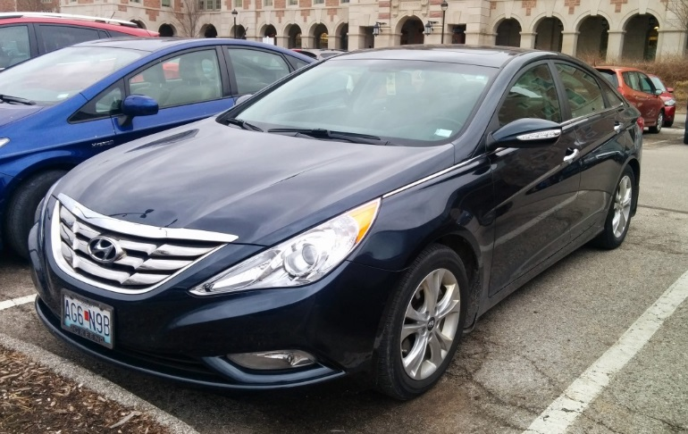

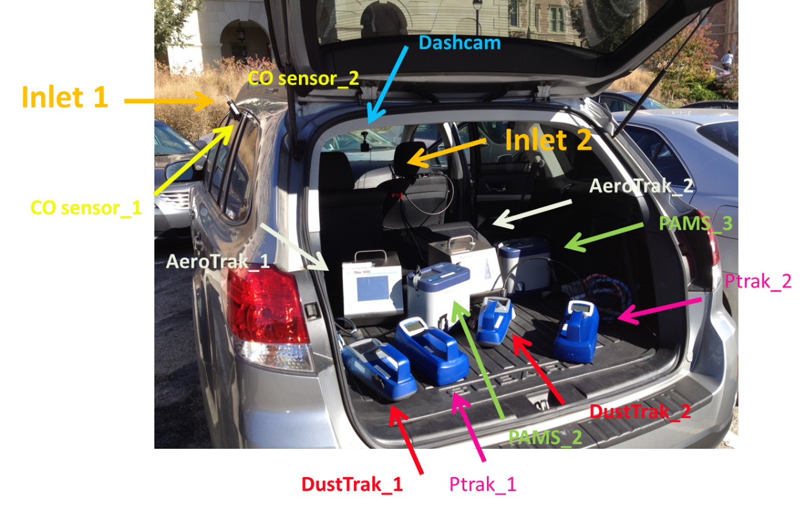
Figure S1: Photographs of the cars and instrumentation used in the measurement campaign

