Additional file 4: Figure S1A. Monthly rates of pneumonia with an ICU admission by age-group—Vaccine Safety Data Link (VSD), 2006–2010
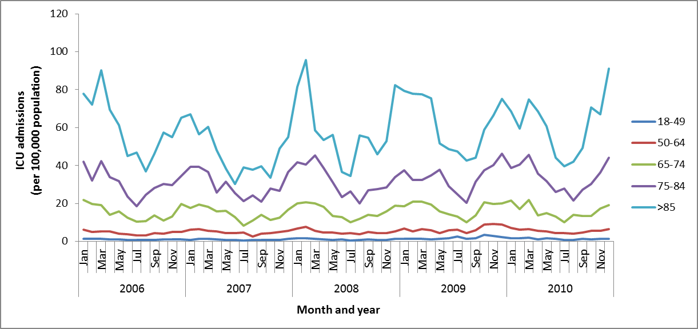
Age-group
(years)
ICU = Intensive care unit

