Supplementary Table. Molecular diagnostic techniques used to detect respiratory viruses in the Influenza Incidence Surveillance Project (IISP).
Site | Influenza Test Method | Influenza prescreening* | Respiratory virus test method | Viruses in Test Panel†
Florida | CDC influenza-specific  RT-PCR | N | Virus-specific  RT-PCR | Influenza, RSV, RV/EV, ADV, PIV-1-3, HMPV
Oregon |  | N
Philadelphia |  | Y
Iowa |  | Y
Minnesota |  | N |  | Influenza, RSV, RV/EV, ADV, PIV-1-3, HMPV, PIV-4, CoV
Utah |  | N | ResPlex II | Influenza, RSV, RV/EV, ADV, PIV1-3, HMPV, PIV-4, CoV, HBoV
Wisconsin |  | N
Los Angeles |  | N | xTAG RVP | Influenza, RSV, RV/EV, ADV, PIV-1-3, HMPV
New York City |  | Y
New Jersey |  | Y
North Dakota |  | Y
Virginia | xTAG RVP‡ | N
*Sites testing first for influenza, then only further testing negative specimens for other respiratory viruses were designated as “prescreening.”
†Virus acronyms: respiratory syncytial virus [RSV], rhinovirus and enterovirus [RV/EV], adenovirus [AdV], parainfluenzavirus [PIV], human metapneumovirus [MPV], coronavirus [CoV], and human bocavirus [HBoV] (none detected).
‡Respiratory virus panel (RVP)

Supplementary Figure 1. Proportion of outpatient visits for acute respiratory infections (ARI) and influenza-like illnesses (ILI) in the Influenza Incidence Surveillance Project, August 2010 through July 2011.
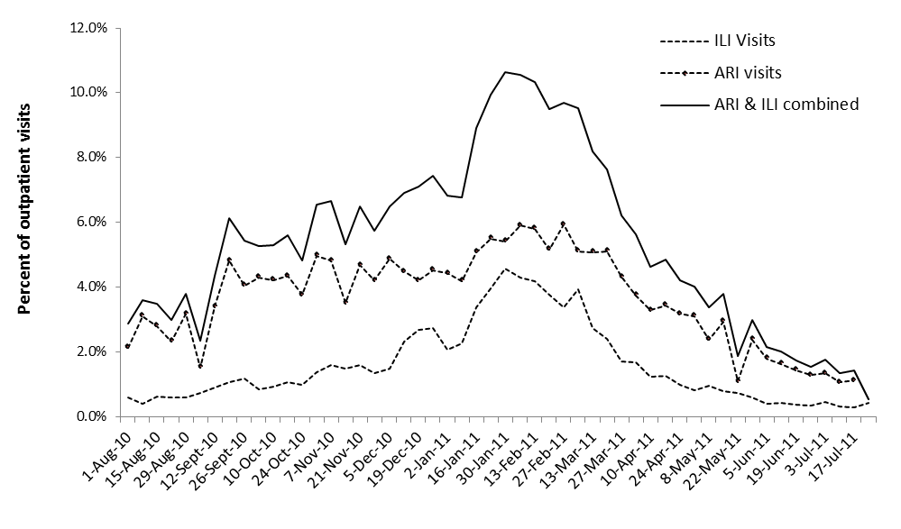

Supplementary Figure 2. Seasonal distribution of respiratory viruses detected by RT-PCR among patients with acute respiratory infections (who did not meet the influenza-like illness case definitions), Influenza Incidence Surveillance Project August 2010 through July 2011. The bars indicate the number of viral detections and the lines indicate the percentage of ILI patients who tested positive.

