Supplementary Material

Supplementary Data for “Genetic Host Specificity of Hepatitis E Virus”
Lara J., Purdy M.A. and Khudyakov Y.E.

MATERIALS and METHODS:
HEV sequence data:
GenBank accession numbers for HEV3 whole-genome sequences are: AB073912, AB074918, AB074920, AB089824, AB091394, AB189072, AB189073, AB189074, AB189075, AB246676, AB248520, AB248521, AB248522, AB290312, AB290313, AB291951, AB291952, AB291953, AB291954, AB291955, AB291956, AB291957, AB291958, AB291960, AB291961, AB291962, AB291963, AB301710, AB369687, AB369689, AB369691, AB437316, AB437317, AB437318, AB443623, AB443624, AB443625, AB443626, AB443627, AB481226, AB481228, AB481229, AF060668, AF060669, AF082843, AF455784, AP003430, AY115488, AY575857, AY575858, AY575859, EU360977, EU375463, EU495148, EU723512, EU723513, EU723514, EU723515, EU723516, FJ426403, FJ426404, FJ527832, FJ641980, FJ956757 and HQ389543.
GenBank accession numbers for HEV4 whole-genome sequences are: AB074915, AB074917, AB080575, AB091395, AB097811, AB097812, AB099347, AB108537, AB161717, AB161718, AB161719, AB193176, AB193177, AB193178, AB197673, AB197674, AB200239, AB220971, AB220972, AB220973, AB220974, AB220975, AB220976, AB220977, AB220978, AB220979, AB253420, AB291959, AB291964, AB291965, AB291966, AB291967, AB291968, AB369688, AB369690, AB481227, AB521805, AB521806, AJ272108, AY594199, AY723745, DQ279091, DQ450072, EF077630, EF570133, EU366959, EU676172, FJ610232, FJ763142, GU119960, GU119961, GU188851, GU206559, GU361892 and HM439284.
GenBank accession numbers for HEV3 Pol sequences are: AB221520, AB221521, AB240441, AB240442, AB240443, AB240444, AB240445, AB240446, AB240447, AB240448, AB240449, AB240450, AB240451, AB369385, AB369386, AB369388, AB369391, AB369392 and EF187824.
GenBank accession numbers for HEV4 Pp and Pol sequences are: AB505793, AB369390, AB2881102, AB240440, AB240439, AB240438, AB240437, AY621106, AY621105, AY621104 and AY621103.
Quality assessment of learned BN:
The accuracy of a learned BN model is written as P(D|BN), meaning the probability of the data (D) given the BN. The log-likelihood of the BN given D is provided by the formula:
$${\text{log}}_{2} (P(D|\text{BN}))=\sum_{i=1}^{n}{\sum_{j=1}^{\text{Qi}}{\sum_{k=1}^{\text{Ri}}{−(N{\text{ijk}}/N)× \text{log} (N{\text{ijk}}/N\text{ij})}}}$$
Where, S is a set of variables (X₁, X₂, …, X_{n}), n ≥ 1; n is the total number of variables in S; X_{i} is a variable with values (X₁, X₂, …, X_{n}); R_{i} is the total number of values of X_{i}; D is the data over S; BN is a Bayesian network model over S; N is the number of instances (examples) over S; P_{i} is a set of parents of X_{i} in BN; W_{ij} is the j^{th} instantiation P_{i}; Q_{i} is the total number of combinations of P_{i} in BN; N_{ijk} is the number of cases in D in which X_{i} = X_{n} and P_{i} = W_{ij} and $N\text{ij}=\sum_{k=1}^{\text{Rj}}{\text{Nijk}}$.
The log-likelihood provides a statistical measure of the goodness-of-fit with which the BN represents the probability distribution in D and can be used to measure how well the BN structure can represent the probability distributions over new (unseen) data. The model is satisfactory if the log-likelihood values of BN given the original D and the log-likelihood values of BN given the new D are close,
$$\text{log} (P(D\text{Training} |\text{BN}) ∞ \text{log} (P(D\text{Test}|\text{BN}))$$
To assess the accuracy of BN_{human} and BN_{swine} to represent probabilistic distributions in D, HEV3 and HEV4 data were each partitioned into corresponding host of origin and randomly divided into training and test sets, where D_{training} = 80% of samples and D_{test} = 20%. In addition, the goodness-of-fit of BN was analyzed to determine how well models derived from data of a specific host could represent the probability distributions in data of the opposite host. The HEV3 and HEV4 data were each divided into D_{training} and D_{test}, where D_{training} = HEV data specific to a host (D_{Host A}) and D_{test} = HEV data from opposite host (D_{Host B}).
First, BN were learned using the D_{training} sets. To ensure accurate computation of log-likelihoods, differences in CPD between the host-based partitioned data were taken into account. The conditional probability tables (CPTs) of nodes in BN were modified to account for an ‘unobserved’ state and assigned a probability of 0.1. Then, learned BN were tested on the D_{test} to compare between the log-likelihood of BN given D_{training} and the log-likelihood of BN given D_{test}.
Strength of dependencies:
The strength of dependencies among interrelated variables was inferred by computing the Kullback-Leibler distance (KL-distance) (Kullback and Leibler, 1951), also known as KL-divergence, between CPTs of paired nodes with and without the arc. This is a statistical measure of dependency between variables; the greater the KL-distance between CPTs is, the greater the strength of the relationship.
This measure was also used to identify the most relevant variables in learned BN models. Identification of such variables was based on the assumption that relevant variables are more likely to have greater numbers of strong influential relations than variables who are less influential or relevant. The relevance of a variable was defined in terms of a node’s strength in BN, which was estimated from the KL-divergence value of arc(s) associated to a node. Three measures were computed to characterize the direction of the influence: (i) outing strength, sum of KL-divergence values of arcs pointing outwards from a node; (ii) entering strength, sum of KL-divergence values of arcs pointing inwards to a node, and (iii) global strength, sum of KL-divergence values of all arcs associated with a node.
Arc confidence analysis:
Confidence about the structure of learned host-specific HEV BN (likelihood of the arcs in BN_{swine} and BN_{human}) was also assessed by measuring how often arcs appeared in a set of sampled networks using a cross-validation method. For this purpose, a jackknife method was used. The jackknife consisted in randomly dividing data into k samples of equal size$(k=\text{15})$. K-1 randomly selected samples were used to learn k BN while the k sample was left out. The frequency with which an edge between any given set of interrelated variable pairs in a given reference BN structure (BN learned using the full dataset) replicated in the K sampled networks was used as a measure for validating pairwise relationships.
In addition, Pearson’s chi-square (χ²) test for independence was computed from BN using the KL-divergence. The p values reported herein represent independence probabilities of χ² tests for each relationship. Mutual information (MI) between variables was computed for each arc in BN to determine the amount of information contributed by each node to the target node.
Intra- and inter-protein epistatic connectivity:
The degree of epistatic connectivity between intra/inter-protein products of the HEV ORFs was determined by examining network pairwise relationships of the nodes in BN (Fig. 1). This degree of connectivity was expressed as a ratio of the number of intra-protein connections to the number inter-protein connections.
Essential graph analysis
The direction of probabilistic relationships (arcs orientation) in BN may also represent causality (Charniak, 1991). For example, if nodes A and B are connected by the directed edge $\left\{A→\left.B\right\}\right.$, then the relation between the variables A & B could be stated as: A causes B or B is a consequence of A. However, it is not possible to define on a BN learned only from data which is the cause and which the consequence. It is just possible to set a probabilistic dependence between variables. As BN is a directed acyclic graph, the structure learning algorithm has to set orientation to each edge that satisfies the acyclic condition.
Nevertheless, a probabilistic relationship between a pair of variables governed by the joint probability law can be used to infer compelled directionality of the relation. For example, BN structures $\left\{A→\left.B\right\}\right.$ and $\left\{A←\left.B\right\}\right.$ are not equivalent relations if each represents a unique joint probability distribution, i.e., $P (B|A)≠P (A|B)$. To test whether arcs between nodes in learned BN (Fig. 1) were compelled to adopt the acquired orientations, a causal analysis was performed. The analysis was based on removing the orientation of the arcs whose orientation could be inverted without changing the joint probability law. Arcs that met this restriction were displayed as undirected edges. Graphs showing both arcs and undirected edges are known as essential graphs. Displaying learned BN models as essential graphs allowed highlighting arcs with compelled directionality.
BN target analysis
Target analysis was performed to determine the mean accuracy with which the networks’ joint probability distribution correctly determines the corresponding states of a variable of interest (i.e. target variable). Furthermore, measuring the effect that changes in the observed values in a given variable has on the probability distribution of the target variable serves as an indication of the extent of influence of that variable on the target. The larger the effect is, the greater the influence. From these measurements one may infer which variables are more relevant to the knowledge of any observations taken by the target variable.
The node encoding the host origin of HEV strains in BNs (Fig. 1) was specified as the target variable. Analysis was performed using the remaining variables to measure effects on the host variable. To determine relevance of variables with respect to target variable, the total effect of each variable on the target variable was first calculated as a ratio of changes in the mean of a variable over changes in the mean of the target. Then, the standardized total effect was computed as a product of the total effect and the ratio of the standard deviations of means for a given variable and the target.
Association between host trait and phylogeny
A posterior set of trees (PST) was created for each genotype using BEAST (ver. 1.7.3) (Drummond and Rambaut, 2007). The HKY substitution model was used with 4 gamma rate categories and invariant sites. An uncorrelated lognormal clock was used with a fixed rate of 1.3x10⁻³ (Purdy and Khudyakov, 2010), a constant size prior with a UPGMA starting tree, and a chain length of 1x10⁷. A 10% burn-in was removed from each posterior set of trees (PST) using LogCombiner (ver. 1.7.3)( http://beast.bio.ed.ac.uk/LogCombiner). Each PST (Fig. S1), containing 9001 trees, was then modified manually to a format recognized by Befi-BaTS (ver. 0.1.1) (Parker et al., 2008), which was used to quantify the degree of correlation between host specificity and shared ancestry. Befi-BaTS was run with 100 replicates to create the null distribution. All statistics in Befi-BaTS display p-values in the normal way except for the UniFrac statistic where the p-value is displayed as 1-p (Table S1).

FIGURES and TABLES
Supplementary Figure S1: Phylogenetic trees for HEV genotypes 3 and 4
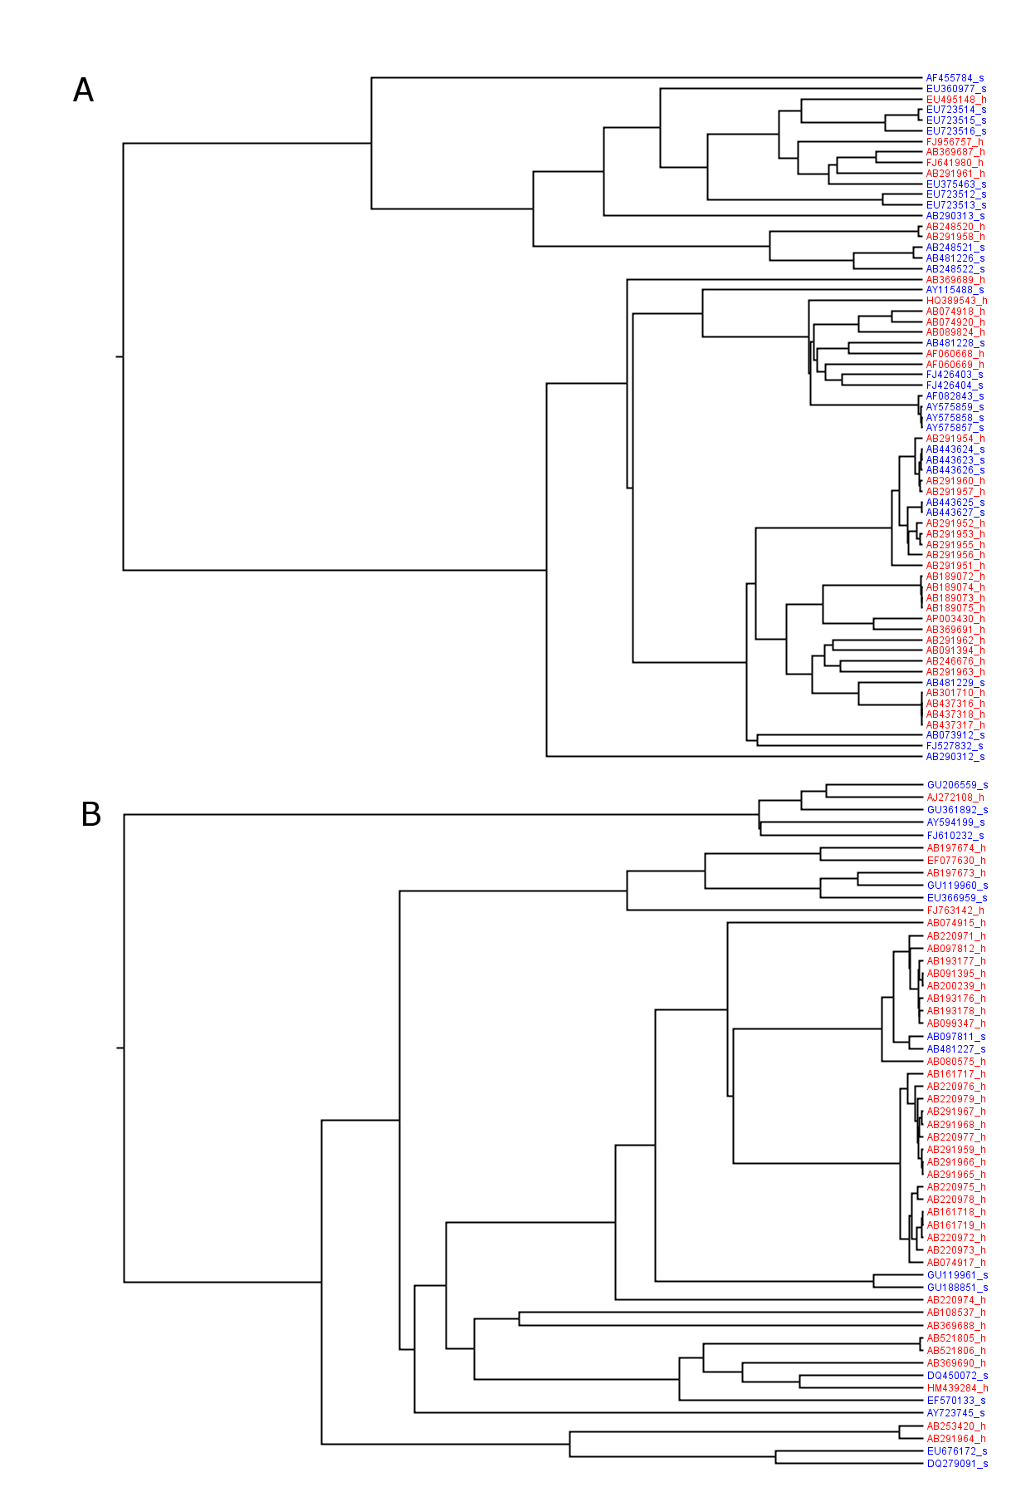
Figure S1. Bayesian trees for HEV3 and HEV4 sequences. A) HEV genotype 3, B) genotype 4, sequences collected from humans are colored red and those from swine are colored blue.
Table S1. Befi-BaTS estimates for HEV ORF1 genotypes 3 and 4. A, genotype 3; B, genotype 4; CI, confidence interval; AI, association index; PS, parsimony score statistic; UniFrac, unique fraction metric; NTI, nearest taxa index; NRI, net relatedness index; PD, phylogenetic diversity; MC(swine), monophyletic clade size statistic for swine host; MC(human), MC for human host. * p ≤ 0.05.
A | observed | 95% CI |  | null | 95% CI
 | mean | lower | upper | mean | lower | upper | significance
AI | 0.54 | 0.50 | 0.61 | 3.42 | 2.59 | 4.31 | 0.00*
PS | 16.28 | 14.00 | 18.00 | 30.95 | 25.96 | 36.44 | 0.00*
UniFrac | 0.40 | 0.35 | 0.45 | 0.15 | 0.06 | 0.24 | 1.00*
NTI | 21527.24 | 19860.88 | 23339.40 | 25646.64 | 23791.59 | 27683.93 | 0.01*
NRI | 1959602.88 | 1692596.25 | 2325691.25 | 2044576.00 | 1977021.88 | 2073318.00 | 0.00*
PD | 43214.71 | 39177.14 | 48295.59 | 46754.61 | 45431.33 | 47964.02 | 0.00*
MC(swine) | 4.00 | 4.00 | 4.00 | 2.98 | 2.00 | 5.00 | 0.24
MC(human) | 6.00 | 6.00 | 6.00 | 3.93 | 2.06 | 6.00 | 0.13
B | observed | 95% CI |  | null | 95% CI
 | mean | lower | upper | mean | lower | upper | significance
AI | 1.42 | 1.39 | 1.48 | 2.33 | 1.44 | 3.14 | 0.05*
PS | 15.90 | 14.00 | 18.00 | 20.87 | 17.65 | 24.40 | 0.00*
UniFrac | 0.31 | 0.24 | 0.39 | 0.25 | 0.12 | 0.42 | 0.64
NTI | 22952.46 | 18775.00 | 27927.28 | 25995.02 | 21921.76 | 29886.83 | 0.10
NRI | 1398800.00 | 1058226.00 | 1825005.25 | 1638025.63 | 1576420.00 | 1701293.00 | 0.00*
PD | 46023.20 | 35652.24 | 58856.26 | 46956.92 | 44272.93 | 49112.30 | 0.12
MC(swine) | 2.00 | 2.00 | 2.00 | 1.87 | 1.00 | 3.00 | 0.62
MC(human) | 16.01 | 16.00 | 16.00 | 5.38 | 3.00 | 8.00 | 0.01*

Table S2. Classification performance of BNC on validation test sets§.
Genotype | ORF1 regions | Sites | Classifier | CA‡ (%) | CA on test set (%)
HEV3 | Polymeraseª | 1367, 1370, 1386, 1391, 1449, 1481, 1488, 1495, 1506, 1523, 1550, 1560, 1596, 1598, 1599, 1612 | BNC | 73.85 | 73.68
HEV4 | Polymeraseª | 1345, 1355, 1356, 1360, 1394, 1417, 1433, 1447, 1450, 1456, 1468, 1550, 1572, 1582, 1585, 1593 | BNC | 78.18 | 85.71
HEV4 | Poly-proline | 707, 718, 732, 733, 742, 756, 760, 767, 772, 779 | BNC | 85.45 | 100
§ Owing to the short length of sequences available in GenBank and in order to maximize the size of the validation set, BNC were re-trained on HEV data, genotypes 3 and 4 ORF1 Pol-domains.
‡CA based on 10-fold CV.
ª Residue site positions based on ORF1 position numbering using reference sequences: EU723514 (HEV3) and AB220971 (HEV4).

REFERENCES
Charniak, E., 1991. Bayesian Networks without Tears. AI Mag 12, 50-63.
Drummond, A.J., Rambaut, A., 2007. BEAST: Bayesian evolutionary analysis by sampling trees. BMC Evol Biol 7, 214.
Kullback, S., Leibler, R.A., 1951. On information and sufficiency. Ann Math Stat 22, 79-86.
Parker, J., Rambaut, A., Pybus, O.G., 2008. Correlating viral phenotypes with phylogeny: accounting for phylogenetic uncertainty. Infect Genet Evol 8, 239-246.
Purdy, M.A., Khudyakov, Y.E., 2010. Evolutionary history and population dynamics of hepatitis E virus. PLoS One 5, e14376.

