eFigure 1. Flow chart of exclusions due to missing air pollution exposure estimates

eFigure 2. 2010 NO_{X} (ppb) and CO (ppm) concentrations contributed by primary mobile sources

eFigure 3. Demographic clusters of Georgia in the 29 county metropolitan Atlanta area

eFigure 4. 29 county metropolitan Atlanta area divided into city regions

eFigure 5. Smooth concentration response curves from generalized additive models using loess smoothers for prenatal and first year of life PM_{2.5} mobile source PM_{2.5}, NO_{X}, and CO and incident asthma by age 5

eTable 1. Risk differences and 95% confidence intervals for natural log-transformed prenatal and first year of life mobile source NO_{X} and CO and asthma incidence

eTable 2. Risk differences and 95% confidence intervals for linear (scaled to the interquartile range) prenatal and first year of life mobile source PM_{2.5}, NO_{X} and CO and asthma incidence

eTable 3. Risk differences and 95% confidence intervals for incident asthma by age 5 and prenatal (n=7,520) and first year of life (n=8,591) mobile source PM_{2.5}, NO_{X}, and CO, modeling exposure by quintiles (Q1-Q5)

eTable 4. Risk differences and 95% confidence intervals for persistent asthma by age 5 and prenatal (n=6,795) and first year of life (n=7,755) mobile source PM_{2.5}, NO_{X}, and CO: per natural log increase in concentration and by quintile (Q1-Q5)

eFigure 6. Risk differences and 95% confidence intervals for persistent asthma by age 5 and prenatal and first year of life mobile source PM_{2.5}, NO_{X}, and CO: per natural log increase and by quintile (Q1-Q5). Numeric results corresponding to this figure are listed in eTable 4.

eTable 5. Results displayed in Figure 4 for first year of life mobile source PM_{2.5} and incident asthma by age 5 among children enrolled through age 5 (n=8,592), comparing different outcome definitions

eFigure 1. Flow chart of exclusions due to missing air pollution exposure estimates

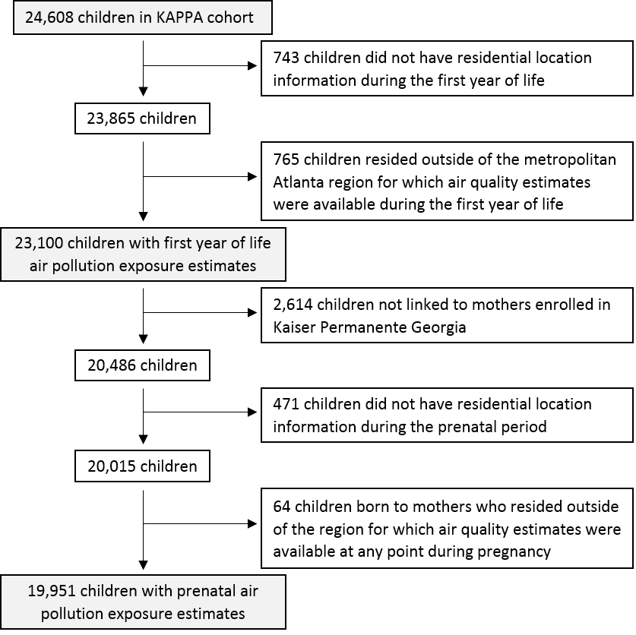

eFigure 2. 2010 NOx (ppb) and CO (ppm) concentrations contributed by primary mobile sources
NO_{X}

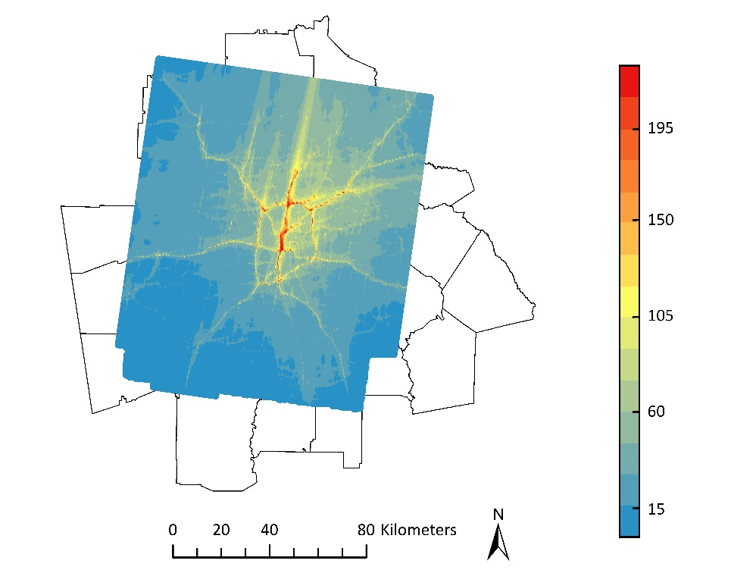
CO

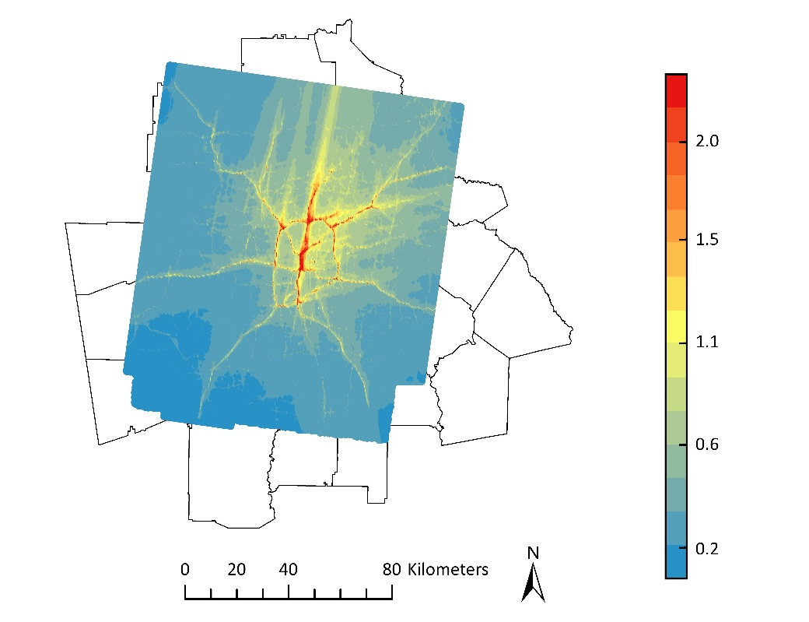
eFigure 3. Demographic clusters of Georgia in the 29 county metropolitan Atlanta area

A clusters (highest SES), B clusters (urban/suburban), C clusters (rural, average to low SES), D clusters (lowest SES). Demographic cluster descriptions are available online at:
Georgia Department of Public Health, Office of Health Indicators for Planning (OHIP). Online Analytical Statistical Information System: Demographic Clusters of Georgia: Accessing the Georgia Deparmtent of Public Health's Data Warehouse. https://oasis.state.ga.us/gis/demographiccluster/DemoClusters2011.htm

eFigure 4. 29 county metropolitan Atlanta area divided into city regions

Legend
29 county metropolitan Atlanta area
Atlanta inside I-285 highway
I-285 highway
16 km (10 miles) outside I-285

eFigure 5. Smooth concentration response curves from generalized additive models using loess smoothers for prenatal and first year of life PM_{2.5} mobile source PM_{2.5}, NO_{X}, and CO and incident asthma by age 5
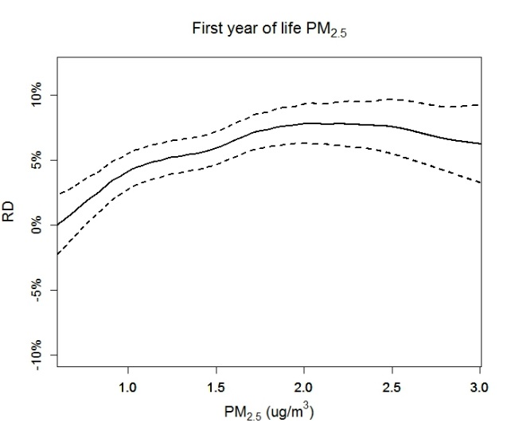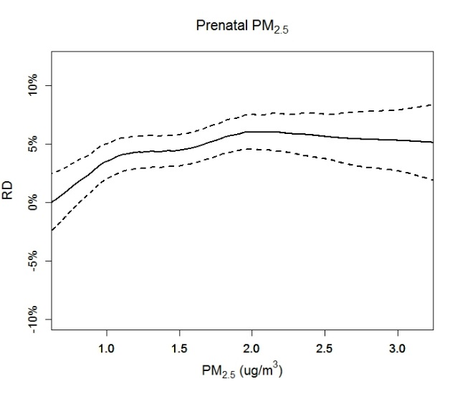
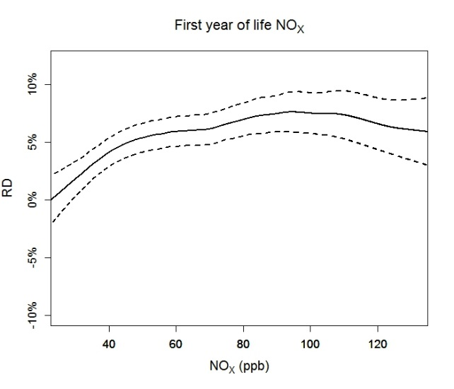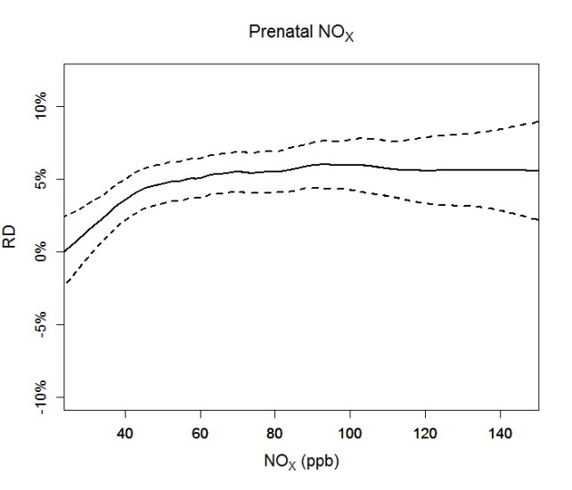
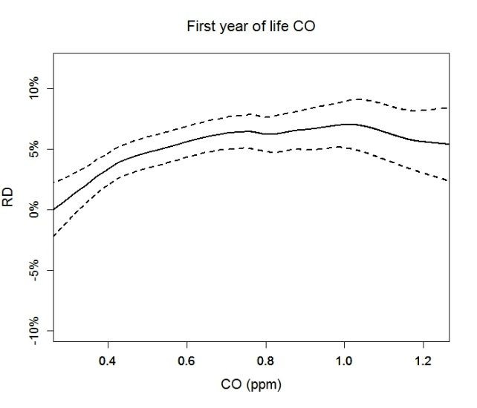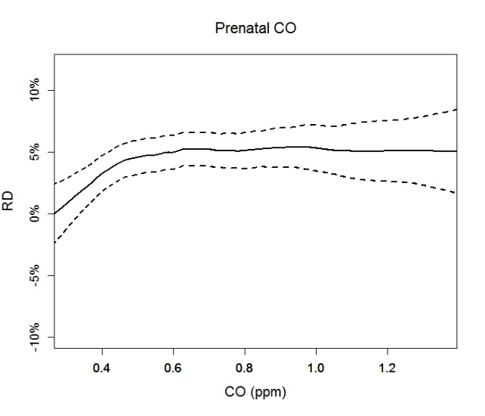
RD = risk difference. Models control for child sex, child race, maternal asthma, birth year, neighborhood socioeconomic status, and city region. Loess smoothers were executed with a span of 0.60.

eTable 1. Risk differences and 95% confidence intervals for natural log-transformed prenatal and first year of life mobile source NO_{X} and CO and asthma incidence
Mobile source NO_{X}, RD per natural log increase in concentration (ppb)
 | Prenatal exposure |  | First year of life exposure
Cohort | Unadjusted  RD (95% CI) | Adjusted  RD (95% CI) | Unadjusted  RD (95% CI) | Adjusted  RD (95% CI)
Age 2 | -0.006 (-0.014, 0.003) | 0.013 (0.002, 0.024) | -0.006 (-0.014, 0.002) | 0.010 (-0.000, 0.021)
Age 3 | -0.007 (-0.019, 0.005) | 0.015 (-0.000, 0.030) | -0.007 (-0.018, 0.005) | 0.016 (0.003, 0.029)
Age 4 | -0.006 (-0.022, 0.009) | 0.020 (-0.001, 0.040) | -0.006 (-0.021, 0.008) | 0.022 (0.003, 0.042)
Age 5 | 0.001 (-0.017, 0.020) | 0.029 (0.005, 0.053) | 0.005 (-0.013, 0.022) | 0.038 (0.014, 0.061)
Age 6 | 0.005 (-0.016, 0.027) | 0.031 (0.003, 0.059) | 0.003 (-0.018, 0.023) | 0.031 (0.003, 0.059)
Mobile source CO, RD per natural log increase in concentration (ppm)
 | Prenatal exposure |  | First year of life exposure
Cohort | Unadjusted  RD (95% CI) | Adjusted  RD (95% CI) | Unadjusted  RD (95% CI) | Adjusted  RD (95% CI)
Age 2 | -0.009 (-0.018, 0.001) | 0.013 (0.002, 0.025) | -0.009 (-0.018, -0.000) | 0.010 (-0.001, 0.022)
Age 3 | -0.011 (-0.025, 0.002) | 0.014 (-0.003, 0.031) | -0.012 (-0.025, 0.001) | 0.015 (-0.001, 0.030)
Age 4 | -0.011 (-0.028, 0.006) | 0.019 (-0.003, 0.041) | -0.012 (-0.028, 0.004) | 0.022 (0.000, 0.043)
Age 5 | -0.002 (-0.022, 0.019) | 0.029 (0.003, 0.055) | 0.002 (-0.018, 0.021) | 0.038 (0.012, 0.064)
Age 6 | 0.002 (-0.022, 0.027) | 0.031 (-0.000, 0.061) | -0.001 (-0.024, 0.022) | 0.031 (0.001, 0.062)
RD=risk difference, ln=natural log. Adjusted models control for child sex, child race, maternal asthma, birth year, neighborhood socioeconomic status, and city region.

eTable 2. Risk differences and 95% confidence intervals for linear (scaled to the interquartile range) prenatal and first year of life mobile source PM_{2.5}, NO_{X} and CO and asthma incidence
Mobile Source PM_{2.5}, RD per IQR (1 µg/m³)
 | Prenatal exposure |  | First year of life exposure
Cohort | Unadjusted  RD (95% CI) | Adjusted  RD (95% CI) | Unadjusted  RD (95% CI) | Adjusted  RD (95% CI)
Age 2 | -0.006 (-0.011, -0.001) | 0.005 (-0.002, 0.011) | -0.007 (-0.013, -0.002) | 0.003 (-0.004, 0.010)
Age 3 | -0.007 (-0.016, 0.002) | 0.004 (-0.005, 0.013) | -0.010 (-0.018, -0.003) | 0.004 (-0.005, 0.013)
Age 4 | -0.007 (-0.017, 0.004) | 0.007 (-0.005, 0.018) | -0.010 (-0.019, -0.001) | 0.008 (-0.005, 0.020)
Age 5 | -0.005 (-0.016, 0.007) | 0.009 (-0.005, 0.023) | -0.005 (-0.017, 0.006) | 0.013 (-0.002, 0.028)
Age 6 | -0.002 (-0.016, 0.012) | 0.010 (-0.007, 0.027) | -0.007 (-0.020, 0.007) | 0.009 (-0.009, 0.027)
Mobile source NO_{X}, RD per IQR (40 ppb)
 | Prenatal exposure |  | First year of life exposure
Cohort | Unadjusted  RD (95% CI) | Adjusted  RD (95% CI) | Unadjusted  RD (95% CI) | Adjusted  RD (95% CI)
Age 2 | -0.004 (-0.009, 0.000) | 0.003 (-0.002, 0.009) | -0.006 (-0.010, -0.001) | 0.002 (-0.004, 0.007)
Age 3 | -0.006 (-0.012, 0.001) | 0.002 (-0.005, 0.009) | -0.008 (-0.014, -0.001) | 0.003 (-0.005, 0.010)
Age 4 | -0.006 (-0.014, 0.002) | 0.003 (-0.007, 0.012) | -0.008 (-0.016, -0.000) | 0.004 (-0.006, 0.015)
Age 5 | -0.005 (-0.014, 0.005) | 0.005 (-0.006, 0.017) | -0.005 (-0.015, 0.005) | 0.008 (-0.004, 0.020)
Age 6 | -0.002 (-0.013, 0.009) | 0.006 (-0.008, 0.019) | -0.006 (-0.017, 0.005) | 0.005 (-0.009, 0.019)
Mobile source CO, RD per IQR (0.4 ppm)
 | Prenatal exposure |  | First year of life exposure
Cohort | Unadjusted  RD (95% CI) | Adjusted  RD (95% CI) | Unadjusted  RD (95% CI) | Adjusted  RD (95% CI)
Age 2 | -0.006 (-0.011, -0.000) | 0.004 (-0.002, 0.010) | -0.007 (-0.012, -0.003) | 0.002 (-0.004, 0.008)
Age 3 | -0.008 (-0.015, -0.000) | 0.002 (-0.006, 0.010) | -0.010 (-0.017, -0.003) | 0.002 (-0.005, 0.010)
Age 4 | -0.008 (-0.017, 0.001) | 0.003 (-0.007, 0.014) | -0.011 (-0.020, -0.002) | 0.005 (-0.006, 0.016)
Age 5 | -0.006 (-0.016, 0.005) | 0.006 (-0.007, 0.018) | -0.007 (-0.017, 0.004) | 0.009 (-0.004, 0.023)
Age 6 | -0.004 (-0.016, 0.009) | 0.006 (-0.009, 0.021) | -0.008 (-0.021, 0.004) | 0.005 (-0.011, 0.021)
RD=risk difference, IQR=interquartile range, Adjusted models control for child sex, child race, maternal asthma, birth year, neighborhood socioeconomic status, and city region.

eTable 3. Risk differences and 95% confidence intervals for incident asthma by age 5 and prenatal (n=7,520) and first year of life (n=8,591) mobile source PM_{2.5}, NO_{X}, and CO, modeling exposure by quintiles (Q1-Q5)
 | First year of life  mobile source PM_{2.5} | First year of life  mobile source NO_{X} | First year of life  mobile source CO
 | RD (95% CI) | RD (95% CI) | RD (95% CI)
Quintile 1 | 0.0 | 0.0 | 0.0
Quintile 2 | 0.049 (0.017, 0.081) | 0.057 (0.024, 0.089) | 0.040 (0.009, 0.072)
Quintile 3 | 0.044 (0.011, 0.077) | 0.058 (0.025, 0.090) | 0.041 (0.009, 0.074)
Quintile 4 | 0.064 (0.029, 0.100) | 0.057 (0.023, 0.092) | 0.063 (0.028, 0.097)
Quintile 5 | 0.054 (0.014, 0.094) | 0.073 (0.034, 0.113) | 0.049 (0.009, 0.088)
 | Prenatal  mobile source PM_{2.5} | Prenatal  mobile source NO_{X} | Prenatal  mobile source CO
 | RD (95% CI) | RD (95% CI) | RD (95% CI)
Quintile 1 | 0.0 | 0.0 | 0.0
Quintile 2 | 0.048 (0.014, 0.082) | 0.044 (0.009, 0.078) | 0.032 (-0.002, 0.065)
Quintile 3 | 0.025 (-0.009, 0.059) | 0.040 (0.005, 0.075) | 0.028 (-0.007, 0.063)
Quintile 4 | 0.057 (0.020, 0.094) | 0.057 (0.020, 0.093) | 0.048 (0.012, 0.085)
Quintile 5 | 0.042 (0.001, 0.083) | 0.047 (0.006, 0.089) | 0.042 (0.001, 0.082)
Models adjusted for child sex, child race, maternal asthma, birth year, neighborhood socioeconomic status, and city region. Quintile 1 used as reference group.
First year of life quintile cut points: PM_{2.5} (µg/m³): <0.92, 0.92-<1.3, 1.3-<1.6, 1.6-<2.1, ≥2.1. NO_{X} (ppb): <34.6, 34.6-<48.5, 48.5-<63.5, 63.5-<85.5, ≥85.5. CO (ppm): <0.38, 0.38-<0.52, 0.52-<0.66, 0.66-<0.85, ≥0.85.
Prenatal quintile cut points: PM_{2.5} (µg/m³): <0.97, 0.97-<1.3, 1.3-<1.7, 1.7-<2.2, ≥2.2. NO_{X} (ppb): <37.0, 37.0-<52.1, 52.1-<68.4, 68.4-<92.7, ≥92.7. CO (ppm): <0.40, 0.40-<0.54, 0.54-<0.69, 0.69-<0.91, ≥0.91.

eTable 4. Risk differences and 95% confidence intervals for persistent asthma by age 5 and prenatal (n=6,795) and first year of life (n=7,755) mobile source PM_{2.5}, NO_{X}, and CO: per natural log increase in concentration and by quintile (Q1-Q5)
 | First year of life  mobile source PM_{2.5} | First year of life  mobile source NO_{X} | First year of life  mobile source CO
 | RD (95% CI) | RD (95% CI) | RD (95% CI)
Per ln increase | 0.045 (0.023, 0.066) | 0.040 (0.018, 0.061) | 0.039 (0.015, 0.062)
Quintile 1 | 0.0 | 0.0 | 0.0
Quintile 2 | 0.041 (0.012, 0.070) | 0.057 (0.028, 0.087) | 0.038 (0.009, 0.067)
Quintile 3 | 0.047 (0.017, 0.078) | 0.066 (0.036, 0.096) | 0.046 (0.016, 0.077)
Quintile 4 | 0.060 (0.027, 0.093) | 0.054 (0.022, 0.086) | 0.053 (0.020, 0.085)
Quintile 5 | 0.054 (0.016, 0.092) | 0.072 (0.035, 0.108) | 0.046 (0.009, 0.083)
 | Prenatal  mobile source PM_{2.5} | Prenatal  mobile source NO_{X} | Prenatal  mobile source CO
 | RD (95% CI) | RD (95% CI) | RD (95% CI)
Per ln increase | 0.044 (0.023, 0.064) | 0.038 (0.017, 0.059) | 0.038 (0.015, 0.062)
Quintile 1 | 0.0 | 0.0 | 0.0
Quintile 2 | 0.039 (0.008, 0.070) | 0.050 (0.019, 0.081) | 0.035 (0.005, 0.065)
Quintile 3 | 0.037 (0.005, 0.068) | 0.050 (0.019, 0.081) | 0.035 (0.003, 0.066)
Quintile 4 | 0.059 (0.025, 0.094) | 0.065 (0.032, 0.098) | 0.051 (0.017, 0.085)
Quintile 5 | 0.055 (0.017, 0.093) | 0.061 (0.024, 0.098) | 0.050 (0.012, 0.087)
RD=risk difference. ln=natural log. Persistent asthma defined as a child meeting the incident asthma classification (at least 1 asthma diagnosis (ICD-9 493.XX) and 1 asthma-related medication dispensing) with evidence of asthma in the past year (at least 1 asthma diagnosis or 1 asthma-related medication dispensing). Models adjusted for child sex, child race, maternal asthma, birth year, neighborhood socioeconomic status, and city region. Quintile 1 used as reference group.
First year of life quintile cut points: PM_{2.5} (µg/m³): <0.92, 0.92-<1.3, 1.3-<1.6, 1.6-<2.1, ≥2.1. NO_{X} (ppb): <34.6, 34.6-<48.5, 48.5-<63.5, 63.5-<85.5, ≥85.5. CO (ppm): <0.38, 0.38-<0.52, 0.52-<0.66, 0.66-<0.85, ≥0.85.
Prenatal quintile cut points: PM_{2.5} (µg/m³): <0.97, 0.97-<1.3, 1.3-<1.7, 1.7-<2.2, ≥2.2. NO_{X} (ppb): <37.0, 37.0-<52.1, 52.1-<68.4, 68.4-<92.7, ≥92.7. CO (ppm): <0.40, 0.40-<0.54, 0.54-<0.69, 0.69-<0.91, ≥0.91.

eFigure 6. Risk differences and 95% confidence intervals for persistent asthma by age 5 and prenatal and first year of life mobile source PM_{2.5}, NO_{X}, and CO: per natural log increase and by quintile (Q1-Q5). Numeric results corresponding to this figure are listed in eTable 4.
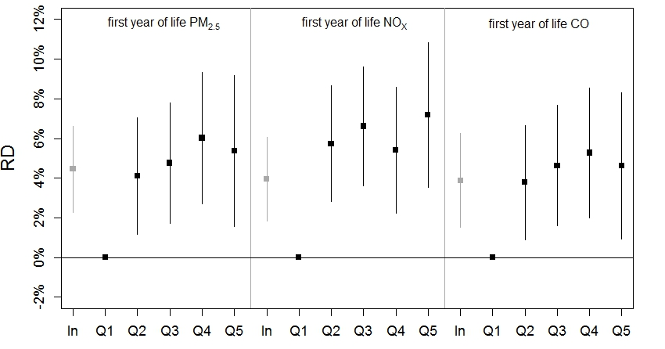

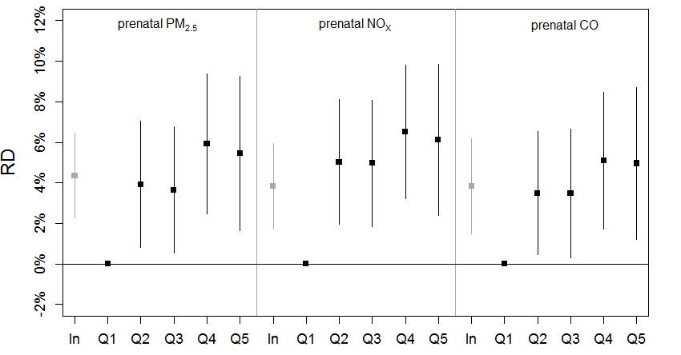

Persistent asthma defined as a child meeting the incident asthma classification (at least 1 asthma diagnosis (ICD-9 493.XX) and 1 asthma-related medication dispensing) with evidence of asthma in the past year (at least 1 asthma diagnosis or 1 asthma-related medication dispensing). Models adjust for child sex, child race, maternal asthma, birth year, neighborhood socioeconomic status, and city region. Numeric results can be found in eTable 4.
eTable 5. Results displayed in Figure 4 for first year of life mobile source PM_{2.5} and incident asthma by age 5 among children enrolled through age 5 (n=8,591), comparing different outcome definitions
Outcome Definition | % meeting definition | Per natural log increase
 |  | RD (95% CI)
- 1 asthma or wheeze diagnosis | 35.9% | 0.037 (0.011, 0.064)
- 1 asthma diagnosis | 29.9% | 0.047 (0.022, 0.072)
- 2 asthma diagnoses | 20.5% | 0.034 (0.012, 0.056)
- 3 asthma diagnoses | 15.3% | 0.031 (0.009, 0.052)
- 2 asthma diagnoses OR 1 acute asthma diagnosis | 21.6% | 0.039 (0.016, 0.062)
- 1 asthma diagnosis OR 2 medication dispensings | 38.7% | 0.039 (0.012, 0.067)
- 1 asthma diagnosis AND 1 medication dispensing (definition used in main analysis) | 28.7% | 0.041 (0.016, 0.066)
- 1 asthma diagnosis AND 2 medication dispensings | 25.2% | 0.042 (0.018, 0.066)
- 1 asthma diagnosis OR 2 medication dispensings 1 of which must be a steroid | 31.3% | 0.051 (0.026, 0.077)
- 1 asthma diagnosis AND 2 medication dispensings 1 of which must be a steroid | 16.2% | —
- 1 asthma diagnosis OR 1 controller dispensing | 31.6% | 0.048 (0.022, 0.074)
- 1 asthma diagnosis AND 1 controller dispensing | 16.7% | —
- 1 asthma diagnosis AND (2 reliever dispensings OR 1 controller dispensing) | 25.4% | 0.040 (0.016, 0.064)
- Any of the following: a) 1 asthma diagnosis AND 1 medication dispensing in the same year, b) 1 asthma-related ED visit or hospitalization, c) 3 asthma diagnoses | 28.5% | 0.043 (0.018, 0.068)
These are the minimum required events for each case definition. Models adjusted for child sex, child race, maternal asthma, birth year, neighborhood socioeconomic status, and city region. Only 1 diagnosis per day counted. — = model did not converge. ED = emergency department; Asthma diagnosis = ICD-9 code 493.XX; Wheeze diagnosis = ICD-9 code 786.07; Acute asthma diagnosis = a) emergency department or inpatient asthma diagnosis or b) asthma diagnosis with status asthmaticus or acute exacerbation (ICD-9 codes 493.01, 493.02, 493.11, 493.12, 493.21, 493.22, 493.91, 493.92); Asthma controller (underlined medications contain a steroid) = aminophylline, beclomethasone diproprionate, budesonide, budesonide/formoterol fumarate, cromolyn sodium, fluticasone propionate, fluticasone/sameterol, mometasone furoate, montelukast sodium, salmeterol xinafoate, theophylline anhydrous, tiotropium bromide, triamcinolone acetonide; Asthma reliever = albuterol, albuterol sulfate, ipratropium bromide, ipratropium/albuterol sulfate, levalbuterol, metaproterenol sulfate; Medication dispensing = dispensing of any asthma controller or reliever.

