SUPPLEMENTAL INFORMATION

Biomonitoring method for the analysis of chromium and cobalt in human whole blood by using an inductively coupled plasma - kinetic energy discrimination - mass spectrometry (ICP-KED-MS)

Joaudimir Castro Georgi*, Yuliya L. Sommer, Cynthia D. Ward, Po-Yung Cheng
Robert L. Jones, and Kathleen L. Caldwell

Inorganic & Radiation Analytical Toxicology Branch
National Center for Environmental Health
Centers for Disease Control and Prevention
4770 Buford Highway, Mailstop F-50
Atlanta, GA 30341-3717

The findings and conclusions in this report are those of the authors and do not necessarily represent the official position of the Center for Disease Control and Prevention. Use of trade names and commercial sources is for identification only and does not constitute endorsement by the U.S. Department of Health and Human Services, or the U.S. Centers for Disease Control and Prevention

Events | Actions
On Probe Down | FAST Vacuum 1 - On
On Probe Down | FAST Valve 1 Load
Probe in Sample at 4s | FAST Valve 1 Inject
Probe in Sample at 3s | Move Rinse: R1=2s & R2=2s
Rinse Completed | Probe Up
On Rinse | FAST Valve 1 Load
On Rinse at 0.5s | Move Rinse: R1=0s & R2=2s
On Rinse at 12.0s | FAST Valve 1 Inject
On Rinse at 13.0s | FAST Valve 1 Load
Rinse completed | Move To Next
Table S1. ESI SC-4Q FAST Method Parameters

Carryover
Figure S1a-1d. Cr and Co responses (intensities and concentration) for alternating 100 µg/L Cr/Co blood samples and aqueous blanks over time (~3.5hrs.) used to calculate optimum number of samples per run.

a.
b.
d.

c.
d.

Accuracy
Figure S2a-d. Linear regression and Bland-Altman plots for Cr and Co for spiked materials and historical proficiency samples.

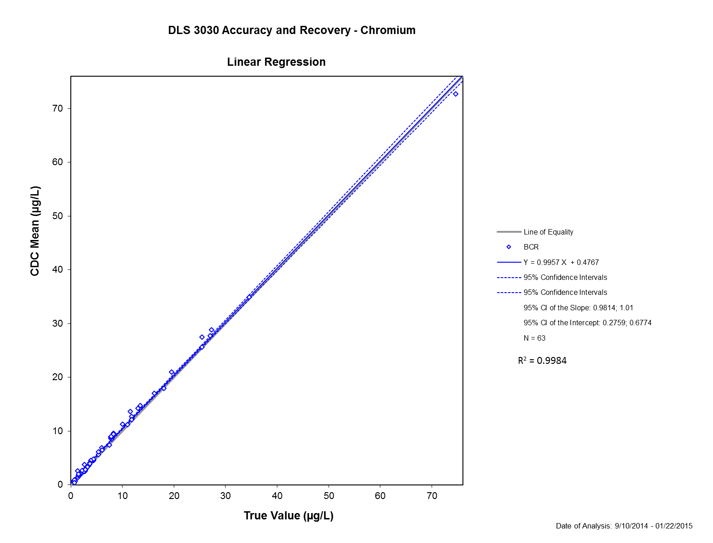
a.
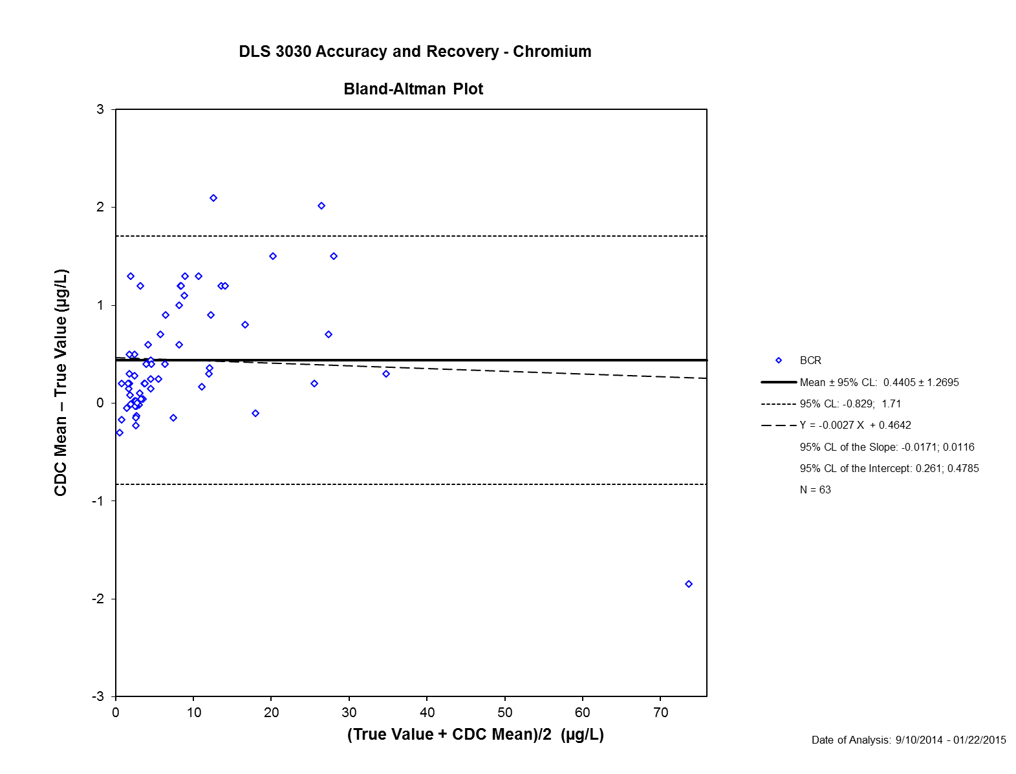
b.
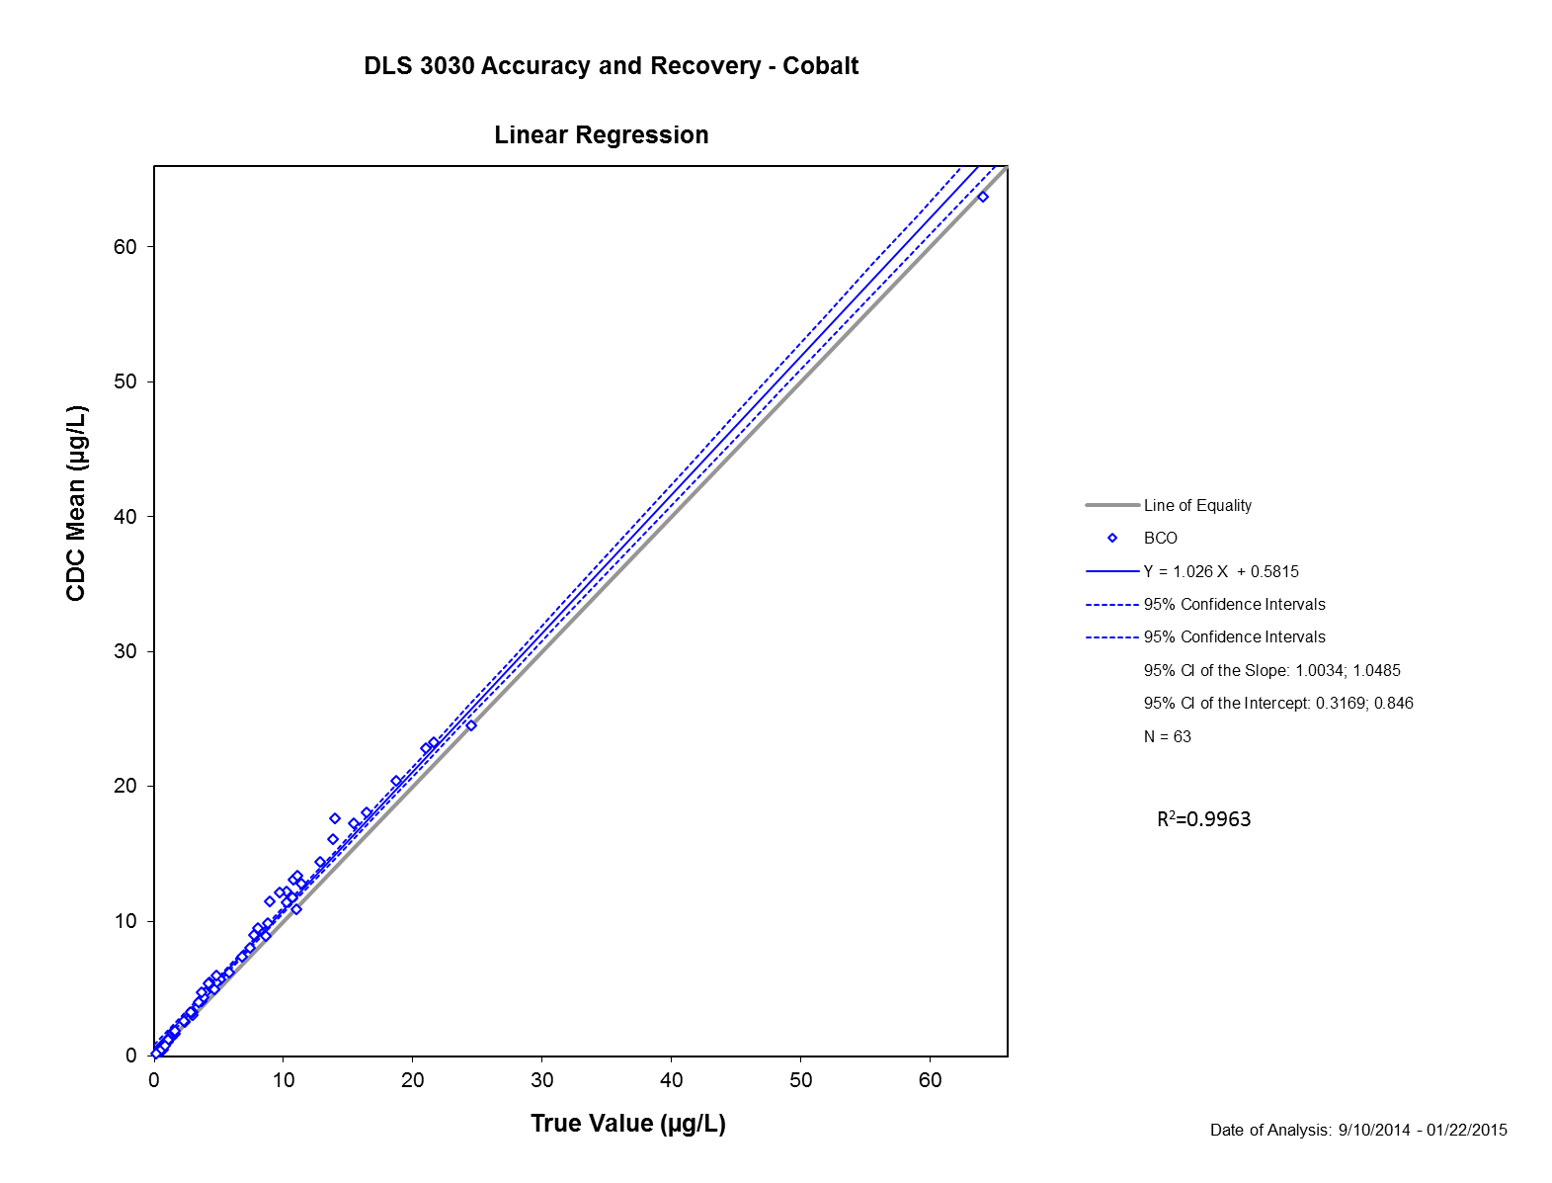
c.

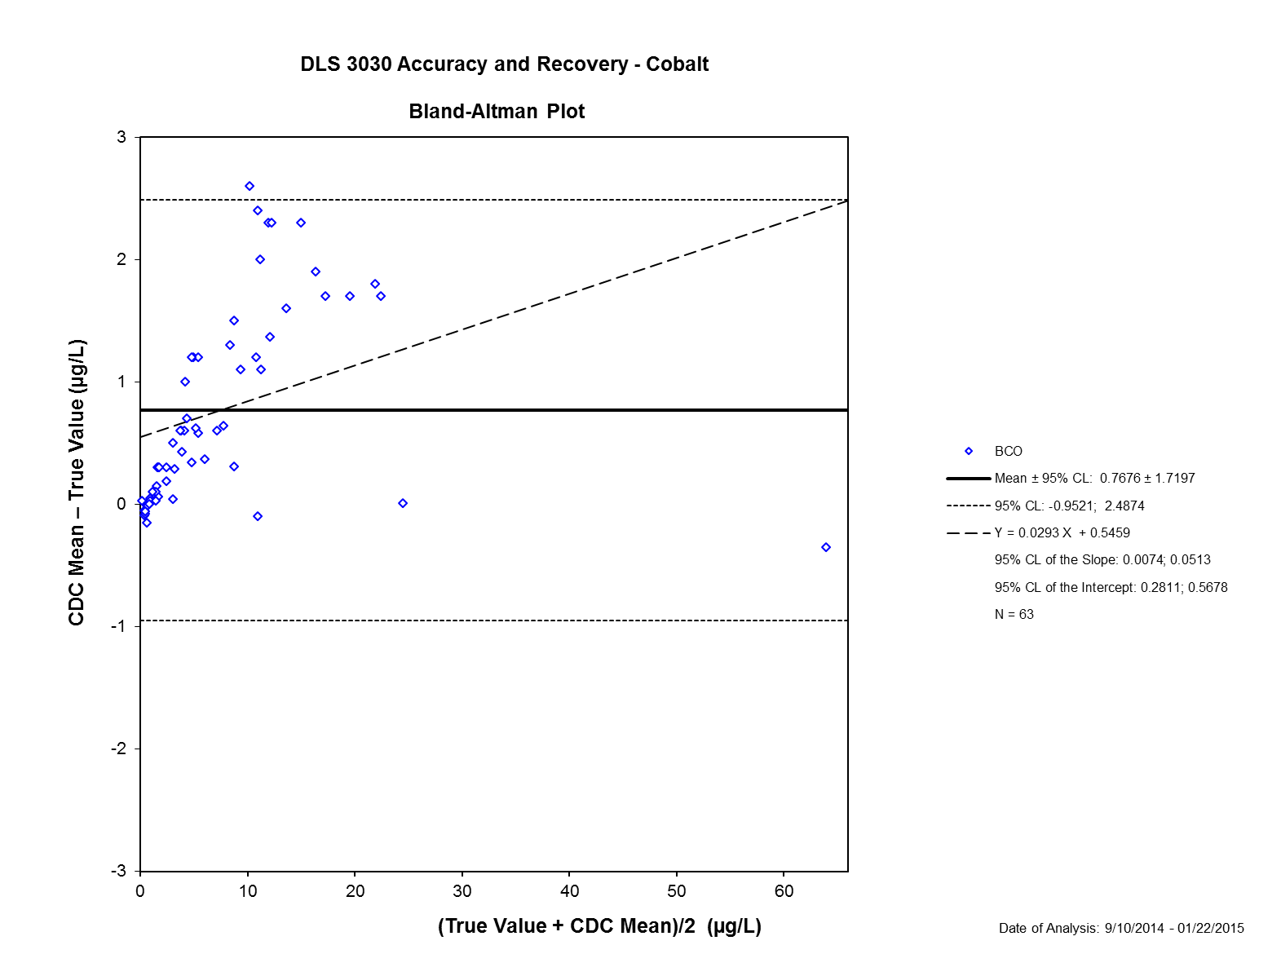
d.
Table S2. New York Department of Health’s (NYDOH) proficiency testing sample results for Cr.
NYDOH samples | True Value | CDC Overall AVG | CDC Overall SD | n (number of samples) | CDC Overall Bias | % Bias | CDC %CV | Recovery %
BE12-06 | 5.40 | 6.10 | 0.09 | 2 | 0.7 | 13 | 1.5 | 89
BE12-07 | 1.70 | 1.90 | 0.10 | 2 | 0.2 | 12 | 5.5 | 89
BE12-08 | 4.40 | 4.80 | 0.13 | 2 | 0.4 | 9 | 2.8 | 92
BE12-09 | 7.90 | 8.50 | 0.17 | 2 | 0.6 | 8 | 1.9 | 93
BE12-10 | 1.30 | 2.60 | 1.56 | 2 | 1.3 | 100 | 60.0 | 50
BE12-11 | 2.60 | 3.80 | 0.35 | 2 | 1.2 | 46 | 9.3 | 68
BE12-12 | 6.00 | 6.90 | 0.29 | 2 | 0.9 | 15 | 4.2 | 87
BE12-13 | 11.50 | 13.60 | 0.29 | 2 | 2.1 | 18 | 2.1 | 85
BE12-14 | 8.30 | 9.60 | 0.01 | 2 | 1.3 | 16 | 0.1 | 86
BE12-15 | 1.60 | 1.90 | 0.15 | 2 | 0.3 | 19 | 8.3 | 84
BE13-01 | 7.70 | 8.70 | 0.01 | 2 | 1.0 | 13 | 0.1 | 89
BE13-02 | 27.30 | 28.80 | 0.34 | 2 | 1.5 | 5 | 1.2 | 95
BE13-03 | 3.90 | 4.50 | 0.01 | 2 | 0.6 | 15 | 0.2 | 87
BE13-04 | 18.00 | 17.90 | 0.31 | 2 | -0.1 | -1 | 1.7 | 101
BE13-05 | 2.20 | 2.70 | 0.02 | 2 | 0.5 | 23 | 0.7 | 81
BE13-07 | 10.00 | 11.30 | 0.71 | 2 | 1.3 | 13 | 6.3 | 88
BE13-06 | 27.00 | 27.70 | 0.62 | 2 | 0.7 | 3 | 2.2 | 97
BE13-08 | 3.70 | 4.10 | 0.08 | 2 | 0.4 | 11 | 1.8 | 90
BE13-09 | 13.00 | 14.20 | 0.26 | 2 | 1.2 | 9 | 1.8 | 92
BE13-10 | 0.70 | 0.90 | 0.25 | 2 | 0.2 | 29 | 27.0 | 78
BE13-11 | 7.70 | 8.90 | 0.09 | 2 | 1.2 | 16 | 1.0 | 87
BE13-12 | 6.10 | 6.50 | 0.12 | 2 | 0.4 | 7 | 1.8 | 94
BE13-13 | 2.80 | 2.80 | 0.01 | 2 | 0.0 | 0 | 0.2 | 100
BE13-14 | 25.40 | 25.60 | 0.15 | 2 | 0.2 | 1 | 0.6 | 99
BE13-15 | 11.80 | 12.10 | 0.32 | 2 | 0.3 | 3 | 2.6 | 98
BE14-01 | 1.50 | 1.70 | 0.13 | 2 | 0.2 | 13 | 7.5 | 88
BE14-02 | 3.60 | 3.80 | 0.31 | 2 | 0.2 | 6 | 8.3 | 95
BE14-03 | 7.80 | 9.00 | 0.31 | 2 | 1.2 | 15 | 3.5 | 87
BE14-04 | 13.50 | 14.70 | 0.04 | 2 | 1.2 | 9 | 0.2 | 92
BE14-05 | 19.50 | 21.00 | 0.23 | 2 | 1.5 | 8 | 1.1 | 93
BE14-06 | 0.70 | 0.40 | 0.00 | 2 | -0.3 | -43 | 0.8 | 175
BE14-07 | 3.70 | 3.90 | 0.02 | 2 | 0.2 | 5 | 0.4 | 95
BE14-08 | 1.50 | 2.00 | 0.55 | 2 | 0.5 | 33 | 27.1 | 75
BE14-09 | 8.30 | 9.40 | 0.03 | 2 | 1.1 | 13 | 0.4 | 88
BE14-10 | 16.20 | 17.00 | 0.03 | 2 | 0.8 | 5 | 0.2 | 95

Table S3. New York Department of Health’s (NYDOH) proficiency testing sample results for Co.
NYDOH samples | True Value | CDC Overall AVG | CDC Overall SD | n (number of samples) | CDC Overall Bias | % Bias | CDC %CV | Recovery %
BE12-06 | 13.80 | 16.10 | 0.12 | 2 | 2.3 | 17 | 1.5 | 86
BE12-07 | 10.80 | 13.10 | 0.10 | 2 | 2.3 | 21 | 5.5 | 82
BE12-08 | 4.00 | 4.70 | 0.01 | 2 | 0.7 | 18 | 2.8 | 85
BE12-09 | 2.30 | 2.60 | 0.01 | 2 | 0.3 | 13 | 1.9 | 88
BE12-10 | 8.00 | 9.50 | 0.02 | 2 | 1.5 | 19 | 59.9 | 84
BE12-11 | 3.50 | 4.10 | 0.08 | 2 | 0.6 | 17 | 9.3 | 85
BE12-12 | 3.80 | 4.40 | 0.01 | 2 | 0.6 | 16 | 4.2 | 86
BE12-13 | 11.10 | 13.40 | 0.15 | 2 | 2.3 | 21 | 2.1 | 83
BE12-14 | 10.20 | 12.20 | 0.06 | 2 | 2.0 | 20 | 0.1 | 84
BE12-15 | 1.40 | 1.50 | 0.00 | 2 | 0.1 | 7 | 8.3 | 93
BE13-01 | 9.70 | 12.10 | 0.01 | 2 | 2.4 | 25 | 0.1 | 80
BE13-02 | 21.60 | 23.30 | 0.02 | 2 | 1.7 | 8 | 1.2 | 93
BE13-03 | 4.30 | 5.50 | 0.04 | 2 | 1.2 | 28 | 0.2 | 78
BE13-04 | 14.00 | 17.60 | 0.13 | 2 | 3.6 | 26 | 1.7 | 80
BE13-05 | 1.40 | 1.70 | 0.02 | 2 | 0.3 | 21 | 0.7 | 82
BE13-07 | 4.80 | 6.00 | 0.04 | 2 | 1.2 | 25 | 6.3 | 80
BE13-06 | 16.40 | 18.10 | 0.03 | 2 | 1.7 | 10 | 2.2 | 91
BE13-08 | 4.20 | 5.40 | 0.03 | 2 | 1.2 | 29 | 1.8 | 78
BE13-09 | 8.90 | 11.50 | 0.01 | 2 | 2.6 | 29 | 1.8 | 77
BE13-10 | 1.10 | 1.20 | 0.02 | 2 | 0.1 | 9 | 27.0 | 92
BE13-11 | 2.80 | 3.30 | 0.00 | 2 | 0.5 | 18 | 1.0 | 85
BE13-12 | 8.80 | 9.90 | 0.05 | 2 | 1.1 | 13 | 1.8 | 89
BE13-13 | 18.70 | 20.40 | 0.00 | 2 | 1.7 | 9 | 0.2 | 92
BE13-14 | 10.70 | 11.80 | 0.10 | 2 | 1.1 | 10 | 0.6 | 91
BE13-15 | 6.80 | 7.40 | 0.05 | 2 | 0.6 | 9 | 2.6 | 92
BE14-01 | 3.40 | 4.00 | 0.03 | 2 | 0.6 | 18 | 7.5 | 85
BE14-02 | 1.50 | 1.80 | 0.07 | 2 | 0.3 | 20 | 8.3 | 83
BE14-03 | 7.70 | 9.00 | 0.04 | 2 | 1.3 | 17 | 3.5 | 86
BE14-04 | 12.80 | 14.40 | 0.06 | 2 | 1.6 | 13 | 0.2 | 89
BE14-05 | 15.40 | 17.30 | 0.07 | 2 | 1.9 | 12 | 1.1 | 89
BE14-06 | 0.80 | 0.80 | 0.03 | 2 | 0.0 | 0 | 0.8 | 100
BE14-07 | 3.70 | 4.70 | 0.04 | 2 | 1.0 | 27 | 0.4 | 79
BE14-08 | 1.60 | 1.90 | 0.02 | 2 | 0.3 | 19 | 27.1 | 84
BE14-09 | 10.20 | 11.40 | 0.12 | 2 | 1.2 | 12 | 0.4 | 89
BE14-10 | 21.00 | 22.80 | 0.06 | 2 | 1.8 | 9 | 0.2 | 92

Ruggedness
The results at the increased and decreased levels for each parameter were compared individually to the results obtained at the optimized parameters (20x dilution, 33 second rinse, 0.4% TMAH in the diluent, 5.0 mL/min He gas, and 1% ethanol in the diluent) for this method. The least squares means, 95% confidence intervals, and corresponding p-values are given.
When varying ethanol % and TMAH % in diluent, KED gas flow, and autosampler rinse time, QC concentration means fall within our QC acceptance range. The concentrations obtained when the dilution factor used during sample preparation was varied indicated that inaccurate values were obtained when a dilution factor other than 20X was used. A p-value < 0.05 indicated a statistically significant difference.

Table S4. Analytical results for Cr and Co in high QC analyzed as samples when the dilution factor used during sample preparation is varied
Chromium
Sample IDs | 15x dilution | 20x dilution | 25x dilution
 | Concentration (µg/L)
High QC-1A | 17.2 | 11.7 | 11.2
High QC -1B | 19.9 | 11.7 | 11.6
High QC -1C | 18.4 | 11.6 | 10.7
High QC -1D | * | 11.6 | 10.9
High QC -2A | 18.3 | 11.6 | 11.6
High QC -2B | 19.6 | 11.7 | 11.1
High QC -2C | 19.1 | 11.6 | 9.99
High QC -2D | * | 11.7 | 9.86
High QC -3A | 17.8 | 11.6 | 9.86
High QC -3B | 19.0 | 11.7 | 9.80
High QC -3C | 17.2 | 11.8 | 10.4
High QC -3D | * | 11.6 | 11.4
Least Squares Mean | 18.5 | 11.7 | 10.7
Confidence Interval (95%) | (18.0, 19.0) | (11.2, 12.1) | (10.3, 11.1)
Comparison (decreased vs. method norm) | p<0.0001
Comparison (increased vs. method norm) |  | p=0.001
Cobalt
Sample IDs | 15x dilution | 20x dilution | 25x dilution
 | Concentration (µg/L)
High QC-1A | 11.6 | 8.74 | 7.93
High QC -1B | 13.2 | 8.51 | 8.25
High QC -1C | 12.7 | 8.56 | 7.54
High QC -1D | * | 8.59 | 7.74
High QC -2A | 12.5 | 8.60 | 8.20
High QC -2B | 13.7 | 8.56 | 7.93
High QC -2C | 13.4 | 8.58 | 7.16
High QC -2D | * | 8.48 | 6.99
High QC -3A | 12.4 | 8.58 | 6.98
High QC -3B | 13.3 | 8.56 | 7.04
High QC -3C | 11.7 | 8.62 | 7.43
High QC -3D |  | 8.54 | 8.00
Least Squares Mean | 12.7 | 8.58 | 7.60
Confidence Interval (95%) | (12.4, 13.0) | (8.28, 8.88) | (7.30, 7.90)
Comparison (decreased vs. method norm) | p<0.0001
Comparison (increased vs. method norm) |  | p<0.0001
*For 15x dilution, there was not enough sample for aliquot "D".
Statistical Significance (p<0.05)

Table S5. Analytical results for Cr and Co in high QC analyzed as samples when the sample rinse time is varied
Chromium
Sample IDs | 24 s rinse | 33 s rinse | 39 s rinse
 | Concentration (µg/L)
High QC-1A | 11.6 | 11.8 | 11.7
High QC -1B | 11.5 | 12.0 | 12.4
High QC -1C | 11.5 | 11.8 | 11.8
High QC -1D | 11.5 | 11.9 | 11.8
High QC -2A | 11.7 | 12.0 | 11.6
High QC -2B | 11.4 | 11.8 | 11.9
High QC -2C | 11.5 | 12.0 | 11.6
High QC -2D | 11.8 | 11.8 | 11.7
High QC -3A | 11.5 | 12.1 | 11.7
High QC -3B | 11.5 | 11.9 | 11.6
High QC -3C | 11.6 | 11.9 | 11.6
High QC -3D | 12.6 | 11.8 | 11.4
Least Squares Mean | 11.6 | 11.9 | 11.7
Confidence Interval (95%) | (11.5, 11.8) | (11.8, 12.0) | (11.6, 11.9)
Comparison (decreased vs. method norm) | p=0.0128
Comparison (increased vs. method norm) |  | p=0.0817
Cobalt
Sample IDs | 24 s rinse | 33 s rinse | 39 s rinse
 | Concentration (µg/L)
High QC-1A | 8.68 | 8.60 | 8.68
High QC -1B | 8.63 | 8.66 | 8.66
High QC -1C | 8.63 | 8.60 | 8.65
High QC -1D | 8.69 | 8.62 | 8.68
High QC -2A | 8.82 | 8.73 | 8.73
High QC -2B | 8.71 | 8.70 | 8.80
High QC -2C | 8.76 | 8.67 | 8.72
High QC -2D | 8.80 | 8.67 | 8.69
High QC -3A | 8.73 | 8.79 | 8.75
High QC -3B | 8.76 | 8.64 | 8.77
High QC -3C | 8.76 | 8.65 | 8.70
High QC -3D | 9.65 | 8.69 | 8.66
Least Squares Mean | 8.80 | 8.67 | 8.71
Confidence Interval (95%) | (8.66, 8.94) | (8.53, 8.81) | (8.57, 8.85)
Comparison (decreased vs. method norm) | p=0.0441
Comparison (increased vs. method norm) |  | p=0.5421
Statistical Significance (p<0.05)

Table S6. Analytical results for Cr and Co in high QC analyzed as samples when the percentage of TMAH in the diluent is varied
Chromium
Sample IDs | 0.3% TMAH | 0.4% TMAH | 0.5% TMAH
 | Concentration (µg/L)
High QC-1A | 11.9 | 12.7 | 12.5
High QC -1B | 12.2 | 12.3 | 12.9
High QC -1C | 12.2 | 12.3 | 12.5
High QC -1D | 12.1 | 12.2 | 12.6
High QC -2A | 11.9 | 12.6 | 12.6
High QC -2B | 12.0 | 12.8 | 12.5
High QC -2C | 12.0 | 12.2 | 12.4
High QC -2D | 11.8 | 13.1 | 12.4
High QC -3A | 12.0 | 12.2 | 12.4
High QC -3B | 12.1 | 12.8 | 12.5
High QC -3C | 11.8 | 12.4 | 12.9
High QC -3D | 11.9 | 12.3 | 11.5
Least Squares Mean | 12.0 | 12.5 | 12.5
Confidence Interval (95%) | (11.8, 12.2) | (12.3, 12.7) | (12.31, 12.66)
Comparison (decreased vs. method norm) | p=0.0002
Comparison (increased vs. method norm) |  | p=0.9767
Cobalt
Sample IDs | 0.3% TMAH | 0.4% TMAH | 0.5% TMAH
 | Concentration (µg/L)
High QC-1A | 9.41 | 9.18 | 9.52
High QC -1B | 9.46 | 9.14 | 9.48
High QC -1C | 9.27 | 9.07 | 9.50
High QC -1D | 9.26 | 9.01 | 9.48
High QC -2A | 9.28 | 9.29 | 9.54
High QC -2B | 9.39 | 9.29 | 9.53
High QC -2C | 9.30 | 9.14 | 9.42
High QC -2D | 9.31 | 8.81 | 9.51
High QC -3A | 9.27 | 8.96 | 9.48
High QC -3B | 9.21 | 9.12 | 9.51
High QC -3C | 9.33 | 9.23 | 9.54
High QC -3D | 9.33 | 9.23 | 8.23
Least Squares Mean | 9.32 | 9.12 | 9.40
Confidence Interval (95%) | (9.18, 9.45) | (8.99, 9.26) | (9.26, 9.53)
Comparison (decreased vs. method norm) | p=0.0463
Comparison (increased vs. method norm) |  | p=0.0069
Statistical Significance (p<0.05)

Table S7. Analytical results for Cr and Co in high QC analyzed as samples when the percentage of ethanol used in the diluent is varied
Chromium
Sample IDs | 0.8% ethanol | 1% ethanol | 1.2% ethanol
 | Concentration (µg/L)
High QC-1A | 11.4 | 12.0 | 11.8
High QC -1B | 11.1 | 11.3 | 11.8
High QC -1C | 11.3 | 11.3 | 11.8
High QC -1D | 11.1 | 11.3 | 11.8
High QC -2A | 11.2 | 11.2 | 11.7
High QC -2B | 11.4 | 11.3 | 11.7
High QC -2C | 11.1 | 11.2 | 11.7
High QC -2D | 11.2 | 11.1 | 11.6
High QC -3A | 11.2 | 11.2 | 11.8
High QC -3B | 11.6 | 11.1 | 11.7
High QC -3C | 11.5 | 11.2 | 11.8
High QC -3D | 11.1 | 11.2 | 10.9
Least Squares Mean | 11.3 | 11.3 | 11.7
Confidence Interval (95%) | (11.1 , 11.4) | (11.1, 11.4) | (11.5, 11.8)
Comparison (decreased vs. method norm) | p=0.7707
Comparison (increased vs. method norm) |  | p<0.0001
Cobalt
Sample IDs | 0.8% ethanol | 1% ethanol | 1.2% ethanol
 | Concentration (µg/L)
High QC-1A | 8.38 | 8.57 | 8.40
High QC -1B | 8.38 | 8.53 | 8.49
High QC -1C | 8.53 | 8.58 | 8.42
High QC -1D | 8.39 | 8.57 | 8.44
High QC -2A | 8.54 | 8.61 | 8.52
High QC -2B | 8.52 | 8.61 | 8.44
High QC -2C | 8.48 | 8.52 | 8.48
High QC -2D | 8.56 | 8.50 | 8.38
High QC -3A | 8.58 | 8.63 | 8.45
High QC -3B | 8.77 | 8.50 | 8.43
High QC -3C | 8.50 | 8.52 | 8.42
High QC -3D | 8.51 | 8.54 | 7.55
Least Squares Mean | 8.51 | 8.56 | 8.37
Confidence Interval (95%) | (8.42 , 8.61) | (8.46, 8.65) | (8.27, 8.47)
Comparison (decreased vs. method norm) | p=0.5079
Comparison (increased vs. method norm) |  | p=0.0084
Statistical Significance (p<0.05)

Table S8. Analytical results for Cr and Co in high QC analyzed as samples when the KED He gas flow rate is varied
Chromium
Sample IDs | 4 mL/min | 5 mL/min | 6 mL/min
 | Concentration (µg/L)
High QC-1A | 12.9 | 12.5 | 12.1
High QC -1B | 13.0 | 12.5 | 12.1
High QC -1C | 13.1 | 12.3 | 12.1
High QC -1D | 13.0 | 12.2 | 12.0
High QC -2A | 13.2 | 12.2 | 12.6
High QC -2B | 13.2 | 12.3 | 12.2
High QC -2C | 13.1 | 12.2 | 12.1
High QC -2D | 13.0 | 12.1 | 11.9
High QC -3A | 13.4 | 12.2 | 12.1
High QC -3B | 12.8 | 12.2 | 11.9
High QC -3C | 12.9 | 12.2 | 11.9
High QC -3D | 12.9 | 12.1 | 12.0
Least Squares Mean | 13.0 | 12.3 | 12.1
Confidence Interval (95%) | (12.9, 13.2) | (12.1, 12.4) | (11.9, 12.2)
Comparison (decreased vs. method norm) | p<0.0001
Comparison (increased vs. method norm) |  | p=0.008
Cobalt
Sample IDs | 4 mL/min | 5 mL/min | 6 mL/min
 | Concentration (µg/L)
High QC-1A | 8.93 | 8.95 | 9.06
High QC -1B | 8.90 | 9.01 | 9.09
High QC -1C | 8.98 | 8.89 | 9.14
High QC -1D | 8.96 | 8.92 | 9.03
High QC -2A | 9.00 | 8.95 | 9.10
High QC -2B | 9.11 | 9.00 | 9.06
High QC -2C | 8.97 | 9.03 | 9.17
High QC -2D | 8.95 | 9.02 | 9.11
High QC -3A | 9.21 | 9.04 | 9.19
High QC -3B | 8.91 | 9.01 | 9.10
High QC -3C | 8.95 | 9.04 | 9.13
High QC -3D | 8.95 | 8.99 | 9.17
Least Squares Mean | 8.99 | 8.99 | 9.11
Confidence Interval (95%) | (8.92, 9.05) | (8.92, 9.06) | (9.04, 9.18)
Comparison (decreased vs. method norm) | p=0.9185
Comparison (increased vs. method norm) |  | p<0.0001
Statistical Significance (p<0.05)

Linearity
Table S9. Results of the analysis of calibration verification samples analyzed with the regular calibration curve (N=9 per each concentration)
Samples | Expected concentration Co and Cr, µg/L | Average measured concentration Cr, µg/L | Average measured concentration Co, µg/L | Average recovery Cr, % | Average recovery Co, %
1 | 20 | 21.4 | 22.7 | 107 | 113
2 | 50 | 51.2 | 53.1 | 102 | 106
3 | 100 | 108 | 111 | 108 | 111

Table S10. Calibration verification samples’ target vales, measured concentrations and % recovery analyzed with extended calibration curve (N=6 per each concentration except samples between 150 and 750 µg/L where N=3)
Elevated Samples | Expected concentration µg/L | Average measured concentration Cr, µg/L | Average measured concentration Co, µg/L | Average recovery Cr, % | Average recovery Co, %
1 | 150 | 141 | 135 | 94 | 90
2 | 250 | 242 | 232 | 97 | 93
3 | 500 | 468 | 538 | 94 | 108
4 | 750 | 707 | 832 | 94 | 111
5 | 1000 | 946 | 1109 | 95 | 111
6 | 1500 | 1457 | 1633 | 97 | 109
7 | 2000 | 2306 | 2173 | 115 | 109
8 | 2500 | 2919 | 2760 | 117 | 110
9 | 3000 | 3418 | 3321 | 114 | 111
10 | 5000 | 5722 | 5562 | 114 | 111

Range
To quantify samples with concentrations falling above standard calibration curve (>15µg/L) we implemented the use of an extended calibration curve. Dilution of the samples is not used since % recoveries are outside the allowable range of 90-110%. To quantify samples with concentrations above those of the extended calibration curve (> 100 µg/L) we diluted samples with base blood. The maximum dilution factor is 50X with base blood for samples ≤ 5000 µg/L. Dilution factors above 50X provide % recoveries outside of the acceptance range (90-110%).
Table S11. Average recoveries of the 25 and 100 µg/L samples diluted with base blood
 |  |  | Chromium |  |  | Cobalt
Dilution | Expected concentration, µg/L | Number of samples | Average Concentration, µg/L | Standard Deviation | Average % Recovery | Average Concentration, µg/L | Standard Deviation | Average % Recovery
2x | 25 | 3 | 25.9 | 0.6 | 104 | 24.8 | 0.9 | 99
5x | 25 | 3 | 24.0 | 0.4 | 96 | 23.3 | 0.2 | 93
10x | 100 | 5 | 122 | 22 | 122 | 123 | 14 | 123
20x | 100 | 5 | 101 | 7.8 | 101 | 104 | 14 | 104

Table S12: Average recoveries of the high concentration blood samples diluted with deionized water.

Average Concentration (µg/L) | Expected Conc. (µg/L) | Average Recovery (%) | Standard deviation | RSD (%) | Dilution
Chromium
1020 | 1000 | 102 | 1.5 | 1.4 | 10x
1036 | 1000 | 104 | 0.08 | 0.08 | 20x
5109 | 5000 | 102 | 1.6 | 1.6 | 50x
6264 | 6000 | 104 | 1.1 | 1.1 | 100x
7468 | 6500 | 115 | 0.3 | 0.21 | 100x
8223 | 7000 | 117 | 0.73 | 0.62 | 100x
10240 | 7500 | 137 | 4.2 | 3.1 | 100x
11324 | 10000 | 113 | 1.6 | 1.4 | 100x
24089 | 20000 | 120 | 2.8 | 2.4 | 200x
Cobalt
935 | 1000 | 94 | 1.3 | 1.4 | 10x
949 | 1000 | 95 | 0.11 | 0.12 | 20x
4848 | 5000 | 97 | 1.2 | 1.2 | 50x
5584 | 6000 | 93 | 0.94 | 1.0 | 100x
6286 | 6500 | 97 | 0.18 | 0.19 | 100x
6978 | 7000 | 100 | 0.47 | 0.47 | 100x
7869 | 7500 | 105 | 1.5 | 1.4 | 100x
10329 | 10000 | 103 | 1.1 | 1.1 | 100x
21776 | 20000 | 109 | 3.1 | 2.9 | 200x

Table S13. Average recoveries of the high concentration blood samples diluted with base blood.
Average Concentration (µg/L) | Expected Conc. (µg/L) | Average Recovery (%) | Standard deviation | RSD (%) | Dilution
Chromium
962 | 1000 | 96 | 3.9 | 4.0 | 20x
3254 | 3000 | 108 | 1.3 | 1.2 | 50x
4847 | 5000 | 97 | 6.8 | 7.0 | 100x
6125 | 5500 | 111 | 0.06 | 0.05 | 100x
6562 | 6000 | 109 | 6.9 | 6.3 | 100x
6361 | 7000 | 91 | 4.3 | 4.7 | 100x
10436 | 8000 | 130 | 2.1 | 1.6 | 100x
Cobalt
979 | 1000 | 98 | 3.7 | 3.7 | 20x
3181 | 3000 | 106 | 1.5 | 1.5 | 50x
4758 | 5000 | 95 | 7.0 | 7.3 | 100x
6344 | 5500 | 115 | 0.62 | 0.54 | 100x
6875 | 6000 | 115 | 13.0 | 11 | 100x
6203 | 7000 | 88 | 5.2 | 5.9 | 100x
8724 | 8000 | 109 | 2.1 | 2.0 | 100x

Table S14. Average recoveries of the high concentration blood samples diluted with base blood 50x.
Average Concentration (µg/L) | Expected Conc. (µg/L) | Average Recovery (%) | Standard deviation | RSD (%) | Dilution
Chromium
3062 | 3000 | 102 | 1.6 | 1.6 | 50x
4926 | 5000 | 99 | 1.3 | 1.3 | 50x
Cobalt
3001 | 3000 | 100 | 2.0 | 2.0 | 50x
4853 | 5000 | 97 | 2.8 | 2.90 | 50x

