Supplemental Figure 1: Imprecision distribution of individual results by sample and assay technology
(Panel A: Immunoassays, Panel B: Mass spectrometry assays)
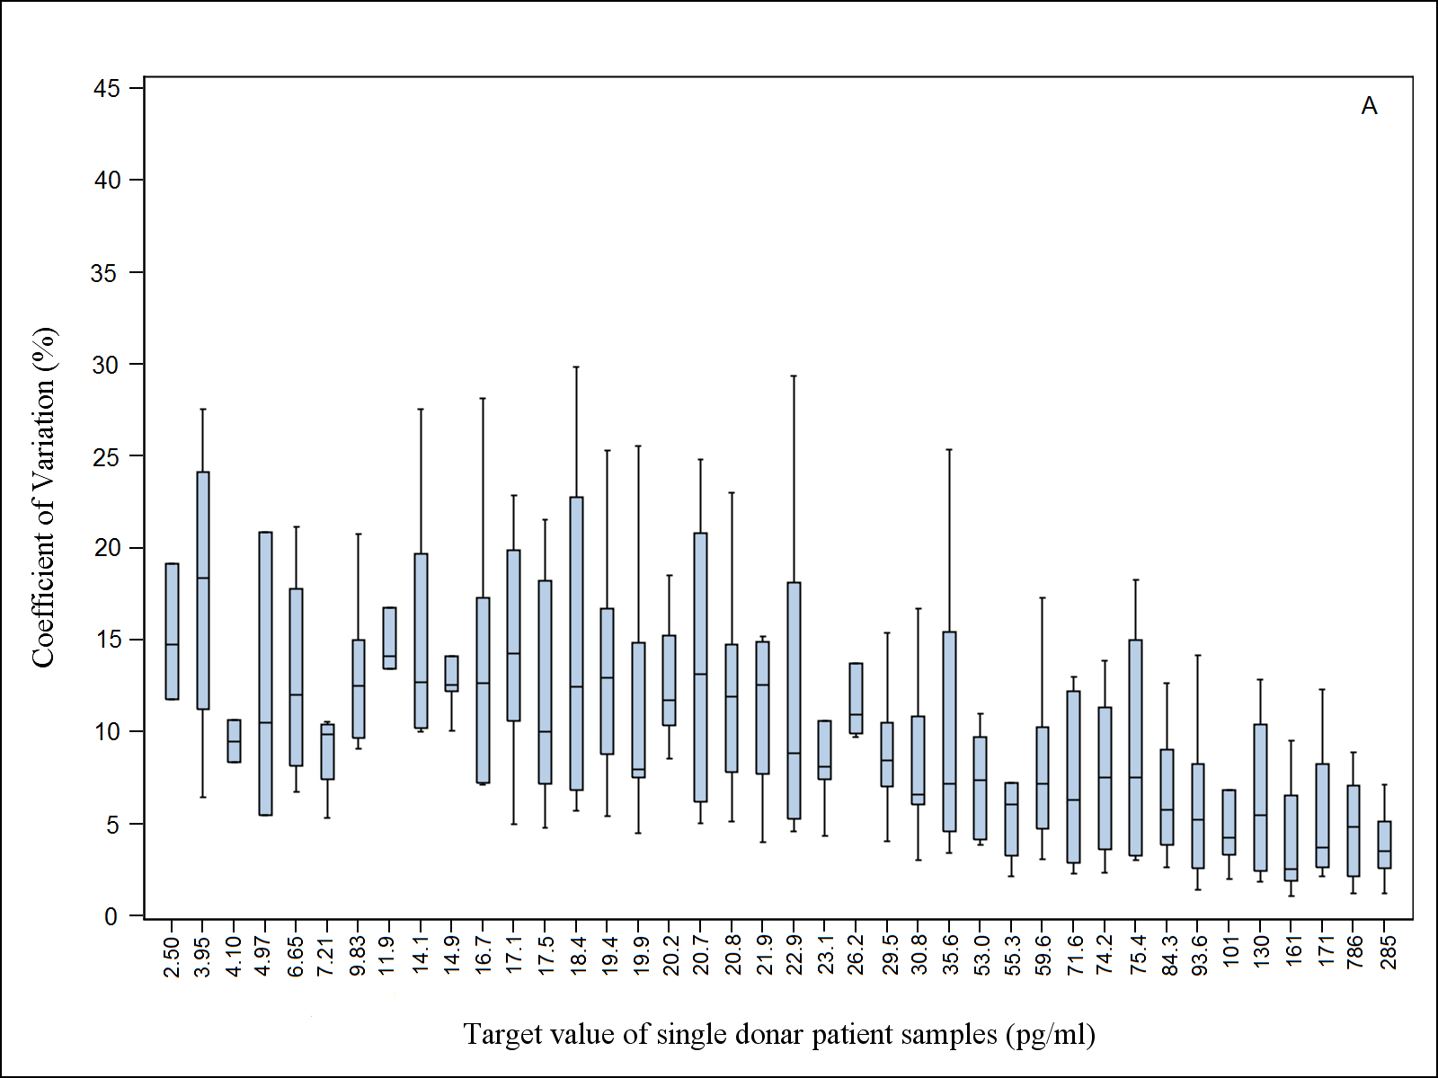
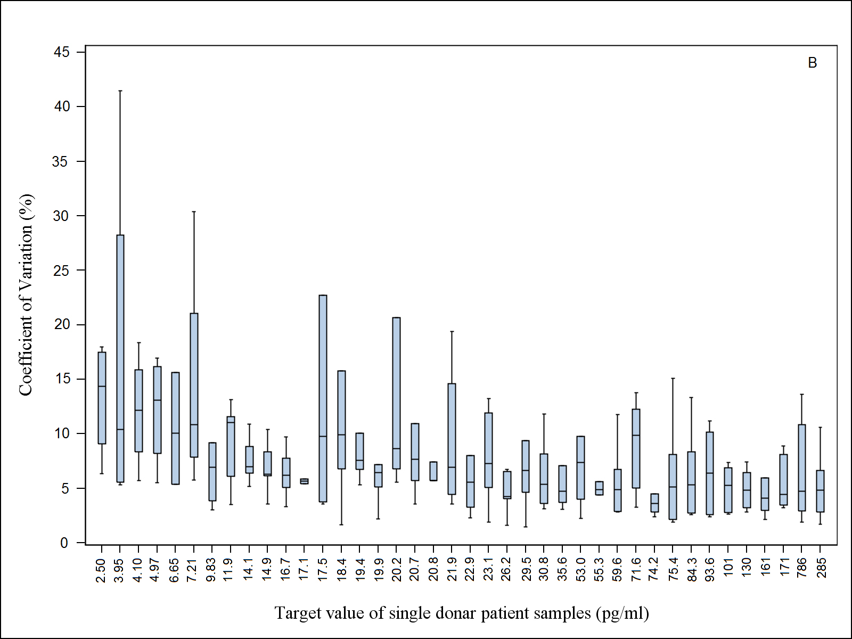

Supplemental Figure 2: Weighted regression (95%CI) and percent bias plots (95%CI) of results reported by individual assays against the reference values

Supplemental Table 1: Characteristics of patient sera
Sample ID | Gender | AGE | Target | Lab ID with this sample being outside the reportable range
1 | M | 45 | 19.9 | 1,7, 8, 11
2 | M | 38 | 17.5 | 1,7, 8, 11
3 | M | 56 | 14.1 | 1,7, 8, 11
4 | M | 54 | 22.9 | 1
5 | M | 52 | 14.9 | 1,7, 8, 11
6 | M | 53 | 19.4 | 1,7, 8, 11
7 | F | 66 | 9.83 | 1, 3, 4, 7, 8, 11, 15
8 | M | 77 | 18.4 | 1,7, 8, 11
9 | M | 69 | 20.7 | 1
10 | M | 26 | 20.2 | 1
11 | F | 44 | 29.5
12 | M | 74 | 16.7 | 1,7, 8, 11
13 | F | 30 | 35.6
14 | F | 58 | 3.95 | 1, 2, 3, 4, 5, 6, 7, 8, 9, 10, 11, 15, 17
15 | F | 21 | 161
16 | M | 64 | 30.8
17 | M | 32 | 20.8 | 1
18 | F | 40 | 84.3
19 | F | 31 | 74.2
20 | F | 41 | 101
21 | F | 37 | 171
22 | M | 54 | 26.2
23 | M | 41 | 17.1 | 1,7, 8, 11
24 | F | 40 | 186
25 | M | 47 | 11.9 | 1,7, 8, 11
26 | F | 37 | 21.9 | 1
27 | F | 57 | 75.4
28 | F | 33 | 130
29 | F | 76 | 2.5 | 1, 2, 3, 4, 5, 6, 7, 8, 9, 10, 11, 15, 17
30 | F | 74 | 4.1 | 1, 2, 3, 4, 5, 6, 7, 8, 9, 10, 11, 15, 17
31 | F | 35 | 53
32 | F | 59 | 4.97 | 1, 2, 3, 4, 6, 7, 8, 9, 10, 11, 15, 17
33 | F | 39 | 59.6
34 | F | 43 | 285
35 | F | 66 | 23.1 | 1
36 | F | 72 | 7.21 | 1, 3, 4, 7, 8, 11, 15, 17
37 | F | 28 | 6.65 | 1, 3, 4, 6, 7, 8, 11, 15, 17
38 | F | 26 | 93.6
39 | F | 40 | 55.3
40 | F | 52 | 71.6

Supplemental Table 2: Reported interquartile ranges of different study populations
Study (Reference) | Cohort | Number of patients | Interquartile Range (pg/mL) |  | Width of quartile (pg/mL)
Columbia, MO, USA (1) | Case | 71 | 10.00 | 22.99 | 4.33
 | Control | 133 | 8.01 | 24.00 | 5.33
Guernsey, UK (2) | Case | 61 | 9.45 | 15.53 | 2.02
 | Control | 178 | 7.90 | 12.80 | 1.63
NHS, USA (3) | Case | 155 | 5.01 | 12.01 | 2.33
 | Control | 310 | 5.01 | 11.00 | 2.00
ORDET, Italy (4) | Case | 67 | 4.25 | 8.17 | 1.31
 | Control | 264 | 4.30 | 8.25 | 1.32
Rancho Bernardo, USA (5) | Case | 31 | 7.00 | 15.99 | 3.00
 | Control | 287 | 8.01 | 17.00 | 3.00
RERF, Japan (6) | Case | 23 | 13.46 | 24.00 | 3.51
 | Control | 45 | 11.41 | 25.88 | 4.82
SOF, USA (7) | Case | 97 | 5.01 | 11.00 | 2.00
 | Control | 243 | 5.01 | 8.01 | 1.00
Washington County, USA (8) | Case | 29 | 11.00 | 21.00 | 3.33
 | Control | 58 | 8.01 | 21.00 | 4.33
Melbourne Collaborative Cohort Study (9) | Case | 197 | 12.5 | 20.2 | 2.57
 | Control | 857 | 12.4 | 19.3 | 2.30

References to Supplemental Table 2:
[1] Dorgan JF, Longcope C, Stephenson HE Jr, Falk RT, Miller R, Franz C, et al. Relation of prediagnostic serum estrogen and androgen levels to breast cancer risk. Cancer Epidemiol Biomarkers Prev. 1996;5(7):533-9.
[2] Thomas HV, Key TJ, Allen DS, Moore JW, Dowsett M, Fentiman IS, et al. A prospective study of endogenous serum hormone concentrations and breast cancer risk in post-menopausal women on the island of Guernsey. Br J Cancer. 1997;76:401-5.
[3] Hankinson SE, Willett WC, Manson JE, Colditz GA, Hunter DJ, Spiegelman D, et al. Plasma sex steroid hormone levels and risk of breast cancer in postmenopausal women. J Natl Cancer Inst. 1998:90;1292-9.
[4] Berrino F, Muti P, Micheli A, Bolelli G, Krogh V, Sciajno R, et al. Serum sex hormone levels after menopause and subsequent breast cancer. J Natl Cancer Inst. 1996:88;291-6.
[5] Garland CF, Friedlander NJ, Barrett-Connor E, Khaw KT. Sex hormones and postmenopausal breast cancer: A prospective study in an adult community. Am J Epidemiol. 1992:135;1220-30.
[6] Kabuto M, Akiba S, Stevens RG, Neriishi K, Land CE. A prospective study of estradiol and breast cancer in Japanese women. Cancer Epidemiol Biomarkers Prev. 2000:9(6);575-9.
[7] Cauley JA, Lucas FL, Kuller LH, Stone K, Browner W, Cummings SR. Elevated serum estradiol and testosterone concentrations are associated with a high risk for breast cancer. Ann Intern Med. 1999:130:270-7.
[8] Helzlsouer KJ, Alberg AJ, Bush TL, Longcope C, Gordon GB, Comstock GW. A prospective study of endogenous hormones and breast cancer. Cancer Detect Prev. 1994;18:79-85.
[9] Baglietto L, Severi G, English DR, Krishnan K, Hopper JL, McLean C, et al. Circulating steroid hormone levels and risk of breast cancer for postmenopausal women. Cancer Epidemiol Biomarkers Prev. 2010:19(2);492-502.

Supplemental Table 3: Evaluation of Study Participants Using Proposed Evaluation Criteria
Lab ID# | # Samples Reported (Outliers Removed) | # Samples Meeting Proposed Evaluation Criteria* | Percentage of Reported Samples Meeting Proposed Evaluation Criteria (%)
1 | 31 | 11 | 35
2 | 39 | 18 | 46
3 | 36 | 19 | 53
4 | 33 | 17 | 52
5 | 40 | 20 | 50
6 | 40 | 9 | 23
7 | 32 | 18 | 56
8 | 40 | 4 | 10
9 | 40 | 0 | 0
10 | 40 | 0 | 0
11 | 30 | 13 | 43
12 | 40 | 31 | 78
13 | 40 | 29 | 73
14 | 40 | 38 | 95
15 | 34 | 30 | 88
16 | 40 | 37 | 93
17 | 35 | 11 | 31
*Evaluation Criteria: Samples with target concentrations >20 pg/mL, a bias of +12.5 % and at concentrations <20 pg/mL a maximum allowable bias of +2.5 pg/mL is met

Description of assumptions and calculations performed to assess contribution of individual components on the overall variability of an assay

Calibration bias affects all measurements to the same extent in a predictable manner resulting in a parallel shift and/or a change in slope of the relationship between the reference value and the measured value. It can be expressed as the difference between predicted values and the corresponding target values. As a weighted sum of squares the calibration bias is computed as:
Calibration bias = Σ(sample wt_{i})(sample_{i} predicted value - sample_{i} target value)²/Σ(sample wt_{i})
= $\frac{\sum_{i=1}^{n}{\left({Wt}_{i}\right) {({\overbrace{Y}}_{i}- x_{i})}^{2}}}{\sum_{i=1}^{n}{{Wt}_{i}}}$

The imprecision is the variability of the individual sample measurements around their mean value. This parameter is assumed to represent normally distributed random error. As a weighted sum of squares the imprecision is computed as:
Imprecision = Σ_{i}[sample wt_{i} Σ_{j}(sample_{ij} replicate value - sample_{i} mean value)²/]/Σ_{ij}(sample wt_{i})
= $\frac{\sum_{i=1}^{n}{\left({Wt}_{i}\right) }{\sum_{j=1}^{k_{i}}{ }(Y_{ij}-{\overline{Y}}_{i})}^{2}}{\sum_{i=1}^{n}{\sum_{j=1}^{k_{i}}{{Wt}_{i}}}}$
Non-specificity/specimen effects can be described as a parameter that corresponds to all measurements performed on a sample to the same extent, but is different across samples. Non-specificity results in scatter of individual sample mean values around the predicted values. It can be expressed as the difference of the sample means from their predicted values obtained from the regression equation. As a weighted sum of squares the specimen effect is computed as:
Specimen Effect = Σ(sample wt_{i})(sample_{i} predicted value - sample_{i} mean value)²/Σ(sample wt_{i})
= $\frac{\sum_{i=1}^{n}{\left({Wt}_{i}\right) {({\overbrace{Y}}_{i}- {\overline{Y}}_{i})}^{2}}}{\sum_{i=1}^{n}{{Wt}_{i}}}$

The overall variability comprises calibration bias, imprecision and specimen effect. It can be expressed as the sum of the weighted sums of squares of the various sources of error (calibration bias, specificity/matrix effects, and imprecision), after using a weighted regression to model the relationship between the results reported for each sample and the reference values assigned by the RMP.

Overall Variability = Calibration bias + Imprecision + Specimen Effect

= $\frac{\sum_{i=1}^{n}{\left({Wt}_{i}\right) {({\overbrace{Y}}_{i}- x_{i})}^{2}}}{\sum_{i=1}^{n}{{Wt}_{i}}}$ + $\frac{\sum_{i=1}^{n}{\left({Wt}_{i}\right) }{\sum_{j=1}^{k_{i}}{ }(Y_{ij}-{\overline{Y}}_{i})}^{2}}{\sum_{i=1}^{n}{\sum_{j=1}^{k_{i}}{{Wt}_{i}}}}+\frac{\sum_{i=1}^{n}{\left({Wt}_{i}\right) {({\overbrace{Y}}_{i}- {\overline{Y}}_{i})}^{2}}}{\sum_{i=1}^{n}{{Wt}_{i}}}$

