Supplemental Figure 1. Dose-response association between urinary antimony and LTL (natural log-transformed) in (a) all adult participants; (b) adults aged 20-39 years; (c) adults aged 40-59 years; and (d) adults aged 60-85 years of NHANES 1999-2002. Y-axis represents the difference in LTL (natural log-transformed) between individuals with any value of antimony compared with individuals with 0.04 ng/mL of urinary antimony; the red dashed line represents zero for the Y-axis (i.e., where there is no difference in LTL). The black dashed lines represent the 95% confidence of interval. Knots (placed at 5th, 35th, 65th and 95th percentile) are represented by dots (red). Models adjusted for urinary creatinine (natural log-transformed), sex, age (years, continuous), age squared, education (less than high-school, high school graduate, some college and above), race/ethnicity (non-Hispanic white, non-Hispanic black, Mexican American, other), alcohol consumption, self-reported smoking status (current, former, or never smoker), serum cotinine (natural log-transformed), body weight status (underweight/normal, overweight, obese), and urinary lead (natural log-transformed).
- 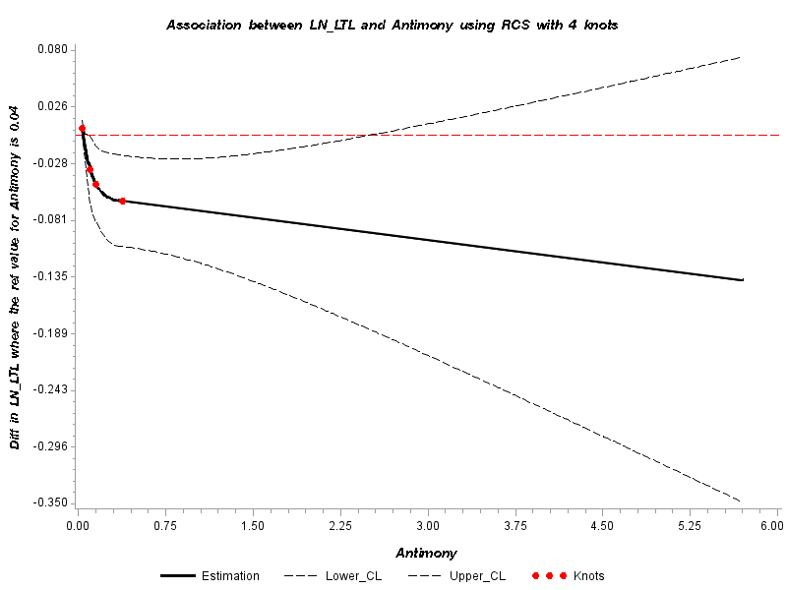 | - 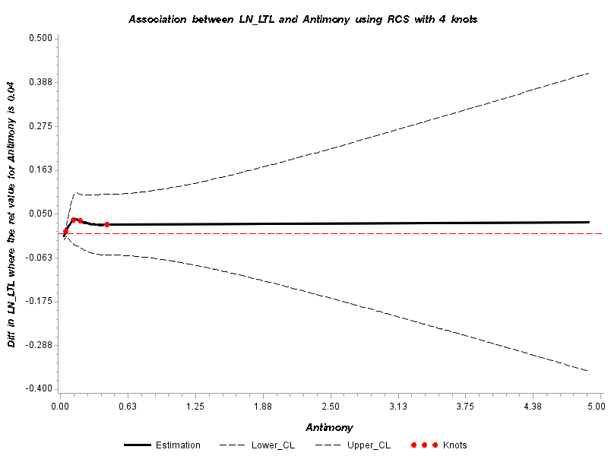
- 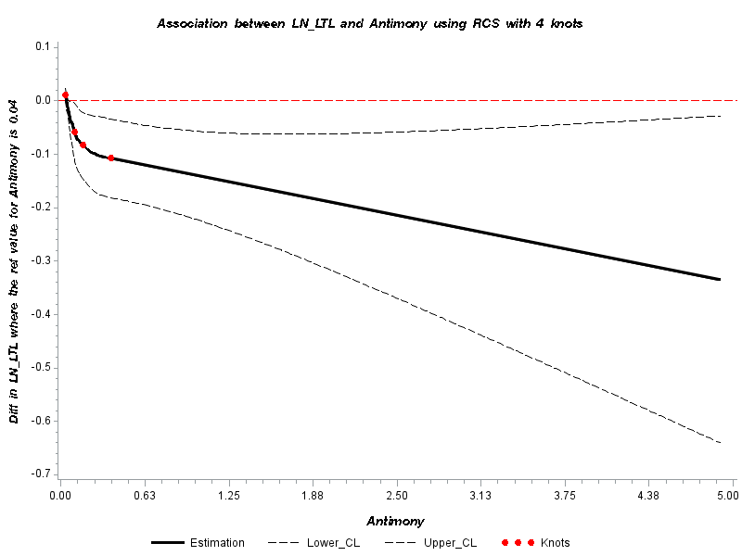 | - 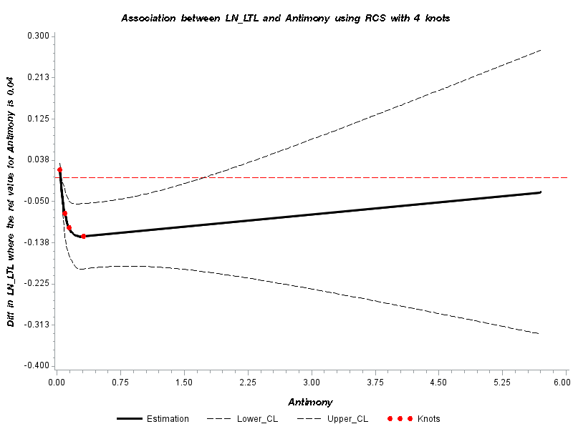

Supplemental Figure 2. Dose-response association between creatinine-adjusted antimony (antimony-cr) and LTL (natural log-transformed) (a) all adult participants; (b) adults aged 20-39 years; (c) adults aged 40-59 years; and (d) adults aged 60-85 years of NHANES 1999-2002. Y-axis represents the difference in LTL (natural log-transformed) between individuals with any value of creatinine adjusted-antimony compared with individuals with 0.02 μg/g of creatinine adjusted-antimony; the red dashed line represents zero for the Y-axis (i.e., where there is no difference in LTL). The black dashed lines represent the 95% confidence of interval. Knots (placed at 5th, 35th, 65th and 95th percentile) are represented by dots (red). The red dashed line represents zero for the Y-axis (i.e., where there is no difference in LTL). Models adjusted for sex, age (years, continuous), age squared, education (less than high-school, high school graduate, some college and above), race/ethnicity (non-Hispanic white, non-Hispanic black, Mexican American, other), alcohol consumption, self-reported smoking status (current, former, or never smoker), serum cotinine (natural log-transformed), body weight status (underweight/normal, overweight, obese), and urinary lead (natural log-transformed).
-    