**Appendix:**

**Table S1. Estimated monthly percent change (MPC) in HBV DNA viral load and APRI over time using a jointly-modeled bivariate linear mixed model .**

|  |  |  |  |  |
| --- | --- | --- | --- | --- |
| **Bivariate linear mixed model** | | | | |
|  | **Viral load (IU/ML)** | | **APRI** | |
| **MPC (95% CI)** | **p** | **MPC (95% CI)** | **p** |
| **Treated** | | | | |
| <5 months | -32.4% (-44.1%, -18.4%) | <.001 | -5.6% (-9.3%, -1.7%) | 0.006 |
| 5­–28 months | -1.7% (-2.9%, -0.6%) | 0.003 | -1.0% (-1.3%, -0.6%) | <.001 |
| >28 months | -1.4% (-2.6%, -0.3%) | 0.014 | -0.3% (-0.6%, 0.1%) | 0.124 |
| **Untreated** | | | | |
| < 5 months | 7.1% (-24.8%, 52.4%) | 0.704 | -3.3% (-8.9%, 2.6%) | 0.271 |
| 5–28 months | -3.2% (-5.0%, -1.4%) | <.001 | -0.6% (-1.0%, -0.1%) | 0.012 |
| >28 months | -1.1% (-2.7%, 0.5%) | 0.169 | 1.2% (0.8%, 1.5%) | <.001 |

**Table S2. Accuracy of the FIB4 in predicting cirrhosis or non-advanced cirrhosis in treated patients based on optimal cut-offs.**

|  |  |  |  |  |
| --- | --- | --- | --- | --- |
| **FIB4** | **Biopsy results** | | | |
| **F0–F2** | **F3** | **F4** | **Accuracy (%)** |
| **≤1.58** | 16 | 2 | 1 | 84.2% |
| **1.58≤5.17** | 6 | 3 | 10 |  |
| **>5.17** | 1 | 0 | 6 | 85.7% |



**Figure S2. Individual patient trajectories and predicted mean trajectory of FIB4 and APRI over time in “never immunologically active” untreated patients (—: predicted mean trajectory; shaded area: 95% confidence band; - - - : 1.58 cut off for non-advanced fibrosis).**

1. **FIB4 B. APRI**

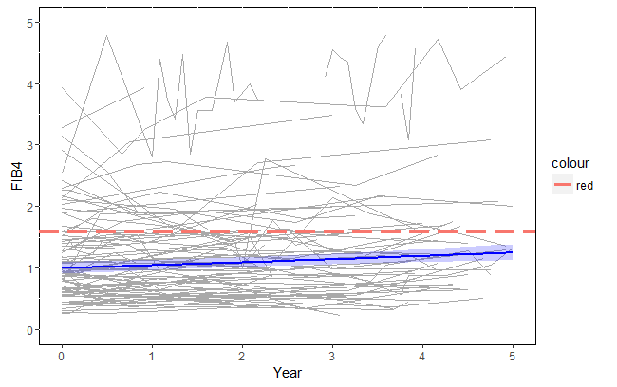 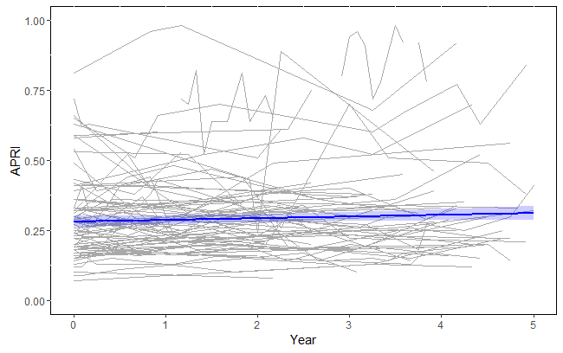

1.58 cut off for non-advanced fibrosis

Monthly increase=0.17% (p=0.076)

Monthly increase=0.38% (p=0.0015)

**Figure S3. Receiver Operating Characteristic Curves (ROC) for FIB4 and APRI predicting advanced fibrosis (F3-4) or cirrhosis (F4) in HBV patients after treatment initiation (n=45).**

1. **Advanced fibrosis (F3-4 vs. F0-2) B. Cirrhosis (F4 vs. F0-3)**

|  |  |  |  |  |
| --- | --- | --- | --- | --- |
| ROC Model | Mann-Whitney | | | |
| **Area** | **Standard Error** | **95% Wald Confidence Limits** | |
| FIB4 | 0.8360 | 0.0632 | 0.7121 | 0.9598 |
| APRI | 0.7609 | 0.0712 | 0.6212 | 0.9005 |

|  |  |  |  |  |
| --- | --- | --- | --- | --- |
| ROC Model | Mann-Whitney | | | |
| **Area** | **Standard Error** | **95% Wald Confidence Limits** | |
| FIB4 | 0.8634 | 0.0527 | 0.7602 | 0.9667 |
| APRI | 0.7983 | 0.0699 | 0.6612 | 0.9354 |

