Appendix 1
Critical Congenital Heart Disease Newborn Screening Resources

- Advisory Committee on Heritable Disorders in Newborns and Children: http://www.hrsa.gov/advisorycommittees/mchbadvisory/heritabledisorders/index.html
- Newborn Screening Technical assistance and Evaluation Program: (NewSTEPs): https://www.newsteps.org/cchd
- American Academy of Pediatrics (AAP): www.aap.org
- AAP online learning center: PediaLink: http://pedialink.aap.org
- Centers for Disease Control and Prevention (CDC): www.cdc.gov/ncbddd/heartdefects/screening.html
- Children’s National Medical Center: http://childrensnational.org/pulseox/
- Virginia Department of Health and University of Virginia: www.newbornscreeningeducation.org
- Wisconsin Screening Hearts In NEwborns (SHINE) Project: www.wisconsinshine.org

Appendix 2

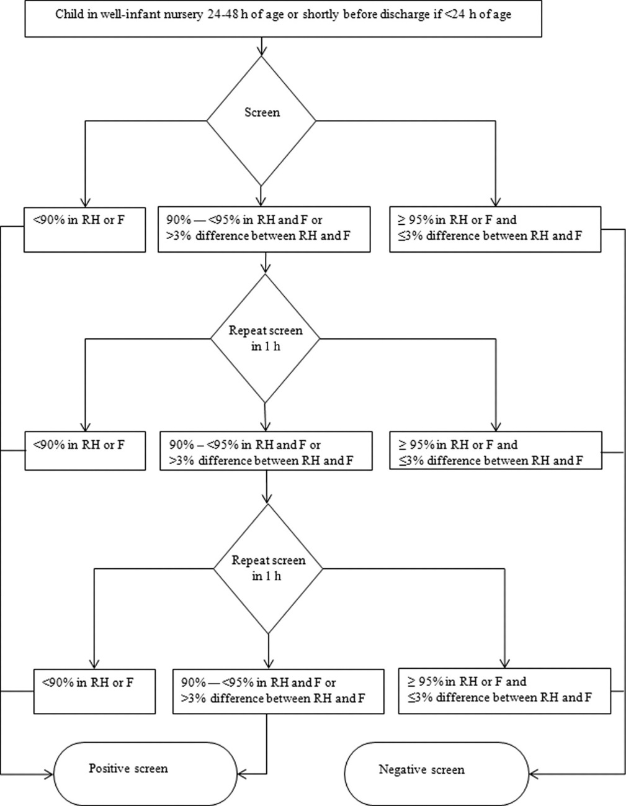
Alex R. Kemper et al. Pediatrics 2011;128:e1259-e1267
The proposed pulse-oximetry monitoring protocol based on results
from the right hand (RH) and either foot (F).

