Suppl Figure A – Follow-Up Rates Across Time
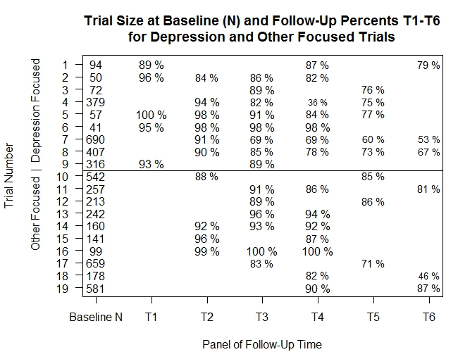
Footnote:
Trial 18 is missing 49 participants at baseline.

