Table S1. Demographic, alcohol use, and network characteristics of the Full, Stringent, and Inclusive samples for the simulation study
 | No missing | 10% missing |  |  | 25% missing
Characteristic | Full Sample | Full Samples (avg.)ª | Stringent Samples (avg.) ª | Inclusive Samples (avg.) ª | Full Samples (avg.) ª | Stringent Samples (avg.) ª | Inclusive Samples (avg.) ª
N | 160 | 160.0 (0.0) | 116.6 (1.6) | 129.6 (0.6) | 160.0 (0.0) | 68.2 (2.3) | 90.0 (1.5)
% male | 52.5 | 52.5 (0.0) | 51.9 (0.0) | 52.0 (0.0) | 52.3 (0.0) | 53.9 (0.0) | 53.6 (0.0)
M (SD) pocket money per month
W1 | 8.0 | 7.8 (0.3) | 7.8 (0.3) | 7.8 (0.3) | 7.9 (0.7) | 7.9 (0.7) | 7.9 (0.7)
W2 | 9.8 | 9.8 (0.5) | 9.8 (0.5) | 9.8 (0.5) | 10.1 (0.7) | 10.1 (0.7) | 10.1 (0.7)
M (SD) alcohol use
W1 | 2.8 | 2.8 (0.1) | 2.8 (0.1) | 2.8 (0.1) | 2.7 (0.1) | 2.7 (0.1) | 2.7 (0.1)
W2 | 3.0 | 3.0 (0.1) | 3.0 (0.1) | 3.0 (0.1) | 3.1 (0.1) | 3.1 (0.1) | 3.1 (0.1)
W3 | 3.3 | 3.4 (0.1) | 3.4 (0.1) | 3.4 (0.1) | 3.4 (0.1) | 3.4 (0.1) | 3.4 (0.1)
M (SD) friend indegree
W1 | 3.7 | 3.3 (0.0) | 2.7 (0.2) | 2.8 (0.1) | 2.7 (0.1) | 1.6 (0.2) | 1.8 (0.1)
W2 | 3.3 | 2.9 (0.0) | 2.3 (0.2) | 2.6 (0.1) | 2.4 (0.1) | 1.4 (0.2) | 1.8 (0.1)
W3 | 3.1 | 2.8 (0.1) | 2.3 (0.2) | 2.4 (0.1) | 2.3 (0.1) | 1.3 (0.2) | 1.5 (0.1)
ªThe average value for the samples drawn from the 10 simulated data sets with missing.

Table S2. SABM results for the Full sample, Inclusive samples and Stringent samples for the simulation study: Effects on friendship dynamics and alcohol use dynamics
 | No missing |  | 10% missing |  |  |  |  |  | 25% missing
 | Full |  | Full |  | Stringent |  | Inclusive |  | Full |  | Stringent |  | Inclusive
PARAMETER | Est. | (SE) | Est.ª | (SE) ª | Est. ª | (SE) ª | Est. ª | (SE) ª | Est. ª | (SE) ª | Est. ª | (SE) ª | Est. ª | (SE) ª
Effects on Friendships
Rate period 1 | 13.80 | (1.16) | 12.54 | (1.19) | 9.02 | (1.02) | 10.39 | (1.16) | 11.30 | (1.90) | 4.60 | (1.00) | 6.60 | (1.10)
Rate period 2 | 10.17 | (0.95) | 9.75 | (0.90) | 7.04 | (0.83) | 8.14 | (0.88) | 8.30 | (1.40) | 3.40 | (0.80) | 5.00 | (0.80)
Structural effects
outdegree | -3.01 | (0.25) * | -3.15 | (0.29) * | -2.82 | (0.37)* | -2.87 | (0.32)* | -2.50 | (1.40) | -5.60 | (176.10) | -3.40 | (0.70)*
reciprocity | 2.32 | (0.11) * | 2.34 | (0.15) * | 2.50 | (0.16) * | 2.43 | (0.14) * | 2.60 | (0.90) | 3.40 | (1.20) | 2.90 | (0.30) *
transitive triplets | 0.65 | (0.05) * | 0.73 | (0.05) * | 0.85 | (0.08) * | 0.78 | (0.06) * | 0.80 | (0.40) | 1.30 | (0.60)* | 1.00 | (0.10) *
3-cycles | -0.48 | (0.08) * | -0.62 | (0.11) * | -0.62 | (0.14) * | -0.58 | (0.12) * | -0.60 | (0.70) | -0.90 | (0.70) | -0.70 | (0.30) *
indegree popularity (sqrt) | 0.03 | (0.06) | -0.06 | (0.08) | -0.04 | (0.11) | 0.00 | (0.09) | -0.40 | (0.70) | -0.20 | (0.60) | -0.10 | (0.20)
outdegree activity (sqrt) | -0.27 | (0.06) * | -0.14 | (0.06) * | -0.42 | (0.11)* | -0.39 | (0.09) * | -0.10 | (0.20) | -0.60 | (0.50) | -0.40 | (0.20)
Covariates
male alter | 0.10 | (0.10) | 0.08 | (0.12) | 0.13 | (0.15) | -0.10 | (0.09) | 0.10 | (0.20) | 0.30 | (0.40) | -0.10 | (0.20)
male ego | -0.02 | (0.11) | 0.02 | (0.13) | 0.02 | (0.16) | 0.07 | (0.10) | 0.00 | (0.20) | 0.10 | (0.80) | 0.00 | (0.20)
same male | 0.95 | (0.10) * | 0.98 | (0.11) * | 0.97 | (0.13) * | 0.07 | (0.10) | 1.00 | (0.20)* | 1.30 | (0.50)* | 0.10 | (0.20)
money alter | 0.01 | (0.01) | 0.01 | (0.01) | 0.01 | (0.01) | 0.01 | (0.01) | 0.00 | (0.00) | 0.00 | (0.00) | 0.00 | (0.00)
money sq. alter | 0.00 | (0.00) * | 0.00 | (0.00) | 0.00 | (0.00) | 0.00 | (0.00) | 0.00 | (0.00) | 0.00 | (0.00) | 0.00 | (0.00)
money ego | 0.01 | (0.01) | 0.00 | (0.01) | 0.00 | (0.01) | 0.00 | (0.01) | 0.00 | (0.00) | 0.00 | (0.00) | 0.00 | (0.00)
money similarity | 1.32 | (0.26) * | 1.28 | (0.32)* | 1.21 | (0.39) * | 1.30 | (0.34) * | 1.40 | (0.50)* | 1.50 | (1.00) | 1.30 | (0.50) *
Alcohol use
alcohol alter | -0.06 | (0.06) | -0.05 | (0.08) | -0.09 | (0.10) | 0.88 | (0.52) | 0.20 | (0.80) | -1.00 | (145.90) | 1.50 | (1.30)
alcohol sq. alter | 0.04 | (0.08) | 0.00 | (0.10) | 0.04 | (0.10) | 0.13 | (0.13) | -0.50 | (1.30) | 0.10 | (0.40) | 0.10 | (0.20)
alcohol ego | 0.04 | (0.06) | 0.04 | (0.07) | 0.07 | (0.11) | 0.02 | (0.14) | 0.00 | (0.10) | 1.00 | (145.40) | 0.00 | (0.20)
alcohol similarity | 0.63 | (0.34) | 0.56 | (0.46) | 1.13 | (0.62) | 0.95 | (0.12) * | 0.50 | (1.20) | 8.90 | (593.90) | 1.10 | (0.20) *
Effects on Alcohol Use
Rate period 1 | 1.68 | (0.31) | 1.59 | (0.34) | 1.57 | (0.35) | 1.63 | (0.35) | 1.60 | (0.50) | 1.60 | (0.60) | 1.70 | (0.50)
Rate period 2 | 2.70 | (0.54) | 2.71 | (0.66) | 2.62 | (0.65) | 2.67 | (0.61) | 3.00 | (1.10) | 2.90 | (1.20) | 2.90 | (0.90)
linear shape | 0.44 | (0.15) * | 0.47 | (0.18) * | 0.50 | (0.19) * | 0.50 | (0.19) * | 0.40 | (0.20) | 0.50 | (0.30) | 0.40 | (0.20) *
quadratic shape | 0.00 | (0.11) | 0.03 | (0.13) | -0.06 | (0.11) | -0.04 | (0.11) | 0.00 | (0.20) | -0.20 | (0.20) | -0.20 | (0.10)
Covariates
male | N.S. |  | N.S. |  | N.S. |  | N.S. |  | N.S. |  | N.S. |  | N.S.
money | 0.02 | (0.02) | 0.02 | (0.02) | 0.03 | (0.02) | 0.02 | (0.02) | 0.00 | (0.00) | 0.00 | (0.00) | 0.00 | (0.00)
Network influence
average similarity | 6.79 | (2.43) * | 7.47 | (2.95)* | 6.18 | (2.64) * | 6.57 | (2.65) * | 5.30 | (3.40) | 4.10 | (3.60) | 3.90 | (2.40)
Est. = Unstandardized parameter estimate. SE = Standard error. N.S. = Not statistically significant; these effects were not included in the final model because they were found to be nonsignificant during the forward selection model specification.
*Effects that are significant at the p<.05 level.
ªAverage statistic of 10 models fit to the 10 different simulated data sets for this type of analytic sample.

Figure S1. Visualization of Standard Error deviations of the SABM parameter estimates for the Full samples, Stringent samples, and Inclusive samples with 10% and 25% missing data, relative to the SABM results for the Full Sample with no missing.
Note. The images show the original parameter estimates in black, centered at 0 with associated levels of statistical significance plotted via the point size (i.e., larger points correspond to smaller p-values). The colored (red, blue, and green) points show parameter estimates for each random draw in the simulation, centered around the original estimates with the size of points indicating p-values (i.e., larger points correspond to smaller p-values). The light bars indicate two standard errors (as estimated in the model without any missing values) on either side of the original parameter estimate to clearly show when new parameter estimates fall outside of this range. These bars also show relative differences in standard errors for the original model without missing values.

(a) Standard SABM fit to Full samples (n=10) with 10% missing data | (b) Standard SABM fit to Full samples (n=10) with 25% missing data
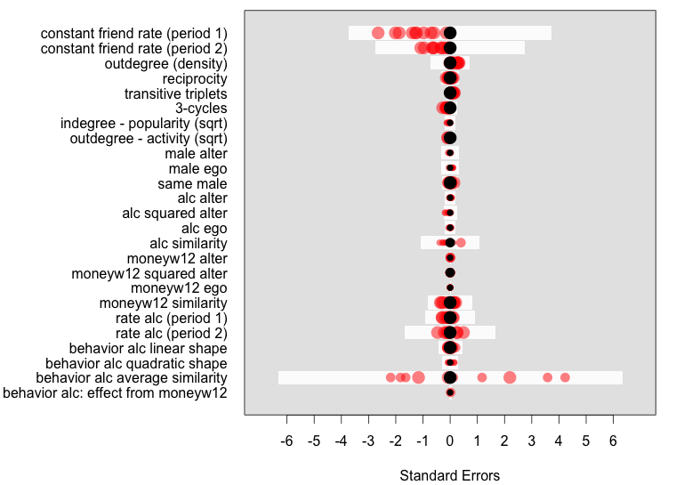 | 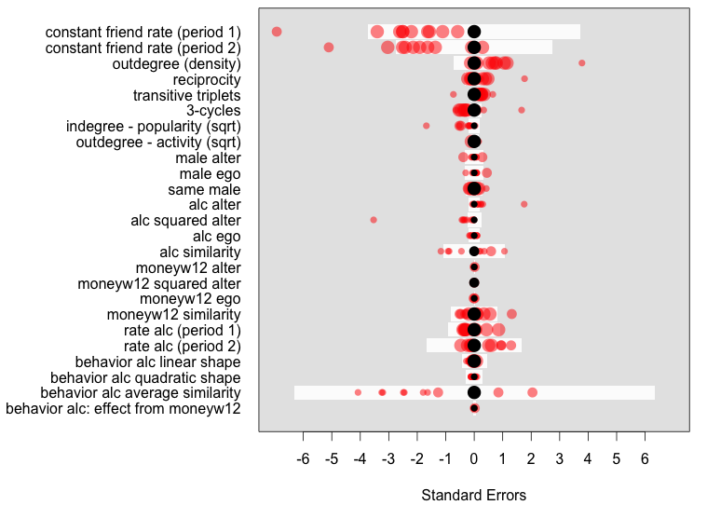

(c) Standard SABM fit to Stringent samples (n=10) derived from simulations with 10% missing data | (d) Standard SABM fit to Stringent samples (n=10) derived from simulations with 25% missing data
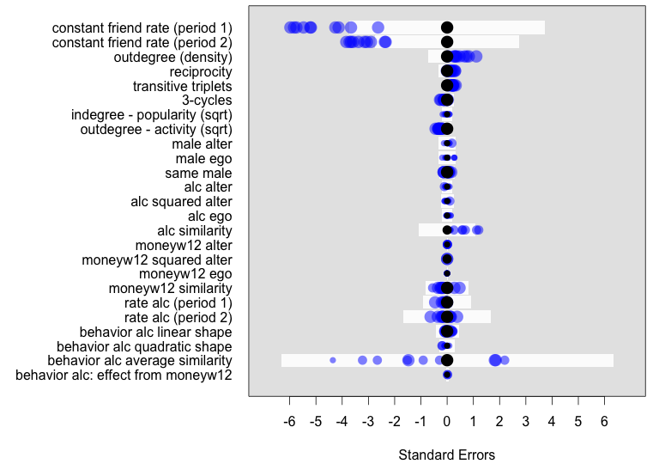 | 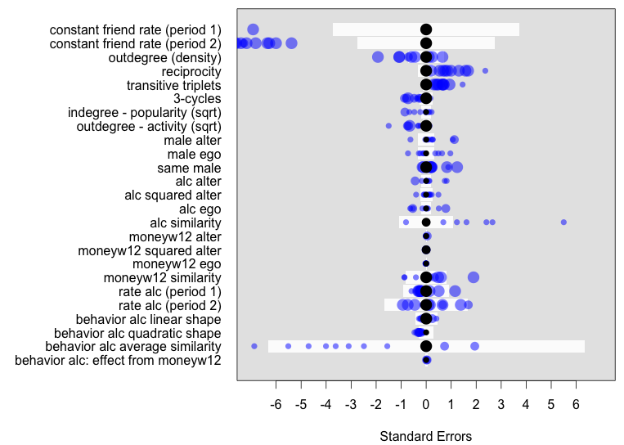
(e) Multi-group SABM fit to Inclusive samples (n=10) derived from simulations with 10% missing data | (e) Multi-group SABM fit to Inclusive samples (n=10) derived from simulations with 25% missing data
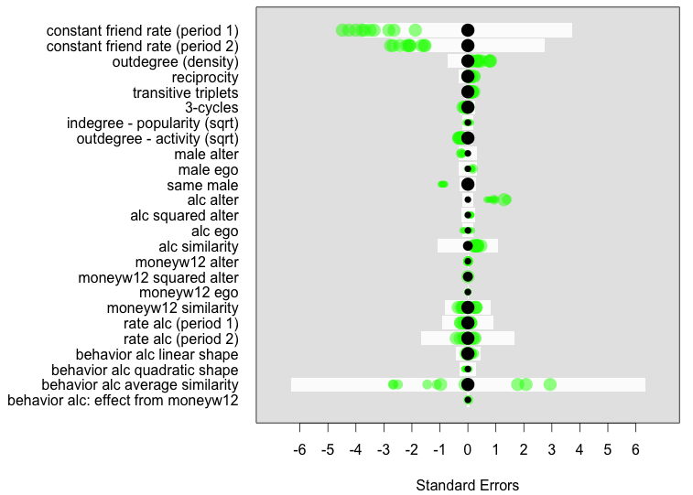 | 