Supplemental Table 1. Serum creatinine calibration in different NHANES survey periods

Years | Serum Creatinine Calibration Equation | Reference
1988-1994 | Standard Creatinine =  0.960*(measured creatinine) – 0.184 | http://www.cdc.gov/nchs/data/nhanes/nhanes_03_04/general_%20note_for_serum_creatinine.pdf*
1999-2000 | Standard Creatinine =  1.013*(measured creatinine) + 0.147 | https://wwwn.cdc.gov/ Nchs/Nhanes/1999-2000/LAB18.htm *
2001-2002 | None | https://wwwn.cdc.gov/ Nchs/Nhanes/2001-2002/L40_B.htm*
2003-2004 | None | https://wwwn.cdc.gov/ Nchs/Nhanes/2003-2004/L40_C.htm *
2005-2006 | Standard creatinine =  0.978*(measured creatinine) – 0.016 | http://www.cdc.gov /nchs/nhanes/nhanes2005-2006/BIOPRO_D.htm
2007-2008 | None | http://www.cdc.gov/ nchs/data/nhanes/nhanes_07_08/CRE_biopro_E_met_DXC800.pdf
2009-2010 | None | http://www.cdc.gov/ NCHS/data/nhanes/nhanes_09_10/BIOPRO_F_met_creatinine.pdf
2011-2012 | None | http://www.cdc.gov/ nchs/data/nhanes/nhanes_11_12/BIOPRO_G_met_creatinine.pdf
* see also Selvin E, Manzi J, Stevens LA, Van Lente F, Lacher DA, Levey AS, Coresh J: Calibration of serum creatinine in the National Health and Nutrition Examination Surveys (NHANES) 1988-1994, 1999-2004. Am J Kidney Dis 2007; 50 (6) 918-926.

Supplemental Table 2. Sampled number of NHANES participants with CKD stages 3-4 (eGFR 15-59 ml/min/1.73m² by CKD-EPI equation) in U.S. adults by demographic and diabetic categories, NHANES 1988-1994 through 2011-2012

Years
 | 1988-1994 | 1999-2000 | 2001-2002 | 2003-2004 | 2005-2006 | 2007-2008 | 2009-2010 | 2011-2012
Total | 1089 | 351 | 436 | 483 | 401 | 477 | 488 | 404
Age
20-39 years | 9 | 5 | 4 | 2 | 3 | 3 | 2 | 5
40-64 years | 115 | 35 | 59 | 54 | 59 | 78 | 78 | 78
65-79 years | 491 | 160 | 180 | 203 | 167 | 238 | 223 | 178
≥80 years | 474 | 151 | 193 | 224 | 172 | 158 | 185 | 143
Sex
Male | 517 | 164 | 210 | 215 | 205 | 209 | 231 | 194
Female | 572 | 187 | 226 | 268 | 196 | 268 | 257 | 210
Race/ethnicity
Non-Hispanic white | 762 | 210 | 323 | 339 | 290 | 315 | 318 | 210
Non-Hispanic black | 202 | 72 | 64 | 58 | 74 | 84 | 85 | 107
Other race/ethnicity | 125 | 69 | 49 | 86 | 37 | 78 | 85 | 87
Diabetes status
With diabetes mellitus | 278 | 92 | 104 | 140 | 121 | 159 | 186 | 162
Without diabetes mellitus | 811 | 259 | 332 | 343 | 280 | 318 | 302 | 242

CKD=chronic kidney disease
CKD-EPI = Chronic Kidney Disease-Epidemiology Collaboration
eGFR = estimated glomerular filtration rate
NHANES = National Health and Nutritional Examination Survey

Supplemental Table 3. Sampled number of NHANES participants with (by CKD-EPI equation) with expanded definition which includes albuminuria ≥30 mg/g regardless of eGFR level in U.S. adults by demographic and diabetic categories, NHANES 1988-1994 through 2011-2012

Years
 | 1988-1994 | 1999-2000 | 2001-2002 | 2003-2004 | 2005-2006 | 2007-2008 | 2009-2010 | 2011-2012
Total | 2517 | 748 | 866 | 867 | 799 | 1015 | 936 | 861
Age
20-39 years | 367 | 89 | 104 | 76 | 112 | 105 | 102 | 113
40-64 years | 658 | 192 | 238 | 203 | 226 | 328 | 272 | 293
65-79 years | 867 | 280 | 286 | 319 | 245 | 374 | 337 | 268
≥80 years | 625 | 187 | 238 | 269 | 216 | 208 | 225 | 187
Sex
Male | 1120 | 345 | 409 | 413 | 384 | 466 | 447 | 419
Female | 1397 | 403 | 457 | 454 | 415 | 549 | 489 | 442
Race/ethnicity
Non-Hispanic white | 1264 | 356 | 511 | 508 | 446 | 541 | 495 | 352
Non-Hispanic black | 643 | 155 | 158 | 142 | 182 | 201 | 170 | 250
Other race/ethnicity | 610 | 237 | 197 | 217 | 171 | 273 | 271 | 259
Diabetes status
With diabetes mellitus | 725 | 218 | 246 | 265 | 251 | 363 | 348 | 317
Without diabetes mellitus | 1792 | 530 | 620 | 602 | 548 | 652 | 588 | 544

Supplemental Table 4. Prevalence (percentage) of CKD stages 3-4 (eGFR 15-59 ml/min/1.73m² by MDRD equation) in U.S. adults by demographic and diabetic categories, NHANES 1988-1994 through 2011-2012; CI is 95% confidence interval of prevalence (as percentage) are shown in parentheses; N represents the population number in 100,000's (number of significant digits varies by number of sampled NHANES participants in each cell)

Years
 | 1988-1994 | 1999-2000 | 2001-2002 | 2003-2004 | 2005-2006 | 2007-2008 | 2009-2010 | 2011-2012
Total Population | 5.6%  (5.1-6.2%)  N = 94.44 | 7.0%  (5.9-8.1%)  N = 125 | 8.1%  (6.8-9.4%)  N = 153 | 7.8%  (6.6-9.1%)  N = 152 | 8.1%  (6.3-9.9%)  N = 159 | 8.3%  (6.7-9.9%)  N = 167 | 7.8%  (6.8-8.9%)  N = 162 | 8.4%  (7.0-9.8%)  N = 177
Age
20-39 years * | 0.3%  (0.1-0.4%) | 1.2%  (0.6-1.8%) | 0.6%  (0.1-1.1%) | 0.3%  (0.0-0.7%) | 0.2%  (0.0-0.5%) | 0.7%  (0.0-1.5%) | 0.7%  (0.1-1.3%) | 1.1%  (0.3-1.9%)
40-64 years | 4.0%  (3.3-4.8%) | 5.1%  (3.7-6.5%) | 6.3%  (3.7-8.9%) | 4.8%  (3.2-6.4%) | 5.7%  (3.8-7.5%) | 5.5%  (3.4-7.7%) | 4.8%  (3.8-5.7%) | 6.0%  (4.5-7.6%)
65-79 years | 20.2%  (17.9-22.6%) | 22.8%  (19.1-26.6%) | 25.3%  (22.1-28.5%) | 26.1%  (21.9-30.3%) | 24.8%  (21.4-28.3%) | 27.4%  (22.8-31.9%) | 25.0%  (22.8-27.2%) | 23.5%  (19.6-27.4%)
≥80 years | 38.4%  (34.5-42.3%) | 49.9%  (39.8-59.9%) | 59.2%  (51.8-66.6%) | 55.3%  (50.4-60.1%) | 52.0%  (45.8-58.3%) | 47.1%  (39.8-54.5%) | 48.7%  (44.4-53.1%) | 49.8%  (42.7-57.0%)
Sex
Male | 4.3%  (3.6-4.9%) | 5.4%  (4.5-6.3%) | 6.7%  (5.3-8.2%) | 6.2%  (5.3-7.1%) | 6.2%  (4.7-7.8%) | 6.7%  (4.8-8.6%) | 6.1%  (4.9-7.3%) | 6.8%  (5.3-8.3%)
Female | 6.9%  (6.0-7.8%) | 8.4%  (6.7-10.2%) | 9.4%  (8.0-10.8%) | 9.4%  (7.7-11.1%) | 9.8%  (7.4-12.2%) | 9.7%  (7.8-11.6%) | 9.5%  (8.2-10.8%) | 9.9%  (8.2-11.6%)
Race/ethnicity
Non-Hispanic white | 6.4%  (5.6-7.1%) | 7.8%  (6.5-9.2%) | 9.8%  (8.4-11.3%) | 9.1%  (7.8-10.3%) | 9.7%  (7.7-11.6%) | 10.0%  (8.0-12.1%) | 9.3%  (8.1-10.5%) | 10.0%  (8.1-11.9%)
Non-Hispanic black | 3.6%  (3.1-4.2%) | 5.1%  (3.7-6.6%) | 5.1%  (3.6-6.6%) | 4.9%  (3.7-6.1%) | 5.0%  (3.4-6.6%) | 5.3%  (3.8-6.8%) | 6.3%  (5.0-7.7%) | 6.5%  (5.1-8.0%)
Other race/ethnicity | 2.8%  (1.4-4.1%) | 4.7%  (2.7-6.8%) | 2.9%  (1.0-4.8%) | 4.5%  (2.9-6.0%) | 3.2%  (1.6-4.7%) | 3.4%  (2.2-4.7%) | 3.8%  (2.8-4.8%) | 4.5%  (3.6-5.5%)
Diabetes status
With diabetes mellitus | 16.2%  (14.0-18.5%) | 16.3%  (12.9-19.6%) | 19.2%  (13.9-24.5%) | 21.9%  (17.0-26.8%) | 20.2%  (15.7-24.8%) | 18.3%  (14.6-22.1%) | 22.3%  (18.9-25.7%) | 20.2%  (16.9-23.5%)
Without diabetes mellitus | 4.8%  (4.3-5.3%) | 6.2%  (5.1-7.3%) | 7.1%  (5.7-8.5%) | 6.3%  (5.1-7.5%) | 6.8%  (4.9-8.7%) | 7.0%  (5.4-8.6%) | 6.1%  (5.2-6.9%) | 6.9%  (5.3-8.5%)
*estimates in this row have large relative standard error (RSE) and thus may be less reliable

Supplemental Table 5. Prevalence (percentage) of CKD (by MDRD equation) with expanded definition which includes albuminuria ≥30 mg/g regardless of eGFR level by demographic and diabetic categories, NHANES 1988-1994 through 2011-2012; 95% confidence interval of prevalence (as percentage) are shown in parentheses; N represents the population number in 100,000's (number of significant digits varies by number of sampled NHANES participants in each cell)

Years
 | 1988-1994 | 1999-2000 | 2001-2002 | 2003-2004 | 2005-2006 | 2007-2008 | 2009-2010 | 2011-2012
Total Population | 12.5%  (11.6-13.3%)  N = 209.2 | 14.6%  (13.0-16.2%)  N = 262 | 15.2%  (13.6-16.8%)  N = 286 | 14.7%  (13.0-16.4%)  N = 287 | 15.4%  (13.0-17.7%)  N = 303 | 15.9%  (14.2-17.5%)  N = 320.5 | 13.8%  (12.7-15.0%)  N = 286 | 15.6%  (13.8-17.4%)  N = 327
Age
20-39 | 5.0%  (4.3-5.8%) | 7.1%  (4.9-9.3%) | 5.5%  (3.9-7.1%) | 5.2%  (3.6-6.8%) | 6.2%  (5.2-7.1%) | 6.4%  ( 4.9-7.8%) | 5.3%  (4.2-6.3%) | 6.9%  (5.5-8.3%)
40-64 | 11.2%  (10.0-12.4%) | 12.8%  (10.8-14.8%) | 14.0%  (11.3-16.6%) | 11.6%  (9.6-13.6%) | 13.0%  (10.0-16.1%) | 12.8%  (10.7-15.0%) | 10.6%  (9.3-11.8%) | 12.8%  (10.5-15.2%)
65-79 | 31.3%  (28.1-34.4%) | 34.5%  (31.4-37.6%) | 37.4%  (33.0-41.9%) | 37.6%  (32.4-42.7%) | 34.1%  (30.5-37.7%) | 39.7%  (36.7-42.6%) | 34.2%  (30.9-37.5%) | 33.3%  (30.1-36.5%)
≥80 | 52.3%  (48.2-56.5%) | 65.5%  (58.1-73.0%) | 68.5%  (61.7-75.3%) | 66.4%  (62.3-70.6%) | 65.2%  (59.7-70.8%) | 60.8%  (51.1-70.5%) | 59.3%  (54.0-64.6%) | 64.2%  (57.3-71.1%)
Sex
Male | 10.0%  (8.7-11.3%) | 12.0%  (10.3-13.7%) | 13.5%  (11.7-15.4%) | 13.3%  (11.5-15.1%) | 12.4%  (9.7-15.0%) | 13.5%  (11.4-15.6%) | 11.9%  (10.8-13.0%) | 13.8%  (11.0-16.6%)
Female | 14.7%  (13.5-16.0%) | 17.0%  (14.9-19.1%) | 16.8%  (15.1-18.5%) | 16.1%  (14.1-18.1%) | 18.1%  (15.4-20.9%) | 18.1%  (16.1-20.1%) | 15.7%  (13.9-17.5%) | 17.2%  (15.3-19.1%)
Race/ethnicity
Non-Hispanic white | 12.6%  (11.4-13.8%) | 14.6%  (12.9-16.3%) | 16.1%  (14.5-17.8%) | 14.8%  (12.9-16.6%) | 15.8%  (13.1-18.4%) | 16.9%  (14.8-19.0%) | 14.6%  (13.2-15.9%) | 15.9%  (13.7-18.2%)
Non-Hispanic black | 13.6%  (12.7-14.6%) | 14.2%  (11.9-16.5%) | 14.9%  (11.9-17.9%) | 14.4%  (11.3-17.6%) | 15.3%  (12.6-18.1%) | 15.2%  (12.3-18.1%) | 14.3%  (11.9-16.6%) | 17.5%  (15.5-19.4%)
Other race/  ethnicities | 10.6%  (8.2-13.0%) | 14.8%  (11.7-17.9%) | 11.7%  ( 9.3-14.1%) | 14.7%  (11.6-17.9%) | 13.7%  (11.0-16.4%) | 12.4%  (10.3-14.5%) | 11.2%  (9.0-13.3%) | 13.5%  (10.9-16.2%)
Diabetes status
With diabetes mellitus | 39.3%  (36.1-42.4%) | 36.8%  (31.8-41.8%) | 44.2%  (38.7-49.7%) | 42.0%  (37.0-47.0%) | 40.0%  (33.7-46.3%) | 39.0%  (35.9-42.2%) | 37.3%  (32.4-42.2%) | 37.4%  (33.6-41.2%)
Without diabetes mellitus | 10.3%  (9.6-11.0%) | 12.8%  (11.2-14.4%) | 12.6%  (10.7-14.5%) | 11.8%  (9.8-13.7%) | 12.8%  (10.3-15.2%) | 12.9%  (11.2-14.7%) | 11.0%  (9.9-12.1%) | 12.8%  (11.1-14.4%)

Supplemental Table 6. Temporal trends in the U.S. population prevalence of chronic kidney disease derived from the National Health and Nutrition Examination Surveys from prior peer-reviewed publications (adapted from Hsu RK, Hsu CY. Am J Kidney Dis 2013; 62:214-6)
Study | CKD definition | Disease prevalence during time period |  |  | Change in prevalence per year | GFR estimating equation | Filtration marker calibration and alignment
 |  | 1976-1980 | 1988-1994 | 1999-2004
Hsu Annals 2004¹ | eGFRcr <60 | 2.0%ª | 2.5%ª |  | +1.7% per year^{b} | 4-variable MDRD Study Equation⁶ | For both time periods, Cleveland Clinic calibrated Cr = Cr - 0.23
Coresh JASN 2005² | CKD stages 1-4 (eGFRcr and ACR) |  | 8.8% | 9.4%  (1999-2000) | +0.8% per year | 4-variable MDRD Study Equation⁶ | 1988-1994: Cleveland Clinic calibrated Cr = Cr - 0.23;  1999-2000: Cleveland Clinic calibrated Cr = Cr + 0.13
 | eGFRcr <60 |  | 4.4% | 3.8%  (1999-2000) | -1.7% per year
Coresh JAMA 2007³ | CKD stages 1-4 (eGFRcr and ACR) |  | 10.0% | 13.1% | +2.6% per year^{b} | IDMS-traceable MDRD Study Equation⁷ | 1998-1994: standardized Cr = -0.184 + 0.960*Cr;  1999-2000: standardized Cr = 0.147+1.013*Cr;  2000-4:no calibration  Conservative trend analysis added 0.04mg/dl to 1988-1994 creatinine values
 | eGFRcr <60  (primary analysis) |  | 5.6% | 8.1% | +3.5% per year^{b}
 | eGFRcr <60  (conservative trend analysis) |  | data not shown | data not shown | +1.4% per year^{b}
Foley CJASN 2009⁴ | CKD stages 1-5 (eGFRcyc and ACR) |  | 15.1% | 14.9%  (1999-2002) | -0.1% per year | CKD-EPI cystatin C 2008⁸ | No calibration performed for cystatin C.
 | eGFRcys <60 |  | 6.4% | 6.9%  (1999-2002) | +0.8% per year
Grams AJKD 2013⁵ | eGFRcys <60 |  | 5.5% | 8.7%  (1999-2002) | +4.9% per year^{b} | CKD-EPI Cystatin C 2012⁹ | 1988-1994: standardized cystatin C = 1.12*[0.022+0.80*(cystatin C)];  1999-2002: standardized cystatin C = 1.12*[cystatin C-0.12]
 | eGFRcr-cys <60 |  | 4.4% | 7.1%  (1999-2002) | +5.0% per year^{b} | CKD-EPI Cr-cystatin C 2012⁹
Abbeviations: eGFRcr, creatinine-based estimated glomerular filtration rate (ml/min/1.73m²); ACR, albumin-to-creatinine ratio; eGFRcys, cystatin
C-based estimated glomerular filtration rate (ml/min/1.73m²); eGFRcr-cys, creatinine and cystatin C-based estimated glomerular filtration rate (ml/min/1.73m²); MDRD, Modification of Diet in Renal Disease; IDMS, isotope dilution mass spectrometry; CKD-EPI, Chronic Kidney Disease Epidemiology Collaboration; Cr, creatinine (mg/dL)
ªfor age 20-74 blacks and whites only
^{b}represents statistically significant change in the original study
1. Hsu CY, Vittinghoff E, Lin F, Shlipak MG. The incidence of end-stage renal disease is increasing faster than the prevalence of chronic renal insufficiency. Ann Intern Med. 2004;141(2):95-101.
2. Coresh J, Byrd-Holt D, Astor BC, et al. Chronic kidney disease awareness, prevalence, and trends among US adults, 1999 to 2000. J Am Soc Nephrol. 2005;16(1):180-188.
3. Coresh J, Selvin E, Stevens L, et al. Prevalence of chronic kidney disease in the United States. JAMA. 2007;298(17):2038-2047.
4. Foley RN, Wang C, Snyder JJ, Collins AJ. Cystatin C levels in US adults, 1988-1994 versus 1999-2002: NHANES. Clin J Am Soc Nephrol. 2009;4(5):965-972.
5. Grams ME, Juraschek SP, Selvin E, et al. Trends in the prevalence of reduced GFR in the United States: a comparison of creatinine- and cystatin C-based estimates. Am J Kidney Dis. 2013;62(2):253-260.
6. Levey AS, Greene T, Kusek JW, Beck GJ. A simplified equation to predict glomerular filtration rate from serum creatinine [abstract]. J Am Soc Nephrol. 2000;11:155A.
7. Levey AS, Coresh J, Greene T, et al. Using standardized serum creatinine values in the Modification of Diet in Renal Disease Study equation for estimating glomerular filtration rate. Ann Intern Med. 2006;145(4):247-254.
8. Stevens LA, Coresh J, Schmid CH, et al. Estimating GFR using serum cystatin C alone and in combination with serum creatinine: a pooled analysis of 3,418 individuals with CKD. Am J Kidney Dis. 2008;51(3):395-406.
9. Inker LA, Schmid CH, Tighiouart H, et al. Estimating glomerular filtration rate from serum creatinine and cystatin C. N Engl J Med. 2012;367(1):20-29.

Supplemental Figure 1. Adjusted prevalence (as percentage) of CKD (by CKD-EPI equation) with expanded definition which includes albuminuria ≥30 mg/g regardless of eGFR level by age (1A), sex (1B), race/ethnicity (1C), and presence or absence of diabetes mellitus (1D), National Health and Nutritional Examination Survey (NHANES) 1988-1994 through 2011-2012
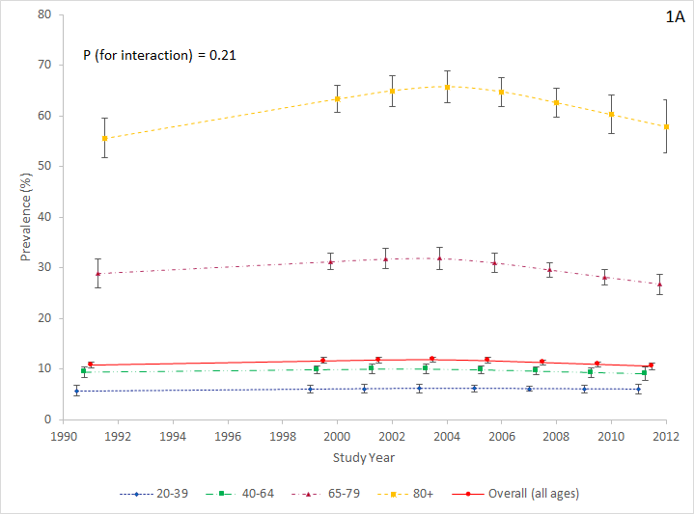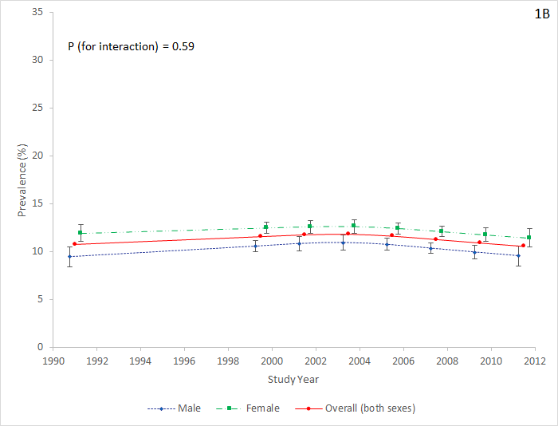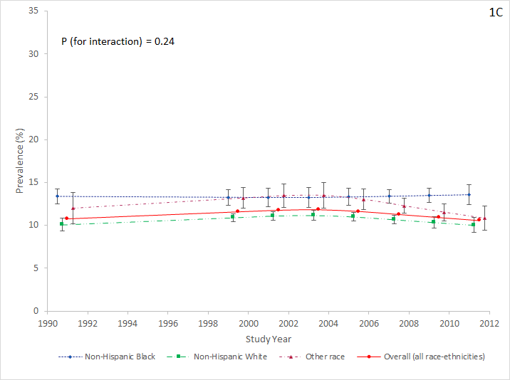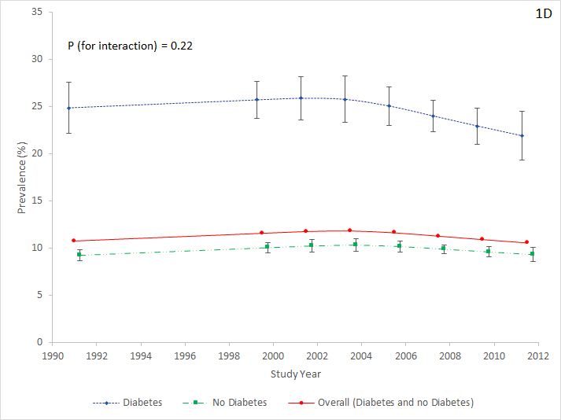

Each subgroup is adjusted for the other three subgroup variables (e.g. 1A is adjusted for sex, race/ethnicity, and diabetes status).
Supplemental Figure 2. Adjusted prevalence (as percentage) of chronic kidney disease (CKD) stages 3-4 (by Modification of Diet in Renal Disease study [MDRD] equation) in U.S. adults by age (2A), sex (2B), race/ethnicity (2C) and presence or absence of diabetes mellitus (2D)
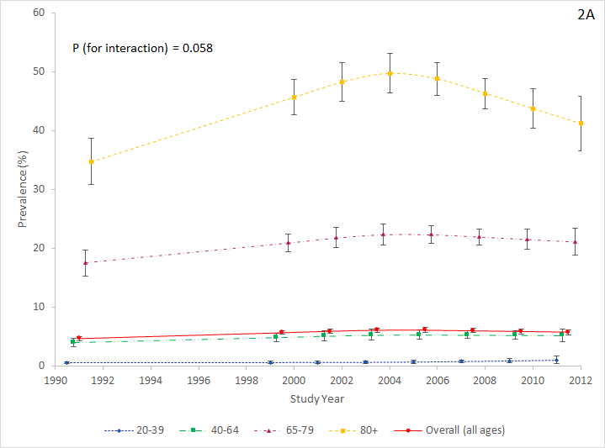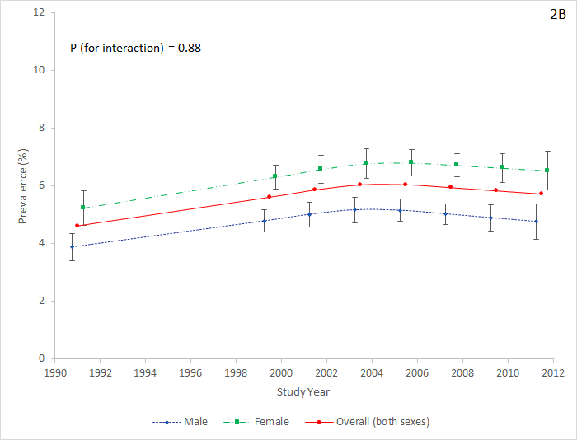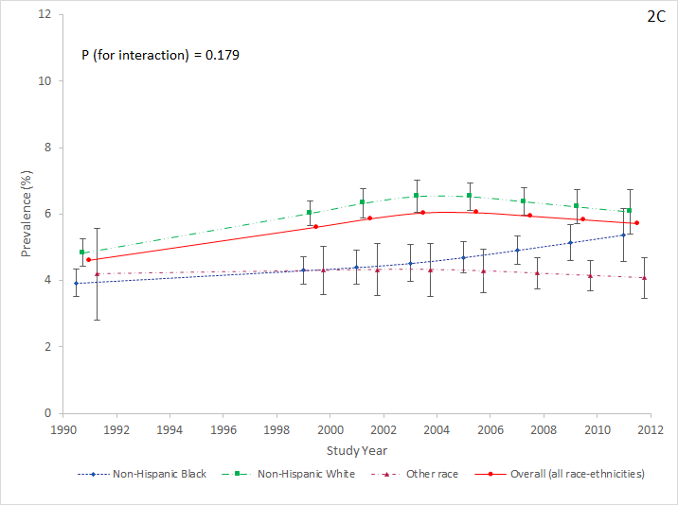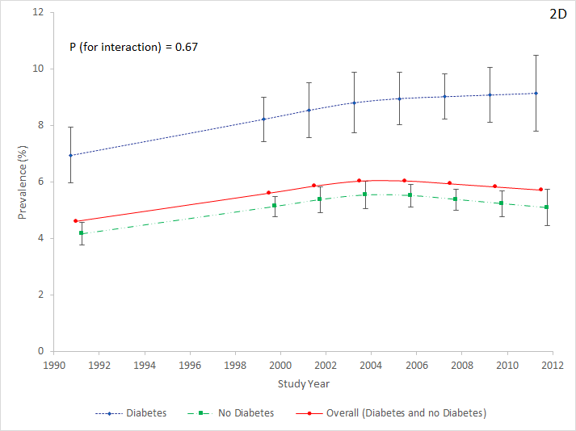

Each subgroup is adjusted for the other three subgroup variables (e.g. 2A is adjusted for sex, race/ethnicity, and diabetes status).
Supplemental Figure 3. Adjusted prevalence (as percentage) of CKD (by MDRD equation) with expanded definition which includes albuminuria ≥30 mg/g regardless of estimated glomerular filtration rate (eGFR) level by age (3A), sex (3B), race/ethnicity (3C), and presence or absence of diabetes mellitus (3D)
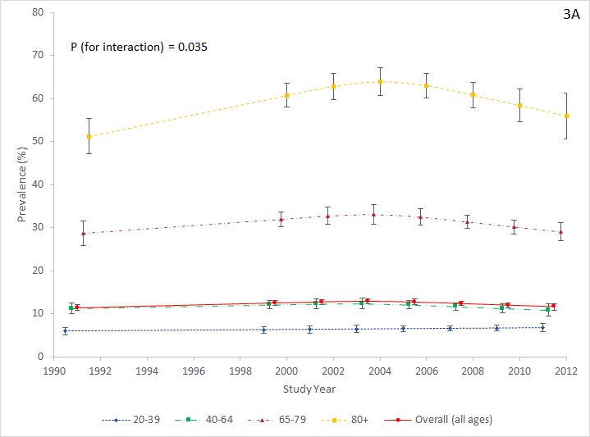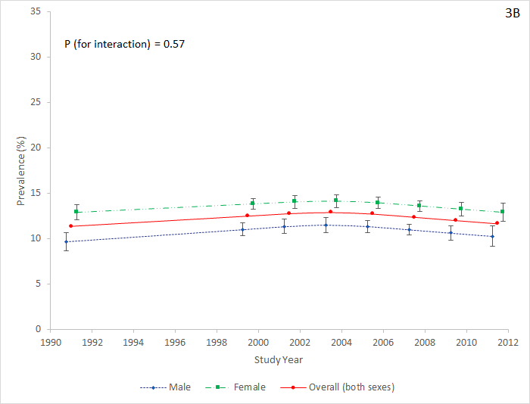
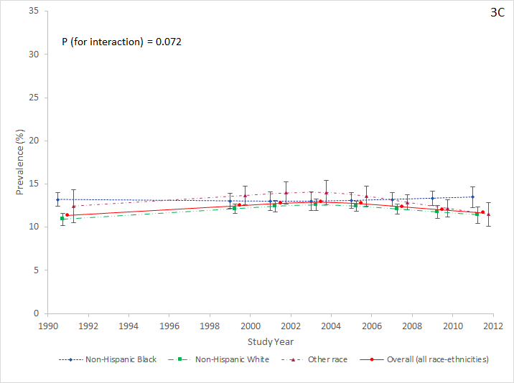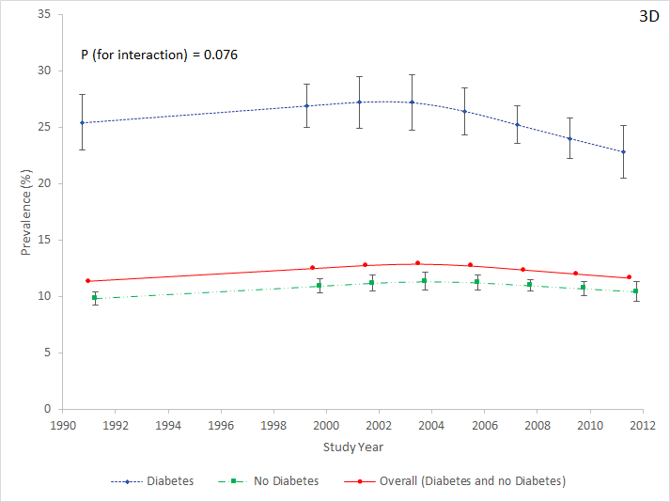

Each subgroup is adjusted for the other three subgroup variables (e.g. 3A is adjusted for sex, race/ethnicity, and diabetes status).

