Maternal exposure to ozone and PM_{2.5} and the prevalence of orofacial clefts in four U.S. states

Ying Zhou¹, Suzanne M. Gilboa², Michele L. Herdt^{3, 4}, Philip J. Lupo⁵, W. Dana Flanders⁶, Yang Liu⁷, Mikyong Shin¹, Mark A. Canfield⁸, Russell S. Kirby⁹

¹Environmental Health Tracking Branch, Division of Environmental Hazards and Health Effects, National Center for Environmental Health, Centers for Disease Control and Prevention, Atlanta, GA, USA

²Birth Defects Branch, Division of Congenital and Developmental Disorders, National Center on Birth Defects and Developmental Disabilities, Centers for Disease Control and Prevention, Atlanta, GA, USA

³New York State Department of Health, Center for Environmental Health, Albany, NY, USA

⁴State University of New York at Albany, Department of Epidemiology and Biostatistics, Rensselaer, NY, USA

⁵Baylor College of Medicine, Department of Pediatrics, Section of Hematology-Oncology, Houston, TX, USA

⁶Department of Epidemiology, Rollins School of Public Health, Emory University, Atlanta, GA, USA

⁷Department of Environmental Health, Rollins School of Public Health, Emory University, Atlanta, GA, USA

⁸Birth Defects Epidemiology and Surveillance Branch, Texas Department of State Health Services, Austin, TX, USA

⁹Department of Community and Family Health, College of Public Health, University of South Florida, Tampa, FL, USA

Supplementary Material

Table S1. Percentage of live births, and of cases of all orofacial clefts, cleft lip with or without cleft palate (CL +/- CP) and cleft palate (CP) in the study that fall into different demographic categories, by state, from 2001¹ to 2007²

Characteristic | Category | AZ |  |  | FL |  |  | NY⁴ |  |  | TX
 |  | Live births³ | CL +/- CP³ | CP³ | Live births³ | CL +/- CP³ | CP³ | Live births³ | CL +/- CP³ | CP³ | Live births³ | CL+/- CP³ | CP³
 |  | % | % | % | % | % | % | % | % | % | % | % | %
Sex | Male | 51 | 60 | 45 | 51 | 61 | 41 | 51 | 64 | 46 | 51 | 62 | 44
 | Female⁵ | 49 | 40 | 55 | 49 | 39 | 59 | 49 | 36 | 54 | 49 | 38 | 56
Maternal race-ethnicity | Hispanic | 45 | 43 | 48 | 28 | 27 | 22 | 13 | 14 | 12 | 49 | 53 | 46
 | Black, non-Hispanic | 3 | 1 | 2 | 21 | 13 | 17 | 10 | 6 | 6 | 11 | 7 | 8
 | Other, non-Hispanic | 9 | 17 | 8 | 4 | 3 | 4 | 5 | 5 | 5 | 4 | 4 | 5
 | White, non-Hispanic⁵ | 43 | 38 | 42 | 47 | 57 | 57 | 72 | 75 | 76 | 36 | 36 | 41
Maternal education | 12 years or less (diploma or GED) | 59 | 65 | 60 | 53 | 56 | 52 | 41 | 51 | 47 | 61 | 65 | 64
 | 13-15 (some college or AA) | 21 | 19 | 20 | 25 | 24 | 25 | 26 | 25 | 25 | 20 | 20 | 20
 | 16+ (college graduate/above)⁵ | 19 | 16 | 20 | 22 | 19 | 22 | 33 | 24 | 28 | 19 | 15 | 16
Maternal smoking | Smoked during pregnancy | 5 | 6 | 7 | 7 | 9 | 10 | 13 | 17 | 15 | 6 | 7 | 9
 | No smoking during pregnancy⁵ | 95 | 94 | 93 | 93 | 91 | 90 | 87 | 83 | 85 | 94 | 93 | 91
First baby | Nulliparous | 37 | 36 | 39 | 42 | 40 | 42 | 40 | 41 | 38 | 38 | 36 | 35
 | Multiparous⁵ | 63 | 64 | 61 | 58 | 60 | 58 | 60 | 59 | 62 | 62 | 64 | 65
Maternal age⁶ | Mean (SD) | 26.6 (6.0) | 26.3 (6.0) | 26.7 (6.2) | 27.3 (6.2) | 27.2 (6.2) | 27.5 (6.2) | 28.9 (6.2) | 28.0 (6.2) | 29.3 (6.2) | 26.4 (6.1) | 26.2 (6.3) | 26.9 (6.1)
County | Number of counties | 15 |  |  | 67 |  |  | 57 |  |  | 254

Notes:
- Due to the availability of air pollution data, only births with the start of week 5 of gestation on or after January 1, 2001 were included in the analysis. Observations with missing health characteristic data were excluded from the analysis.
- All births with week 5 of gestation on or after April 15, 2007 were excluded from the dataset, to avoid including only preterm births in this analysis.
- The numbers listed in the table were percentages that fall into different categories except for the row of “Maternal age”.
- NY data excluded New York City.
- Used as reference in the logistic regression.
- Maternal age was included as a linear term in the logistic regression. The variable’s mean (standard deviation) are listed in the table.
Table S2 Odds ratios and 95% confidence intervals for variables that were adjusted for in regression analysis for four states combined, 2001¹ to 2007²

Parameter | CL +/- CP | CP
Male infant sex³ | 1.53 (1.44, 1.63) | 0.75 (0.70, 0.81)
Race-ethnicity⁴
Hispanic | 0.97 (0.90, 1.05) | 0.87 (0.79, 0.97)
Black, non-Hispanic | 0.59 (0.52, 0.67) | 0.71 (0.62, 0.83)
Other, non-Hispanic | 1.18 (1.03, 1.36) | 0.99 (0.82, 1.19)
Maternal education⁵
12 years or less | 1.35 (1.23, 1.49) | 1.35 (1.20, 1.52)
13-15 years | 1.20 (1.09, 1.32) | 1.17 (1.03, 1.32)
Smoked during pregnancy⁶ | 1.08 (0.97, 1.20) | 1.19 (1.03, 1.36)
Mother's first baby⁷ | 0.93 (0.87, 0.99) | 1.01 (0.92, 1.10)
Maternal Age | 1.00 (0.99, 1.01) | 1.02 (1.01, 1.03)

Notes:
- Due to the availability of air pollution data, only births with the start of week 5 of gestation on or after January 1, 2001 are included in the analysis.
- All births with week 5 of gestation on or after April 15, 2007 are excluded from the dataset, to avoid including only preterm births in this analysis.
- Reference = female infant sex
- Reference = white, non-Hispanic
- Reference = 16 years or more (college graduate/above)
- Reference = no smoking during pregnancy
- Reference = not first baby (Multiparous)

Table S3. Adjusted odds ratios¹ and 95% confidence intervals associated with each 10 μg/m³ increase in PM_{2.5} (μg/m³) and 10 ppb of ozone concentrations during weeks 5 to 10 of gestation by state and for the four states combined, 2001² to 2007³. The county level PM_{2.5} and ozone concentrations used in the regressions were the simple averages of their corresponding census tract level concentrations.

 | CL+/-CP |  | CP
State | OR (95% CI) for ozone | OR (95% CI) for PM_{2.5} | OR (95% CI) for ozone | OR (95% CI) for PM_{2.5}
Arizona | 1.03 (0.94, 1.13) | 1.62 (0.82, 3.20) | 1.01 (0.90, 1.15) | 1.52 (0.60, 3.87)
Florida | 1.01 (0.90, 1.13) | 0.79 (0.43, 1.46) | 1.03 (0.90, 1.18) | 0.99 (0.46, 2.11)
New York (excluding New York City) | 1.00 (0.91, 1.09) | 1.35 (0.90, 2.03) | 0.95 (0.86, 1.05) | 1.49 (0.93, 2.39)
Texas | 1.00 (0.94, 1.06) | 0.96 (0.69, 1.34) | 0.97 (0.90, 1.05) | 1.70 (1.09, 2.65)
Four states combined | 0.99 (0.96, 1.03) | 1.09 (0.89, 1.33) | 0.98 (0.94, 1.03) | 1.44 (1.11, 1.86)

Notes:
- Odds ratios have been adjusted for infant sex, race-ethnicity, maternal education, smoking status during pregnancy, whether this is mother's first baby, maternal age. More details on these variables can be found in Supplementary material Table S1.
- Due to the availability of air pollution data, only births with the start of week 5 of gestation on or after January 1, 2001 are included in the analysis.
- All births with week 5 of gestation on or after April 15, 2007 are excluded from the dataset, to avoid including only preterm births in this analysis.
- Definition of abbreviations: CL+/-CP = cleft lip with or without cleft palate; CP =cleft palate alone; CI = confidence interval; OR = odds ratio.

Table S4. Adjusted odds ratios¹ and 95% confidence intervals associated with each 10 μg/m³ increase in PM_{2.5} (μg/m³) and 10 ppb of ozone concentrations during weeks 5 to 10 of gestation, 2001² to 2007³ for the four states combined, when all births were assumed to occur on the 8th, 15th and 22nd of the birth month.

Birth day of birth month | CL+/-CP |  | CP
 | OR (95% CI) for ozone | OR (95% CI) for PM_{2.5} | OR (95% CI) for ozone | OR (95% CI) for PM_{2.5}
8th | 0.99 (0.96, 1.03) | 1.11 (0.90, 1.36) | 0.98 (0.93, 1.02) | 1.42 (1.09, 1.84)
15th ⁴ | 0.99 (0.96, 1.03) | 1.09 (0.89, 1.33) | 0.98 (0.94, 1.03) | 1.44 (1.11, 1.86)
22nd | 1.00 (0.96, 1.03) | 1.06 (0.86, 1.31) | 0.98 (0.94, 1.03) | 1.35 (1.04, 1.77)

Notes:
- Odds ratios have been adjusted for infant sex, race-ethnicity, maternal education, smoking status during pregnancy, whether this is mother's first baby, maternal age. More details on these variables can be found in Supplementary material Table S1.
- Due to the availability of air pollution data, only births with the start of week 5 of gestation on or after January 1, 2001 are included in the analysis.
- All births with week 5 of gestation on or after April 15, 2007 are excluded from the dataset, to avoid including only preterm births in this analysis.
- This is the assumption in primary analysis.
- Definition of abbreviations: CL+/-CP = cleft lip with or without cleft palate; CP =cleft palate alone; CI = confidence interval; OR = odds ratio.

Figure S1 Average county-level PM_{2.5} concentration in contiguous United States between 2001 and 2007
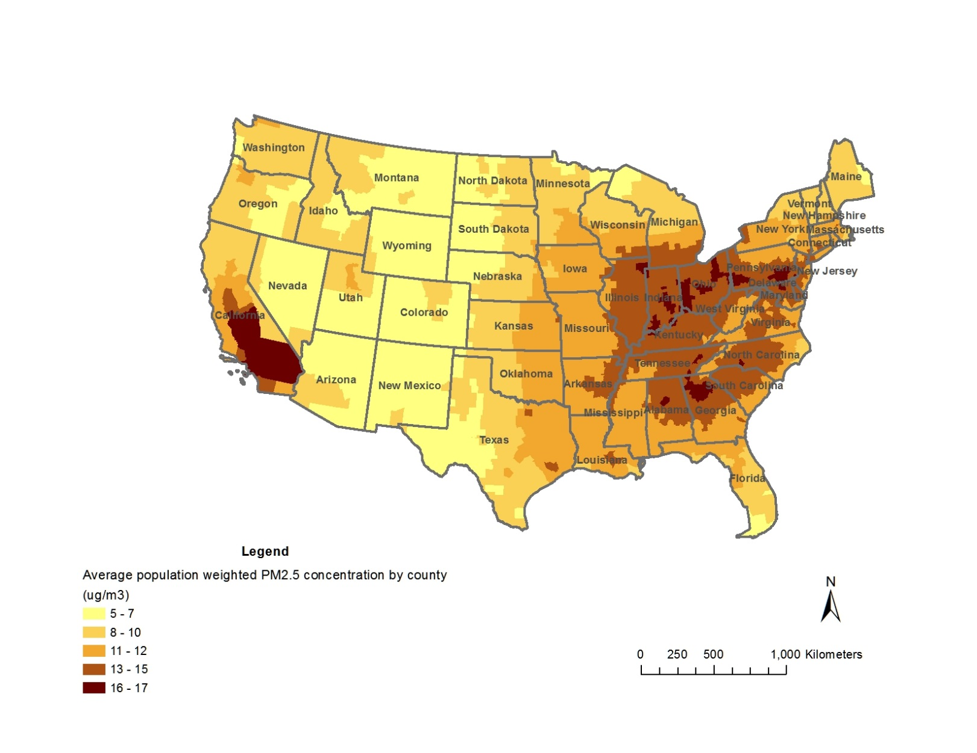

Figure S2 Average county-level ozone concentration in contiguous United States between 2001 and 2007
